Informing the Design of a Prevention and Early Intervention Adult Social Care Framework for Northern Ireland
Lived Experience Report

Dr Mary Webster, June 2026
Contents
1. Executive summary 3
2. What early intervention and prevention means to those who draw on care and support 3
3. Current challenges within adult social care in NI 4
3.1 A crisis-driven system 4
3.2 Difficult navigation and access 5
3.3 Fragmentation and inconsistency 6
3.4 Workforce and professional knowledge 6
4. Community, relationships and prevention 7
5. Information, advocacy and support 8
6. Voice, power and co-production 9
7. Accountability and system leadership 10
8. Vision for effective early intervention and prevention 11
9. Key recommendations 12
10. Conclusion 12

Executive summary
This report has been prepared to share the voices of those with lived experience to contribute to the development of an early intervention and prevention framework for adult social care in Northern Ireland (NI). The report shares the perceptions, experiences and opinions of people who currently draw on adult care and support in NI. This information has been gained through IMPACT projects led across the trusts in partnership with host organisations, including both statutory and community and voluntary services. Additionally, IMPACT hosted a lived experience community of practice to explore what we have learned from the evidence review and to inform the design of a draft adult social care framework.
Through engagement with many participants with lived experience of adult social care, as well as carers and advocates, key themes were identified in relation to experiences of early intervention, as well as barriers and opportunities for accessing early support. Recommendations for improving the adult social care system were co-designed with participants. A clear and consistent message emerged throughout this work: while participants strongly believed that early intervention and prevention were essential, current systems remained predominantly crisis driven. Participants described significant challenges in accessing support, navigating services, obtaining accurate information and influencing decisions that affected their lives. They also highlighted the importance of community-based approaches, meaningful relationships, advocacy and genuine co-production in creating a more preventative and person-centred system. The findings demonstrate a need for systemic change that shifts social care from reactive crisis management towards proactive planning, prevention and partnership with people who draw on care and support.

What early intervention and prevention means to those who draw on care and support
Participants described early intervention as support that is available at the earliest point of need, before problems escalate into crises.
Key themes included:
- Preventing deterioration in health, wellbeing and independence.
- Providing the right support at the right time.
- Supporting people to remain connected to their communities.
- Offering personalised, person-centred approaches.
- Supporting carers and families.
- Promoting safeguarding, safety and quality of life.
- Improving awareness of available services and supports.
- Beginning preventative approaches earlier in life where appropriate.
Participants illustrated what preventative support could ultimately enable:
“What I really wanted was simple: choice, independence, and the flexibility to live my own life.”
Person drawing on care and support
There was unanimous agreement that early intervention and prevention are important in adult social care. However, it was also agreed that these approaches were not implemented effectively in NI.
“I think, especially here in Northern Ireland, we've kind of shifted the focus…to purely early intervention and prevention of crisis rather than…of health care and social care needs.”
Person drawing on care and support

Current challenges within adult social care in NI
Participants discussed barriers to navigating adult social care systems and accessing information.

3.1 A crisis-driven system
They described a system that often responded only when needs had become severe.
Examples included:
- Delays in accessing assessments and support.
- Waiting until people reach crisis point before intervention occurs.
- Insufficient planning for progressive conditions.
- Limited support for carers before they become overwhelmed.
- Funding models that prioritise crisis response over prevention.
Participants emphasised that delayed intervention frequently resulted in poorer outcomes, greater distress and higher long-term costs.
“By the time people get onto crisis and trying to care for and provide help for the person, it's very often nearly too late…the situation and the person and the people who are trying to care for that person are just getting more and more distressed and more and more helpless.”
Family carer

3.2 Difficult navigation and access
One of the strongest themes identified was the difficulties people experienced when attempting to access support.
Participants described:
- No clear entry point into services.
- Complex and fragmented pathways.
- Repeated signposting between organisations without resolution.
- Lack of accessible information.
- Limited awareness of available services and entitlements.
- Over-reliance on individuals and families to navigate systems independently.
Many felt that they often discovered available support through chance encounters or peer networks rather than through formal pathways.
“We didn’t even know who to call. It was other parents who told me what to do.”
Family carer
“Parents are left to do the groundwork. It shouldn’t be like this.”
Family carer

3.3 Fragmentation and inconsistency
Participants highlighted considerable variation across regions and service areas, which contributed to confusion and mistrust.
Challenges included:
- Inconsistent service provision across trusts.
- Poor transitions between children's and adult services.
- Limited coordination between organisations.
- Loss of continuity through organisational and digital system changes.
- Different experiences depending on geography rather than need.
“No one had taken ownership after Children’s Services ended. Adult services didn’t even know who we were.”
Family carer
“We cannot continue with the situation where everything's so... inconsistent, and one policy for one trust is being done differently by another. It's just absolutely impossible.”
Family carer

3.4 Workforce and professional knowledge
Concerns were identified regarding workforce capacity and expertise.
Issues included:
- Limited staff availability.
- Insufficient knowledge of rare and progressive conditions.
- Lack of autism-specific knowledge in some services.
- Reduced continuity of relationships with professionals.
- Loss of traditional social work functions focused on long-term support.
It was stressed that effective prevention depends on knowledgeable professionals who understand changing needs and can support lifespan planning.
“[The occupational therapist] wasn't up to date with [my son’s] illness. How can people make decisions for other people when they don't know the up to date-ness of an illness?”
Family carer
“We've had the same [GP] for 30 years and he is superb. And I think that continuity, so we don't have that change. I don't have to repeat my story. I know he gets it.”
Family carer

Community, relationships and prevention
A recurring message was that prevention is fundamentally about people and relationships rather than services alone.
Participants highlighted:
- The importance of peer support.
- The value of community networks.
- The role of carers and families in identifying changing needs.
- Risks of social isolation for disabled people and carers.
- The importance of meaningful opportunities for participation and connection.
“People have a right to live at home…people have a right to socialization…people have a right to be part of their community.”
Family carer
Participants felt that stronger community infrastructure could reduce pressure on formal services while improving wellbeing and independence.
Suggested approaches included:
- Investment in peer support programmes.
- Community development initiatives.
- Neighbourhood-based support models.
- Flexible personalised support arrangements.
- Greater collaboration between statutory and community organisations.
“Having the same person each day helps me feel safe and in control.”
Person drawing on care and support
“I feel proud of what I do. I help someone live their life the way they want to.”
Personal assistant

Information, advocacy and support
Information and advocacy emerged as critical components of prevention. Participants reported difficulties obtaining accurate and up to date information. Digital exclusion and complex systems were identified as significant barriers.
“There's so many different avenues to go to try and get information…There's no consistent messaging coming out and people don't really know where to look.”
Person drawing on care and support
Participants suggested:
- Publicly accessible service directories.
- "One-stop-shop" information and advice services.
- Care navigators to help individuals and families access support.
- Independent advocacy services.
- Peer advocates with lived experience.
- Improved communication across organisations.
Many participants felt that effective navigation support could prevent problems escalating and reduce unnecessary distress.
“Within mental health you have peer advocates, I don't see an equivalent across all other areas where you would have a lived experience expert who can guide you.”
Family carer
“Having someone in my corner who could speak up made all the difference.”
Person drawing on care and support

Voice, power and co-production
Consistently emphasised was the importance of individuals being meaningfully involved in decisions affecting their lives.
Concerns included:
- Lived experience being undervalued.
- Consultation without visible action.
- Limited advocacy structures.
- Lack of accountability following engagement exercises.
- Insufficient opportunities to influence implementation.
Participants stressed that co-production must move beyond consultation and involve genuine power-sharing.
“Until we are part of commissioning, nothing will change. Until we're at that top table, we will continue to be done to.”
Family carer
Recommendations included:
- Embedding lived experience throughout governance structures.
- Strengthening patient and public involvement (PPI) mechanisms.
- Developing peer workforce roles.
- Co-commissioning services with people who draw on care and support.
- Remunerating lived experience contributions appropriately.
“Being involved in this project has meant that my voice, and the voices of those I represent, have been heard.”
Person drawing on care and support

Accountability and system leadership
Accountability was identified as a major challenge within the current system.
Key concerns included:
- Lack of transparency regarding funding decisions.
- Weak accountability mechanisms.
- Poor implementation of existing strategies.
- Workforce instability resulting from short-term funding arrangements.
- Limited confidence that engagement leads to meaningful change.
“If that is going to be the infrastructure where people live their lives, what are the key services that we actually need to be making with five-year budgets, not annual budgets?”
Family carer
Participants called for:
- Stronger regional oversight.
- Greater consistency across trusts.
- Transparent reporting of outcomes.
- Ring-fenced investment in prevention.
- Clear accountability for implementation.
“It matters deeply to me that every person, regardless of where they live, can benefit from a fair, equitable, and consistent approach.”
Person drawing on care and support

Vision for effective early intervention and prevention
Participants co-designed a shared vision of what good early intervention and prevention should look like in the NI adult social care system, which is detailed in Figure 1 below.
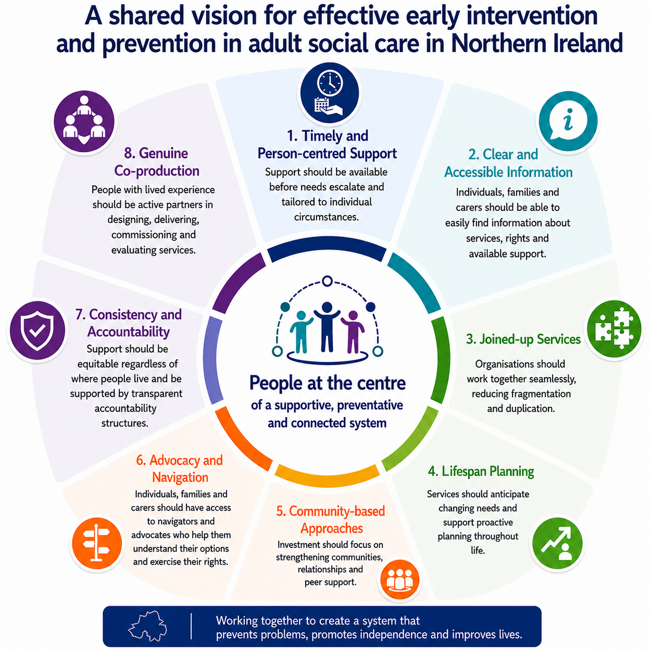
Figure 1. Shared vision for effective early intervention and prevention in the NI adult social care system

Key recommendations
Together, participants identified the following priorities for reform:
- Shift investment from crisis response towards prevention and early intervention.
- Develop clear pathways and accessible entry points into support.
- Establish care navigator and advocacy roles.
- Improve public information and service directories.
- Strengthen support for carers and families.
- Invest in community development and peer support infrastructure.
- Improve workforce training, particularly regarding complex and progressive conditions.
- Promote anticipatory planning and future-focused support.
- Ensure greater consistency across trusts and regions.
- Strengthen accountability and transparency mechanisms.
- Embed lived experience within governance, commissioning and decision-making structures.
- Adopt genuine co-production throughout implementation and evaluation.

Conclusion
Engagement with people with lived experience highlighted strong agreement that early intervention and prevention are fundamental to a sustainable, person-centred adult social care system in NI. However, participants described a system that remains largely reactive, fragmented and difficult to navigate, leading to poorer health and wellbeing outcomes for those who draw on care and support, as well as significant financial pressures on the system.
Several practical solutions were identified and a clear vision for change. Central to this vision is a shift towards proactive support, stronger communities, accessible information, meaningful relationships, effective advocacy and genuine partnerships with people who draw on care and support. Participants expressed optimism that meaningful reform is possible if lived experience remains central to the redesign and implementation of the NI adult social care framework.

