
Discussion Paper V1.2
Developing a Sustainable Early Intervention/ Prevention Adult Social Care Framework. Enabling people to live well, independently and with purpose in a place they call home.
Overview
This framework suggests a four-tiered model of adult social care, designed to prioritise early intervention, prevention, and community-based support, while ensuring responsive access to specialist care when required.
The framework adopts a strength based approach, building support around the strengths of the individual supported by all HSC systems, strategies and strengths.
The framework will shape a fundamental shift from assessing need to supporting and enabling health, independence, and social wellbeing whilst leading change in the framing, funding and positioning of social care in NI.
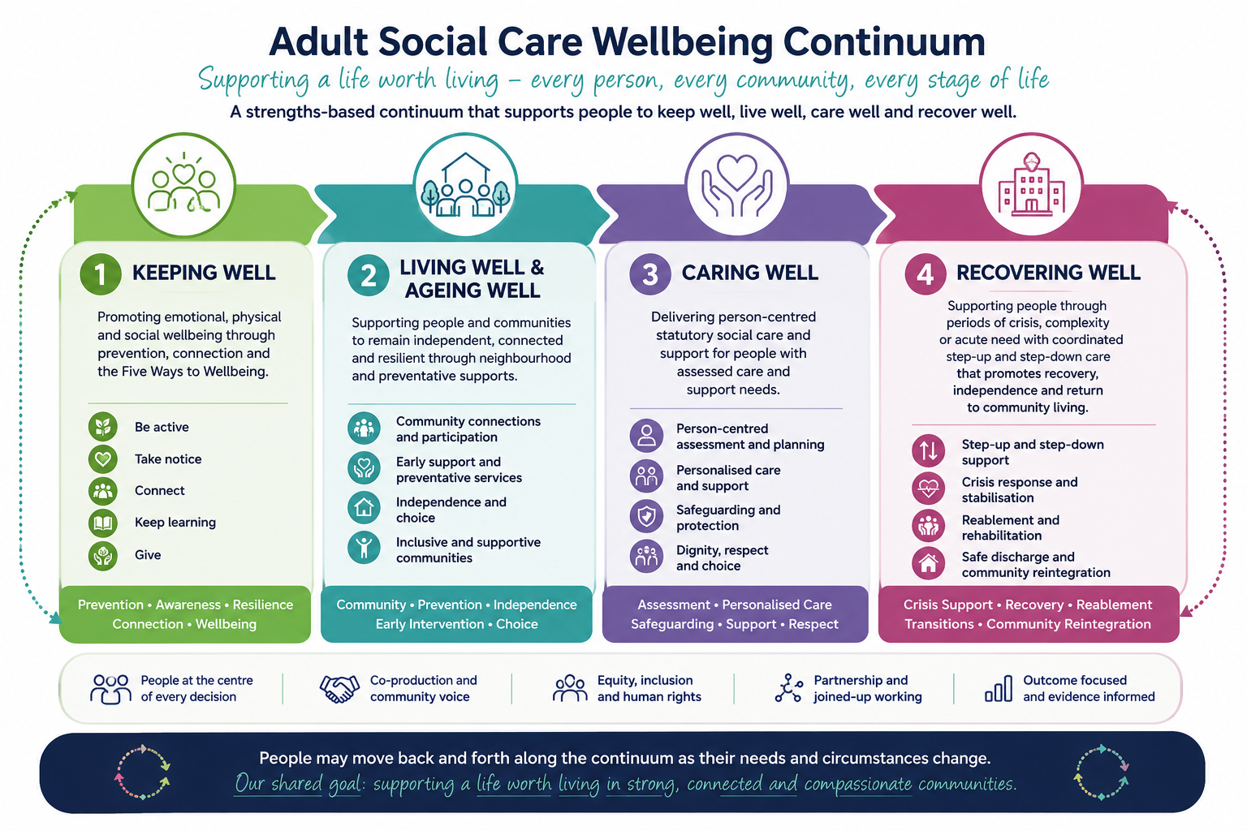
*Consideration to be given to adding a 4th section entitled ‘Dying Well’
- Keeping Well - Supporting and Enabling Health and Social Wellbeing
Keeping Well the first point of contact and the foundation of the social care system ensuring universal, community-based and accessible support.
It focuses on promoting meaningful connections within local communities, addressing loneliness and social isolation, supporting a sense of belonging, and making it normal and easy to be connected locally to receive support at the earliest point. Social care services which support and enable independent living will be visible within the community. Local hubs or organizations will connect and navigate people to local community supports. Social Care Support Plans promoted to assist individuals, carers and families may be developed.
Keeping Well is embedding within the population health agenda led by PHA and outcomes can be measured using the established 5 Steps to Wellbeing outcomes tool which is central to existing voluntary and community sector contracts and utilised at community level.
Key Features
- Community pathways to support living well at home
- Shared NI digital platform mapping community services and access arrangements
- Focus on supporting and enabling rather than assessing need
- Building caring communities
- Supporting Unpaid Carers

- Living Well & Ageing Well
Living Well & Ageing Well provides targeted support for individuals with emerging needs. Focus includes early intervention, maintaining independence, and anticipatory care. The aim of intervention is to ensure formal care is avoided or delayed through timely support. Delivered through integrated neighbourhood teams, multidisciplinary teams, and programmes such as Impact AgeWell etc. Central to this tier is a strong emphasis on future and contingency planning within local communities.
Living Well and Ageing Well are strategic priorities for the Public Health Agency. Impact will be measured through already established outcomes (PHA) and additional priorities linked specifically to the role of social care and impact of this approach (to be determined).

- Caring Well
Person-Centered Care in Your Community
Tier 3 supports individuals with complex needs that require statutory assessment, care planning, and provision of regulated services.
The focus remains on person-centered care and supporting people at home. A shift in focus away from assessing need and managing risk will move to assessing capability, promoting choice and risk enablement. This shift will be central to the changing ethos of social care intervention. Multi-disciplinary care and support planning takes place linked to local community networks.
Measurement will be shaped by existing delegated statutory functions performance arrangement supported by key priorities to support longer term change for social care. This will include leadership and support to the social care workforce.
- Recovering Well
Step Up & Step Down - Specialist Support to Stay at Home
Recovering Well supports individuals with acute or complex needs requiring intensive intervention. A multi-disciplinary community support service focuses on providing community health and care, stepping up to prevent hospital or care admissions and supporting step down.
Stepping Up
- Intensive multidisciplinary support
- Hospital and care at home approaches
- Preventing admission where possible
Hospital as a Last Resort
- Admission only when necessary
- Immediate discharge and step-down planning from point of admission.
Stepping Down
- Reducing support intensity
- Reconnecting with community supports
- Transition back to Tier 3

Summary
The adult social care continuum should be developed to ensure a strengths based collective system supporting prevention, early intervention, community care, and specialist support when required. This framework is not linear. It is flexible and responsive, allowing movement between tiers based on health and social wellbeing. It is built on current strategic foundations and will be developed to influence and align with the neighbourhood model.

Discussion questions
Does the proposed adult social care well-being continuum articulate a clear and shared vision for the future of adult social care in Northern Ireland. What works well? What needs to change?
Does the framework sufficiently reposition social care as
- preventative
- strengths based
- community connected/assets based
- person centred
Are there significant gaps?
What existing prevention initiatives, community assets or models should be aligned to or incorporated within the framework and its pathways (to be developed)?
What barriers currently prevent earlier intervention within adult social care?

Roles and Responsibilities Across the Social Care Pathways in the Adult Social Care Wellbeing Continuum

As the adult social care framework and NI neighborhood model is developed it is important for social care and social work to be clear about roles and responsibilities within and across the adult social care continuum.
Based on the international evidence on strengths-based social care, prevention frameworks, neighbourhood models, strengths-based guidance, and strategic adult social care reform literature, there is a strong rationale for redefining the roles of both social care workers and social workers across the four tiers of the adult social care wellbeing continuum
The key shift in the literature is that social care workers increasingly become enablers of wellbeing, independence, community connection and relational support. One of the most important themes emerging internationally is that social care workers are no longer viewed solely as “task-based carers.” Increasingly they are viewed as:
- wellbeing workers
- enablers
- community connectors
- relationship-based practitioners
- prevention workforce
- recovery and independence workforce
Similarly, whilst social workers hold complex statutory, safeguarding, and professional decision-making roles usually most visible in tier 3 and 4. Their role in prevention/early intervention are increasingly positioned as:
- system leaders
- complexity navigators
- human rights practitioners
- community social workers
- prevention leaders
- multidisciplinary coordinators
- professional decision-makers in complexity and risk
Rather than all roles sitting in Tier 3 or Tier 4 statutory services, the evidence suggests social care and social work operate across the full continuum of prevention, early intervention, community wellbeing and specialist support. Suggested roles are as outlined as follows;

*These proposed roles and responsibilities are intended to initiate discussion and engagement regarding the future contribution of social care and social work within the adult social care continuum, enabling a preventative and neighbourhood focused model of support.

Social Care Roles in the Adult Social Care Wellbeing
Continuum

Keeping Well | • supporting people to access community activities  • reducing loneliness and social isolation  • promoting wellbeing and independence  • encouraging self-management and resilience  • supporting digital inclusion and access to information  • community navigation and signposting  • supporting access to social prescribing opportunities  • identifying early concerns before escalation
Living Well & Ageing  Well | • supporting daily living skills  • confidence building  • promoting independence  • short-term enablement support  • assisting people to remain at home safely  • assisting with personal care and daily living
Caring Well | • delivering person-centred support  • supporting dignity, choice and independence  • supporting communication and sustaining relationships  • promoting participation in community life
Recovering Well | • crisis response support  • reablement and rehabilitation support  • hospital discharge support  • supporting step-down pathways  • supporting recovery-focused goals

Social Work Roles in the Adult Social Care Wellbeing
Continuum

Keeping Well | • community capacity building  • supporting development of preventative pathways  • identifying emerging social risks and inequalities  • promoting rights and inclusion  • supporting co-production with communities
Living Well & Ageing  Well | • strengths-based assessment  • early intervention planning  • complex family support  • self-directed support  • assessing, supporting carers and future planning
Caring Well | • assessment under statutory legislation  • safeguarding responsibilities  • care and support planning  • Mental Capacity and human rights considerations  • professional accountability for complex decisions
Recovering Well | • safeguarding investigations  • Mental Health and Adult Protection functions  • hospital discharge coordination  • complex risk management  • statutory interventions during crises

Discussion
What individuals, professional groups or organisations need to be engaged in further conversations to explore proposed roles and responsibilities?
Do the suggested roles and responsibilities reflect the future direction required for adult social care within a preventative, strengths based and neighbourhood focused model?
Considering the development of the draft adult social care well-being continuum and the proposed roles and responsibilities, what do steering group members believe should be the key next steps to support further development, engagement, testing and implementation across the system?

Barbara Campbell 03/26

