Increasing Adult Social Care Occupational Therapists Engagement with Research in the West Midlands
IMPACT Demonstrator Project, 2025/26
Alicia Ridout & Jane Clark, Senior Strategic Improvement Coaches
March 2026

Contents
Project Background 4
Pre-Project Evidence 4
Published evidence 5
Capacity 5
Careers 5
Culture 5
People drawing on care and support evidence 6
Practitioner (occupational therapists) evidence 6
Workforce Data 6
Survey of occupational therapists 8
Findings narrative 9
What do you need to be more engaged with research? 9
What competencies do you feel confident in applying? 9
Qualitative Themes 9
Canvasing wider ASC occupational therapy groups – The OT Show 11
Summary 13
Project Engagement Phase 2 13
Hacks 13
Hack 1 - 'Getting started - thinking and defining, planning & pitching’. 14
Hack 2 - 'Writing workshop - Abstracts, bids, proposals and collaborating’. 14
Hack 3 - ‘Involving people, partnering and co-design in research’. 15
Hack 4 -‘Sustaining engagement with research – plotting your course’ 16
Focus groups 16
Managers and supervisors 17
Apprentices, preceptees and students 18
Overarching areas for enquiry 19
Defining an occupational therapy Experts by Experience group 19
EbE Roles Proposed: 20
Future recommended steps to deliver the model: 22
Adult Social Care Occupational Therapy Showcase event in February 2026 23
Critically Appraised Topic (CAT) Groups 29
Theory of Change: Development and final outcomes 30
Approach 30
Step 1 – Who needs to be involved 30
Step 2 - Agreeing long-term goals 30
Step 3 - Identify the context and define assumptions 31
Context 31
Key issues 32
Assumptions 32
Step 4 - Planning activities 33
Step 5 - Expected outputs 34
Step 6 - Measuring change 34
Step 7 – writing up the theory of change 34
Learning 35
Recommendations 35
Next steps 36
Appendix 1 - Early engagement stakeholder questions 37
Appendix 2 - Engagement Programme 40
Appendix 3 - Theory of change (full) 42
Appendix 4 – Risks and mitigations 53

Project Background
This IMPACT Demonstrator project grew out of a recognition by West Midlands Association of Directors of Adult Social Services (WMADASS) that significant challenges exist for the occupational therapy workforce within adult social care.

Pre-Project Evidence
Two reports were published in 2024 during the development of the Demonstrator idea by partners.
- WMADASS published a report on optimisation of occupational therapy in adult social care (ASC) in June 2024 which highlighted their under-utilisation, despite evidence that they are taking disproportionate numbers of referrals (RCOT, 2019) . It presents this as a missed opportunity and describes the gap between NHS research activities/opportunities and ASC professionals’ awareness or uptake.
- Local Government Association (LGA) Allied Health Professionals (AHP) Health Check survey, occupational therapy report, described falling standards in safe workload and case allocation and feelings that employers did not understand the challenges they faced or promoted effective solutions (July 2024) . It placed the West Midlands as the second lowest nationally in effective workforce planning systems and strategic partnerships, third joint lowest nationally in provision of professional development with a lack of occupational therapists’ visibility in the council systems.
In addition to these reports, a programme across the regions ASC services had been initiated two years prior to the Demonstrator, to increase staff engagement with research, however, no occupational therapists had utilised the opportunities provided. This triggered the collaborative effort to create a Demonstrator project, as part of IMPACT, which ultimately created two half time roles dedicated to creating a new theory of change from a test and learn approach to improving occupational therapists’ engagement with research in the West Midlands. The project was co-funded with WM Applied Research Collaboration (ARC) and IMPACT, hosted by WMADASS and lasted twelve months. A follow-on project to further test a new approach to knowledge utilisation in practice by one local authority occupational therapy team, was also funded for six months.
Whilst the content of both the WMADASS and LGA reports is wide-ranging, the IMPACT Demonstrator sought to address several key recommendations and issues identified, relating to increasing occupational therapy engagement with research:
- The use and creation of evidence to support the occupational therapy profession in increasing its profile and visibility at the leadership level.
- Exploring capacity building in research and continuing professional development (CPD) pathways for the profession.
- Understanding what works to build confidence and competence in using research, applying research competencies to service improvement, and building career pathways to research.
The project aimed to support occupational therapists to engage with research/activities as a mechanism to increase use of existing and create new routes to access CPD or post graduate learning, enhancing the development of research related career pathways. It aimed to improve recruitment and aid retention of occupational therapists and ultimately improve the evidence base for best practice in adult social care which can deliver better outcomes for people accessing care and support.
This report uses the IMPACT triad of evidence to underpin the project and ensure all activities have been co-designed with people with lived experience and occupational therapists in the region, and wider stakeholders from local to national levels of influence.

Published evidence
In a review of the key documents “Unlocking the potential: Optimising Occupational Therapy as a High Impact Resource” and Healthcheck Data from May 2025, the following were highlighted as important areas of focus to ensure that the project built on previous findings. These have been grouped around the key emerging themes used within the project.

Capacity
- To explore and improve professional leadership structures and in turn
  - improve recruitment and retention to the sector
  - increase visibility of the occupational therapy profession

Careers
- To develop support for newly qualified occupational therapists.
- To explore and develop professional development opportunities to support the continuing professional development (CPD) of occupational therapists in adult social care. To include
  - Opportunities to engage in research activity
  - Promotion of clinical academic pathways for occupational therapists
  - Increase uptake of NIHR offers
  - Opportunities to share good practice
  - Explore ways to collaborate with NHS and HEI colleagues to share resources that are lacking in adult social care

Culture
- Increase the evidence base to allow occupational therapists to focus on prevention and early intervention, improve outcomes for citizens and maximise cost savings

People drawing on care and support evidence
An advisory group of volunteers was convened, of people who had experience of occupational therapy adult social care services over a prolonged period. They co-created the programme of work for the Demonstrator and specifically used their lived experience at the four Hack events and to create a film for the OT Show and conference where they actively contributed to the discussions and panel conversations with colleagues. The core output is included later in this report as a proposed model of support for the regions occupational therapy teams, mapped to the research cycle below (Figure 1).
Figure 1 Research Cycle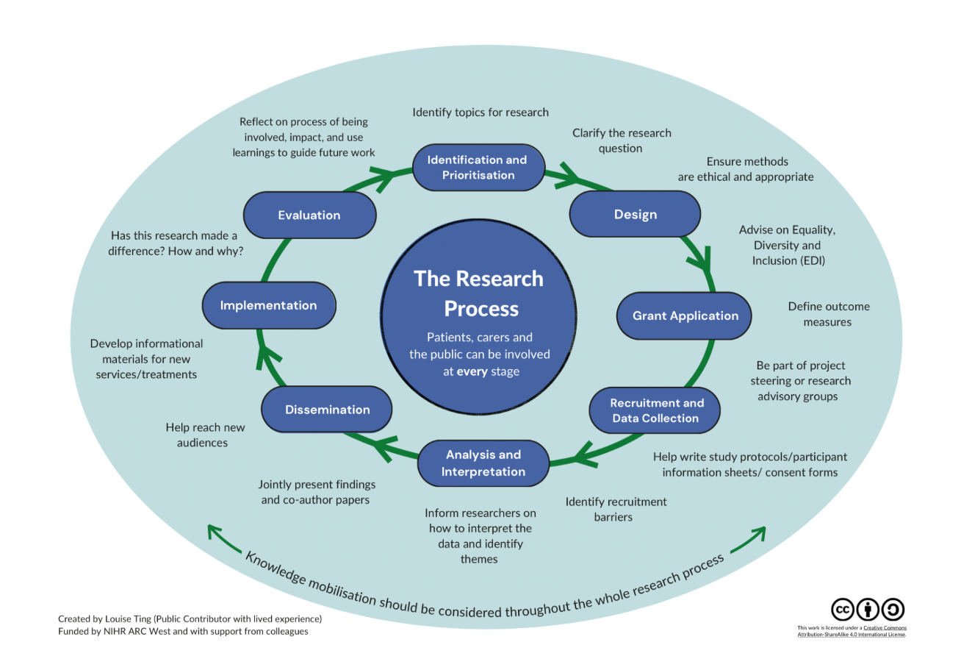

Practitioner (occupational therapists) evidence
The Demonstrator team reviewed the local data and national data sets from Skills for Care to establish a baseline. The team attempted to gather more local data, relying on local knowledge rather than a high-quality data set. There is currently no regional data set that would have helped to provide a robust data analysis of the professions needs in relation to research. The team followed this, and the other evidence reviews (below) with individual and group conversations across the project. The findings are shared in the following sections.

Workforce Data
Accurate adult social care workforce data is difficult to access. Whilst “skills for care” data is available this does not correlate accurately with OT managers reports of their work force. BCC OT manager reports 70 OT staff and skills for health data states fifty. The data is only presented in fives which presents a particular challenge for a small workforce such as occupational therapy, where numbers less than 5 are not included.
Table 1: Occupational Therapy Workforce Intelligence, Integrated Care System Data
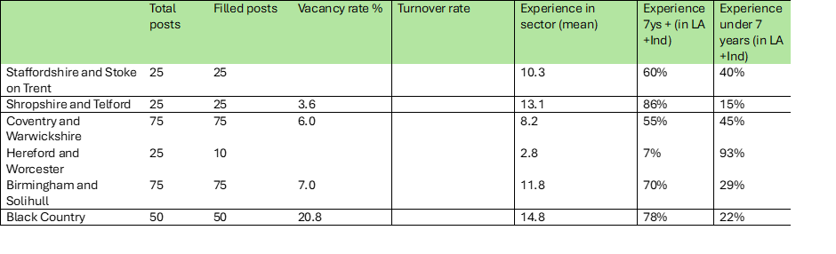
Whilst acknowledging these limitations the workforce data presents a picture of a small workforce (225) across the fourteen west midlands local authorities, with variable sickness, vacancy, and turnover rates. The highest vacancy rate across the west midlands is the black country at 20.8%. Hereford and Worcester have the least experienced workforce with 93% of their occupational therapists with under 7 years’ experience, and together with high number of staff over 50 (54%) this may add to a range of risks across the region. Of the 225 occupational therapy staff two hundred are white British and primarily women.
[All data accessed on 18.3.2025]

Survey of occupational therapists
An online survey was carried out in the first three months of the project to provide a baseline of occupational therapists’ engagement with research. A total of fifty-seven people responded. The following provides a summary of this survey, from which the programme of activities was co-designed with stakeholders, people with lived experience of occupational therapy services and occupational therapists in the region.
Tables from occupational therapy survey results
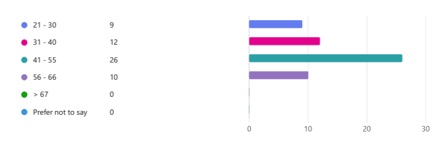
Demographics - Age:

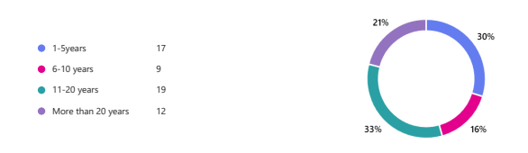
Experience:

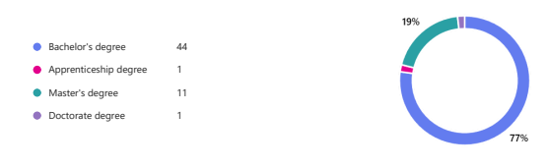
Post Grad
Education:

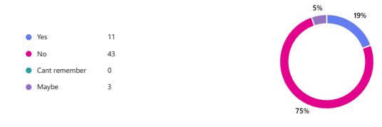

Research
experience:

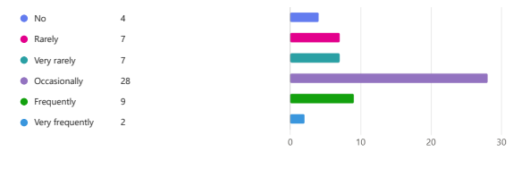
Engagement:

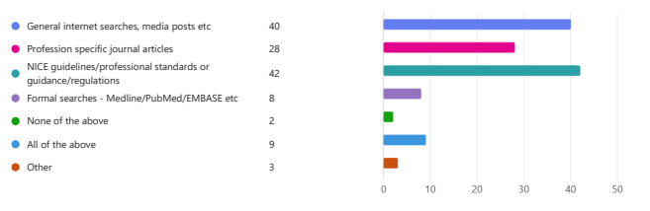
Evidence:

Findings narrative

What do you need to be more engaged with research?
The top findings were that (19%) of respondents wanted time to work with others on research related activities and (18%) wanted dedicated time and development goals to work on. Other priorities included (14%) needing it to be included in their development plan or else it would not happen and (13%) wanted opportunities to practice skills related to research creation, use and dissemination. One to one support was felt to be important to start a research journey (11%) and (12%) needed opportunities to build their confidence. Two respondents were currently studying. There were small numbers of respondents (8) who could not think about it or felt it was not for them, although they would be passive recipients of the outcomes.

What competencies do you feel confident in applying?
The top two competencies were accessing, evaluating and critically appraising literature (20%) and participating in activities such as monitoring/evaluating/using feedback and outcome measures (18%). The next most cited were engaging people (citizens, families, colleagues) in research and the ability to analyse, synthesise and apply to practice, research evidence to answer specific questions/gaps or issues (11%). Using different research methods and ethical processes was next (10%) followed by supporting/mentoring or being a role model/peer reviewer, supervisor, or critique for submissions to support research (9%) and influencing research activities (7%). Six respondents added that they were not confident at all/did not engage with any of the activities listed and one stated:
“As I am a new OT, I feel I need to focus on the job rather than research currently.”
Thirteen respondents added personal comments to the survey free text field.
NB Thematic analysis of the free text field was carried out using Microsoft Copilot, instructed to apply thematic analysis using the Braun and Clarke (2006) six stage approach. The results are presented below, having been reviewed by the authors.

Qualitative Themes

Relating to Barriers:
- Time Constraints and Competing Priorities
  - Many participants described lack of time as a major impediment:
  - “By far the largest hurdle encountered is available time...”
  - “Time and resources are very limited…”
  - Operational demands often force research to take a back seat to frontline duties.
- Limited Organisational Support and Funding
  - There is a strong sense of institutional resistance or apathy:
  - “My local authority doesn't value OT or the benefits of research…”
  - “Further budget cuts have made it even harder…”
  - “Which decreasing budgets and increasing demand…”
  - Participants highlight a systemic lack of financial and managerial support to engage in research.
- Skills Gaps and Confidence Issues
  - Some feel underprepared to contribute meaningfully:
  - “Lack the time, skills and competency to do this myself.”
  - “Never been involved therefore… would require help, support, guidance and learning.”
  - There is a desire to engage, but a need for capacity-building.
- Absence of Accessible Opportunities
  - Interest does not always translate into action:
  - “I don’t come across opportunities to engage in research.”
  - “…even though I have been involved in some meetings, nothing has materialised…”
  - The pathway from willingness to action remains unclear for many.

Relating to Enablers:
- Intrinsic Motivation and Professional Curiosity
  - Despite the hurdles, participants expressed a genuine drive:
  - “I am very interested in participating in research…”
  - “I am very eager to engage…”
  - This enthusiasm provides fertile ground for future engagement if barriers are addressed.
- Need for Strategic Leadership and Cultural Shift
  - A clear theme emerges around the importance of high-level endorsement:
  - “There is a need for senior management to have buy-in… for things to change room has to be given…”
  - Shifting attitudes at leadership levels could unlock systemic support.
- Call for Structural Support and Guidance
  - Respondents identified specific mechanisms that could help:
  - “Access to resources and guidance, networks, mentors would also help.”
  - “…beneficial to be assisted in undertaking service reviews…”
  - Mentorship, training, and reflective support would facilitate engagement.

Canvasing wider ASC occupational therapy groups – The OT Show
The team used the same question to engage a wider occupational therapy audience at the national trade event in Birmingham in November 2025, called the OT Show. The Demonstrator coaches and a member of the Advisory group presented the work to an audience of predominantly occupational therapy colleagues. Attendees completed a survey (53 completed) before and after the session (27 completed) to share their personal levels of research engagement. This sought to verify the regional sample findings and establish the generalisability of insights. Two attendees at that event had been involved in the Demonstrator and did not complete the survey. The findings are presented here, following the initial survey to demonstrate the close alignment of occupational therapy engagement and practices.

OT Show survey outcomes: 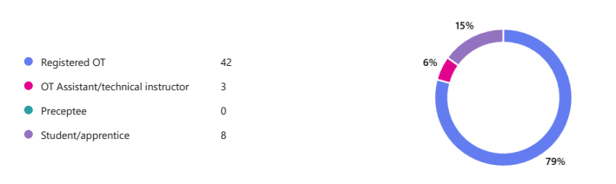
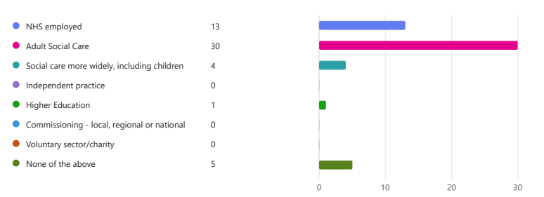
Confidence score pre-presentation: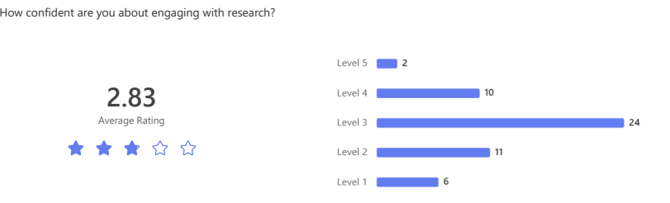
Confidence post-presentation:
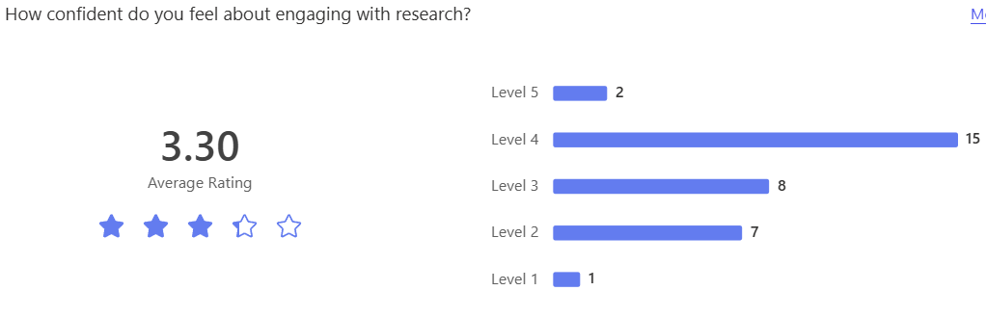
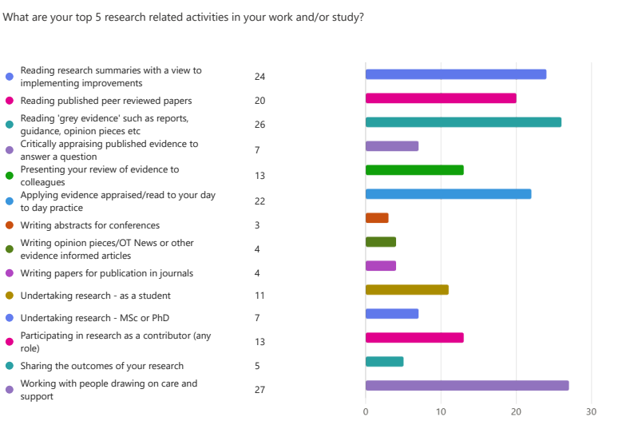
Comments word cloud:
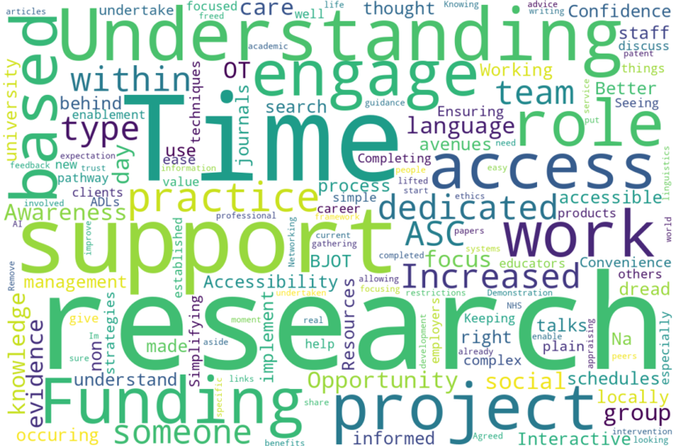
Key learning: The random sample validated the local survey results taken six months previously. There were only 2 people who completed both surveys. Clearly, understanding more about research engagement increased feelings of confidence.

Summary
The survey findings reinforce other recent reports in the region and are aligned to both occupational therapy research and wider evidence relating to social care regulated health professional barriers to engagement with research. The stark comments from respondents indicate significant barriers to engagement relating to the working environment and lack of managerial support within high pressure, demand led services.
The occupational therapists also indicated that they have underutilised research related competencies, and some respondents were enthusiastic about engaging with research but felt they did not encounter any opportunities. There was little evidence of effective communication which undermined OTs awareness of opportunities, including to get involved in the Demonstrator, and their ability to access, use or share at scale, any evidence informed improvements.
The findings from the OT Show reinforce that this is not a regional issue but presents as a wider concern for the profession. It is not currently part of the occupational therapy LGA health check undertaken for the profession in ASC contexts and therefore no national data is available to define the exact scale of risk this presents to the profession.

Project Engagement Phase 2
The team undertook a six-month period of test and learn activities, to support the occupational therapists with potential change plans and prioritisation of effort. The plan can be found in Appendix 2.

Hacks
Purpose / goals for each of the hacks:
- To test and learn - what works/does not to improve engagement with research.
- To use the research circle to structure activities in bite-size formats, in person
- To support open and honest conversation about the barriers and enablers
- To ensure EbE voice is heard and central.
- To support prioritisation of effort to address core problems
- Improvement ideas captured.
At each hack there was dedicated time to share thoughts and ideas about the developing theory of change (culture, capacity and careers), signposting to research resources and time for individual reflection, learning and planning. Certificates of participation were provided to each attendee.

Hack 1 - 'Getting started - thinking and defining, planning & pitching’.
- Problem definition and elevator pitch skills practiced.
Hack one focussed on identifying the problem, exploring what evidence exists and providing opportunities for the OTs to pitch their research ideas. In addition, there were presentations by experienced researchers sharing their stories to demystify the research journey and encourage attendees in their own research journeys. The importance of co-producing research from its inception and how to ensure that the voce of lived experience is captured in research was central to the session.

Outcomes
- Contribution from the group to the developing theory of change
- Attendees participated in pitching their research ideas to each other

Feedback
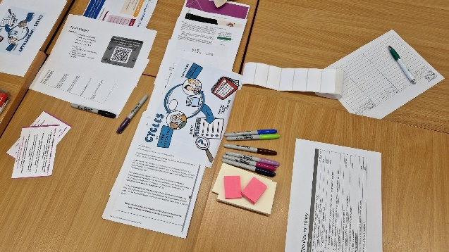
All participants who fed back (6 range 8-10) would recommend attendance at the hack, one person questioned if the session could be longer, key take aways were that the session had provided starting ideas to take into the workplace, gave a better insight into research and to start small and integrate into workforce plans.
“Focus on the problems as they shape the research to make those improvements”
“Thoroughly enjoyed the session, very inspiring”

Hack 2 - 'Writing workshop - Abstracts, bids, proposals and collaborating’.
- Understanding academic writing and skills practice
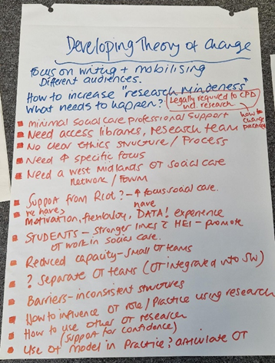
- Writing for different audiences and purposes
The second hack focussed on writing with a presentation from a local university academic outlining the different types of academic writing and why to publish in academic journals. The group explored how to build on the work of others, the process of making an argument and why should we / others care. This was followed by an opportunity to practice writing and share with others.

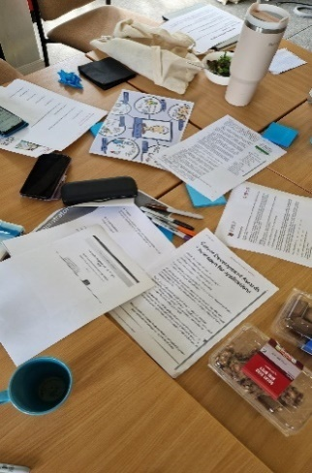
Outcomes
- Each group member completed a writing exercise
- Further contribution from the group to the developing theory of change

Feedback
All participants who fed back (3) would recommend attendance at the hack, key take aways focussed on needing to encourage more local authorities to attend, that it was a positive session and having a better understanding of how to write an abstract.
“Really inspired and have really good understanding of how to write an abstract and the things we need to put in place to enable us to do research”

Hack 3 - ‘Involving people, partnering and co-design in research’.
- Exploring different types of academic partnering
- Co-design doctoral study case example
Hack four focussed on working with others, how to collaborate to mobilise existing knowledge to develop this with others. The group were introduced to the role of stakeholder mapping and had an opportunity to consider their own stakeholder maps. The role of governance, ethics and aspects of finance were presented and there was a session of free writing to further hone their research ideas and next steps.

Outcomes
- Groups developed a local stakeholder map
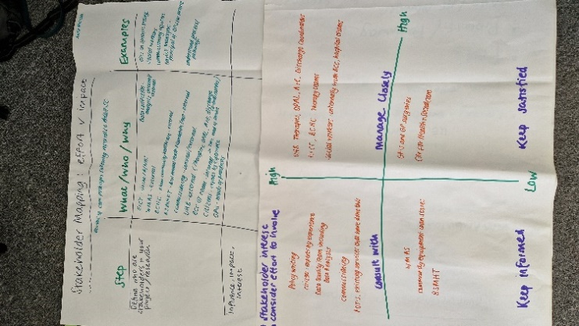
- Attendees working on developing abstracts for OT Show and West Midlands OT Show case
- Further contribution from the group to the developing theory of change

Feedback
Feedback received welcomed the chance to have an opportunity to practice writing.
“How to write an abstract, it was great to have a starting point of just writing something on paper even if it didn’t make sense as this can structure thoughts”

Hack 4 -‘Sustaining engagement with research – plotting your course’
- Planning for change: Regional, service and team level
- Personal development planning/goals
Hack four focussed on how the OTs could sustain this work, what resources could they call on, what would a “research ready region” look like and time to devote to refining their own personal development plan. There were presentations from the Elizabeth Casson Trust, CAHPR and Coventry University - Enhanced Practice.

Outcomes
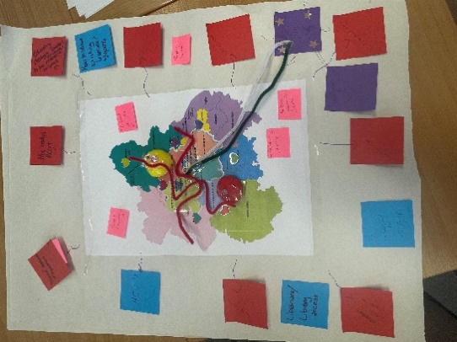
- Development of two visions for a West Midlands occupational therapy research network (see above)
- Attendees continuing to work on developing abstracts for OT Show and West Midlands OT Show case
- Development of a model for an EbE occupational Therapy regional group
- Individuals developed a personal development plan with actions to further their research activities
- Further contribution from the group to the developing theory of change

Feedback
All participants who fed back (3) would recommend attendance at the hack. Key takeaways for participants were the opportunity to work with EbEs, the importance of mentors and secondments in their development and useful resources.
- “That I need to join CAHPR and look at the Elizabeth Casson trust website!”

Focus groups
Several online focus group meetings were set up to support deeper conversations about engagement with research. Following the survey and hack feedback/insights it was felt that two cohorts were a priority for engagement:
1. Service managers/team leaders/supervisors
2. Apprentices, preceptors, and students
Targeted invitations were circulated, and participants were encouraged to explore the challenges within their roles and how these might be ameliorated. The sessions were transcribed and the key content of the conversations extracted, reviewed and subject to the Braun and Clark (2016) approach to thematic analysis by Copilot. The outcomes were then checked, edited, and reviewed.

Managers and supervisors
The following emerged from the manager session, with four attendees:

Research as a New and Intimidating Endeavour
- Research is perceived as unfamiliar and daunting, especially for long-qualified staff.
- Anxiety around initiating research independently.
- Lack of confidence due to time away from academic work.
- “It’s intimidating to get started… it is very new to us.”

Generational and Experience Divide
- Clear divide between newly qualified staff and those long in practice.
- Senior staff often reluctant to re-engage with academic tasks.
- Apprentices and preceptees show more openness but also anxiety.
- “Two extremes on a spectrum… not necessarily interested in taking up anything academic again.”

Digital and Technological Barriers
- Difficulty navigating platforms like Open Athens, Teams, Zoom.
- Lack of tech-savviness impedes access to research.
- Preference for face-to-face learning, but time/travel constraints make digital options more viable.
- “They’re not accessible, hard to use… as soon as you start, this is too difficult.”

Time, Workload, and Service Pressures
- High caseloads and long waiting lists limit time for research.
- Staff split across teams, making release for research difficult.
- Balancing clinical duties with research is a major challenge.
- “Waiting list at 500… if you take an OT out of a team, the impact is great.”

Desire for Collaborative and Supported Research
- Strong interest in group-based research efforts.
- Suggestions for joint work with universities or across authorities.
- Need for mentorship and asset mapping to utilize existing skills.
- “A collaborative approach would be fantastic… make everyone really excited.”

Lack of Direction and Structural Support
- Absence of clear guidance or frameworks for research.
- RCOT and other bodies slow to respond or unclear.
- Fragmentation across authorities and POT roles.
- “RCOT take weeks to get back… POT role differences, no commonality.”

Accessibility and Learning Resources
- Need for short, recorded workshops to build confidence.
- Reading groups and CPD sessions suggested as entry points.
- Importance of breaking down research into manageable steps.
- “10-minute workshop… record it so people can play back anytime.”

Motivation, Recognition, and Incentives
- Research seen as cognitively demanding and time-consuming.
- Need for rewards or recognition to motivate participation.
- Concern about return on investment for services.
- “Need a reward for people… doing research is not a small thing.”

Organisational Accountability and Standards
- Research engagement tied to LGA standards.
- Managers feel accountable but unsupported.
- Suggestion for designated contacts and mini meetings to cascade learning.
- “We’re all accountable for research… need to sign up for it.”
The findings resonated with other insights and feedback but also highlighted key levers and motivations that could support change.

Apprentices, preceptees and students

Need for Protected Time
- “Protected time I think is definitely needed.”
- “By the time you have done that, the day's finished. So where is the time for research?”
This theme captures the tension between clinical workload and research engagement.

Lack of Research Culture and Opportunities
- “The first thing I heard about research was when I went to university last year.”
- “It's definitely not something that was discussed within our team.”
This shows research is not embedded in team practices.

Missed Peer Interaction
- “I'm finding that peer supervisions always cancelled, so we don't really have chance to discuss it.”
- “When do we speak to each other? There is not really much time.”
Highlights the absence of collaborative spaces for research discussion.

Confidence and Voice
- “It's hard - always being the youngest person in the team finding your voice and get your point across.”
- “Just having the confidence to say, look, I think this is something we need to do.”
This theme reflects personal challenges in advocating for research.

Management Support
- “We do have OTs in management positions which helps. They would fight our corner and understand the importance of research.”
Indicates that leadership can enable research engagement.

Overarching areas for enquiry
Across the datasets, the questions reveal a profession seeking clarity, visibility, and strategic inclusion within local authority research systems. There is a strong interest in understanding how OT compares with Social Work, how to build a supportive research culture, and how to ensure that evidence, communication, and organisational structures enable meaningful engagement. There were a range of issues with communications being ineffective and inadequate. The overarching narrative is one of building identity, infrastructure, and purpose to support a sustainable research culture for OTs.

Defining an occupational therapy Experts by Experience group

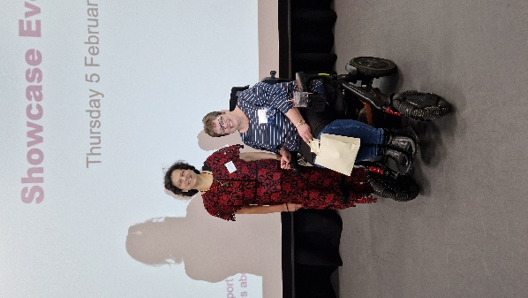

EbE members working throughout the project

The fourth hack event with occupational therapists included a breakout session with the Demonstrator advisory Group, to explore ideas for a future model for Experts by Experience (EbE). This group would aim to service the regions ASC occupational therapist’s innovation, improvement, and research focused activities to ensure user involvement across the lifetime of the project.
The group felt that having a central point of contact for the regions occupational therapists to access to present potential ideas or garner views about priorities would be the most effective approach. Firstly, it was agreed that they would be called the EbE for occupational therapy, or OT EbE for short. The idea centred on a co-funded model, across the POT network in the region, to support all the services, either online or on occasion, in person. Occupational therapists would be able to trigger a meeting via the POT network to request a range of support, mapped to the research lifecycle, for example, illustrated below.

Figure 2: Proposed EbE Model for occupational therapists

EbE Roles Proposed:

All contributors
This would be a general email/form anyone who has used ASC OT services and their carers/families could sign up to join the group and receive information and opportunities to engage with research related activities or service improvement projects.
Research cycle: Occupational therapists would use the research cycle to define support requirements, for early identification of topics, problem definition and impact/dissemination and consultation activities.
Central Point of EbE Contact for the regional occupational therapists:
Designated service to provide linkage to the EbE group via regional POTs.

Research interested
This would be an email list of EbE members actively looking to join participatory work and get involved. Local services may need to consider costs if people are travelling to face to face activities.
Research cycle: Recruitment, for example, to specific project advisory groups or events, ad hoc/occasional interest in specific projects or dissemination activities.

Active partners
This role would be for EbE members who are linked via a university to specific research project/researchers/improvement programmes to ensure robust participation and involvement in the research cycle including dissemination and impact work. This might also be known under the title of PPIE (patient participation, involvement, and engagement) in other organisations.
Research cycle: Design of research proposals, part of wider stakeholder groups, events, and attending/joining support for a range of projects.

EbE researcher/improvement
This would be a small pool of people who have undergone some basic research skills training, are supported by a university and who contribute across the research cycle (e.g. data collection with OTs).
Research cycle: Embedded across the cycle and involved in data collection, writing papers, speaking etc.
All levels of involvement would be open to people using ASC occupational therapy services, currently and in the past. It might also include retired professionals.
The activities which might be included for members of this network:
- Email bulletins with involvement offers events and recruitment to studies.
- Wider communities of practice where occupational therapy is one part of a team providing services and research/improvement projects and where there is an opportunity to influence wider change.
- Local offers that might feed into the region to avoid duplication and accelerate dissemination of the research.
- All people accessing occupational therapy services would be given the opportunity to join via 121 assessment surveys sent out by the therapists (no one system for this is currently available - this needs to be captured at a regional level).
- Links need to be built with local council and University Coproduction/Quality management teams and Quality Assurance Officers as this is where resource is managed and non-research activities are monitored.
- The level 1 roles need to be a source of research ideas i.e. from communities directly (not complaints but rather ideas for finding out why things need improving).
- Level 3 and 4 need to facilitate direct experience exchanges in a safe way.
- A co-design day once a year could help to focus effort on important projects, refine a priority and so on.

Future recommended steps to deliver the model:
- Convene a steering group of existing co-production in research OT EbE to explore options.
- Engage stakeholders cross the 14 Local Authorities and research support organisations, with WM ADASS to draft a proposal for embedding occupational therapy research support with OT EbE team.
- Clarify role descriptions and potential resources to support a future model of OT EbE researchers and partners.
- Ensure a question regarding interest in research involvement is included on all surveys sent by OT services and aggregated at a regional level.
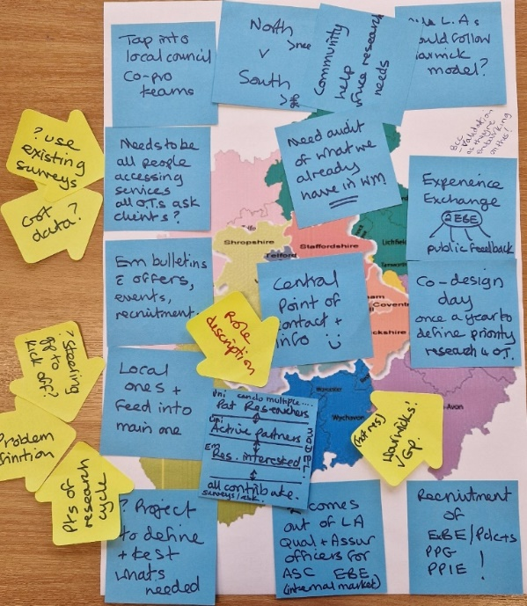
- Consider a proposal for a funded 2-year pilot project to test and evaluate the model using IMPACT approach to improvement.

Adult Social Care Occupational Therapy Showcase event in February 2026

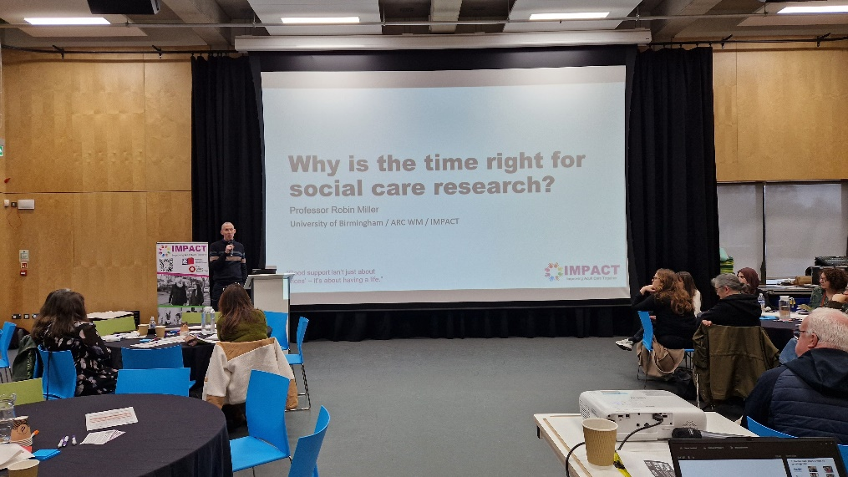
On the 5th February an Adult Social Care Occupational Therapy Showcase was held in Selly Oak, Birmingham. The aim of this event was to
- Celebrate and share excellent occupational therapy practice within adult social care in the midlands
- Provide an opportunity for occupational therapists to submit abstracts, create posters and present their work to peers
- Share the goals and achievements of the project
- Recognise excellence through the presentation of awards
- Share and further develop the theory of change
- Engage attendees in identifying next steps

55 people attended, these included midlands occupational therapists, the Ebe members of the project group, other local authority staff interested in research, stakeholders and representatives from national organisations such as the Royal College of Occupational Therapists, Chief AHP Officer and the Elizabeth Casson Trust.

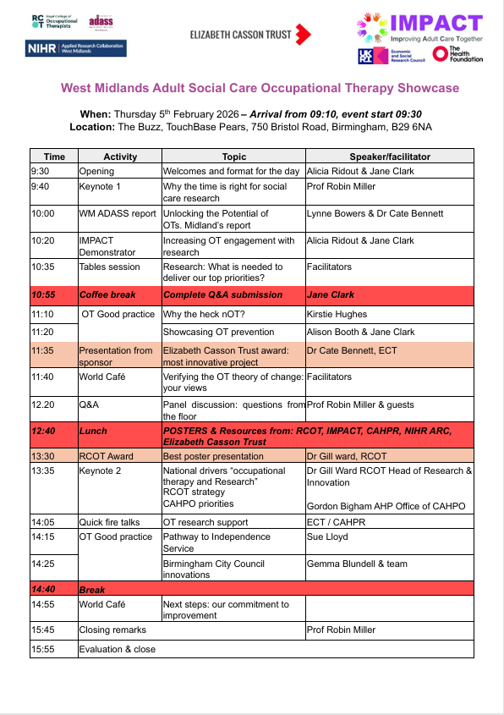
The Programme for the day

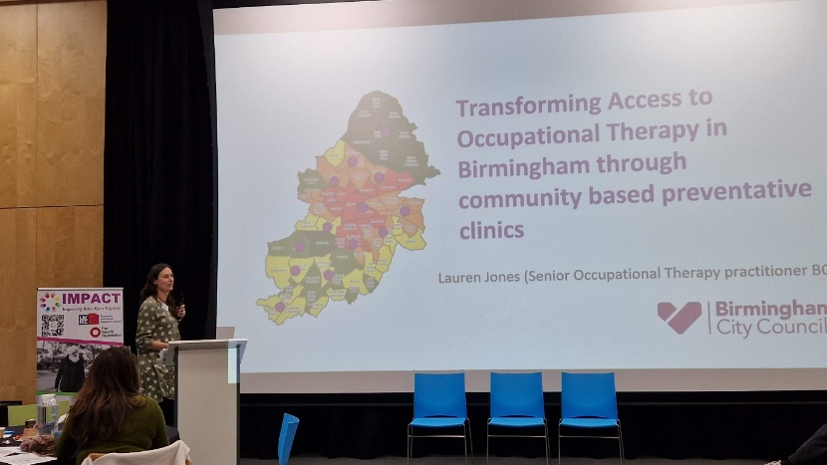

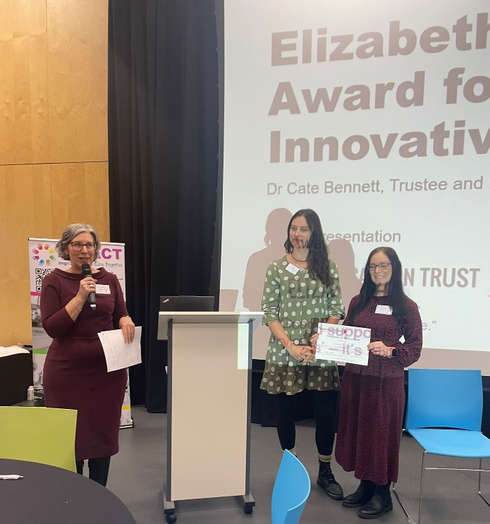

The day focussed on sharing good practice, providing opportunities for adult social care occupational therapists to share their work. Four presented and 6 posters were created and shared at the conference. The conference also included an opportunity to sense check and further develop the theory of change. The views of attendees were gathered through small group work and included in the final theory of change for the project.

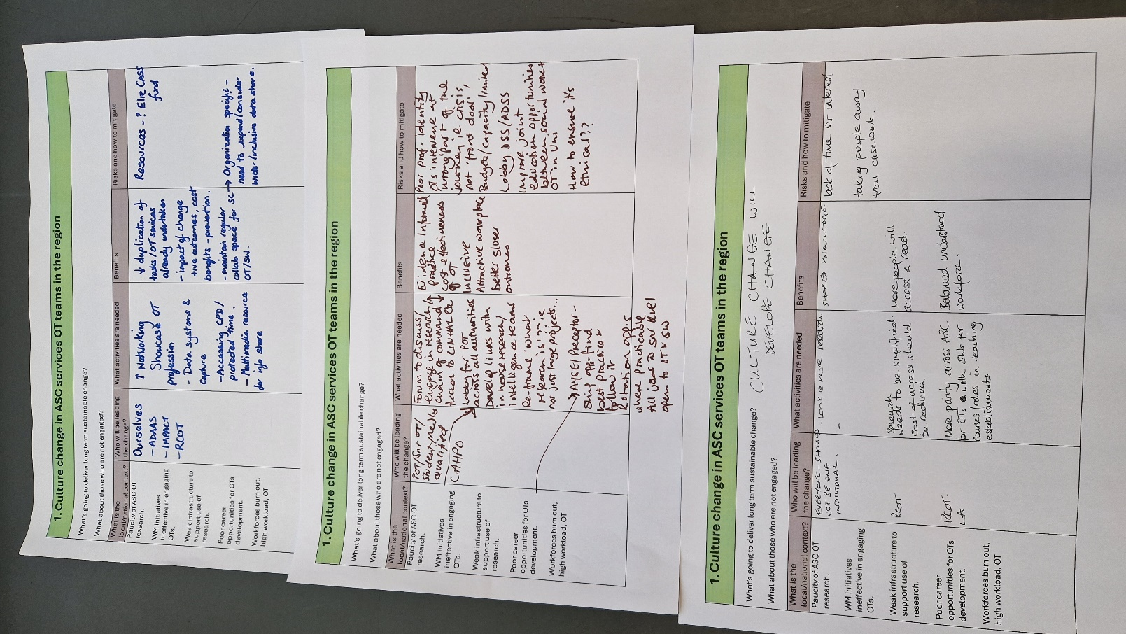
Group feedback on one aspect the theory of change.

One aim of the conference was to focus on the importance of next steps, particularly encouraging individuals and teams to commit to next steps to advance engagement with research. Group exercises using discussion and flip chart captured the actions people identified.
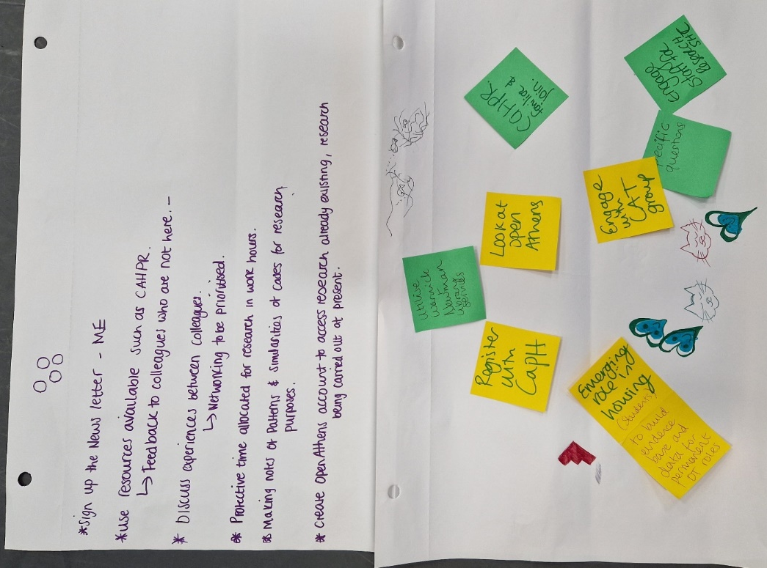
Next Steps example of group discussion captured.
Evaluation of the day
All attendees were encouraged to provide feedback from the day, 25 attendees provided feedback.
- 76% of attendees who completed the evaluation were OT adult social care Midlands OTs
- For 52% of attendees Research was not a usual part of their practice.
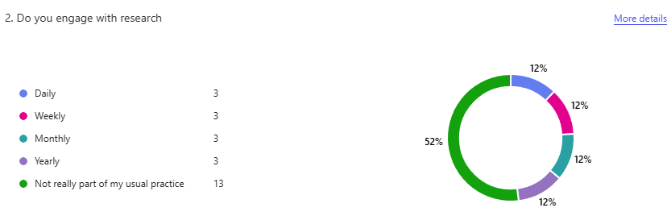

A net promoter score
- 8 were passives (satisfied) with the event and 17 were promoters and would attend a similar event in the future

Key take aways
“Research is not just for academics!”
“It has inspired me”
“Although OTs are humble, we should show off!”
“There is a lot of good stuff happening across the region but were not hearing about it!”
“It was very inspiring to be in the room with so many talented practitioners. It was good to network and celebrate each other's successes.”
“Say yes to opportunity!”

Critically Appraised Topic (CAT) Groups
During the earlier Demonstrator engagement programme, an emerging interactive approach to critically appraising the evidence for improvement, was surfaced. It was aimed at early career researchers and practitioners.
The CAT group methodology was highlighted as an effective tool being used in the West Midlands region. This framework has been developed and trialled by the Impact Accelerator Unit at Keele University and a CAT How To manual developed. A CAT is “developed from a clinical question which is structured and answerable, it provides a summary of the best available evidence, answers a clinical question, and provides a “clinical bottom line.”
Figure 3: Flow diagram of the CAT process.
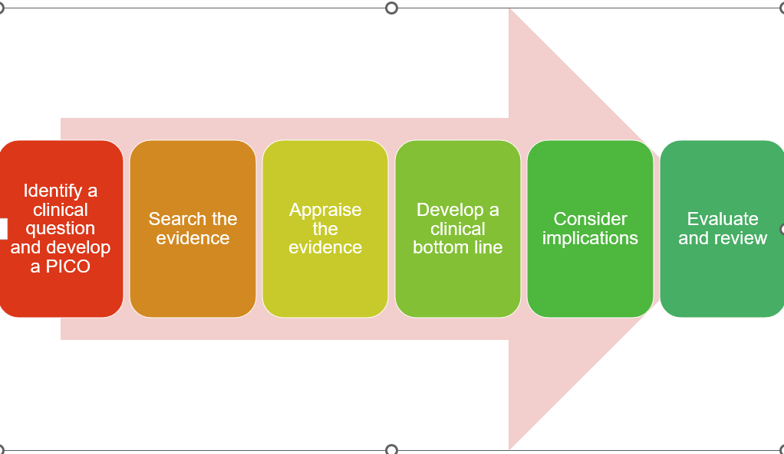

Following the four interactive “hacks” the team of occupational therapists from one local authority were interested in next steps in building their confidence and skill in engaging with evidence. Professor Kay Stevenson and Tina Hadley-Barrow were invited to present to the team. This invite was extended to the Knowledge, evidence and governance lead from Public Health team of this local authority who is in the process of recruiting a Local Authority Research Practitioner (LARP) to begin to explore engaging ASC staff in research across the council.
There was agreement from the group that CAT groups would be a beneficial next step. A small group made up of OT manager, Knowledge Evidence, and governance Manager, newly recruited LARP and library support from Birmingham University and Birmingham Community Health Care (NHS) met to map out next steps. The group agreed that a trial to test out the use of the CAT methodology would be positive and this would be in the CAT in a day format. The aim is for the local Authority OTs to build their confidence and skill in the CAT model to include critical appraisal of evidence, confidence to identify and answer pertinent clinical questions and to be able to apply this to their practice, making changes where appropriate. Funding from the IMPACT programme was approved.
Successful CAT groups require support from librarians to support the development of an evidence summary. There is no library support to local authorities, this differs from the NHS which had dedicated support across all services. This has presented one of the biggest challenges to date in the development of this project. Support was explored via local NHS provision, a local community NHS trust who currently use the CAT model agreed to support the pilot.
The group agreed to deliver two CAT in a day, one in June and one in July. At the end of the IMPACT project (Feb 2026) the dates were confirmed. The two CAT in a day events to be delivered by the Keele University team, co-ordinated by the local authority OT Lead and LARP and supported by six additional days from one of the IMPACT strategic improvement coaches.
Outcomes from this work will be fed back into the IMPACT embedding team to ensure that final learning is captured and shared. The local authority is committed to using this learning to advance their ambition to increase engagement with evidence for all registered practitioners in BCC.

Theory of Change: Development and final outcomes
The team used the IMPACT theory of change methodology and tools, co-creating the outputs by garnering views at the end of each hack and finally at the conference to create a final version.

Approach

Step 1 – Who needs to be involved
Priorities for the Demonstrator theory of change development included occupational therapists from across the fourteen local authorities, key professional organisations such as the Royal college of Occupational Therapists (RCOT), Elizabeth Casson Trust (ECT), Community of Allied Health Professionals in Research (CAHPR) and Higher Education Institutions (HEI) training occupational therapists. Regional leads in Association of Directors of Adult Social Services (ADASS) were hosting the project alongside colleagues in the Applied Research Collaborative (ARC) which was part of the National Institute of Health and care Research (NIHR) infrastructure and co-funder of the Demonstrator. The Demonstrator leads worked directly with these bodies across the twelve months and Principle Occupational Therapists (POTs). In addition to the core stakeholder group and other associated colleagues such as the newly recruited Local Authority Research Practitioners (LARP), an Advisory Group was recruited to ensure the voice of people accessing or with experience of services, were central to the project.

Step 2 - Agreeing long-term goals
The team spent three months reviewing the literature, undertaking a regional survey of occupational therapists to garner the on the ground context from practitioners, engaged with people accessing care and support via occupational therapy services and met with a wide range of stakeholders – research and practice related. This helped to identify the needs of different groups, the characteristics of a potential future vision and clarify the end goal.
The overarching ambition at this stage was to end the year with more occupational therapists engaged with research than at the start of the project. The following were proposed as the goals:
Long-term goal: To build a West Midlands community of occupational therapists in ASC services leading improvement work that is underpinned by evidence, generating new knowledge through research, is a research active region that supports recruitment and retention, and is delivering sustainable and effective change for people accessing care and support.
IMPACT Demonstrator Goals (12 months):
- To stimulate change in the culture, confidence, competence, and career pathways of ASC occupational therapists in the West Midlands.
- To define a theory of change that can deliver the vision and is scalable across a range of organisations at different levels of research readiness.
W Midlands occupational therapy workforce goals (12-24 months):
- To identify local priority research activities to support measurable change in local teams and the experiences of people accessing care and support.
- To actively embed a research-embracing culture and associated practices in operational plans and processes.
- To proactively measure the uptake of professional development/training and evidence appraisal in usual practice and disseminate wider learning to raise the profile of the profession.
- To evidence successful research engagement through funding proposals, projects, and dissemination outcomes to support the wider ASC occupational therapy evidence-base.

Step 3 - Identify the context and define assumptions
Context: The team reviewed key regional and national reports and evidence and the survey outputs and worked with stakeholders, including people with lived experience, to clarify the key priorities.
Themes
A wide range of questions emerged from discussions with stakeholders and occupational therapists, summarised here using Copilot applying Braun and Clarke (2016):
Theme 1: Professional Identity, Parity and Positioning of OT in Research
- This theme captures concerns about how occupational therapy is situated relative to social work and other professions.
Theme 2: Infrastructure, Strategy and System-Level Inclusion
- This theme reflects structural questions about whether occupational therapists are embedded in organisational research planning and how systems support (or fail to support) research engagement.
Theme 3: Evidence, Learning and Knowledge Mobilisation
- This theme focuses on what evidence is needed, how learning happens, and how excellence is identified and shared for the benefit of those accessing services.
Theme 4: Engagement, Communication and Culture Change
- This theme captures the practical and cultural work needed to build a research-active OT community.
Theme 5: Purpose, Value, and the Case for Research
- This theme reflects existential and strategic questions about why this work matters and how to justify it.
Key issues raised from the three types of evidence:
- Lack of engagement with or involvement in generic research support activities in the region
- Indicators of severe strain, workforce burnout, and excessive demands on occupational therapists in ASC
- Paucity of ASC relevant research evidence (or activity to remedy this) to address the challenges being faced/prepare for future change.
- Barriers relating to access to the evidence, time to appraise it, recognition of the need for ASC registered health professionals such as occupational therapists to prioritise evidence gathering, appraisal and mobilisation for effective interventions.
- Structural inequities for ASC occupational therapists in comparison to their NHS colleagues

Assumptions
The Demonstrator team worked on the following assumptions during the design of the change activities:
- Structural inequities will need addressing re access to research & opportunities for engagement will be impacted by factors outside the control of the team.
- Complexity & fragile workforce situation and secondary impacts of structural and other inequities for OTs will be an underlying tenet.
- Segmentation of the stakeholders (national, regional, local, individual) will need to account for the different structures in ASC, to embed an equitable, responsive model for OTs to engage with any research activities, in a context of burn out and service pressures.
- Sustainability of the change will be critical – ease of access to research evidence, universal competence in skills used, clear and accessible career pathways, adapted funding arrangements and embedded CPD in operational work.
- Adaptation over time – local programmes embedded in operational practices and plans to attract, keep, and generate new OT talent.
The project also started just prior to the Health and Care Professions Council (HCPC) audit for occupational therapists. The team anticipated this would be a motivator to the occupational therapists to get involved, however the demands on the therapists were such that this proved an incorrect assumption.

Enablers
Internal
- Areas of high engagement and research readiness
- ADASS and LGA evidence to support operational change.
- Workforce challenges triggering opportunities for deeper embedding (to support recruitment and retention, regulatory compliance, and improved data collection).
External
- ADASS funding, with IMPACT, of the first ever improvement project dedicated to ASC OT engagement with research.
- CAHPO move to DHSC triggering a deeper inclusion of ASC OTs under the arm of the national teams.
- Increased awareness of the career and funding gaps for ASC OTs in research contexts.

Step 4 - Planning activities
Figure 4 High level model developed for the Demonstrator Change programme.
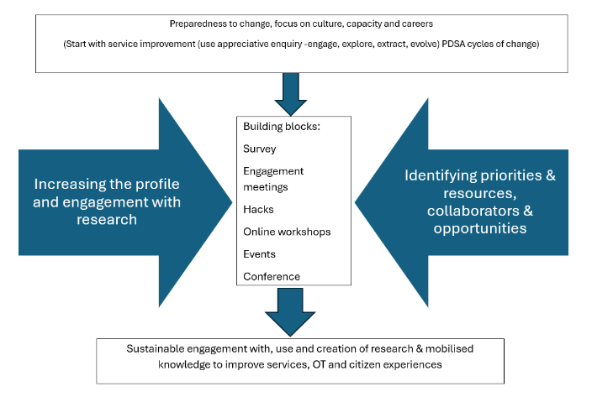

Step 5 - Expected outputs
The outputs expected are illustrated and listed in the figure above. A report and theory of change were core outputs, alongside the activities and wider engagement with those related to research and development organisations.
The longer-term outputs were anticipated to be the establishment of a network of occupational therapists who are research curious, in a culture where research engagement is valued and capacity/capabilities are present to support a more evidence informed practice base. It was also hoped that a regional occupational therapy Experts by Experience group would continue to run, supporting the research related activities for the profession.

Step 6 - Measuring change
The teams’ ambition for the end of the project was informed by the collaborators. By the end of the twelve months:
- Fifty occupational therapists would have engaged with the project and attended a final showcase conference.
- Thirty responses to a regional survey
- to run four ‘hack events’ and run a successful abstract submission process for those engaging with the project with posters created with contributions from sponsors (RCOT and ECT)
- one article for OTN (the RCOT magazine) promoting OT Week engagement activities.
- to present at the OT Show (a national commercial show in the NEC in Birmingham)
- share the project at an international conference.
Qualitative data was sought from those engaging with all the project activities and analysed to better understand the narrative evidence.

Step 7 – writing up the theory of change
IMPACT uses an outcomes chain to reflect the theory of change in Demonstrator projects. More information can be found here: Mission, Vision and Work - IMPACT.

Learning
- That occupational Therapists are interested in research and do want to improve their knowledge, skills and experience in engaging with and developing research
- That occupational therapists in adult social care do not always have the professional leadership infrastructure to support their career development and CPD.
- Further work is needed within many local authorities to develop a culture to support evidence-based practice and for this to be a priority within services
- There is a need for equitable access to published evidence, access to libraries and library support.
- The need for

Recommendations
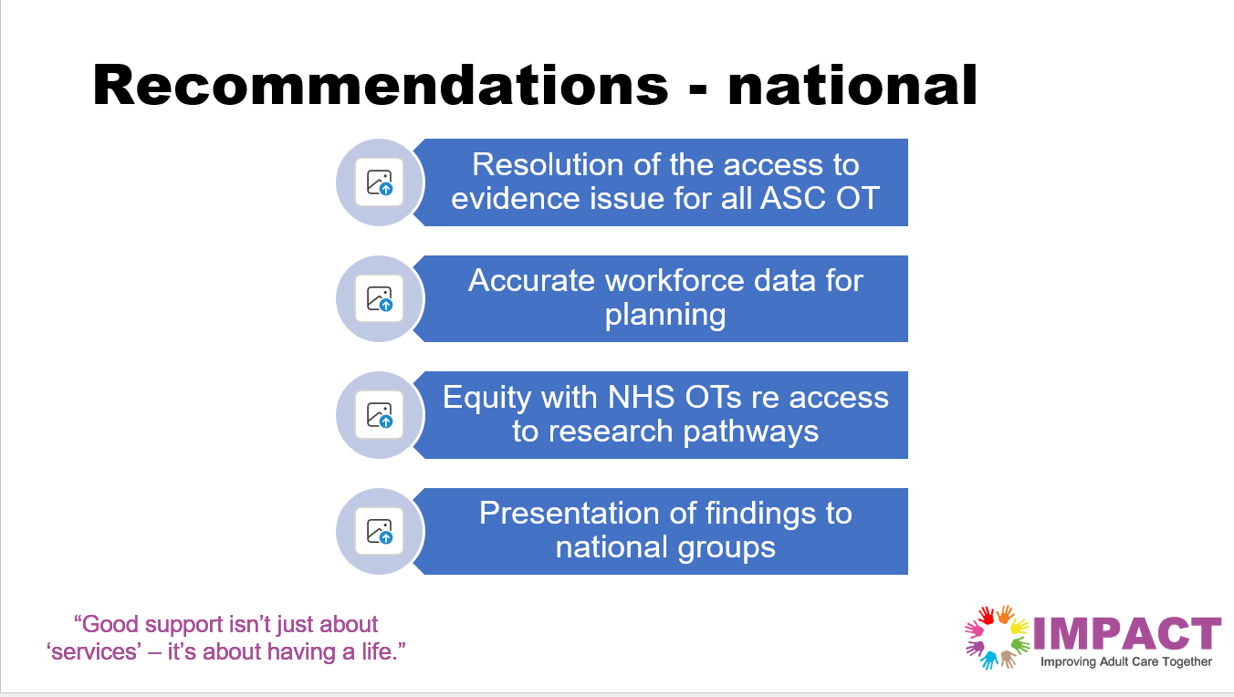

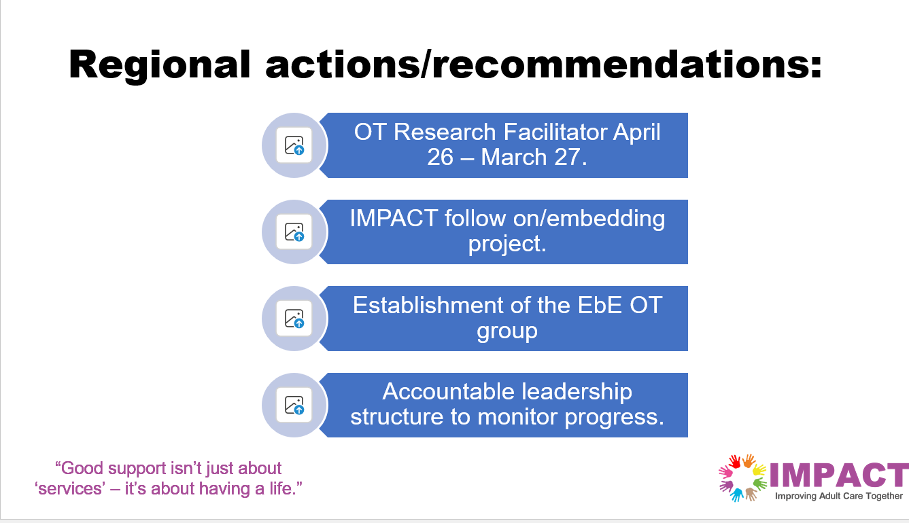
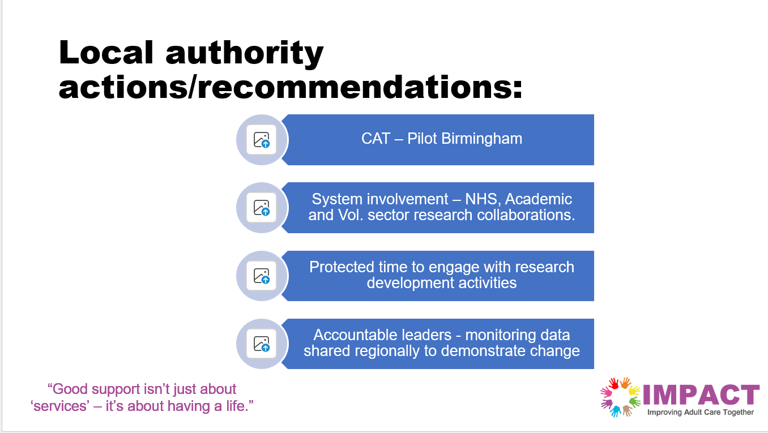

Next steps
- Additional days of IMPACT Strategic Coach over 6 months
- Research Facilitator Occupational Therapy recruited by WMADASS
- Attendance with poster York ARC conference
- ICIC conference poster
- Critically Appraised Topic pilot June / July
- General facilitation and mentoring
- Embedding discussions ongoing with IMPACT team
- Creation of a policy briefing document for dissemination

Appendix 1 - Early engagement stakeholder questions
Copilot: Below is a thematic synthesis following Braun & Clarke’s (2016) reflexive thematic analysis approach. The twenty-one questions were treated as the dataset, coded inductively, clustered codes into candidate themes, refined them, and produced a set of coherent overarching themes with sub-themes.

Thematic Summary (Using Braun & Clarke, 2016)
Theme 1: Professional Identity, Parity and Positioning of OT in Research
This theme captures concerns about how Occupational Therapy is situated relative to Social Work and other professions.
Sub-themes
- Relevance and transferability of existing SW research structures to OT
(Q1, Q5, Q6)
- Shared and divergent professional language and culture
(Q8)
- Clarifying what “research mindedness” means for OT
(Q3)
- Reframing research narratives specifically for OTs
(Q10)
Interpretation
There is a strong desire to articulate OT’s unique research identity while also understanding overlaps with Social Work and NHS pathways. The questions reflect uncertainty about whether OT is being fully recognised or integrated within wider research systems.

Theme 2: Infrastructure, Strategy and System-Level Inclusion
This theme reflects structural questions about whether OTs are embedded in organisational research planning and how systems support (or fail to support) research engagement.
Sub-themes
- Inclusion of OT in local authority research plans
(Q4)
- Understanding typologies and cultures of LA OT communities
(Q18)
- Using appraisal processes to understand patterns of engagement
(Q15)
- Developing equitable CPD and research capacity models
(Q20)
Interpretation
There is a concern that OT may be inconsistently represented across local authorities, and that structural mechanisms (plans, appraisals, CPD frameworks) could be leveraged to build a more coherent research infrastructure.

Theme 3: Evidence, Learning and Knowledge Mobilisation
This theme focuses on what evidence is needed, how learning happens, and how excellence is identified and shared.
Sub-themes
- Clarifying evidence needs and support requirements
(Q11)
- Learning from excellence and identifying what works
(Q16)
- Understanding attrition and gaps in engagement
(Q7)
- Capturing and interpreting survey evidence
(Q18)
Interpretation
The questions reflect a desire for a stronger evidence base about OT research engagement, including both positive exemplars and areas of loss or disengagement.

Theme 4: Engagement, Communication and Culture Change
This theme captures the practical and cultural work needed to build a research-active OT community.
Sub-themes
- Creating space and time for reflective thinking
(Q12)
- Innovative communication approaches
(Q14)
- Encouraging OTs to share and advocate for research
(Q9)
- Engaging user groups meaningfully
(Q13)
- Building community through events and networking
(Q17)
Interpretation
There is a clear recognition that research culture is not just structural but relational. Communication, reflection, and community-building are seen as essential to shifting practice.

Theme 5: Purpose, Value, and the Case for Research
This theme reflects existential and strategic questions about why this work matters and how to justify it.
Sub-themes
- Clarifying the purpose of the research initiative
(Q19)
- Making the case for benefit and impact
(Q19)
- Identifying and dismantling barriers to engagement
(Q21)
Interpretation
Underlying many questions is a need to articulate the “why” of OT research engagement—its value to practitioners, organisations, and service users—and to understand what prevents progress.

Integrated Summary
Across the dataset, the questions reveal a profession seeking clarity, visibility, and strategic inclusion within local authority research systems. There is a strong interest in understanding how OT compares with Social Work, how to build a supportive research culture, and how to ensure that evidence, communication, and organisational structures enable meaningful engagement. The overarching narrative is one of building identity, infrastructure, and purpose to support a sustainable research culture for OTs.

Appendix 2 - Engagement Programme
Engagement Activity | Purpose/goals | Outcomes
Hack Workshops (face to face (:  Hack 1 'Getting started - thinking and defining, planning & pitching’.  Hack 2: 'Writing workshop - Abstracts, bids, proposals and collaborating’.  Hack 3: ‘Involving people, partnering and co-design in research’.  Hack 4: ‘Sustaining engagement with research – plotting your course’ | All hacks:  - To test and learn - what works/does not to improve engagement with research.  - To use the research circle to structure activities in bite-size formats, in person  - To support open and honest conversation about the barriers and enablers  - To ensure EbE voice is heard and central.  - To support prioritisation of effort to address core problems. | Hack 1:  - Problem definition and elevator pitch skills practiced.  - Improvement ideas captured.
Hack 2:
- Understanding academic writing and skills practice
- Writing for different audiences and purposes.
- Improvement ideas captured.
Hack 3:
- Exploring different types of academic partnering
- Co-design doctoral study case example
- Improvement ideas captured.
Hack 4:
- Planning for change: Regional, service and team level
- Personal development planning/goals
- Improvement ideas captured.
Focus Groups  - Managers and senior staff  - Apprentices, students & preceptees | - To deepen understanding challenges and experiences, opportunities, and needs of key groups.  - To collate insights to create a shared opportunity for improvement | - Practitioner evidence of key drivers and priorities  - Priorities for the theory of change  - Priorities to map with Hack themes to drive wider change.  - Clear flags for senior stakeholders for action and scaling
Public engagement:  - OT Week  - OT Show  - Showcase conference | - To widen engagement  - To verify survey findings.  - Dissemination and impact | - Further data on the current challenges  - Raising awareness of the Showcase event and recruiting support

Appendix 3 - Theory of change (full)
The following table provides the detailed activities and logic model for the Demonstrator theory of change. [Read columns top to bottom.]
Key:
OT occupational therapy
ASC adult social care
HCPC Health and care professions council (regulator)
ADASS/DASS Association of Directors of Adult Social Services
LGA Local Government Association
LA Local authorities
KM Knowledge mobilisation
EbE Experts by Experience
WM West Midlands
POT Principle occupational therapy
CAHPO chief Allied Health Professions Officer (in transition to DHSC)
CAHPR Community for AHP Research
RCOT Royal college of Occupational Therapists
ECT Elizabeth Casson Trust
ARC Applied Research collaborative (NB the WM ARC closes 310/03/26)
KM Knowledge Mobilisation (modes of getting evidence into practice)

IMPACT Demonstrator: Increasing Adult Social Care occupational therapy engagement with research in the West Midlands
What is the local/national context? | What are we trying to change? | Who will be leading the change? | What are the main activities? | Who is involved in activities? | What are the key outputs? | What are the benefits in the medium term? | What are longer-term goals?
Paucity of ASC OT research.  WM initiatives ineffective in engaging OTs.  Weak infrastructure to support use of research.  Poor career opportunities for OTs development.  Workforces burn out, high workload, OT shortages, recruitment & retirement issues (50% in 5 yrs), low morale.  CPD restricted.  Research seen as nice to have, not core to registration. | Raise awareness of barriers to OTs engagement with research.  Culture change in ASC services OT teams in a region.  Effective leadership for the profession.  Opportunity to co-design future programmes.  Adoption and scaling developments to deliver change.  Effective communication with OTs.  Increase use of research in improvement work.  Increase the routes to and uptake of Research CPD and career pathways.  Removal of financial barriers to evidence access.  Increased consistency in outcomes across services benefitting people needing OT. | Structural:  Combined:  ADASS  CAHPO  RCOT  National POTs  HCPC  Regional:  WMADASS  POTs  HEIs  Local authority:  Heads of Service.  Team leaders or Senior OTs  Individual:  OTs – novice to expert.  Colleagues  Professional networks  EbE:  WMDASS lead.  Regional KM facilitators.  People accessing services and carers.  Funders:  NIHR  ECT  RCOT | Baseline survey of OT engagement with research – repeated yearly.  Front line data to reinforce real world picture.  Data mapping to OT workforce & CPD records. | Regional OTs in ASC; POTs; WMADASS as lead with LGA partner. | Regional data: ASC OT 14 local authorities; insight into the silent majority re non engagement of services in the region.  Reinforcement of priorities.  Convene a specific leadership team to embed change. | Validation of the challenges and potential enablers, Data to guide activities which could optimise OT engagement.  Role modelling across all activities  Elevate OT social care researchers and skill in evidence use. | Improved trend data from teams, using measures to demonstrate engagement with research.
 |  |  | Review of evidence (3 legs) - scale of the problem & opportunities for change.  Involvement in research – opportunities easy access and sign up. | POTs, WM ADASS, high level scan of evidence - Demonstrator | Themes from evidence to review against current WM reports, citizens, and OT experience.  Benefits realisation for future planning and improvement. | Demonstrate state (strength of evidence and quality of knowledge available) of current evidence. | Trigger funding for improvement and opportunities.  for research.
 |  |  | Engagement with key stakeholders who can effect change.  Improve routes of communication from front line to DASS and reverse.  Operationalise protected time, access to research and evidence synthesis for OT.  Regional working group to manage change including tech and data. | System leaders, CAHPO, RCOT, funders of research support (e.g. ECT), KM fellows.  DASS leader mandated standards of practice in contracts and CPD systems.  LA CIOs, POT network, and a new user group. | Awareness raising, national, regional, and local level. Clarification of career pathways, barriers, and enablers to change at a system level.  Collaborative ‘space’ with SW colleagues.  Protected time for KM activities and research.  Technology fit for a research curious and active ASC OT service. | Raise profile of OT in WM ASC, influencing uptake or and innovation in roles, improvements in infrastructure and career and leadership development priorities.  Improved recruitment and retention, belonging, and careers.  Confident OT workforce in using research systems to generate sharable outputs. | Translation of research engagement into new knowledge, careers, and culture.  No justifying benefits of research in ASC: BAU  Accepted.  Improved reputation and leadership in ASC.  Body of published evidence to share.
 |  |  | EbE Advisory Group convened to increase user voice and support active co-design.  Regional footprint. | EbE.  Demonstrator leads, regional ADASS PAG & IMPACT CPAG  OT Research Facilitator. | EbE voice across the project and supporting new insights, ideas, and priorities.  Sustainable, accessible community for research activities.  Improved EbE involvement as BAU. | Modelling working together.  Innovation in regional service.  Focused on EbE support for OTs improvement work. | Regional support OT involvement, co-creation crosses the research cycle.
 |  |  | Workshops focused on key research activities, using existing valid approaches.  Development of guidelines for the region.  Bids for funding. | Regional ASC OTs; HEI academics; AHP support organisations and OTs in research.  OT EbE regional group.  Funders. | Direct involvement in and relationship development with ASC OTs.  Improved bid support resources.  Collated insights for the development of a future framework for change.  EbE involvement and influence of change.  Awareness of unengaged/absent participants.  Clear impact story of achievements – from CAT to service data. | Route to skill building activities, myth busting, demystifying barriers.  Space and time to engage with activities supported by experts.  Sense of belonging for OTs interested in research. | Embedding of research activities into the professional life course.  Track record of research activities using data and evidence shared or published.
 |  |  | Focus groups.  Routine for a for frontline staff involvement.  Review AYSE / preceptorship best practice guidance.  Inductions and placement guidance reframed and embedded. | Managers and novice practitioners.  Year 2 OTs [risk to retention].  HEI networks and Practice Educators. | Thematic priorities through which to address operational and professional development issues.  Vibrant research curios community of ASC OT.  Measurable guidance to monitor improvement. | Deeper understanding of the challenges and opportunities; idea generation for future change.  Retention and reputational improvement.  Parity of teaching and learning with SW. | Research activities are embedded across every LA OT service.  Frictionless route to engagement with research.
 |  |  | Critical appraisal to mobilise knowledge using accessible approach.  Embedding in team meetings, reporting to POTs & DASS. | OTs and ARC KM fellows; local managers and academics. ADASS & POTs. | Further development of a Critical Appraisal Topic (CAT) product developed by NIHR Knowledge Mobilisation fellows.  Successful bids to run CAT sessions for ASC OTs.  Peer support networks. | Exposure to high quality KM methods.  Competency and confidence building.  Innovation in OT development plans supporting retention.  Evidence of improvement stories. | Universal competency.  Research capacity embedded.  Service innovation.  Overt sharing and learning.
 |  |  | Awareness raising regional and national bodies & leaders to test ideas and influence change.  Reframe research as a range of opportunities.  Leadership prioritises sharing with others.  Celebrating e.g.  OT Show  OT Week  OT Showcase  Networking -  Regular networking focused on research, innovation, and improvement.  Funding mechanisms and routes defined. | Regional OTs.  CAHPO, LGA & WMADASS.  National OT and POT community.  ASC leaders.  NIHR Funders and professional (RCOT, ECT).  Regional HEI active involvement.  Business development ‘offer’ to support success.  Comms teams’ advice | Wider sense checking for challenges, opportunities, and priorities – evidence of what works to scale (critical factors).  Funding understood and accessible in context of service pressures.  EbE voice and influence.  Self-advocacy WM OTs – abstract submissions, poster generation, public speaking and article publication (grey literature), further training, and funding success.  Workforce comms to build confidence in accessing and using evidence.  Morale, retention, and wellbeing of OTs improved.  Better data systems and capture. | Flagship OT engagement with research related activities.  Influencing change at a national level.  Effecting change in the status quo, triggering new conversations.  Trailblazing and evidence informed innovation.  Impact of change +outcomes for prevention.  Sustainability: ASC OT as an attractive context for research interested OTs.  Myth busting stereotypes of OT. | Standards of practice aligned with LA OT research priorities.  Optimised use of resources and OT potential, using evidence informed methods.  Changing expectations re OTs and research e.g. reducing duplication & research careers.  Embedded knowledge creation, and mobilisation.
Key Assumptions:
Structural inequities need addressing - access to research & opportunities for engagement impacted by factors outside the control of the teams.  Ineffective scaling via national leadership structures, unable to give aircover to ASC OT engagement with research. | Fragile workforce and secondary impacts of extreme pressures and structural inequities for OTs. | Nationally:  ADASS  CAHPO  RCOT  POTs  HCPC  Regional:  DASS  POTs  HEIs  Locally  POTs & Head of service.  Team leaders  Individual  ASC OTs  Line managers  HEIs | Sustainability:  Easy access to evidence.  Revised funding expectations to align with workforce & service needs.  Clear, accessible career pathways.  Operational embedding CPD in development plans from novice to expert. | Nationally:  ADASS  CAHPO  RCOT  POTs  HCPC  Regionally:  Regional DASS  POTs  HEIs  Locally  POTs & Head of service.  Team leaders  Individual  ASC OTs  Line managers  HEIs | - Curious culture encouraged by leaders  - Competency and confidence in a range of research activities  - Knowledgeable OTs – seeking support and successfully bid for funding.  - Knowledge mobilisation to improve outcomes for service users.  - Innovations in services built on evidence.  - Sustainability. | ASC OTs actively engaged with research through:  - Confidence in the use and application of research in practice  - Influencing colleagues and people using services, modelling good practices, building trust  - Accessible infrastructure for KM.  - Published evidence generation | New research to improve the ASC OT evidence base.  Scalable interventions to improve engagement nationally.  Reduction in structural inequities to create a research- thriving environment.  & retained workforce.

Appendix 4 – Risks and mitigations
Participants were asked to identify potential risks and mitigations for the changes required to improve engagement in the regions OT services.
Risks and how to mitigate (from OT Showcase conference 5.2.26)
Lack of resources +1 / budgets capacity limited / staff shortages, funding  Lack of time + 2 (taking people away from casework) or interest, overload of information  Constantly increasing demands  Lack of time to write applications | Possible use of Elizabeth Casson Trust funds  Need to expand / consider wider more inclusive data share.  AI could be a risk or a benefit, needs to be used carefully and still need to use critical appraisal skills.  RCOT to recognise OT in ASC
Staff might develop but no career development opportunities, no incentive to improve / continue | Needs greater recognition, better career pathways for OT in ASC
Relevance .... are we researching for the sake of it?  Some good practice (regular space / data collection) could be organisation specific | How do we ensure its ethical?  Ensure relevance of research to own work & people’s needs.
Poor professional identity, OTs intervene at the wrong part of the journey, when person in crisis | Lobby DASS and WMADSS.  To improve joint education opportunities between social work and OTs in university
Risk of duplication do not know what has been done across the country | Improved data and research activities to resolve and adapt practice.
Risk higher management will not support | Use outcome measures

ahp-project-report-jun-24-final.pdf
A National summary report of the Employer Standards Survey for occupational therapists - August 2024 | Local Government Association
https://www.skillsforcare.org.uk/Adult-Social-Care-Workforce-Data/Workforce-intelligence/publications/regional-information/My-region.aspx
https://www.skillsforc8.7are.org.uk/Adult-Social-Care-Workforce-Data/Workforce-intelligence/publications/Workforce-estimates.aspx
http://dx.doi.org/10.1191/1478088706qp063oa

