Inclusive Conversations
Practical tools for supporting LGBTQ+ people in adult social care

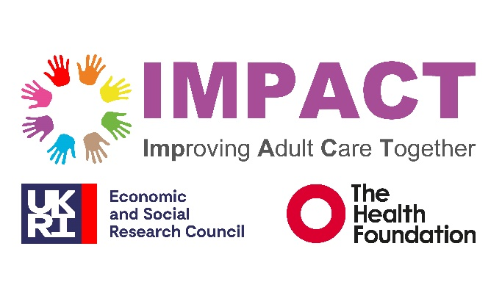


"What matters most isn't getting everything right straight away. It's knowing someone is open, respectful and willing to listen."
Samar, Newham, London

Acknowledgements
This resource was developed by IMPACT in partnership with Newham Adult Social Care, August 2026.
We would like to thank LGBTQ+ participants and community members of London Borough of Newham, and carers, practitioners and members of the project working group who generously shared their experiences, ideas and reflections throughout the project.
Special thanks to The Shaven Raven, graphic artist and Newham LGBTQ+ resident, for illustrating the case studies.
We are grateful to colleagues across IMPACT and Newham Adult Social Care who contributed their time, expertise and feedback throughout the development process.
Staff Persona illustrations were created using Microsoft Copilot from author-led concepts, prompts and visual direction.

Contents
Introduction 4
Part 1 Conversation starter: beginning inclusive conversations to support LGBTQ+ people 6
Opening statement for assessments: starting inclusive conversations 6
Starting the conversation 7
Suggested ways to introduce sensitive questions 8
If someone else is present 8
During reviews 9
If someone shares something personal 9
If you get something wrong 9
Part 2 - Scenarios 11
Scenario 1: Avoiding assumptions about relationships 11
Scenario 2: When family members use a different language 11
Scenario 3: Different name or pronouns from records 12
Part 3 - Staff personas: training and supervision tool 13
Purpose 13
How to use the personas (5 steps) 13
Step 1: Introduce purpose 13
Step 2: Individual reflection 13
Step 3: Group discussion 13
Step 4: Apply to real practice 14
Step 5: Reflect on improvement 14
Persona 1: The Trust Builder 15
Persona 2: The Privacy-First Practitioner 17
Persona 3: The Curious Learner 19
Persona 4: The Confident Practitioner 21
Persona 5: The Values-in-Tension Practitioner 23
Part 4 - Illustrated Case Studies: Learning from Lived Experience 25
Reflections and hopes for practice 52
Appendix A participants and contributors 53

Introduction
This resource was developed through a partnership between IMPACT (Improving Adult Care Together), the UK centre for implementing evidence in adult social care, and Newham Adult Social Care. It aims to support more inclusive and person-centred practice with LGBTQ+ people by bringing together lived experience, evidence and practitioner expertise.
The tools in this resource were developed through conversations and collaboration with LGBTQ+ participants and community members, practitioners and members of the project working group. They are informed by lived experience, practitioner reflection and evidence about the importance of trust, communication and avoiding assumptions in everyday practice.
The resource brings together four practical tools intended to support confidence, reflection and inclusive practice. They are not scripts to memorise or rules to follow, but practical resources that can be adapted to different contexts and conversational styles. They may be used in training, supervision, team meetings or individual reflection.
Whilst each tool can be used independently, it is hoped they will also be used progressively beginning with Part 1 and working through to Part 4. Through this process, practitioners can build confidence, engage in both professional and personal reflection, and become better equipped to respond to the issues explored in the case studies.
Part 1: Conversation starter
Practical prompts to support inclusive conversations during assessments and reviews.
Part 2: Scenarios
Short examples to demonstrate how inclusive communication can support person-centred practice.
Part 3: Staff personas
Reflective tools to support supervision, team discussions and workforce development.
Part 4: Illustrated case studies: learning from lived experience
Narratives co-developed with LGBTQ+ participants and community members that encourage reflection on how communication, assumptions and organisational culture can shape experiences of care and support.

Part 1 Conversation starter: beginning inclusive conversations to support LGBTQ+ people
The following prompts are intended to support inclusive, person-centred conversations during assessments and reviews. Each may be used for roleplay as part of training or staff development.
Some practitioners may feel unsure when asking about sexual orientation, gender identity or relationships, particularly if individuals do not raise these topics first. However, avoiding these conversations can lead to assumptions being made or important aspects of a person’s life and support network being overlooked.
The aim is not to pressure people to disclose personal information, but to create respectful opportunities for people to share what is important to them if they wish to do so.

Opening statement for assessments: starting inclusive conversations
This opening statement is intended to support inclusive, person-centred conversations during assessments and reviews, including conversations about identity, relationships and LGBTQ+ inclusion. It is designed to explain why questions about identity, relationships and inclusion may be asked, and to support practitioners to introduce each confidently and respectfully. This script can be used directly or adapted to fit different conversational styles.

Suggested opening statement:
“It’s important for us to understand what matters to you in your life, the people around you and anything else so we can support you well.
You don’t have to answer anything you don’t want to. We ask everyone these questions so that we don’t make assumptions, and we can make sure support fits you. (In England and Wales, it is a legal requirement to ask under the Care Act, 2014).
I’ll ask questions about things like your relationships, the people important to you, how you’d like to be addressed, and about parts of your identity such as culture, faith, or community. This can include things like sexual orientation, gender identity, or other things that matter to you.
Responses to these questions will be recorded in our records so we can make sure we understand who we are supporting and plan services properly. If you don’t want something written, just let me know.”

Starting the conversation
Examples of prompts | Why this helps
“What would you like me to call you?” (this might be different to their legal name)  OR  “I have you down as X, what would you like me to call you?” | Uses preferred name, avoids assumptions.
“We ask everyone how they would like to be addressed. Are there any titles or pronouns you'd like us to use?”  Examples if needed:  Title: Mr, Ms, Mrs, Mx  Pronouns: he/him, she/her, they/them, or other terms the person uses. | Gives space for people to say if they use a specific title or pronoun.
“This is what we have recorded, is it all accurate?”  e.g. name, age, gender, sex, sexual orientation etc. | Creates an opportunity for individuals to review information about themselves and share any updates they would like recorded.
“Are there any people important in your life you’d like us to know about?” | Opens up relationships and chosen family.
“Do you have a partner or partners or someone important in your life?” | Uses inclusive language that does not assume heterosexual relationships.
“Is there anything about your identity or community that’s important for us to understand when supporting you? For example, religion, disability or LGBTQ+ community connections?” | Explicitly signals LGBTQ+ inclusion alongside other identities and communities.
“Is there anything about your background or experiences that you’d like us to be aware of when supporting you?” | Creates space for people to share experiences or circumstances that may be relevant to their care and support.

Suggested ways to introduce sensitive questions
Examples of prompts | Why this helps
“People describe themselves and their relationships in different ways. To help me understand your situation and the people who are important to you, is there anyone in your life you'd like us to know about?" | Normalises difference and explains why the question is being asked.
“We ask everyone these questions so that we don't make assumptions. Is there anything about your identity that you would like us to record correctly, such as your sexual orientation or gender identity?” | Normalises these questions across all individuals and helps avoid assumptions.

If someone else is present
Examples of prompts | Why this helps
“Would you prefer a bit of time just for you during the assessment?”  If helpful: "If you'd prefer, you can also contact me later by email or arrange another call to discuss anything further." | Safeguarding/privacy.
“If there’s anything you’d rather discuss later, we can always arrange that.” | Allows follow-up where someone may not feel safe or comfortable speaking openly.

During reviews
Examples of prompts | Why this helps
“Since we last met, has anything changed in your life, relationships or support network.” | Keeps reviews conversational and acknowledges that circumstances can change.
“Is there anything you’d like to update about your identity, relationships or support needs?” | Allows individuals to update information without needing to restart the conversation from scratch.
“Is the support you’re receiving still feeling right and respectful for you?” | Encourages reflection on whether support feels inclusive and person-centred.

If someone shares something personal
Examples of prompts | Why this helps
“Thank you for sharing that with me.” | Acknowledges disclosure respectfully and calmly.
“Would you like me to record that information, and is there anyone you would prefer it not to be shared with?” | Clarifies consent, recording and information sharing preferences.
“I’m not sure about the best support or resources for that, but I can find out and come back to you.” | It is better to be honest and follow up than avoid the conversation.
“Would you like information about any community groups or specialist support?” | Offers further support without making assumptions.

If you get something wrong
Situation | Example Response
Using the wrong pronoun or term. | “Sorry, I mean ‘they’.” Or if unsure: “Sorry, can you just remind me about the correct pronoun again.”  Just acknowledge and move on.
Making an incorrect assumption about a relationship. | “Thank you for letting me know.”
Someone doesn’t want to answer. | “That’s absolutely fine. If you want to let us know later then please contact us.”

Remember…
- LGBTQ+ identity is part of normal assessment, not an extra topic, in the same way you ask people about their other support needs.
- Ask everyone these questions - don’t wait for people to bring it up.
- Don’t assume heterosexual relationships or gender identity.
- Use pronouns and names in the same way the person does, both about themselves and people important to them.
- Ask about relationships and support networks early in conversations to help avoid assumptions and ensure records remain accurate.
- Silence or hesitation does not mean absence of identity.

Part 2 - Scenarios
These scenarios are intended to support inclusive, person-centred practice during assessments and reviews, including conversations about identity, relationships and LGBTQ+ inclusion. They show real examples of what people might say and how practitioners can respond in a respectful and consistent way. This resource may be used individually before meetings or as part of training and staff development exercises.
The aim is not to provide scripts to memorise, but to help practitioners feel more confident when conversations or disclosures are different from what they expect.

Scenario 1: Avoiding assumptions about relationships
Situation | Avoid assumptions | More inclusive approach | Recording reminder
A practitioner asks the person if they have a partner and the person replies: “Yes, my partner helps me with shopping and appointments.” The practitioner does not yet know how the person describes their partner or relationship. | “Oh, does he live with you?”  Avoid assuming gender or relationship type before the person has shared this themselves. | “Does your partner live with you?” or “Would you like to tell me a bit about them?” Use neutral language until the person shares more information themselves. | Record the relationship using the language the person uses. For example: “Person stated that her wife, Jane, supports her with shopping and appointments.”

Scenario 2: When family members use a different language
Situation | Check with person | More inclusive approach | Recording reminder
During an assessment, a family member refers to the individual differently from how the person describes themselves. For example, the person may have described themselves as a trans man, and the family refer to them using ‘she’ pronouns. | Avoid automatically following the language used by family members without checking the individual’s preference. | “Just so I make sure I address you correctly, what name and pronouns would you like me to use?” | Record the person’s stated preferences clearly and consistently.

Scenario 3: Different name or pronouns from records
Situation | Avoid assumptions | More inclusive approach | Recording reminder
A person’s name is recorded as Sarah and title Ms. A practitioner asks:  “We ask everyone how they would like to be addressed?”  The person replies:  “I like to be called Alex, and I use they/them pronouns.” | Avoid reacting with surprise or repeatedly referring back to the persons previous name or information on record. | “Thank you for letting me know. Would you like me to note that on your record and use this in any correspondence?” | Use the name and pronouns the person has asked you to use. Check with the person how they would like this recorded and used in letters and records.

Part 3 - Staff personas: training and supervision tool

Purpose
Five personas have been co-developed as practical workforce development tools. They have been designed to support reflection on how everyday communication styles and behaviours can both support, and unintentionally create barriers to, LGBTQ+ inclusion in practice.
The personas should be used as reflective tools, not labels. Staff may recognise elements of more than one persona depending on context, experience, confidence, workload or pressure, and may move between them accordingly.
The aim is not to categorise oneself or judge individual staff, but to reflect on practice and to think about the impact this approach might have on the person receiving support.
Outcomes
- Increased confidence in inclusive communication
- Greater awareness of how unconscious patterns can emerge in practice
- More consistent LGBTQ+ inclusive care
- Identification of targeted training and supervision needs

How to use the personas (5 steps)

Step 1: Introduce purpose
Explain that personas represent patterns of practice, not individuals.

Step 2: Individual reflection
- Does this persona feel familiar in your practice?
- Do you recognise elements of yourself in this persona?

Step 3: Group discussion
- How might this approach affect an LGBTQ+ person receiving support?
- How could this behaviour create barriers to trust or disclosure?
- What would help this practitioner feel more confident?

Step 4: Apply to real practice
Use personas in relation to:
- assessments and reviews
- recording identity information
- safeguarding conversations
- discussing relationships or carers
- everyday communication with people receiving support

Step 5: Reflect on improvement
- What supports inclusive practice?
- What unintentionally creates barriers?
- What would good practice look like in this context?

Persona 1: The Trust Builder
“I want LGBTQ+ people to feel safe with me straight away, but I’m not always sure what I say or do that helps show I’m someone they can talk to openly.”
Snapshot
A reflective practitioner who wants to make it clear they are a safe and open person to talk to about LGBTQ+ identity but is unsure about what language or behaviours they should use to communicate this in practice.
In Practice
This practitioner builds trust carefully and is aware that people may sometimes question whether they are a safe or open person to talk to about LGBTQ+ identity. They want to reassure people that they are supportive and inclusive but aren’t always sure what to say or do in the moment to make that clear.

Strengths
- Builds strong relationships
- Good awareness of different cultures and family dynamics
- Committed to treating people with dignity and respect
Challenges
- Not always sure what words clearly show openness and non-judgement
- May over-monitor themselves, making interactions feel less natural and responsive
- May wait for individuals to raise identity topics
- Would benefit from simple, clear ways to start these conversations

What this might mean for an LGBTQ+ person
- May not immediately feel clear that the practitioner is open to LGBTQ+ conversations
- Could wait for reassurance or cues before sharing aspects of their identity
- May find the practitioner respectful but slightly cautious or difficult to read
- Opportunities for early, open conversations about identity or relationships may be missed
What this practitioner may need
- Clear starter phrases for conversations
- Examples of inclusive reassurance language
- Scripts for opening identity-related discussions
- Conversation Starter prompts (see Part 1)
- Reassurance that ‘imperfect but open’ communication is OK

Persona 2: The Privacy-First Practitioner
“I believe sexuality is private. If someone wants to tell me, they will - I don’t feel it’s my place to ask.”
Snapshot
A committed practitioner who firmly believes that sexuality and gender identity should only be discussed if the person chooses to raise it and is reluctant to initiate these conversations.
In Practice
This practitioner does not routinely ask about sexuality or gender identity in conversations or assessments. Instead, they wait for individuals to bring up this information themselves. They focus on delivering care without initiating LGBTQ+ identity-related discussions.

Strengths
- Respects personal boundaries
- Provides calm, consistent, non-intrusive interactions with people
- Focuses on practical support rather than personal discussion
Challenges
- Does not routinely ask about sexuality or gender identity, even when it may be relevant to support needs
- Relies on individuals to volunteer identity information
- May rely on general rather than identity-focused language in conversations where identity is not raised
- This approach can make it harder to identify or respond to LGBTQ+ needs

What this might mean for an LGBTQ+ person
- May not feel explicitly invited to share their identity or relationships
- Important aspects of identity may remain unknown to staff
- Individuals may assume these topics are not open for discussion
- Care may not fully reflect LGBTQ+ identity, relationships, or needs
What this practitioner may need
- Simple ways to ask inclusive questions
- Example phrases for opening conversations
- Reassurance that asking is appropriate
- Prompts that normalise identity-inclusive language (see Part 1)

Persona 3: The Curious Learner
“I really want to get it right, especially with pronouns, but I’m not always sure what I should be doing in practice.”
Snapshot
An open-minded, well-intentioned practitioner who is keen to support trans people but has gaps in their knowledge and understanding, including about how pronouns are used in practice. They are also sometimes unsure where to find resources or support about how to apply guidance in day-to-day work.
In Practice
This practitioner tries to use trans-inclusive language, such as by asking about and using correct pronouns, chosen names and gender-neutral language, but can misunderstand key concepts, including how ‘they/them’ are used, or may use the wrong pronouns in conversation. They rely heavily on self-learning and lack practical support to apply guidance confidently in real interactions.
Strengths
- Positive and respectful attitude towards trans-inclusion
- Honest about gaps in knowledge and practice
- Actively tries to learn independently and improve practice
Challenges
- Makes mistakes with pronouns or avoids using them when unsure
- Lacks confidence in applying trans-inclusive language
- Unsure where to find reliable guidance or support in practice
- May become hesitant or lose confidence during identity-related conversations

What this might mean for a trans person
- Trans individuals may need to correct pronouns repeatedly
- May feel their identity is not consistently recognised in everyday interactions
- Conversations about identity may feel uncertain or inconsistent
- Trans people may lose confidence that staff understand or support their identity
- Practical examples and scenarios to support confidence in everyday interactions (see Part 2)
What this practitioner may need
- Simple pronoun and language guide
- Examples of real-life usage
- Quick reference prompts
- Reassurance about correcting mistakes

Persona 4: The Confident Practitioner
“I think it’s important we talk about this openly, but I realise I may sometimes go in too fast.”
Snapshot
A confident and capable practitioner who feels comfortable discussing LGBTQ+ topics and actively includes them in their practice. However, their confidence can sometimes lead to assumptions about a person’s comfort or readiness, which may feel rushed or intrusive.
In Practice
This practitioner has both experience and confidence in talking about LGBTQ+ issues and sees inclusion as an important part of good practice. However, they may not always pause to check how a person is feeling about these conversations in the moment or whether they are ready to discuss them.


Strengths
- Confident initiating conversations about identity
- Strong awareness of inclusion
- Willing to challenge poor practice
Challenges
- May move too quickly into sensitive topics
- Can assume comfort or understanding that isn’t there
- May unintentionally overwhelm or pressure people

What this might mean for an LGBTQ+ person
- May feel their identity is recognised too quickly and brought into conversation before they are ready
- Could experience pressure to disclose personal information they are not comfortable sharing
- May find conversations well-intentioned but too direct or fast-moving, particularly where trust has not yet been established
- Risk that individuals may feel their privacy or preferred pace of disclosure is not fully respected
What this practitioner may need
- Prompts to slow and pace conversations
- Examples of consent-based check-in questions
- Tools to support person-led disclosure (see Part 1)
- Examples of inclusive language that keeps conversations open and comfortable

Persona 5: The Values-in-Tension Practitioner
“I want to support people properly, but I sometimes worry about how that sits with my faith, especially if it looks like I’m encouraging something my faith teaches is wrong.”
Snapshot
A practitioner who is committed to providing respectful, person-centred and inclusive care but experiences tension between professional expectations around LGBTQ+ inclusion and personal religious beliefs.
In Practice
This practitioner provides respectful, person-centred care but experiences strong internal conflict when LGBTQ+ topics arise. They may avoid explicitly signposting LGBTQ+ specific services or resources and instead rely on general information as a way of managing concerns about how visible LGBTQ+ support aligns with their faith and values. They focus on maintaining professionalism while reconciling personal beliefs with organisational expectations.

Strengths
- Strong commitment to providing respectful and person-centred care
- Highly reflective about the relationship between faith, values and their professional role
- Careful and thoughtful approach to sensitive conversations with people
Challenges
- Experiences direct internal conflict between professional expectations and religious beliefs regarding LGBTQ+ inclusion that can affect confidence in identity-related conversations
- May feel uncertain about how to provide visible LGBTQ+ support in a way that aligns with their faith
- Can prefer indirect or generalised approaches in both conversations and information sharing rather than explicit LGBTQ+ signposting
- May struggle to apply professional duties around inclusion and equality in practice when these are felt to conflict with personal beliefs
What this might mean for an LGBTQ+ person
- LGBTQ+ support may feel less clearly signposted or explicitly stated
- People may receive more general information rather than tailored LGBTQ+ resources
- May experience care that is respectful but less visibly affirming
- Could feel uncertainty about how openly LGBTQ+ identity is accepted or acknowledged
- May feel that important aspects of their identity are not fully recognised or respected
What this practitioner may need
- Clear organisational expectations
- Examples of inclusive practice that feel manageable
- Scripts for neutral but affirming signposting
- Space for open and honest reflective supervision discussions and support

Part 4 - Illustrated Case Studies: Learning from Lived Experience
All illustrated case studies were developed collaboratively with LGBTQ+ people and community members involved in the project. They reflect lived experiences, priorities and perspectives shared by contributors and are presented with their agreement. Some contributors have chosen to use their own names, while others have chosen to use pseudonyms to protect their privacy. Illustrations accompanying the stories do not depict individuals directly.

Miri’s Story
“Instead of assuming the gender of a partner, ask ‘Who is important to you?”
There is always an assumption that I’m straight. It’s rarely said directly, but it sits underneath questions, forms and conversations. It’s in the way people ask about partners, pregnancy or family. It’s also what isn’t asked as much as what is. Over time, those assumptions build up.
I identify as queer and bisexual, but in many care and medical settings I don’t automatically disclose that. Straight people don’t have to. They don’t walk into appointments feeling like they need to clarify who they are before they can receive support. For me, it’s often a calculation; do I have the energy to correct this? Is it relevant? Will it change how I’m treated? I rarely speak up. Often, I just mask and let the assumption pass because I’m tired.
What would make a difference isn’t being asked to declare my sexuality in every setting. It’s being in environments where assumptions aren’t made in the first place. Simple, neutral questions can go a long way. Instead of assuming the gender of a partner, ask ‘Who is important to you?’ Instead of assuming what my relationships look like, ask open questions that don’t position heterosexuality as the default. That shift removes the pressure from me to correct someone and makes the space feel safer without me having to disclose anything personal.
I’ve also learned that visible signs of inclusion, like posters or rainbow symbols, don’t automatically equal safety. They can be reassuring, but only when backed up by genuine understanding. I’ve been in spaces that looked inclusive on the surface but didn’t feel that way in practice. For me, inclusion must be at the core of how an organisation operates - in training, in language, in everyday professionalism. It’s about holding your judgments and recognising that personal beliefs should never interfere with respectful care.
Another important point is that LGBTQ+ people are not one homogenous group. We don’t all share the same politics, experiences, or views. Many experience racism and misogyny within LGBTQ+ spaces. Some of us are older, younger, gender non-conforming, neurodivergent, disabled, religious, or from different cultural backgrounds. In my case, I’m also autistic and have ADHD. I see parallels between advocating for my neurodivergence and advocating for my sexuality and gender. In both cases, I’ve had to navigate systems that weren’t designed with me in mind.
What I want from adult social care - and from any service - isn’t special treatment. It’s thoughtful practice. Fewer assumptions. More listening. An understanding that inclusion isn’t about ticking a box; it’s about recognising the full diversity of the people you support and creating an environment where we don’t have to fight to be seen.

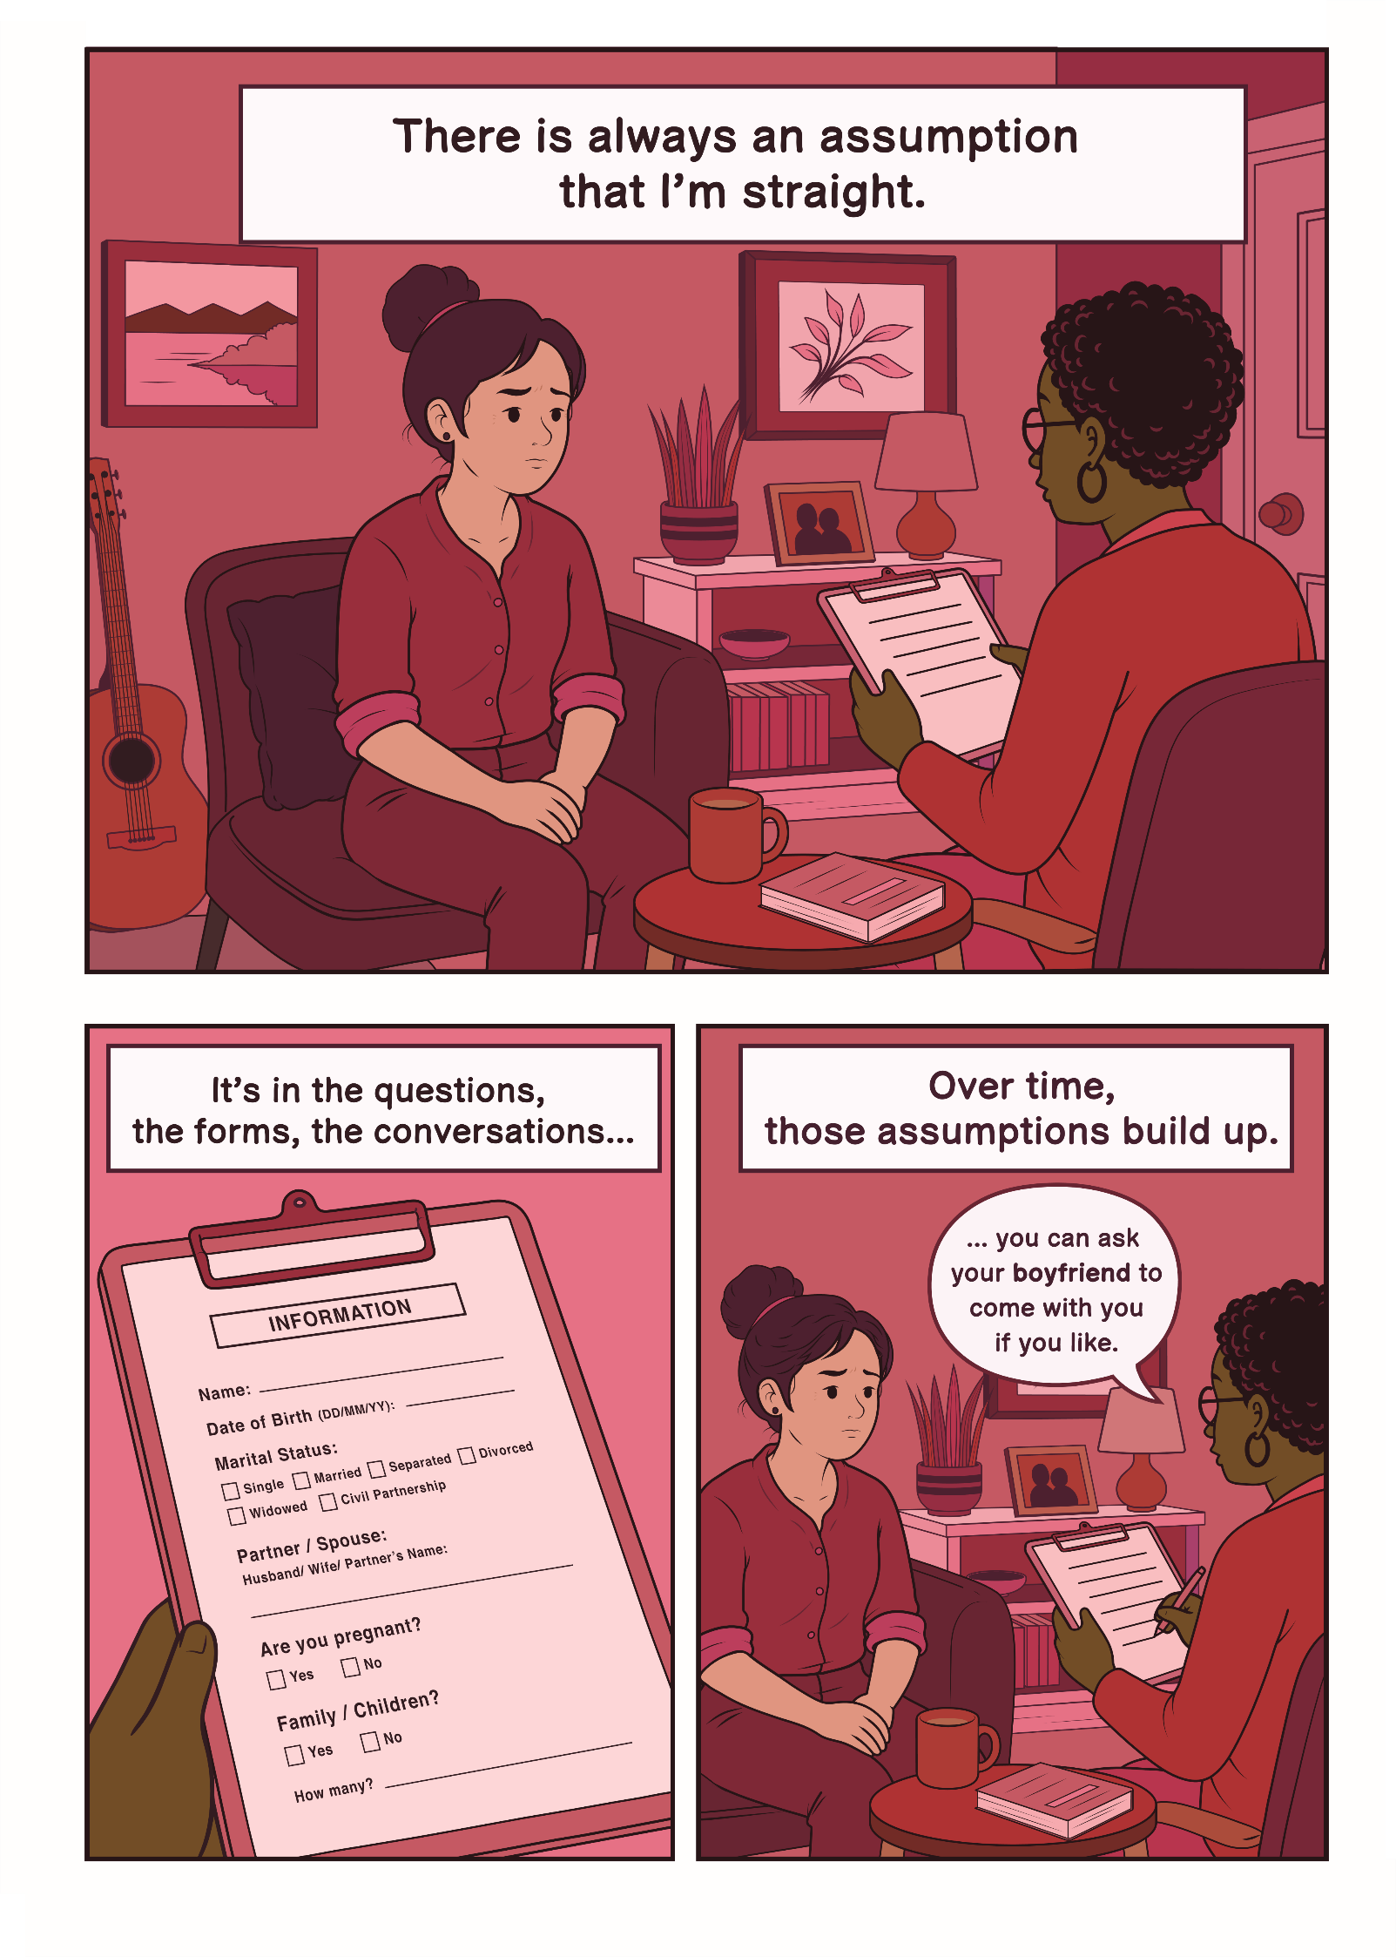

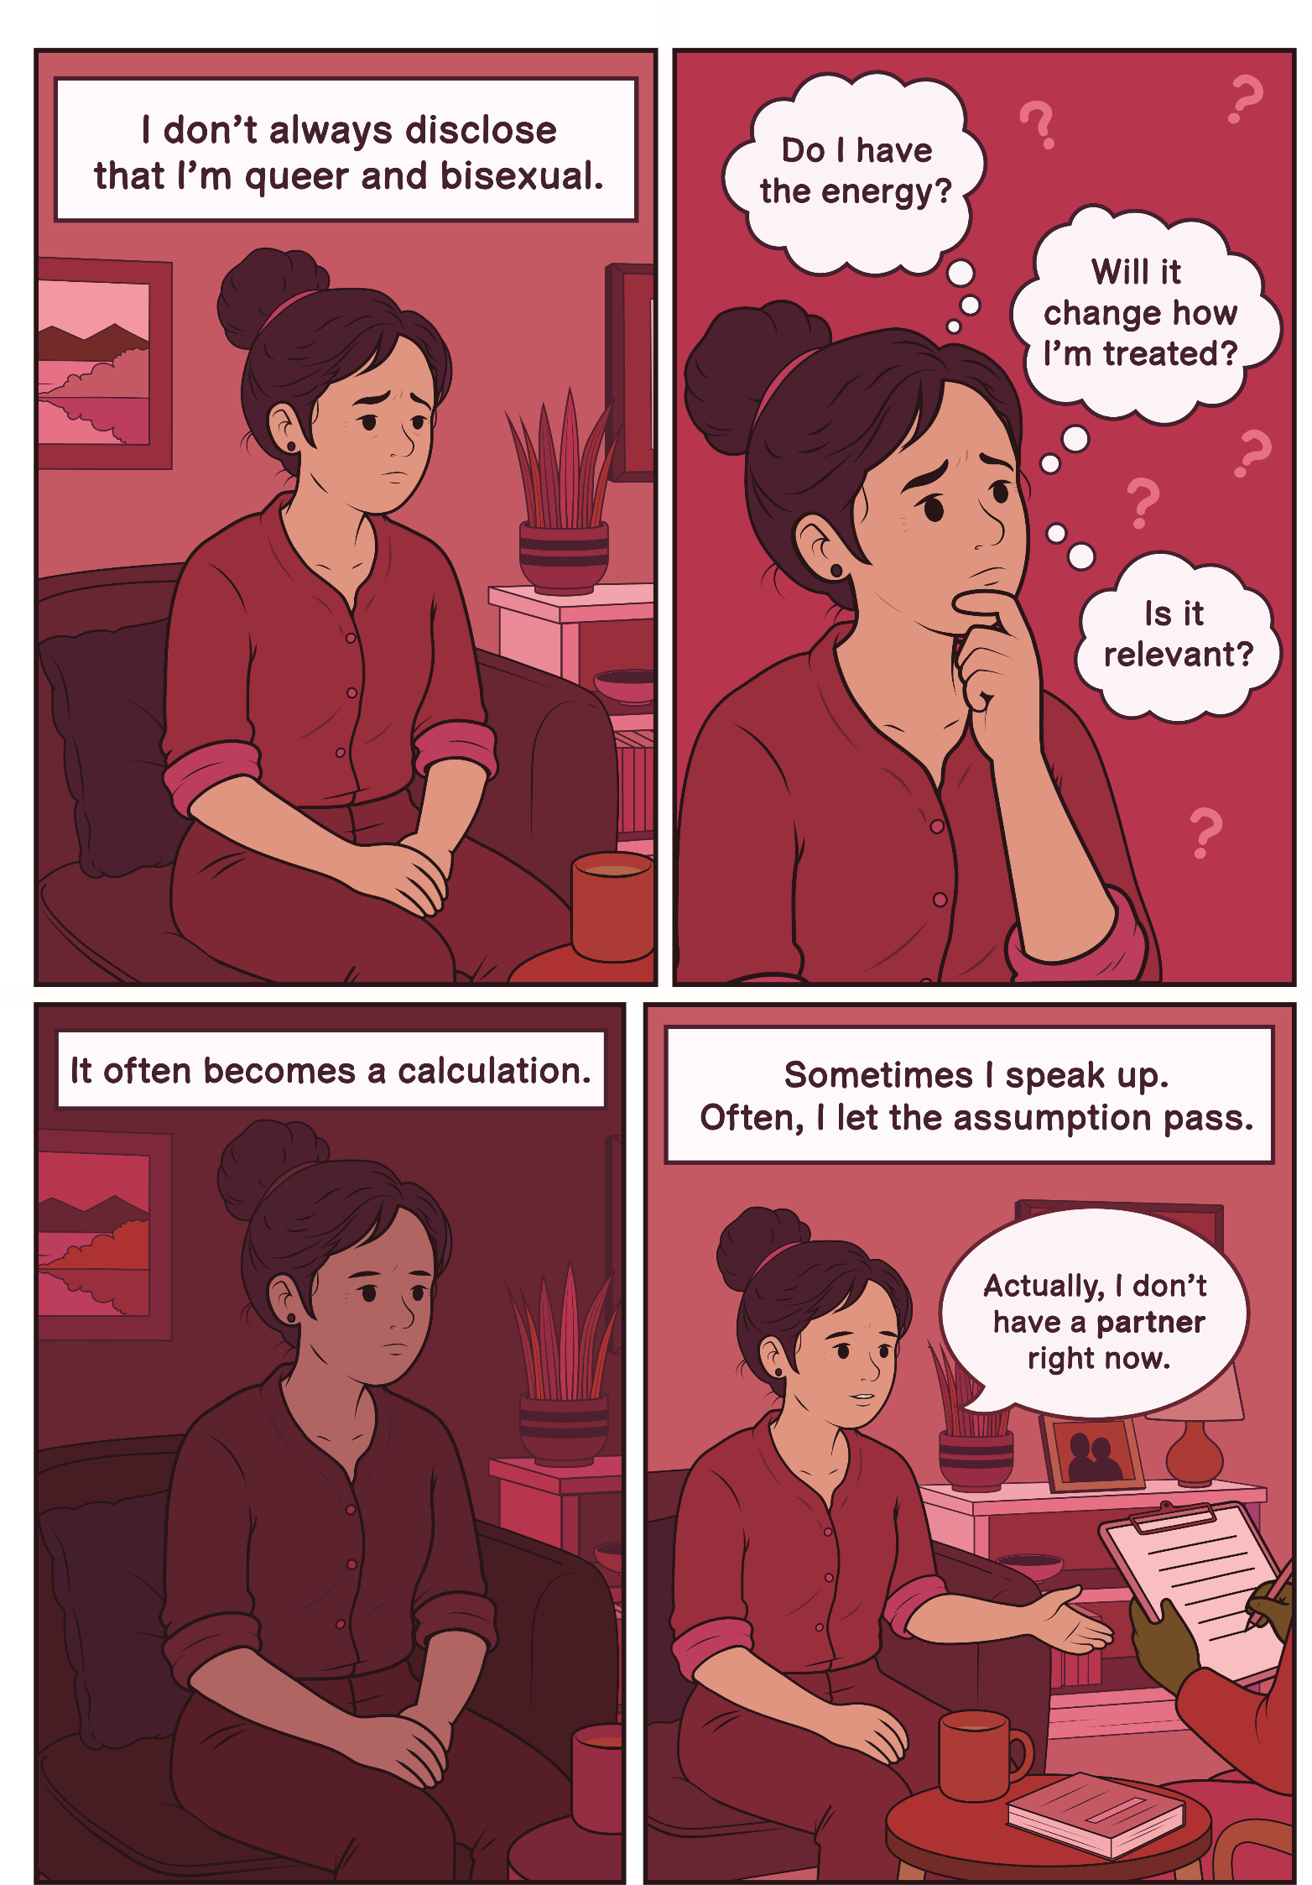

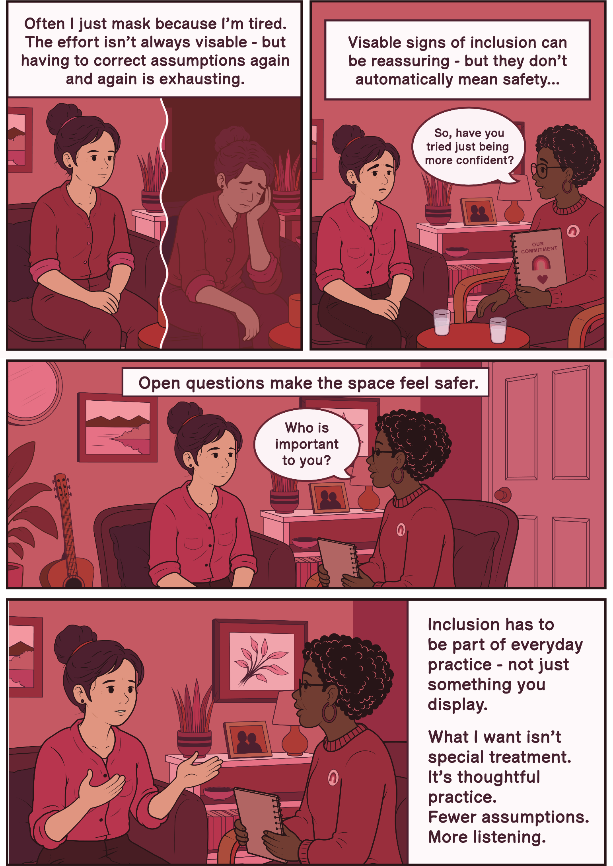

Jay’s Story
“In one report, I was referred to throughout as ‘Name/them’, as if ‘them’ were part of my surname.”
I am autistic and I have multiple sclerosis. I am also non-binary and use they/them pronouns. In my experience with adult social care, these parts of my identity have often been dismissed or misunderstood.
When we first moved, I was refused an assessment even though I was entitled to one. During a phone assessment, my wife - who is also my carer - was speaking alongside me, as they often do to support me. The social worker accused us of lying because she didn’t believe we were two different people. It's as if she couldn’t accept that two people she 'perceived' as female could be in a relationship. The consequences of that interaction were monumental. I could no longer safely engage with that worker. Support stalled. I remained without help. For me, this isn’t just about awkward conversations or microaggressions, it has been life-altering. The lack of support has left me feeling stuck, hopeless and at times intensely suicidal. When professionals misuse their power, the consequences can be life-threatening.
My non-binary identity is rarely respected. In one report, I was referred to throughout as ‘Name/them’, as if ‘them’ were part of my surname. Another staff member thought my first name was ‘Other’ because of how gender options were recorded. The system doesn’t even allow ‘Mx’ as a title. These errors might sound small, but it feels aggressive when no one even tries. I don’t expect perfection; I understand that people make mistakes with pronouns. I don’t mind mistakes, but I need to see that people are trying. Effort matters. Respect matters.
Being disabled adds another layer; disabled people are often treated like children, or as if we shouldn’t have relationships or that our relationships are just pretend. Housing options have assumed I am single. This has put real strain on my relationship. According to the Care Act, relationships are important - yet support systems often fail to recognise us as a couple. A senior professional once asked me in relation to housing, ‘How bothered are you about your marriage?’ That question cut deeply. My marriage is the most important part of my life. To hear it reduced like that made me feel invisible.
What I need is simple; respect my pronouns and recognise that queer and gender-diverse disabled people exist. Understand that your behaviour has monumental consequences because when you dismiss my identity or my marriage, it harms my mental health.

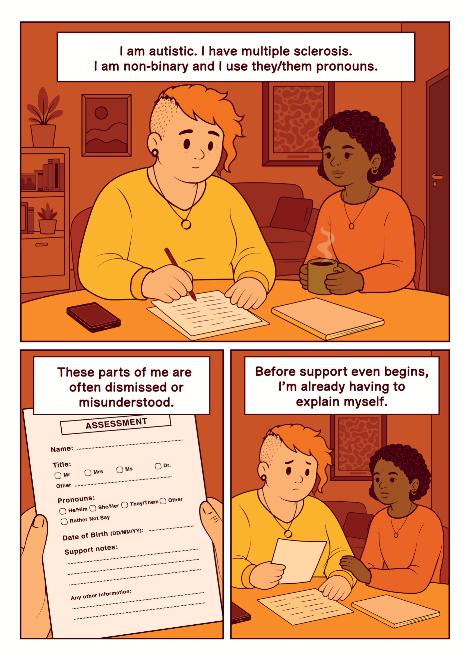

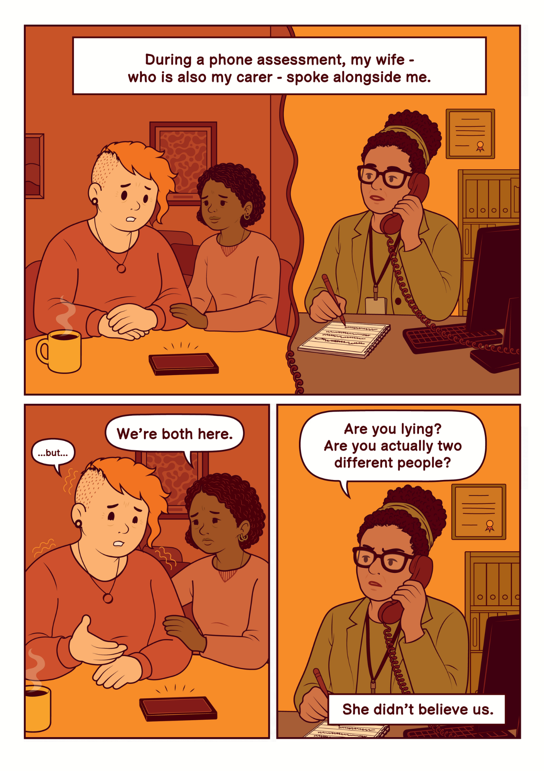

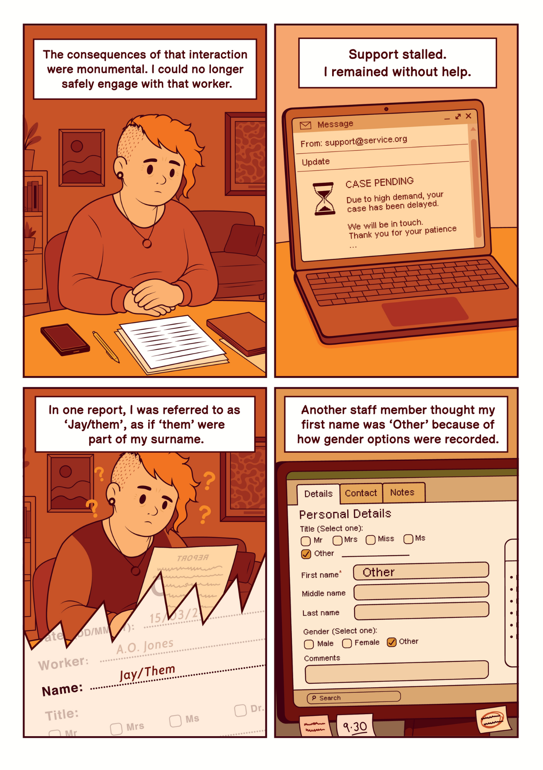

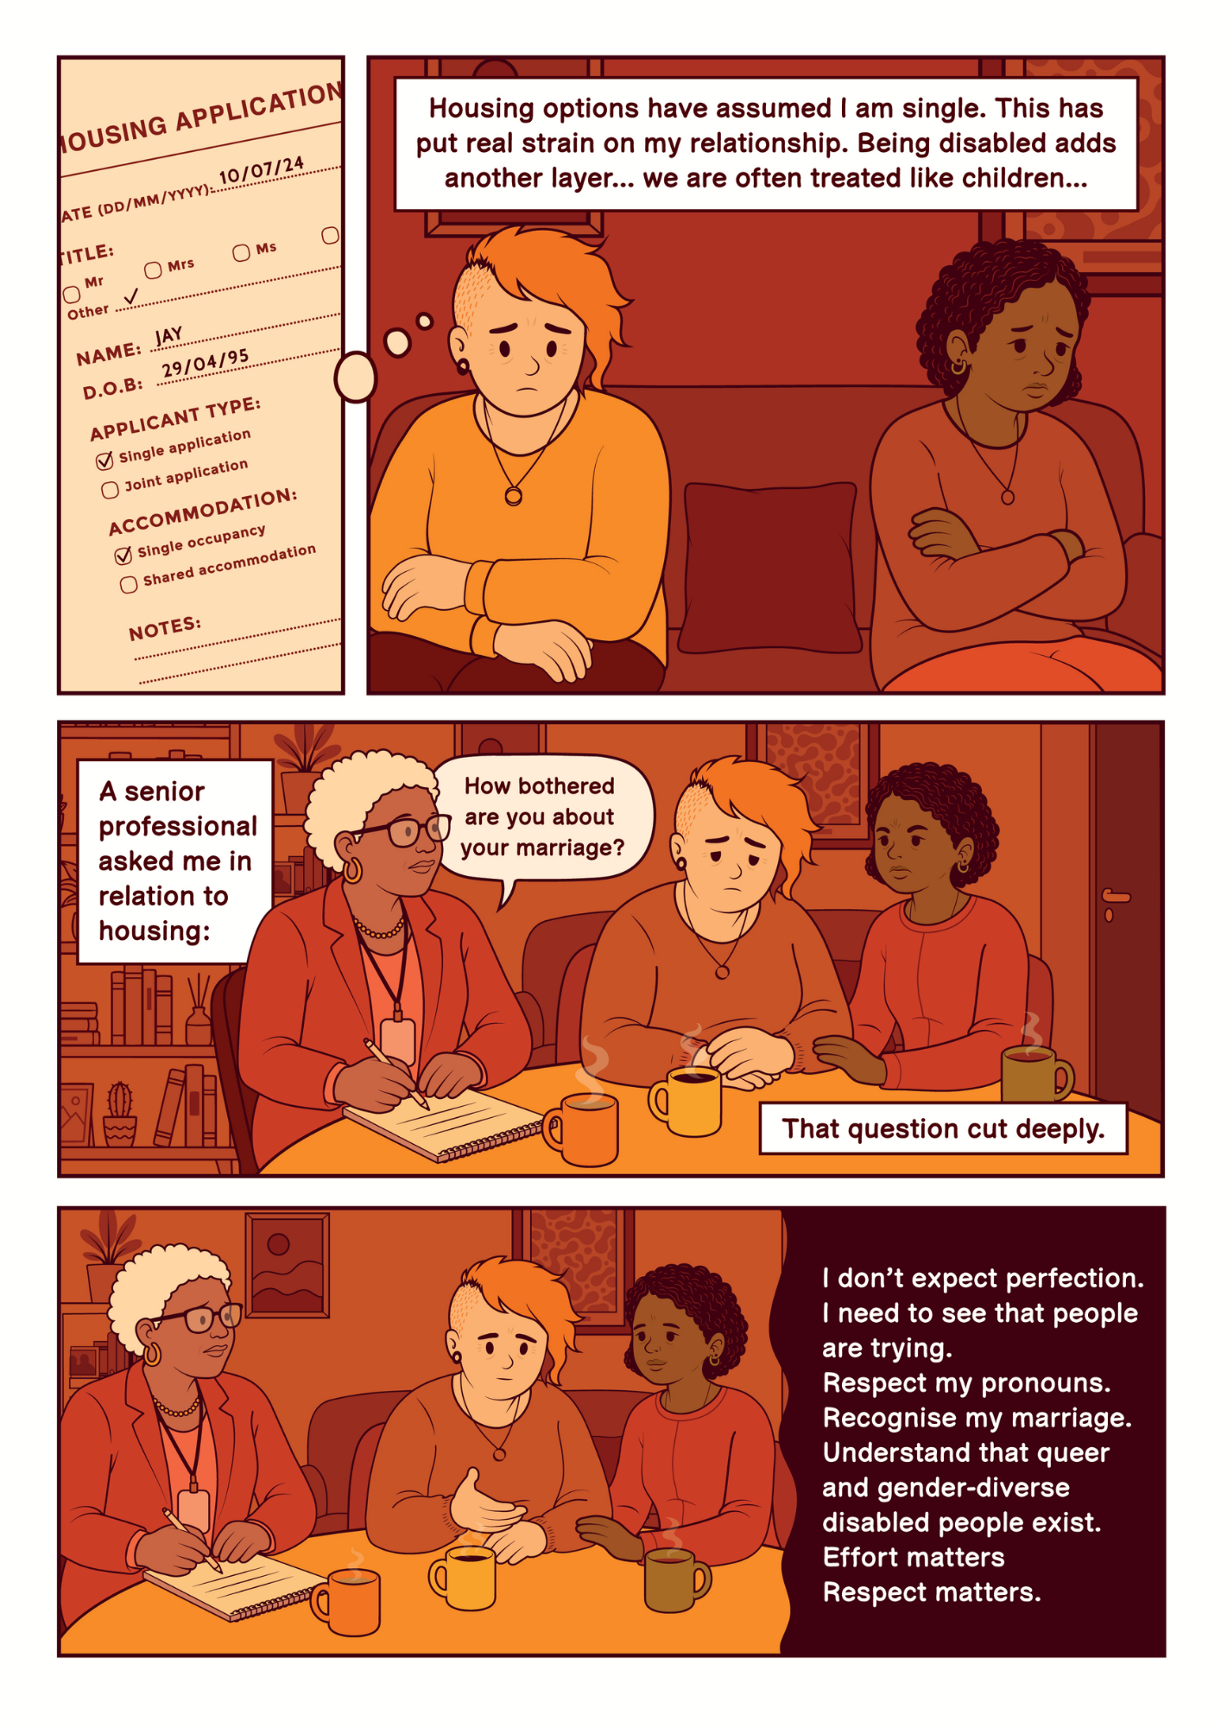

Amina’s Story
“I need support from this person, but now I’m managing their discomfort as well as my own.”
I am my partner’s carer. What I need professionals to understand is simple, please don’t assume who I am before you’ve even asked. I’m a Black woman and people often assume they already know things about me. They assume I’m Christian. They assume I’m in a heterosexual relationship. They assume the person I care for is my husband and that they must also be Black because I am. None of that is true. I’m not Christian. I’m not in a straight relationship. My partner isn’t Black. I’m also older than people tend to think. These assumptions create a barrier before we’ve even started talking about care.
Sometimes it’s subtle, religious comments in professional settings, or immediately referring to my partner as ‘your husband’. This moment shows how little understanding some staff have about gender diversity. Every time someone assumes my partner is my husband, or misunderstands who we are, I have to correct them. That moment is always awkward. I can feel the shift. I need support from this person, but now I’m managing their discomfort as well as my own. It’s extra emotional labour on top of caring responsibilities.
Over time, that emotional labour adds up. I’ve told social services I’m at breaking point. The strain has affected my mental health to the point that I’ve needed medication. Instead of practical help that addressed the barriers we were facing, I was told to seek therapy. That felt dismissive. I wasn’t asking for coping strategies. I was asking for support that would make the situation better.
When professionals make assumptions about my race or relationship, I feel othered. When they ask open questions - What is your relationship? What pronouns do you use? - and listen without judgement, I feel seen. That difference shapes whether I trust the social care staff. What I need is for staff to ask, listen and not make assumptions, but inclusion alone is not enough; it has to be backed by real support.

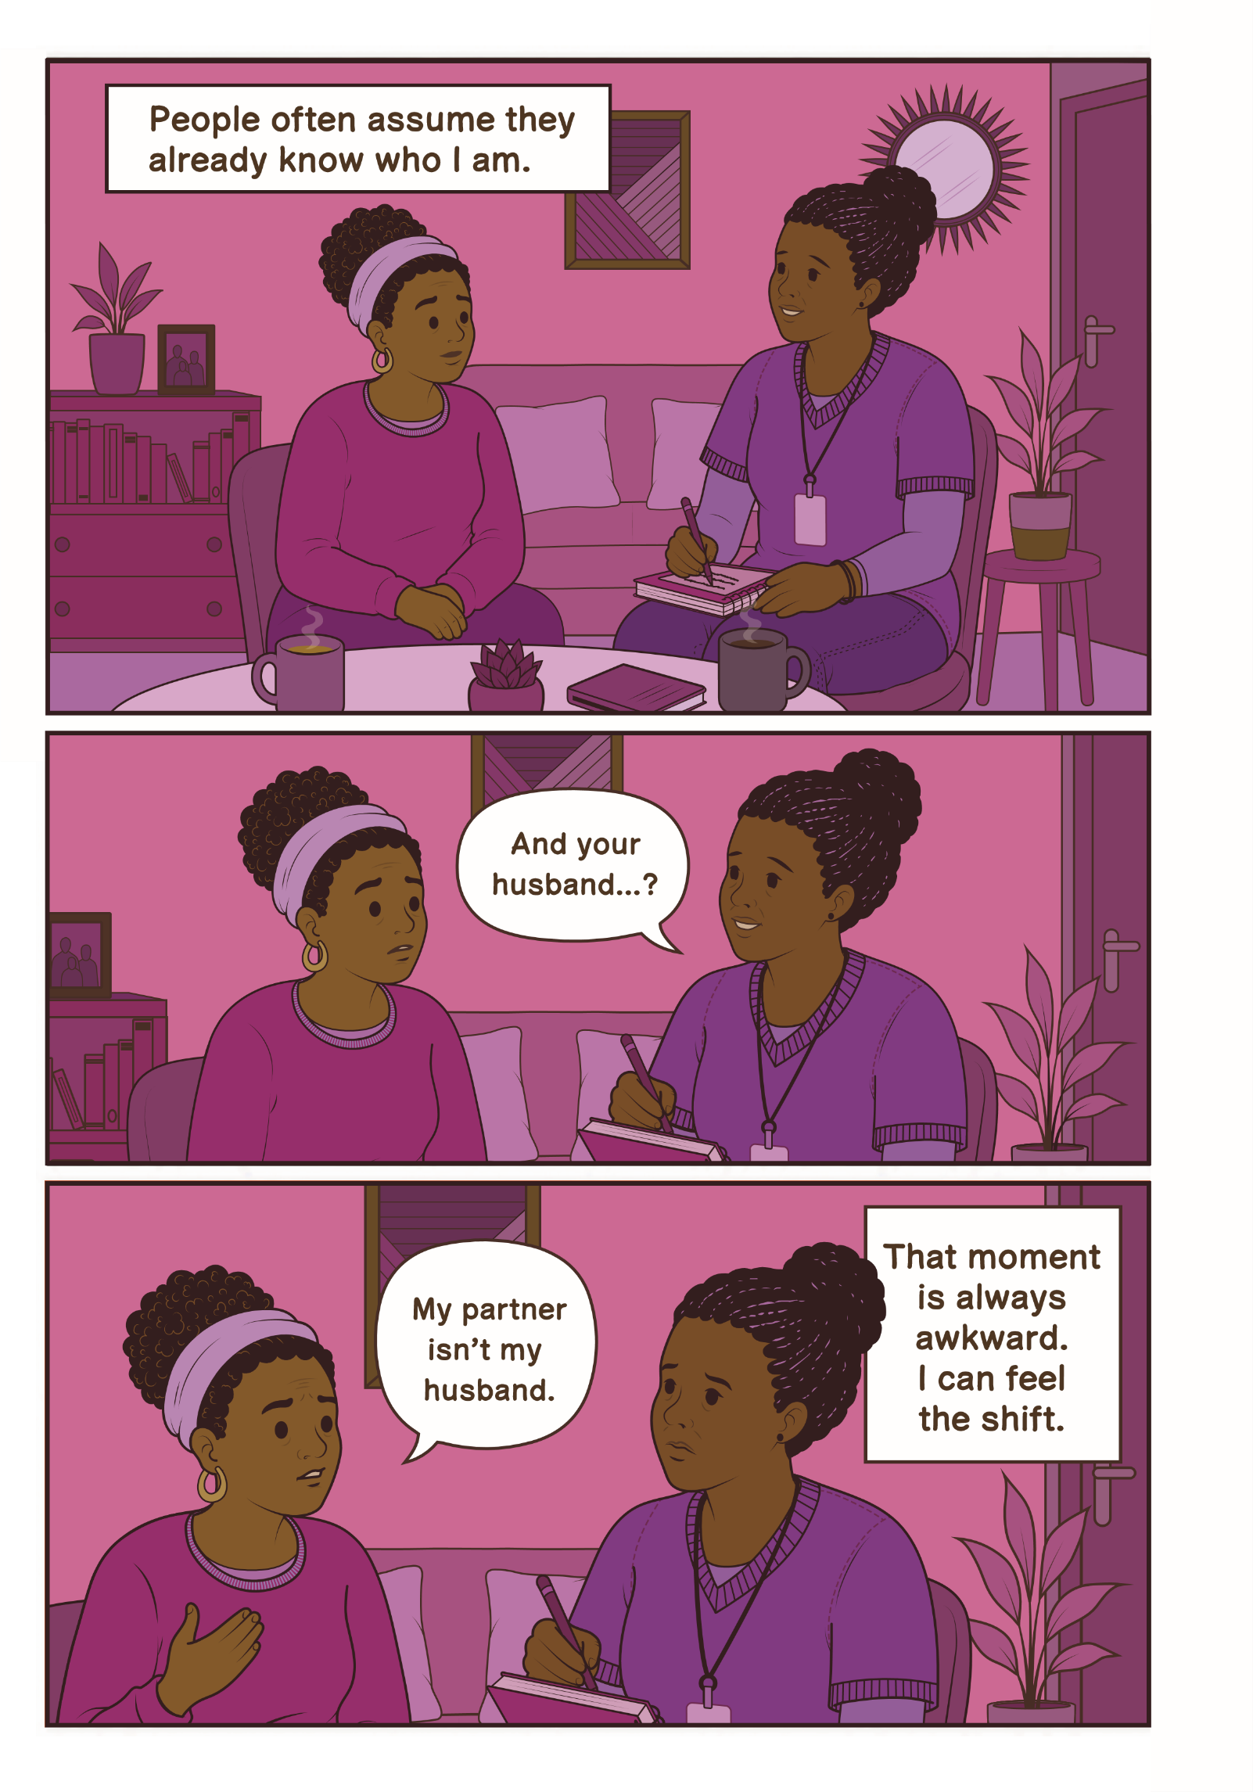

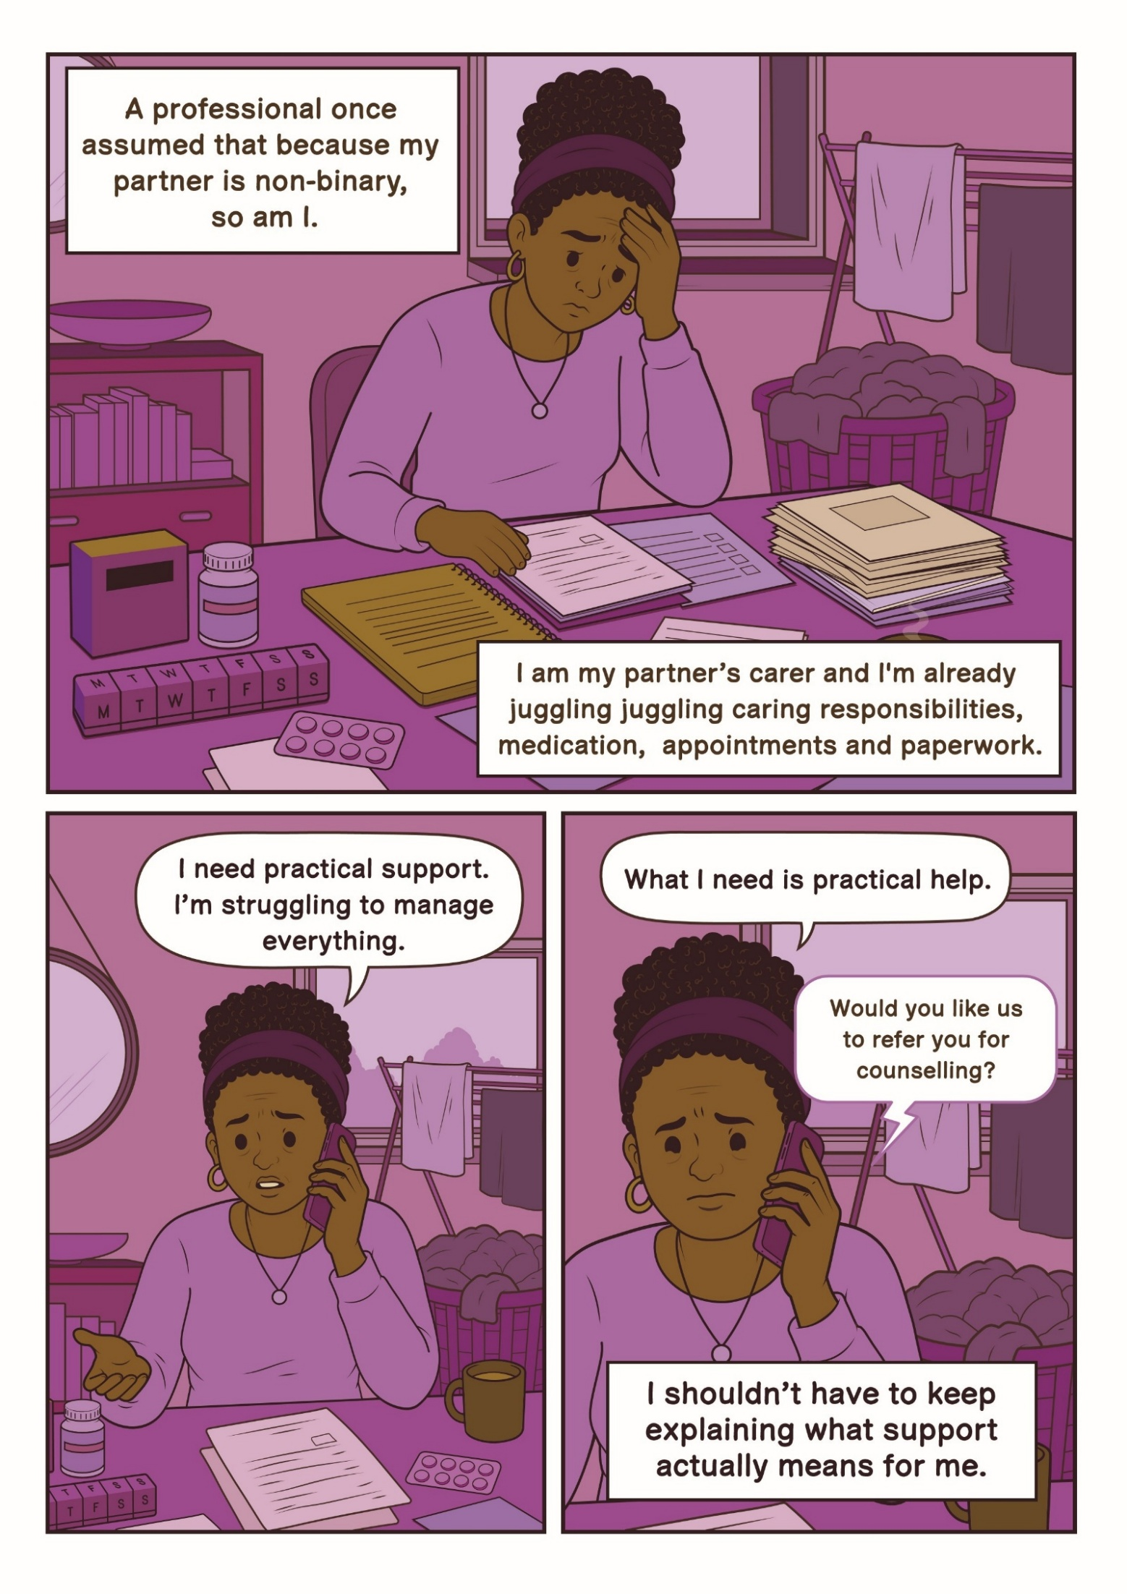

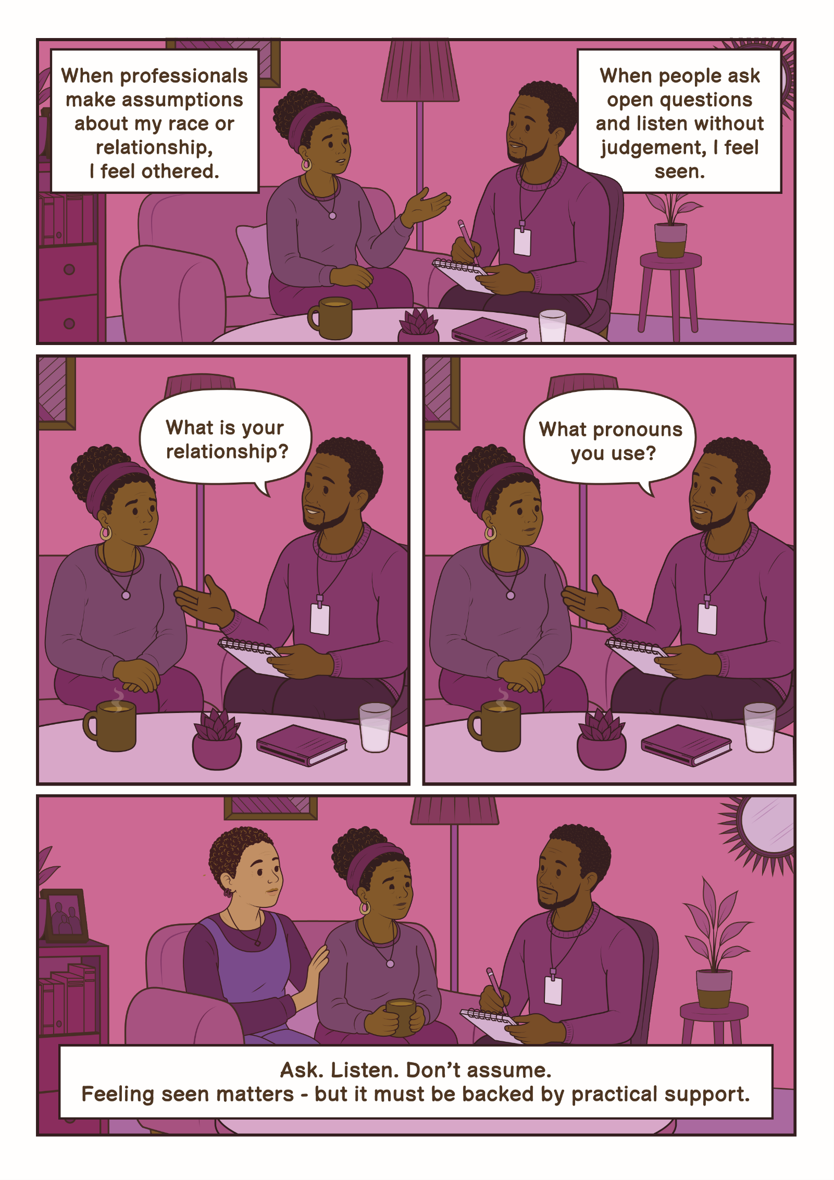

Ria’s Story
“Representation isn’t about special treatment; it’s about spaces where I don’t have to constantly explain who I am just to be heard.”
I’m Ria. Navigating health and care systems as a Black queer non-binary woman often feels like a balancing act. I constantly adjust how I speak, how I sit, even how I dress, just to make sure I’m seen as polite, cooperative or safe. It’s referred to as code-switching, but really, it’s survival. I present in a way some people read as quite masculine. I keep my hair shaved and usually wear comfortable clothes like jeans and T-shirts. Often, I can feel the atmosphere shift when I walk into a room. Every appointment, every interaction, is a calculation; will I be judged? Will my identity make this harder? Do I have the energy to explain who I am, or is it safer to stay quiet?
Masking like this is exhausting. I’ve walked into hospitals and care settings already feeling anxious, and the effort of softening who I am adds another layer of strain. Once, a nurse’s attitude toward me shifted after overhearing me speak Nigerian Pidgin English with my sister. Suddenly I wasn’t treated as ‘other’ anymore; I felt recognised. Moments like that remind me how often people make assumptions about who I am.
Representation matters. Receiving counselling from Black women who understood parts of my cultural background has been deeply healing. Their understanding isn’t just professional, it’s lived. Seeing staff who understand aspects of my identity - my race, culture or queerness - signals that I can trust them before I’ve even spoken. Representation isn’t about special treatment; it’s about spaces where I don’t have to constantly explain who I am just to be heard.
For adult social care staff, the most important thing is noticing what residents may be communicating through their behaviour. I might be quiet, polite or overly accommodating - not because everything is fine, but because I’m managing my identity in real time to feel safe. When staff pause, listen and reflect, it makes a huge difference. That’s what turns care from something I have to endure into something I can trust. I want staff to understand that my identity is not a complication. The effort of managing perceptions, masking and constantly code-switching is exhausting. When professionals respond with curiosity rather than judgement, it transforms the interaction. Understanding behaviour as a survival strategy, and reflecting on unconscious bias, helps create real safety for people like me.

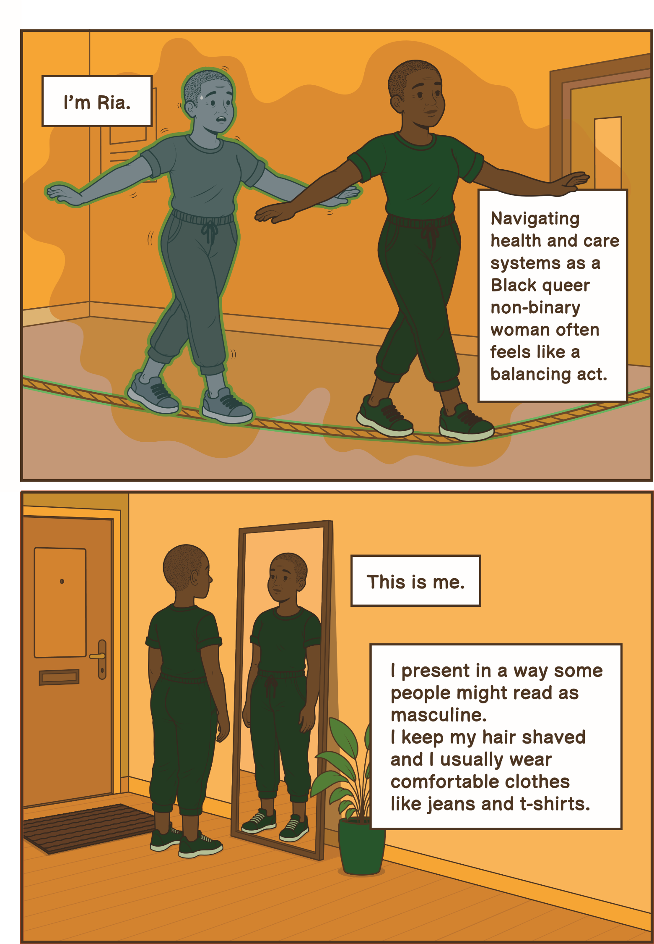

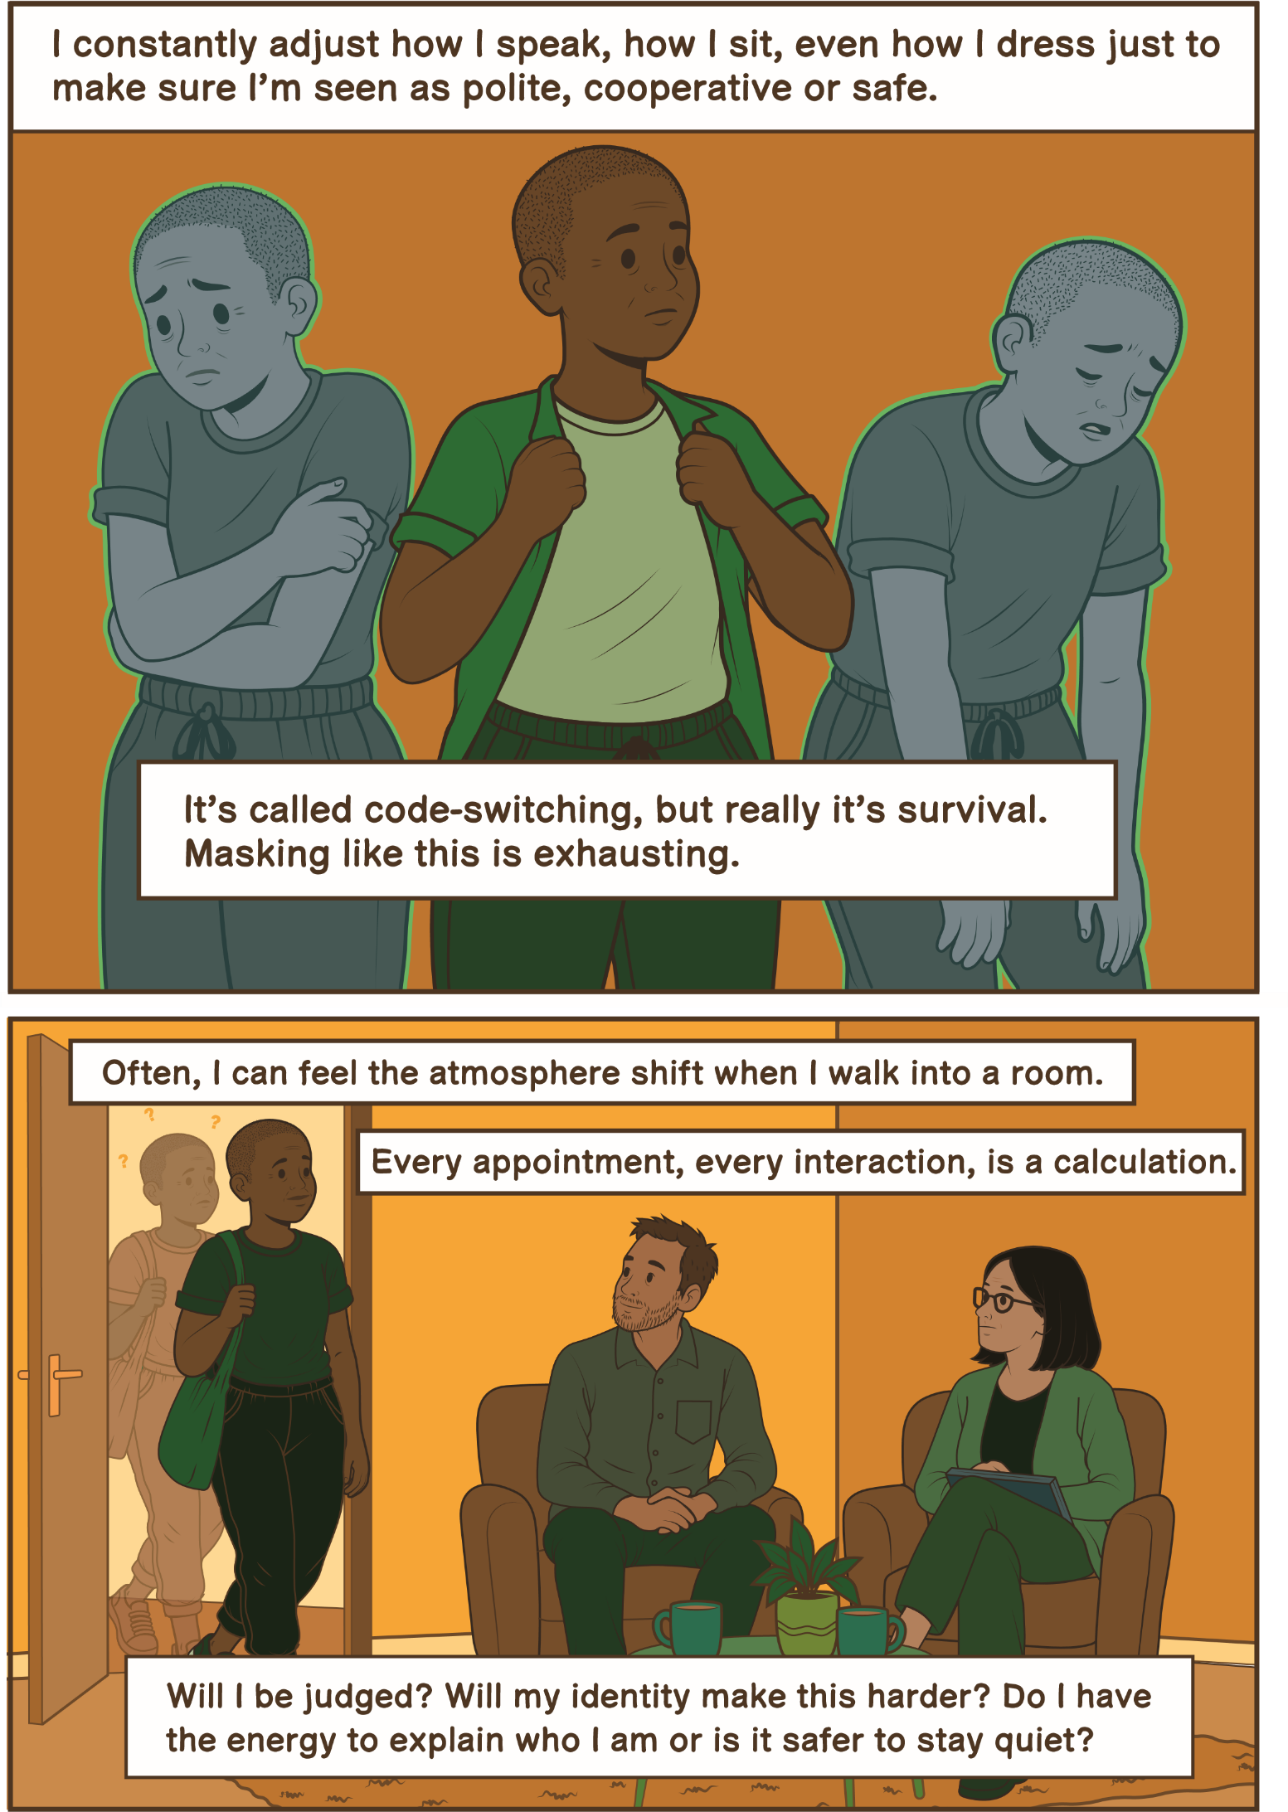

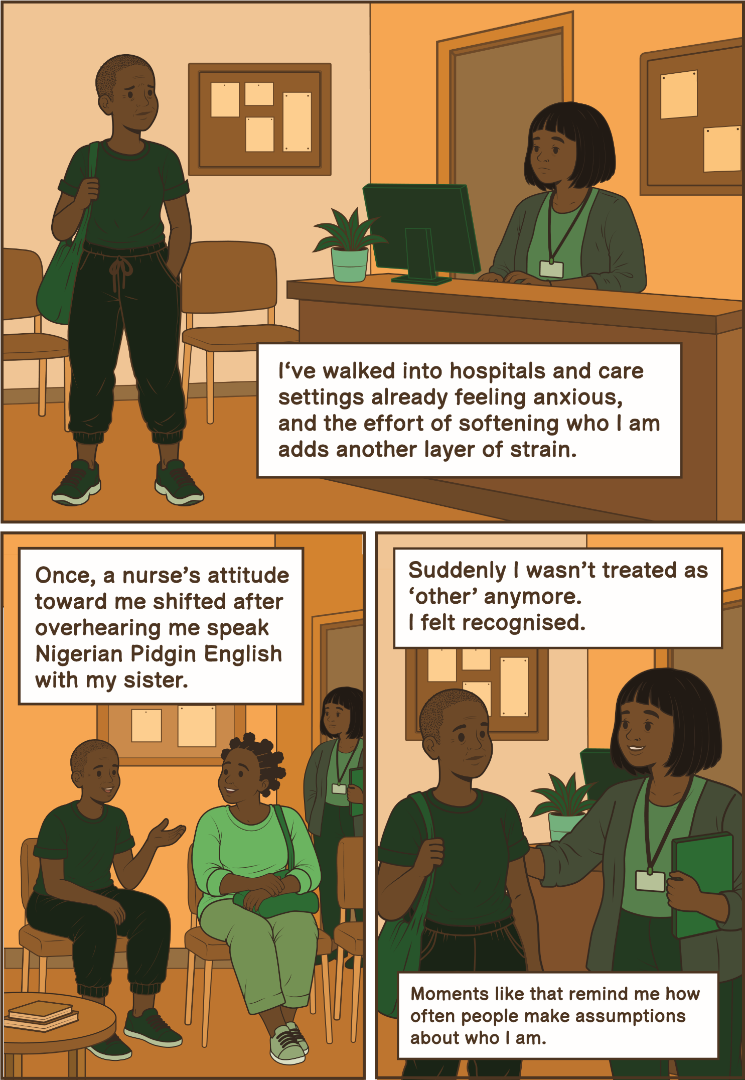

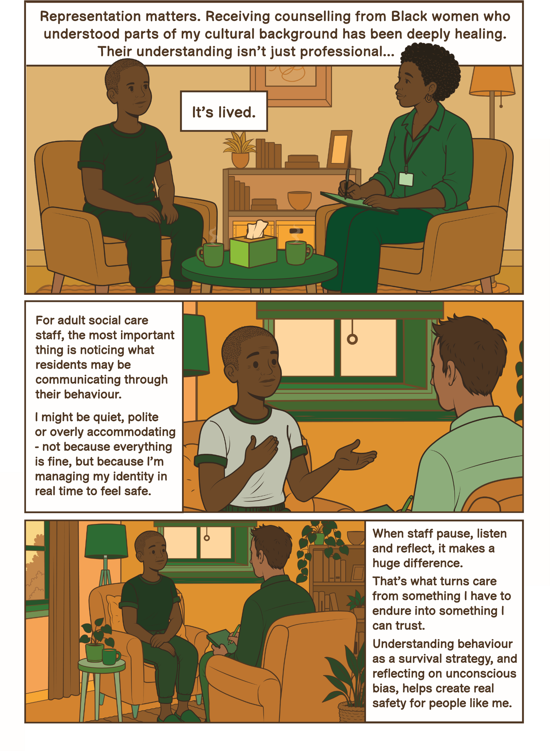

.
Richard
“I don’t need to be celebrated for being gay. I just need to know that if I’m vulnerable, the people supporting me will treat me with dignity and won’t let their personal beliefs affect the care I receive.”
I’m 58 and I’m gay. I’ve worked in and around social care for over twenty years, so I’ve seen both good and bad practice up close. Because of that, I think a lot about what would happen if I needed care myself one day. My biggest concern is safety. In social care, your experience often depends on the individual staff supporting you and staff change frequently. You might have a team who are kind, respectful and completely accepting, and then a few months later they’ve left and you’re left with people whose views are very different. That inconsistency makes me feel very vulnerable. I’ve seen situations where residents were told that being attracted to the same sex was dirty or immoral. I’ve seen how quickly cultures in services can change when managers or staff move on. So, if I were in a care home, I honestly don’t think I would tell people that I’m gay. I’d want that information kept off my records because it just doesn’t feel safe for it to be there.
That creates its own problems. If I had a partner, I might introduce them as a friend or relative just to avoid potential judgement or gossip. Hiding such a big part of your life is stressful but sometimes feels like the safer option. Part of this fear comes from my past. When I was younger, there was open violence against gay people where I lived. People were attacked simply for being in places known to be used by gay men. Those experiences stay with you; even decades later they continue to shape how safe you feel being open about who you are.
What would make a difference is not just policies or rainbow posters, but consistency and accountability. Training needs to be meaningful and repeated, not a one-off tick-box exercise. All staff need to understand that discriminatory attitudes are not acceptable, and organisations need to act when those attitudes show up in practice. I don’t need to be celebrated for being gay. I just need to know that if I’m vulnerable, the people supporting me will treat me with dignity and won’t let their personal beliefs affect the care I receive. Until that feels guaranteed, it’s hard not to feel that being open about my sexuality in care settings could put me at risk.

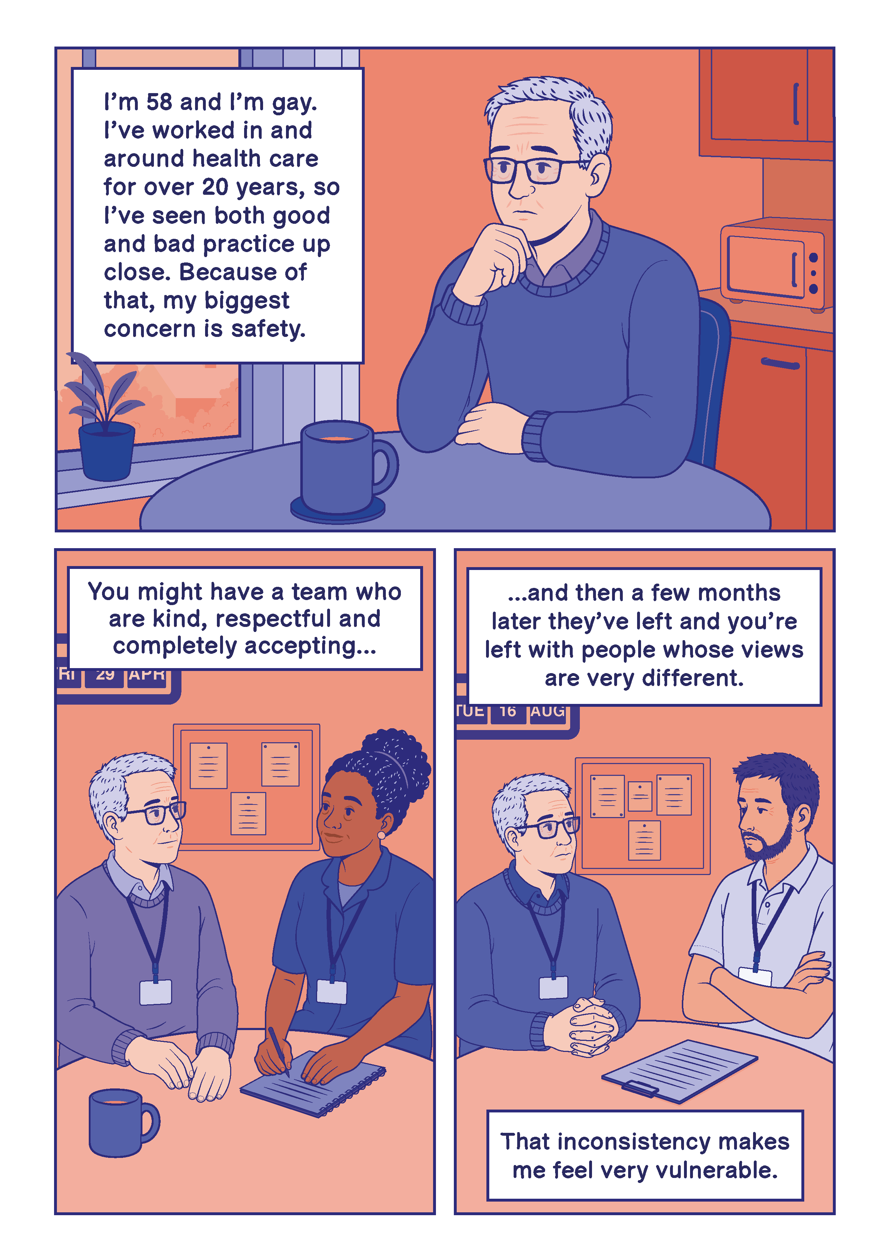

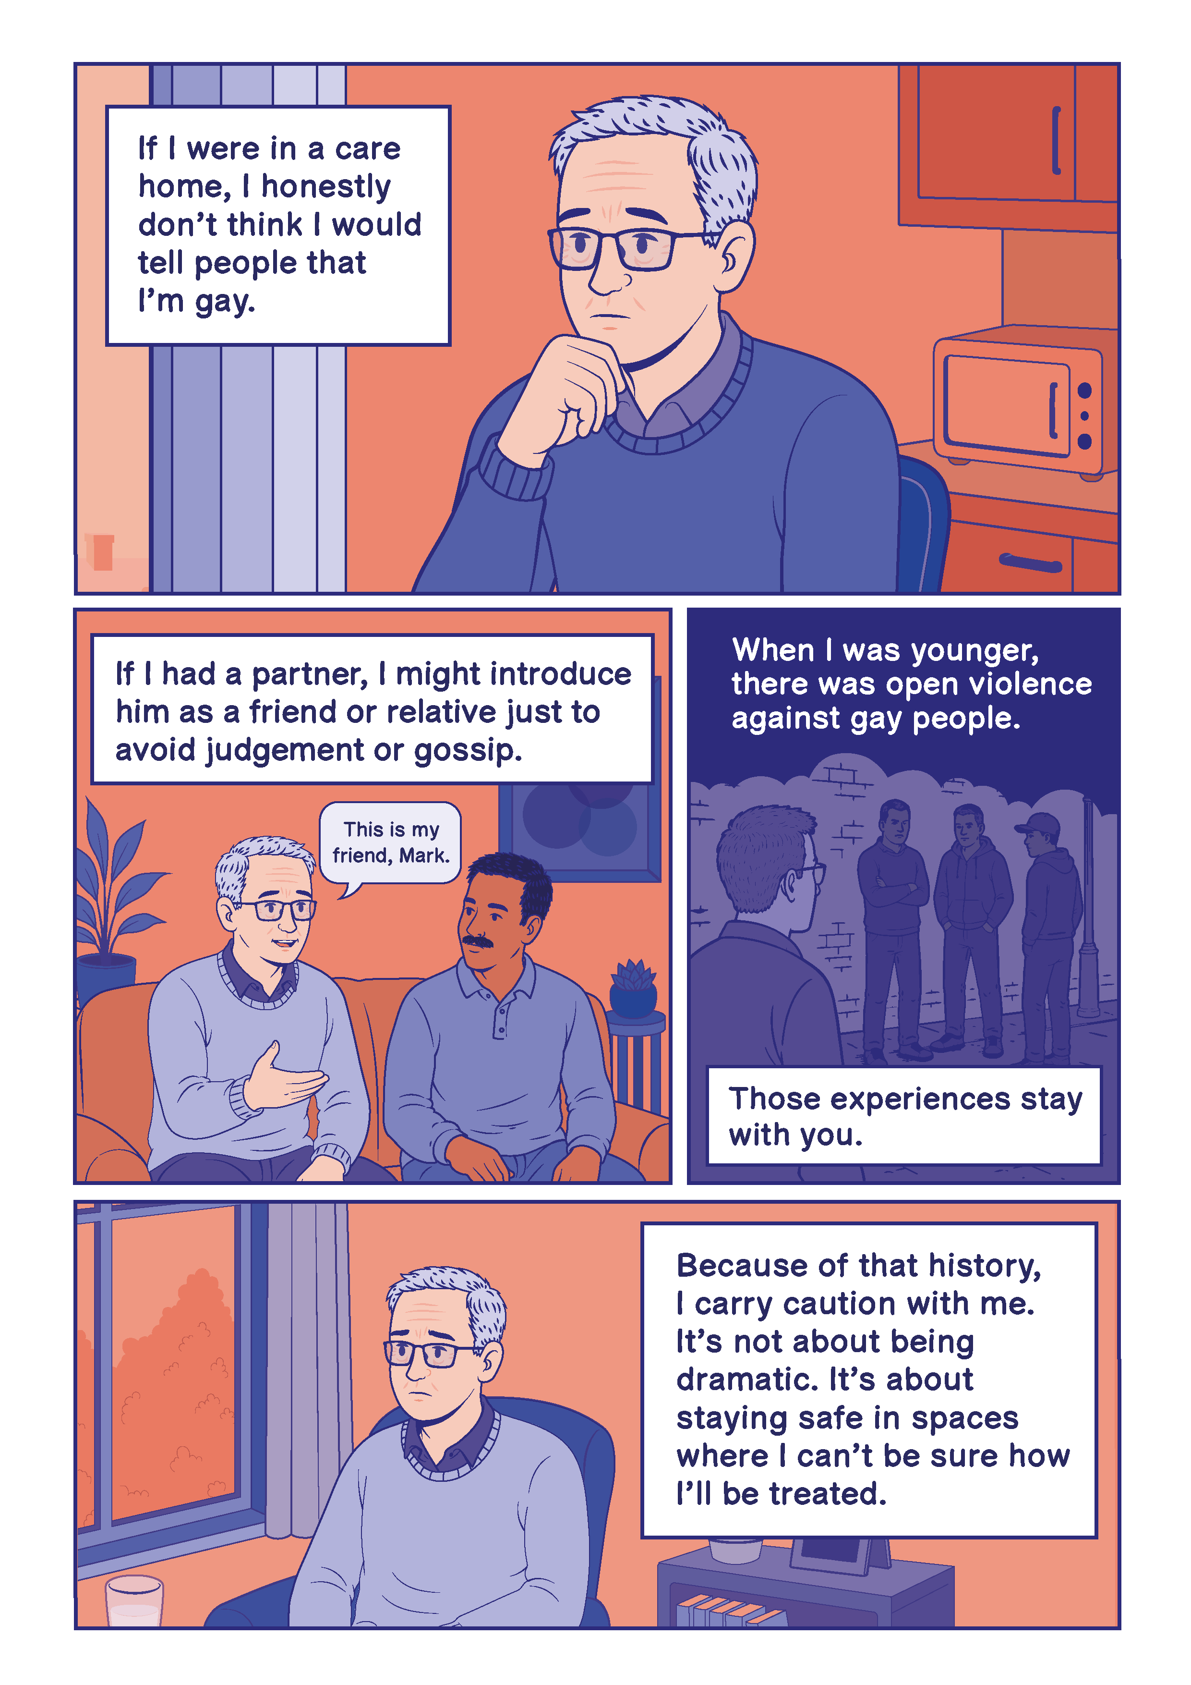

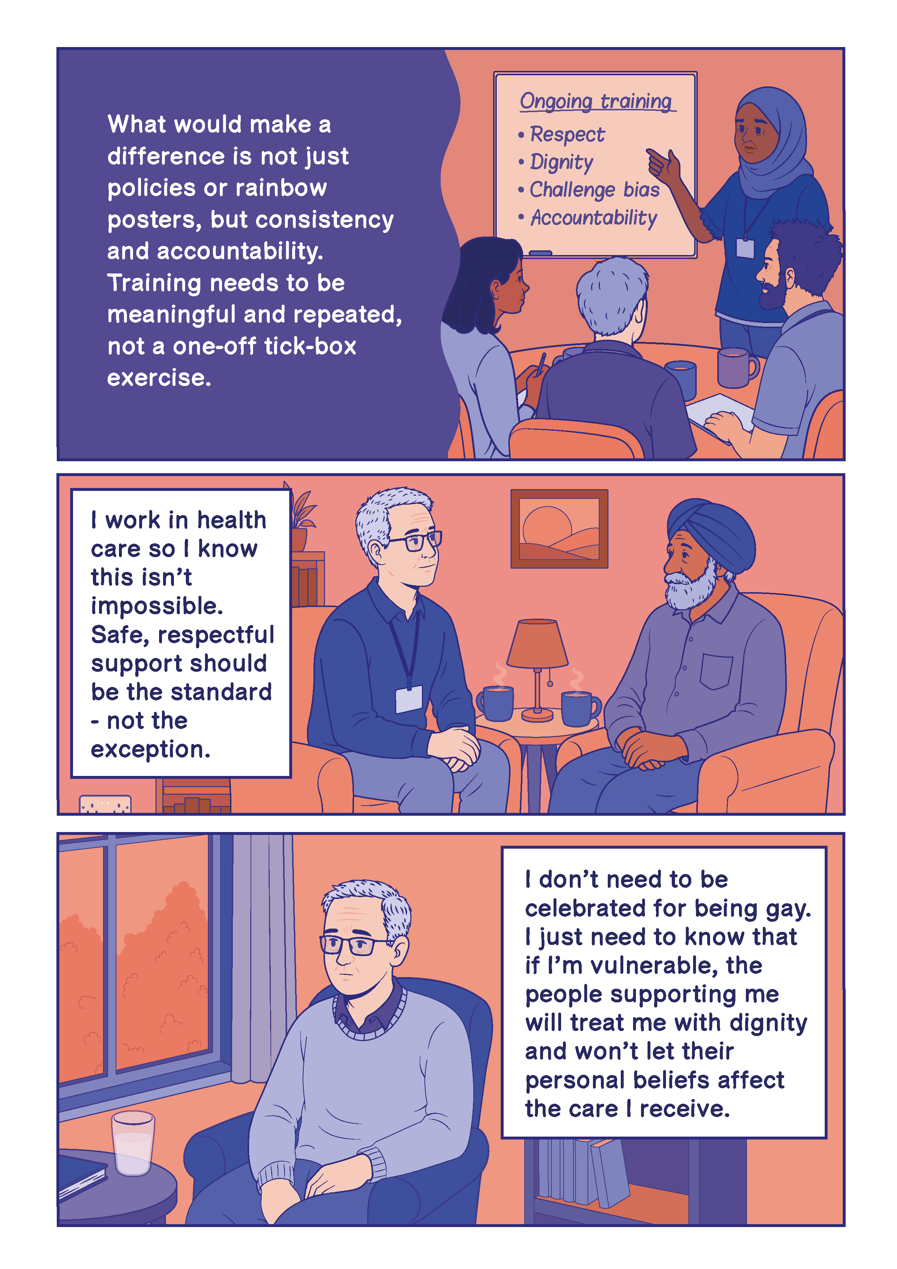

Reflections and hopes for practice
Members of the Newham Adult Social Care project working group reflected that confidence was gained in discussing LGBTQ+ inclusion through open conversation, shared learning and having space to think together about practice. Practitioners described the importance of safe and supportive environments where questions could be explored without fear of getting things wrong. All hope that the tools developed will support ongoing conversations within teams, encourage reflection in supervision and training, and help create environments where inclusion is discussed proactively rather than only in response to concerns or complaints.
Working group members recognised that many of the principles within this resource, such as avoiding assumptions, building trust and creating opportunities for people to share what matters to them, have relevance beyond LGBTQ+ inclusion and may support more inclusive approaches across other areas of practice.
Ultimately, it is hoped that this resource will contribute to a culture where people feel able to ask questions, learn together and provide care and support that is respectful, reflective and inclusive.

Appendix A participants and contributors
Name | Role | Area/Organisation
IMPACT
Sebastian Buser | Facilitator | IMPACT
Karen Watchman | Facilitator Delivery Lead | IMPACT
Irena Connon | Project Officer | IMPACT
Kimberley Coutts-Murray | Project Co-ordinator | IMPACT
Project host partners
Kay Hyatt | Workforce Development Team Manager | Newham Council
Adam Webb | Transformation Manager (Adults and Health) | Newham Council
Co-development working group
Nuala Sheehan | Social Care Officer | Newham Council
Wunmi Ajayi | Social Worker | Newham Council
Gerry O’Kello | Commissioner | Newham Council
Maria Xavier | Senior Support Worker | Newham Council
Gregory Brown | Reablement Officer | Newham Council
Rachel Hunt | Practice Manager | Newham Council
Kay Hyatt | Workforce Development Team Manager | Newham Council
Community co-development partners
Miri | LGBTQ+ Resident | London Borough of Newham
Jay | LGBTQ+ Resident | London Borough of Newham
Amina | LGBTQ+ Resident | London Borough of Newham
Ria | LGBTQ+ Resident | London Borough of Newham
Richard | LGBTQ+ Resident | London Borough of Newham
Creative Contributor
Shaven Raven Designs | Graphic Illustrator | London Borough of Newham

Mx (pronounced mix or mux) is a title that indicates neither marital status nor gender.

