Inclusive Conversations
Practical tools for supporting LGBTQ+ people in adult social care

Part Two
Scenarios


This document forms one part of a larger programme of work, Inclusive Conversations, co-produced by Newham Council and IMPACT.
Inclusive Conversations is designed to help social care staff feel more
confident having conversations about sexuality and gender identity.


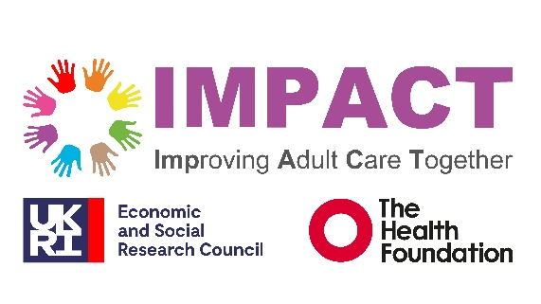

Scenarios
These scenarios are intended to support inclusive, person-centred practice during assessments and reviews, including conversations about identity, relationships and LGBTQ+ inclusion. They show real examples of what people might say and how practitioners can respond in a respectful and consistent way. This resource may be used individually before meetings or as part of training and staff development exercises.
The aim is not to provide scripts to memorise, but to help practitioners feel more confident when conversations or disclosures are different from what they expect.

Scenario 1: Avoiding assumptions about relationships
Situation | Avoid assumptions | More inclusive approach | Recording reminder
A practitioner asks the person if they have a partner and the person replies: “Yes, my partner helps me with shopping and appointments.” The practitioner does not yet know how the person describes their partner or relationship. | “Oh, does he live with you?”  Avoid assuming gender or relationship type before the person has shared this themselves. | “Does your partner live with you?” or “Would you like to tell me a bit about them?” Use neutral language until the person shares more information themselves. | Record the relationship using the language the person uses. For example: “Person stated that her wife, Jane, supports her with shopping and appointments.”

Scenario 2: When family members use a different language
Situation | Check with person | More inclusive approach | Recording reminder
During an assessment, a family member refers to the individual differently from how the person describes themselves. For example, the person may have described themselves as a trans man, and the family refer to them using ‘she’ pronouns. | Avoid automatically following the language used by family members without checking the individual’s preference. | “Just so I make sure I address you correctly, what name and pronouns would you like me to use?” | Record the person’s stated preferences clearly and consistently.

Scenario 3: Different name or pronouns from records
Situation | Avoid assumptions | More inclusive approach | Recording reminder
A person’s name is recorded as Sarah and title Ms. A practitioner asks:  “We ask everyone how they would like to be addressed?”  The person replies:  “I like to be called Alex, and I use they/them pronouns.” | Avoid reacting with surprise or repeatedly referring back to the persons previous name or information on record. | “Thank you for letting me know. Would you like me to note that on your record and use this in any correspondence?” | Use the name and pronouns the person has asked you to use. Check with the person how they would like this recorded and used in letters and records.

