Inclusive Conversations
Practical tools for supporting LGBTQ+ people in adult social care

Part Four
Illustrated Conversations: Learning from Lived Experience

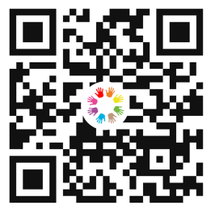
This document forms one part of a larger programme of work, Inclusive Conversations, co-produced by Newham Council and IMPACT.
Inclusive Conversations is designed to help social care staff feel more
confident having conversations about sexuality and gender identity.


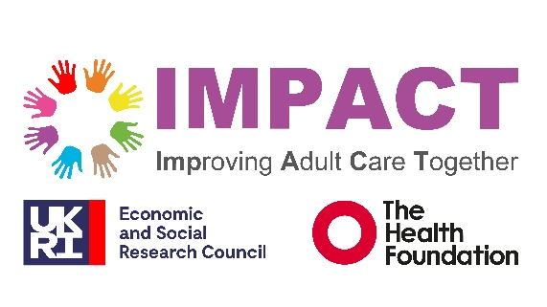

Illustrated Case Studies: Learning from Lived Experience
All illustrated case studies were developed collaboratively with LGBTQ+ people and community members involved in the project. They reflect lived experiences, priorities and perspectives shared by contributors and are presented with their agreement. Some contributors have chosen to use their own names, while others have chosen to use pseudonyms to protect their privacy. Illustrations accompanying the stories do not depict individuals directly.

Miri’s Story
“Instead of assuming the gender of a partner, ask ‘Who is important to you?”
There is always an assumption that I’m straight. It’s rarely said directly, but it sits underneath questions, forms and conversations. It’s in the way people ask about partners, pregnancy or family. It’s also what isn’t asked as much as what is. Over time, those assumptions build up.
I identify as queer and bisexual, but in many care and medical settings I don’t automatically disclose that. Straight people don’t have to. They don’t walk into appointments feeling like they need to clarify who they are before they can receive support. For me, it’s often a calculation; do I have the energy to correct this? Is it relevant? Will it change how I’m treated? I rarely speak up. Often, I just mask and let the assumption pass because I’m tired.
What would make a difference isn’t being asked to declare my sexuality in every setting. It’s being in environments where assumptions aren’t made in the first place. Simple, neutral questions can go a long way. Instead of assuming the gender of a partner, ask ‘Who is important to you?’ Instead of assuming what my relationships look like, ask open questions that don’t position heterosexuality as the default. That shift removes the pressure from me to correct someone and makes the space feel safer without me having to disclose anything personal.
I’ve also learned that visible signs of inclusion, like posters or rainbow symbols, don’t automatically equal safety. They can be reassuring, but only when backed up by genuine understanding. I’ve been in spaces that looked inclusive on the surface but didn’t feel that way in practice. For me, inclusion must be at the core of how an organisation operates - in training, in language, in everyday professionalism. It’s about holding your judgments and recognising that personal beliefs should never interfere with respectful care.
Another important point is that LGBTQ+ people are not one homogenous group. We don’t all share the same politics, experiences, or views. Many experience racism and misogyny within LGBTQ+ spaces. Some of us are older, younger, gender non-conforming, neurodivergent, disabled, religious, or from different cultural backgrounds. In my case, I’m also autistic and have ADHD. I see parallels between advocating for my neurodivergence and advocating for my sexuality and gender. In both cases, I’ve had to navigate systems that weren’t designed with me in mind.
What I want from adult social care - and from any service - isn’t special treatment. It’s thoughtful practice. Fewer assumptions. More listening. An understanding that inclusion isn’t about ticking a box; it’s about recognising the full diversity of the people you support and creating an environment where we don’t have to fight to be seen.

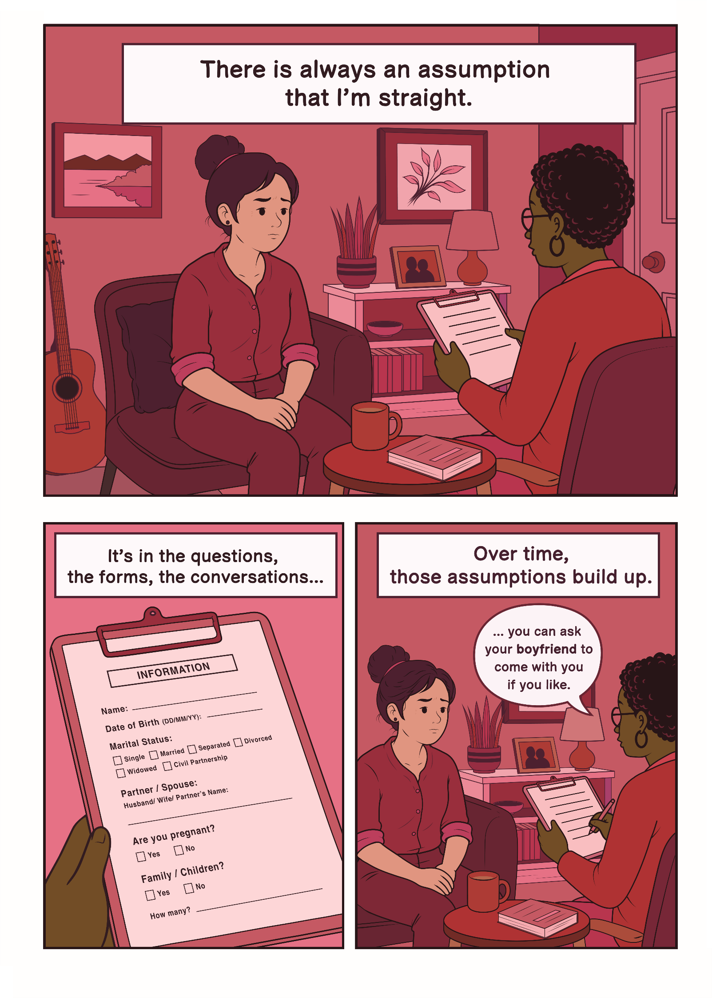

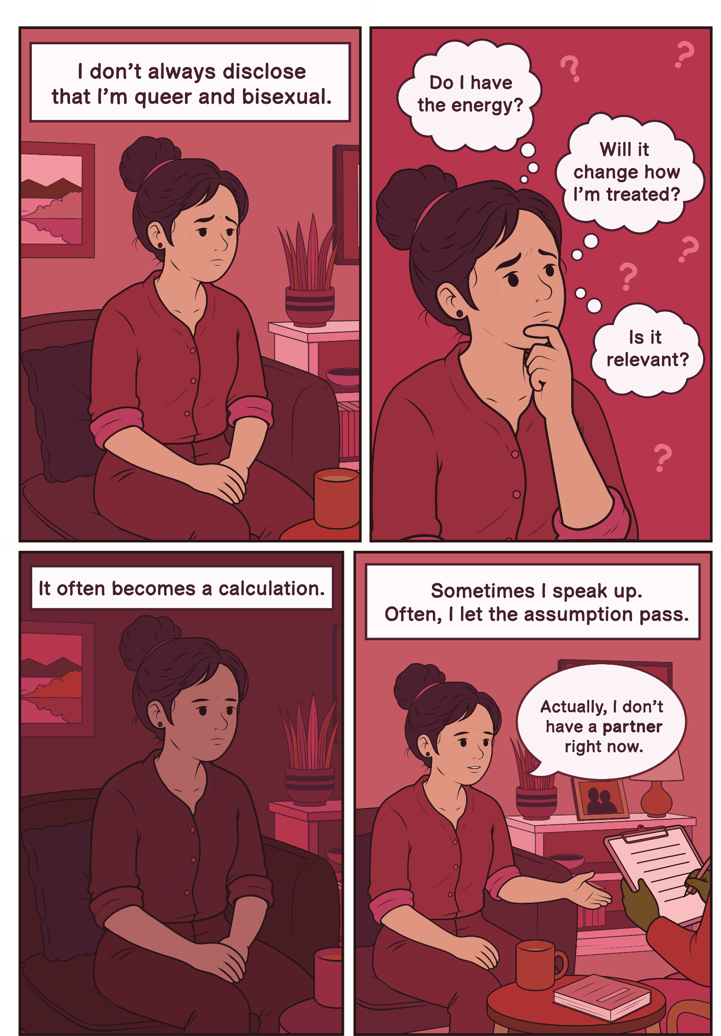

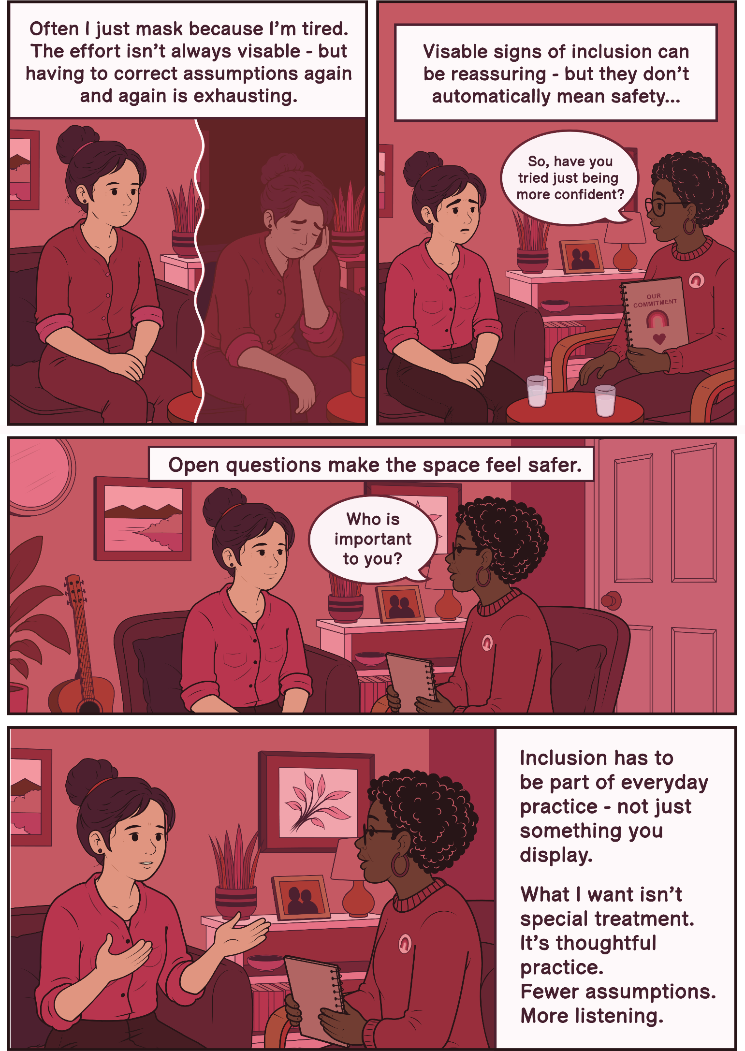

Jay’s Story
“In one report, I was referred to throughout as ‘Name/them’, as if ‘them’ were part of my surname.”
I am autistic and I have multiple sclerosis. I am also non-binary and use they/them pronouns. In my experience with adult social care, these parts of my identity have often been dismissed or misunderstood.
When we first moved, I was refused an assessment even though I was entitled to one. During a phone assessment, my wife - who is also my carer - was speaking alongside me, as they often do to support me. The social worker accused us of lying because she didn’t believe we were two different people. It's as if she couldn’t accept that two people she 'perceived' as female could be in a relationship. The consequences of that interaction were monumental. I could no longer safely engage with that worker. Support stalled. I remained without help. For me, this isn’t just about awkward conversations or microaggressions, it has been life-altering. The lack of support has left me feeling stuck, hopeless and at times intensely suicidal. When professionals misuse their power, the consequences can be life-threatening.
My non-binary identity is rarely respected. In one report, I was referred to throughout as ‘Name/them’, as if ‘them’ were part of my surname. Another staff member thought my first name was ‘Other’ because of how gender options were recorded. The system doesn’t even allow ‘Mx’ as a title. These errors might sound small, but it feels aggressive when no one even tries. I don’t expect perfection; I understand that people make mistakes with pronouns. I don’t mind mistakes, but I need to see that people are trying. Effort matters. Respect matters.
Being disabled adds another layer; disabled people are often treated like children, or as if we shouldn’t have relationships or that our relationships are just pretend. Housing options have assumed I am single. This has put real strain on my relationship. According to the Care Act, relationships are important - yet support systems often fail to recognise us as a couple. A senior professional once asked me in relation to housing, ‘How bothered are you about your marriage?’ That question cut deeply. My marriage is the most important part of my life. To hear it reduced like that made me feel invisible.
What I need is simple; respect my pronouns and recognise that queer and gender-diverse disabled people exist. Understand that your behaviour has monumental consequences because when you dismiss my identity or my marriage, it harms my mental health.

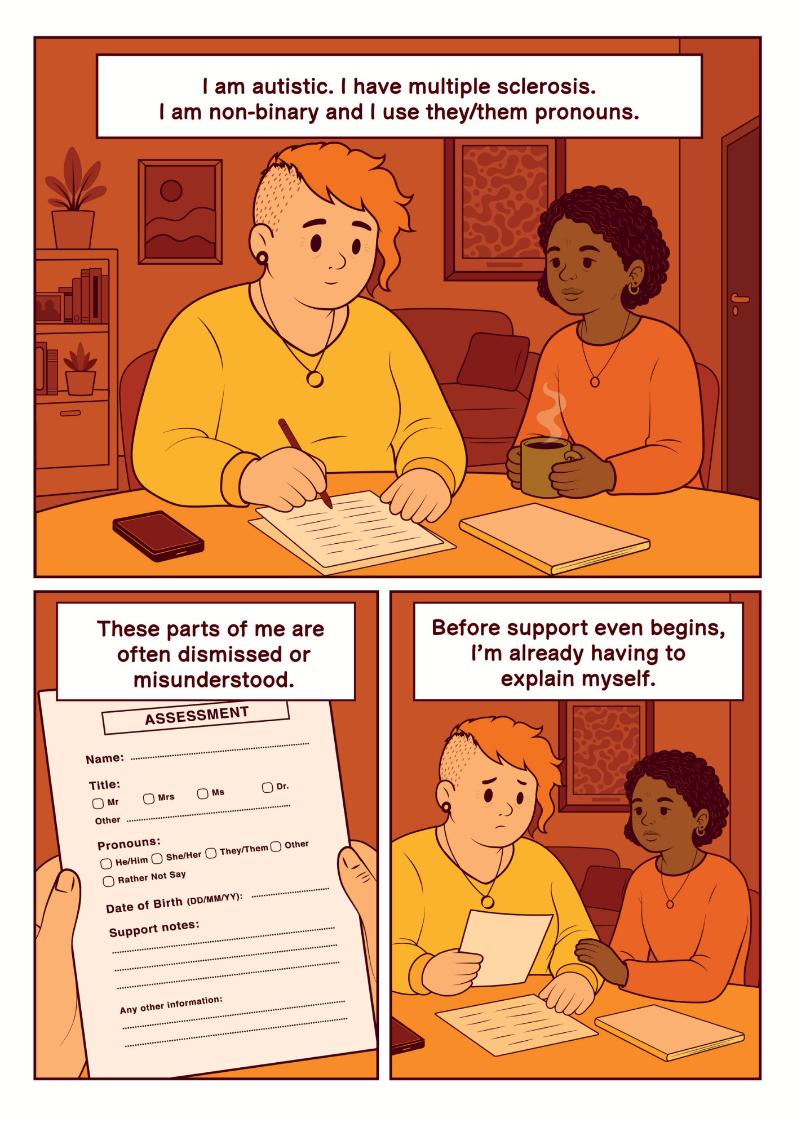

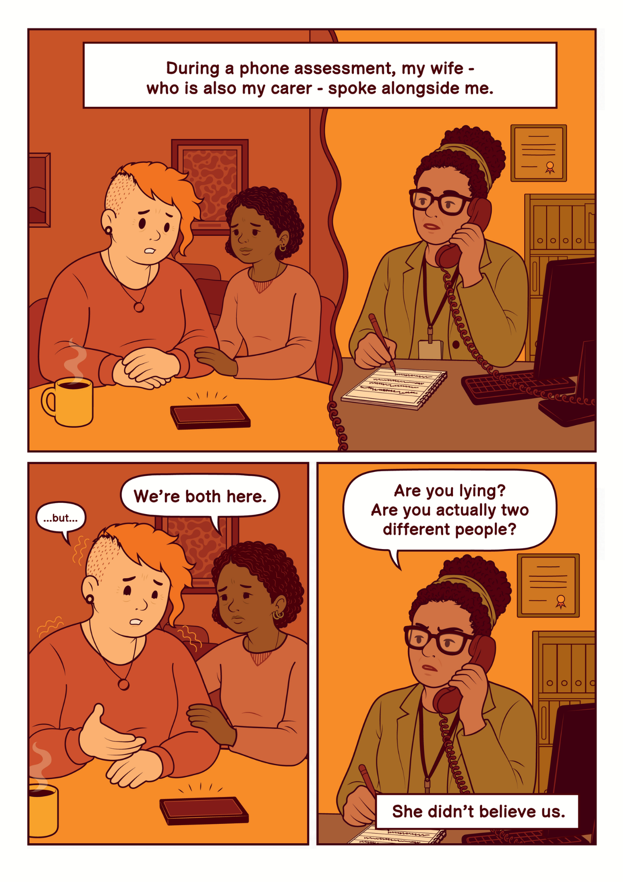

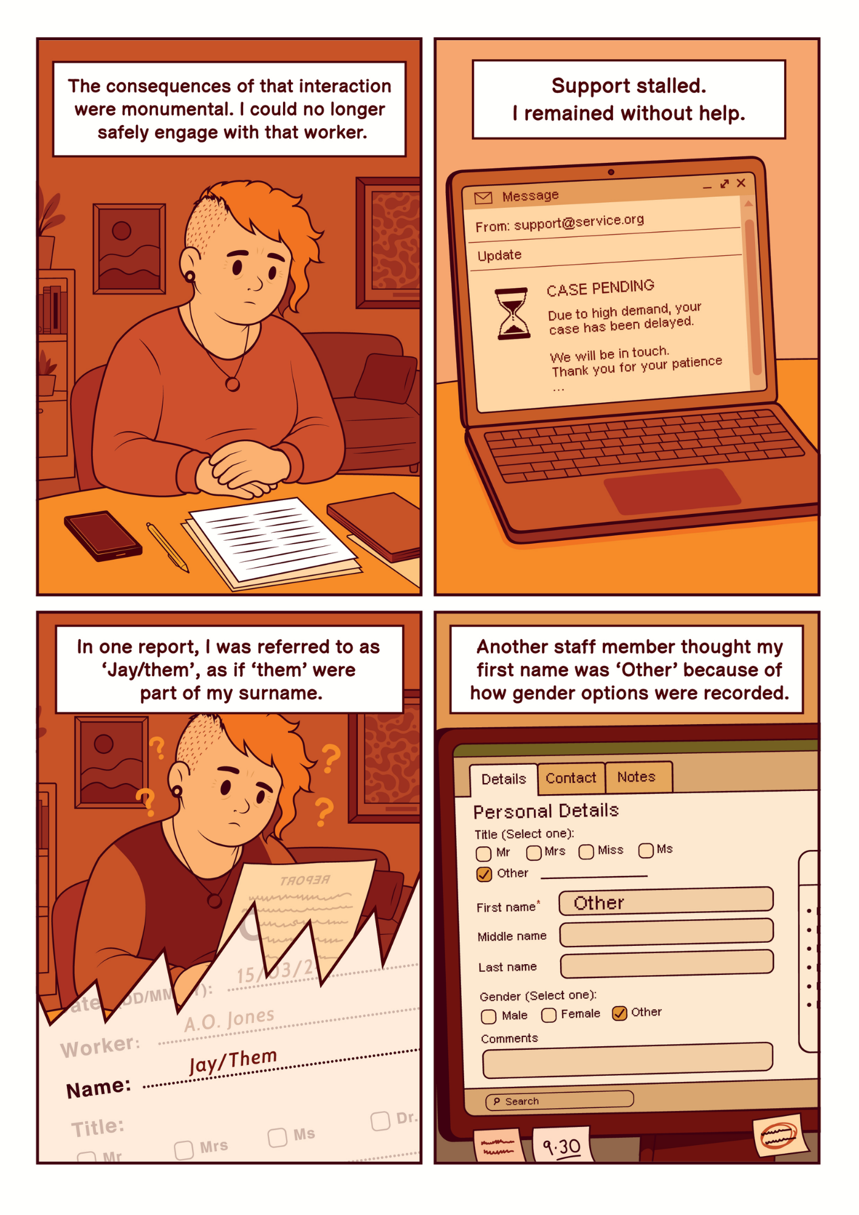

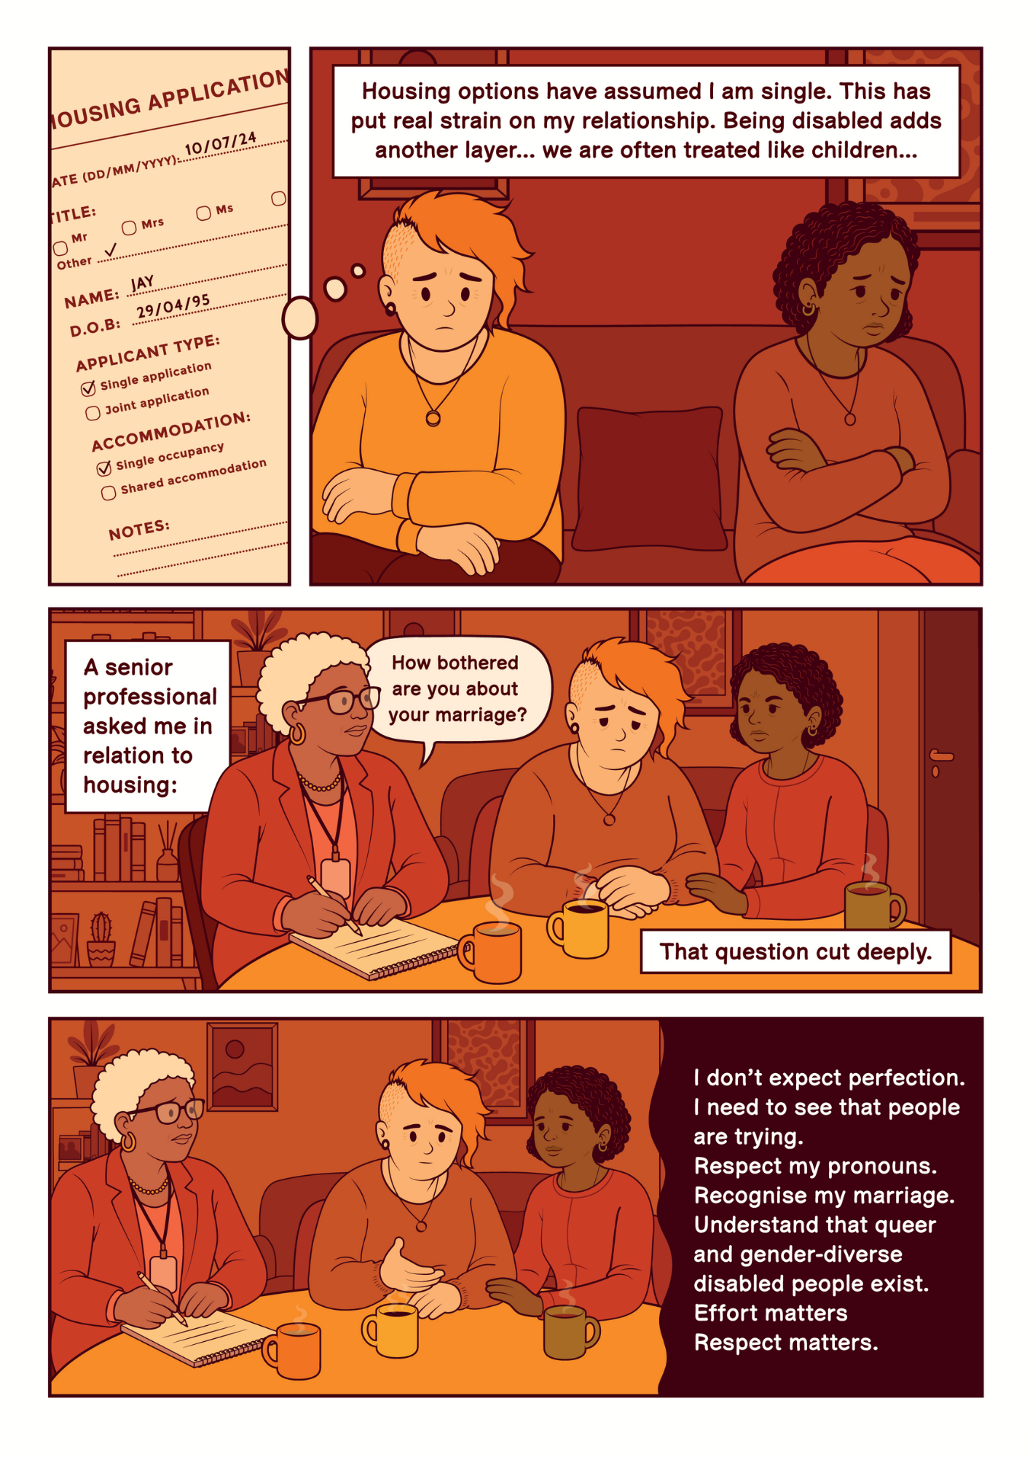

Amina’s Story
“I need support from this person, but now I’m managing their discomfort as well as my own.”
I am my partner’s carer. What I need professionals to understand is simple, please don’t assume who I am before you’ve even asked. I’m a Black woman and people often assume they already know things about me. They assume I’m Christian. They assume I’m in a heterosexual relationship. They assume the person I care for is my husband and that they must also be Black because I am. None of that is true. I’m not Christian. I’m not in a straight relationship. My partner isn’t Black. I’m also older than people tend to think. These assumptions create a barrier before we’ve even started talking about care.
Sometimes it’s subtle, religious comments in professional settings, or immediately referring to my partner as ‘your husband’. This moment shows how little understanding some staff have about gender diversity. Every time someone assumes my partner is my husband, or misunderstands who we are, I have to correct them. That moment is always awkward. I can feel the shift. I need support from this person, but now I’m managing their discomfort as well as my own. It’s extra emotional labour on top of caring responsibilities.
Over time, that emotional labour adds up. I’ve told social services I’m at breaking point. The strain has affected my mental health to the point that I’ve needed medication. Instead of practical help that addressed the barriers we were facing, I was told to seek therapy. That felt dismissive. I wasn’t asking for coping strategies. I was asking for support that would make the situation better.
When professionals make assumptions about my race or relationship, I feel othered. When they ask open questions - What is your relationship? What pronouns do you use? - and listen without judgement, I feel seen. That difference shapes whether I trust the social care staff. What I need is for staff to ask, listen and not make assumptions, but inclusion alone is not enough; it has to be backed by real support.

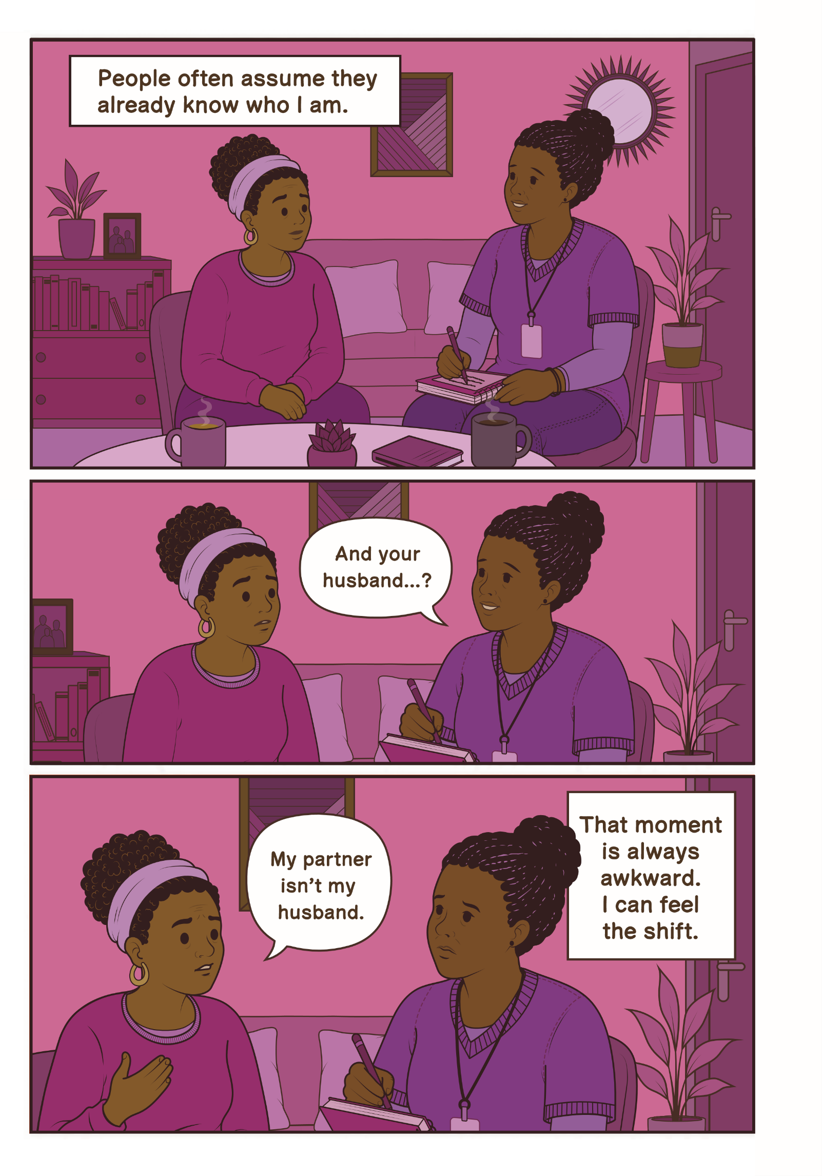

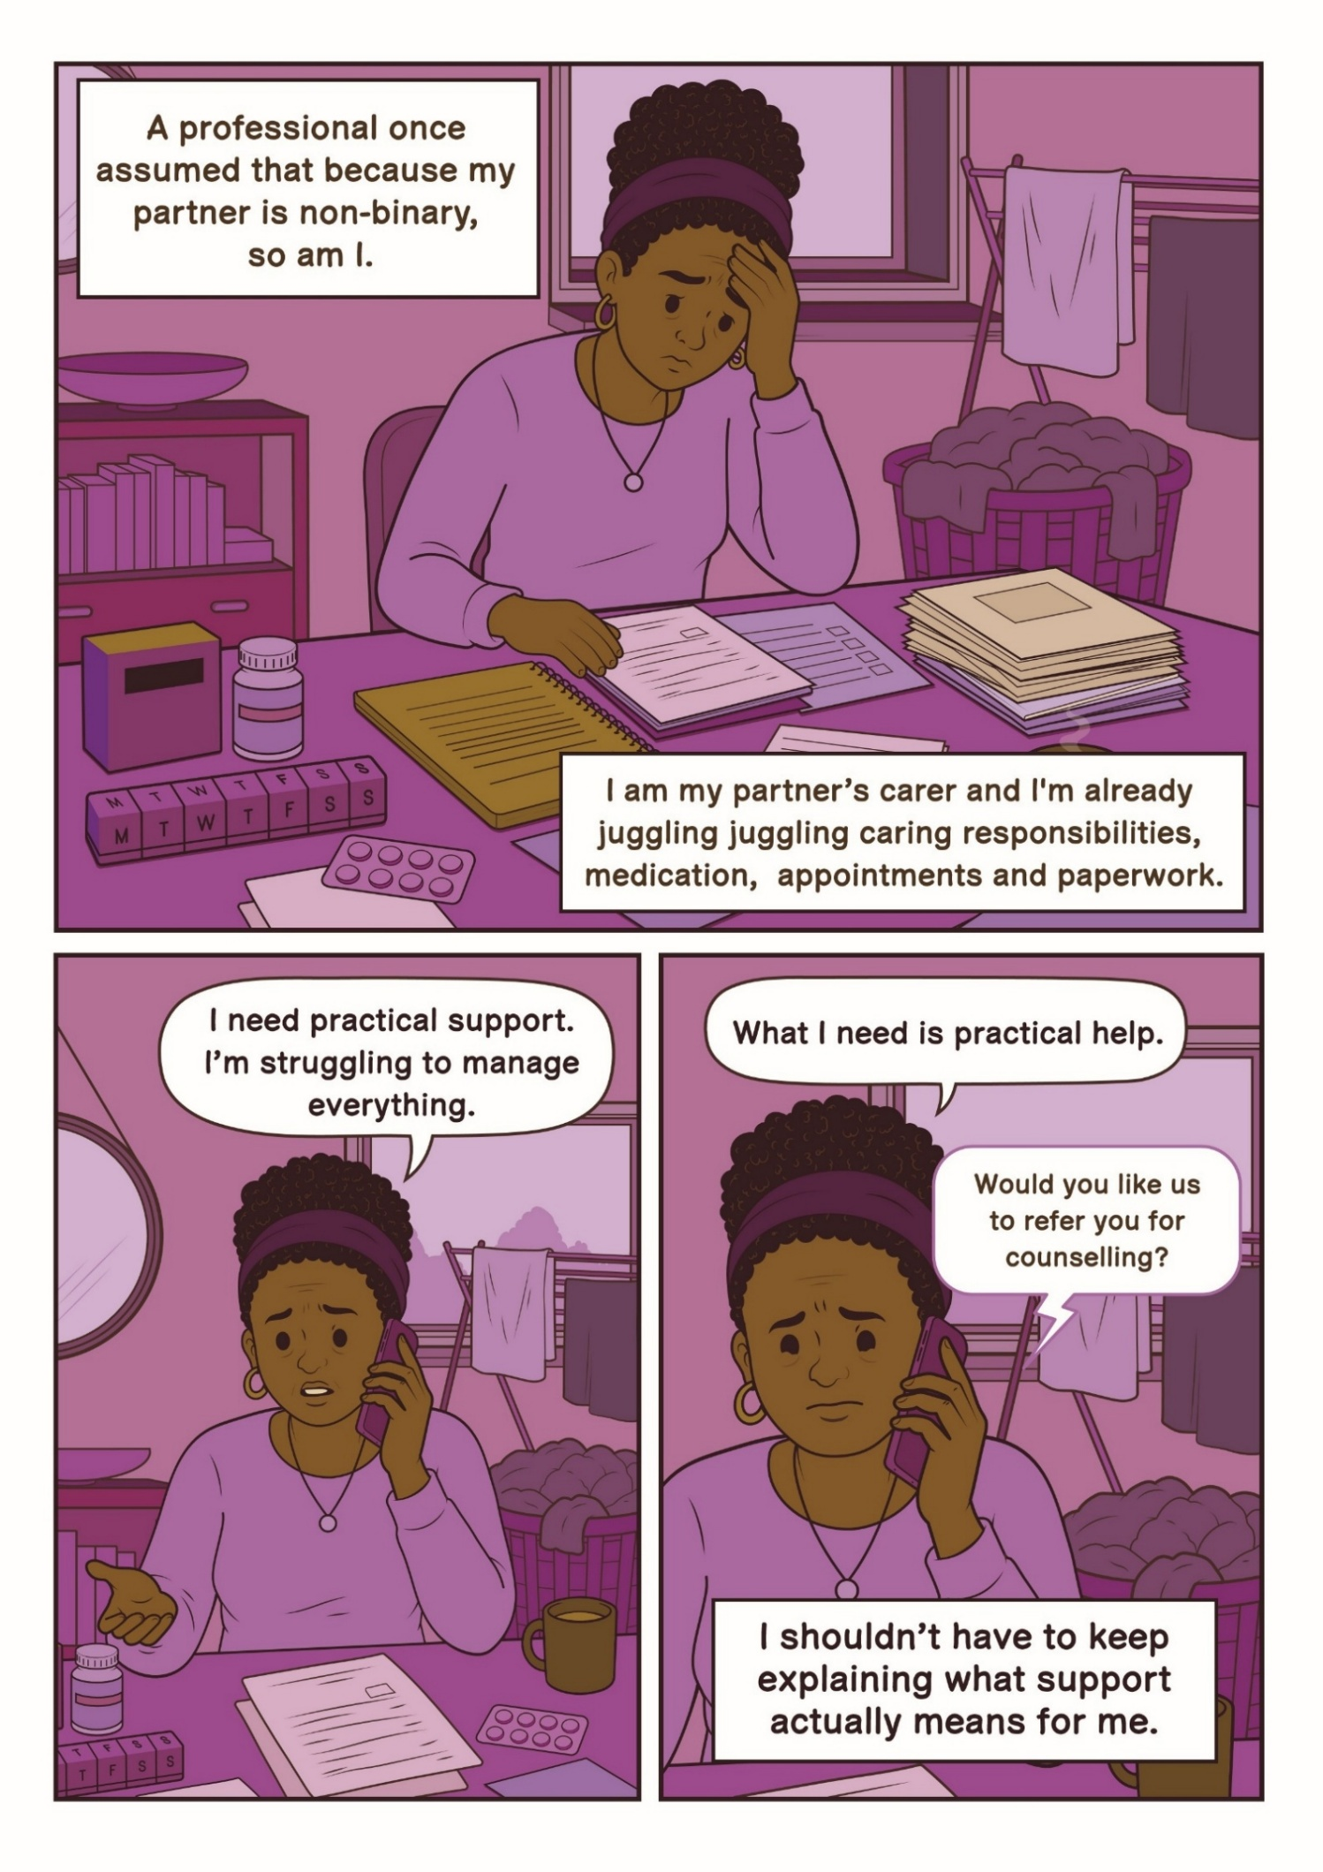

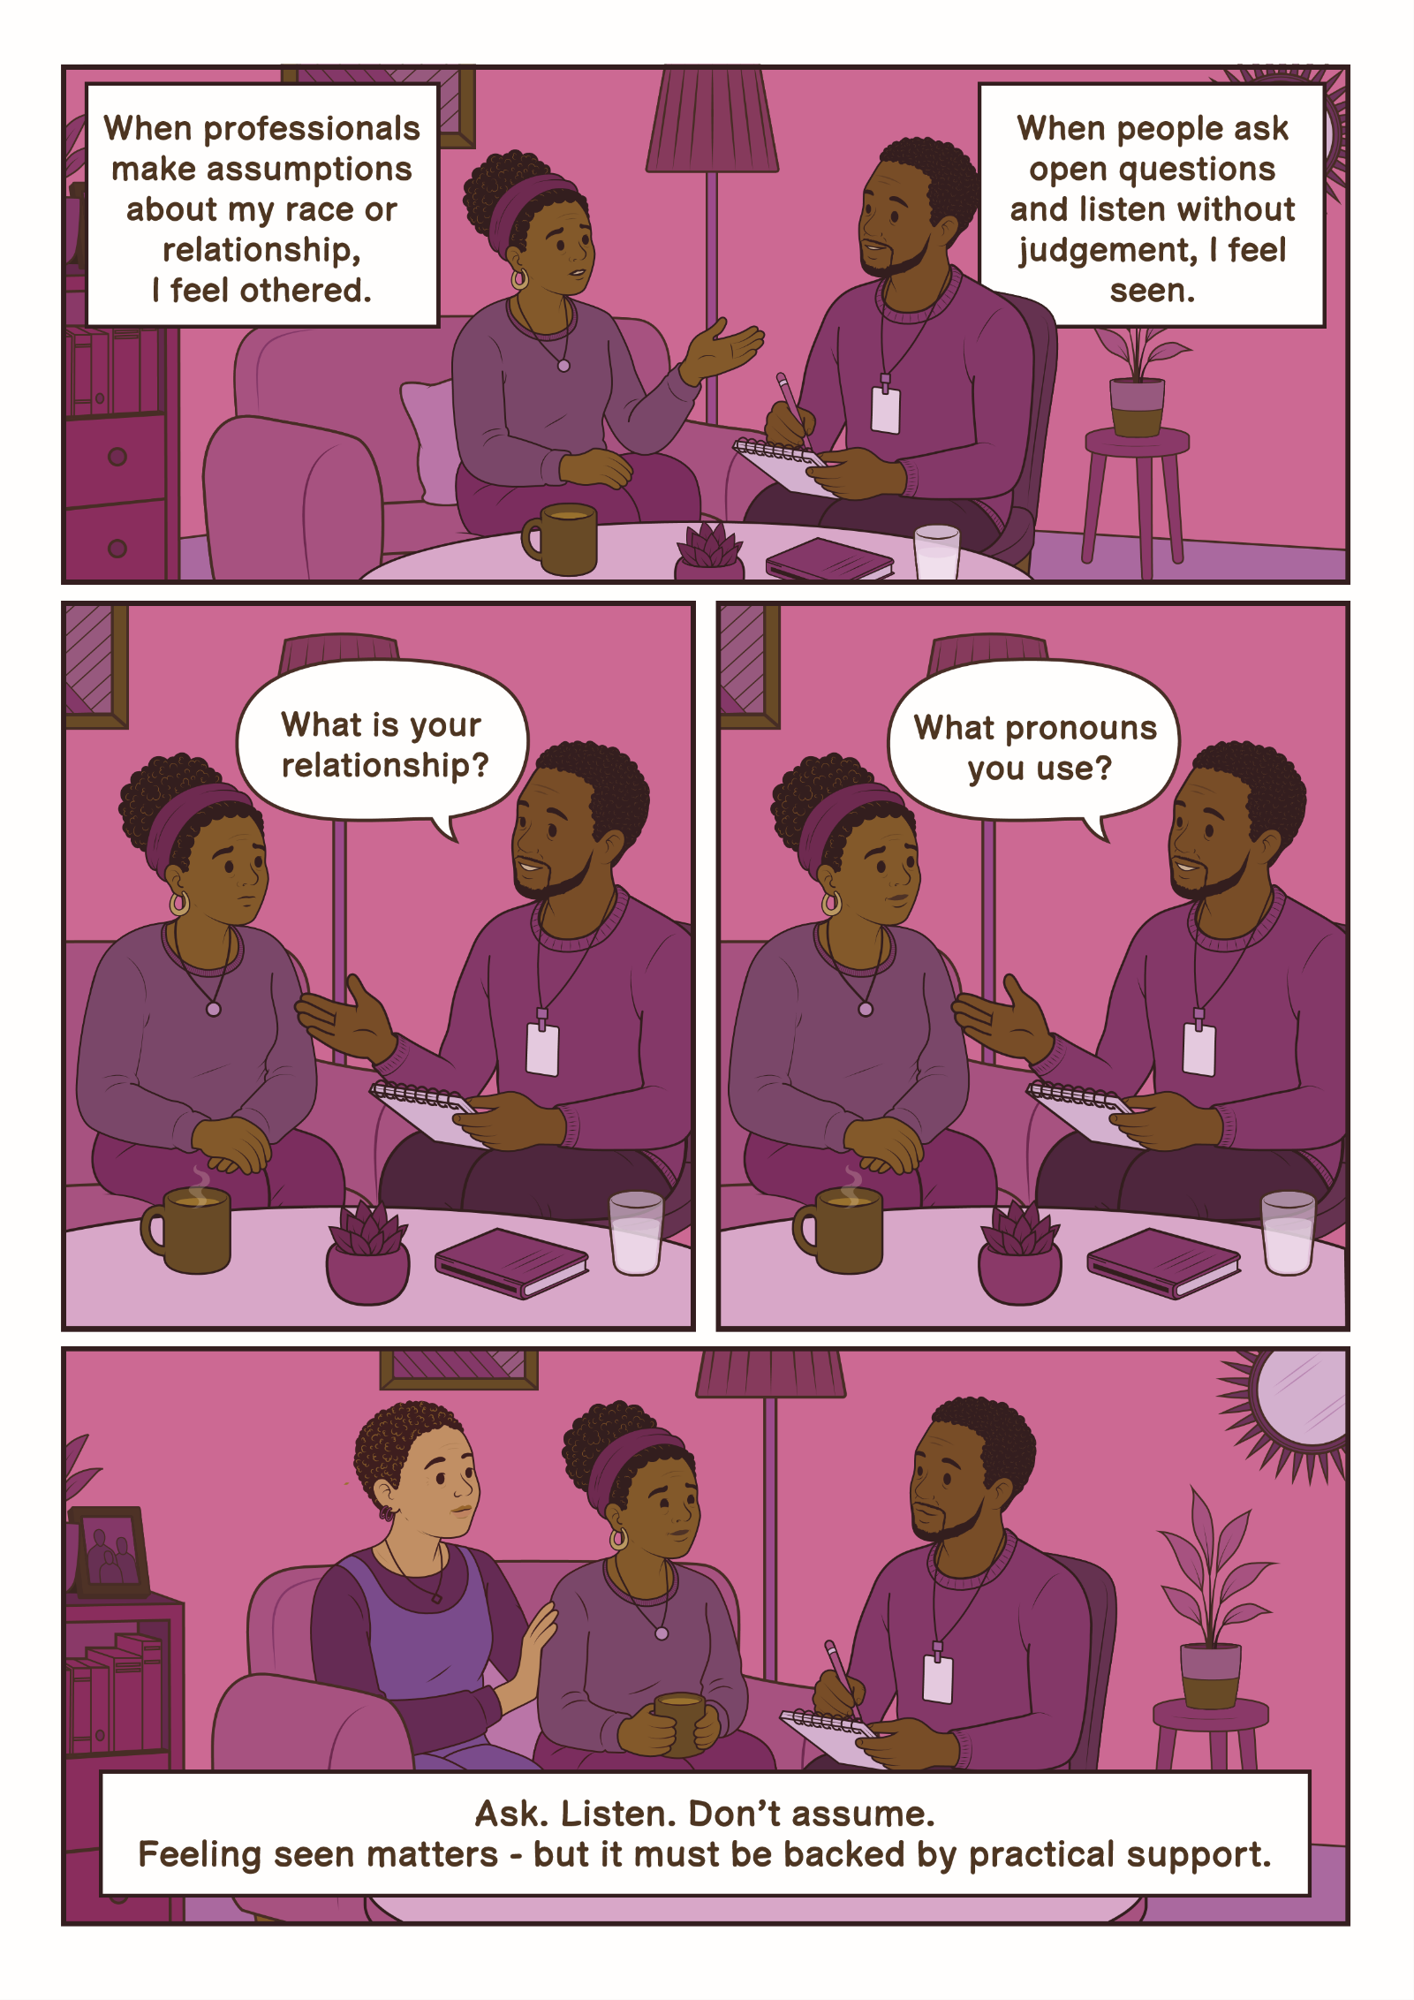

Ria’s Story
“Representation isn’t about special treatment; it’s about spaces where I don’t have to constantly explain who I am just to be heard.”
I’m Ria. Navigating health and care systems as a Black queer non-binary woman often feels like a balancing act. I constantly adjust how I speak, how I sit, even how I dress, just to make sure I’m seen as polite, cooperative or safe. It’s referred to as code-switching, but really, it’s survival. I present in a way some people read as quite masculine. I keep my hair shaved and usually wear comfortable clothes like jeans and T-shirts. Often, I can feel the atmosphere shift when I walk into a room. Every appointment, every interaction, is a calculation; will I be judged? Will my identity make this harder? Do I have the energy to explain who I am, or is it safer to stay quiet?
Masking like this is exhausting. I’ve walked into hospitals and care settings already feeling anxious, and the effort of softening who I am adds another layer of strain. Once, a nurse’s attitude toward me shifted after overhearing me speak Nigerian Pidgin English with my sister. Suddenly I wasn’t treated as ‘other’ anymore; I felt recognised. Moments like that remind me how often people make assumptions about who I am.
Representation matters. Receiving counselling from Black women who understood parts of my cultural background has been deeply healing. Their understanding isn’t just professional, it’s lived. Seeing staff who understand aspects of my identity - my race, culture or queerness - signals that I can trust them before I’ve even spoken. Representation isn’t about special treatment; it’s about spaces where I don’t have to constantly explain who I am just to be heard.
For adult social care staff, the most important thing is noticing what residents may be communicating through their behaviour. I might be quiet, polite or overly accommodating - not because everything is fine, but because I’m managing my identity in real time to feel safe. When staff pause, listen and reflect, it makes a huge difference. That’s what turns care from something I have to endure into something I can trust. I want staff to understand that my identity is not a complication. The effort of managing perceptions, masking and constantly code-switching is exhausting. When professionals respond with curiosity rather than judgement, it transforms the interaction. Understanding behaviour as a survival strategy, and reflecting on unconscious bias, helps create real safety for people like me.

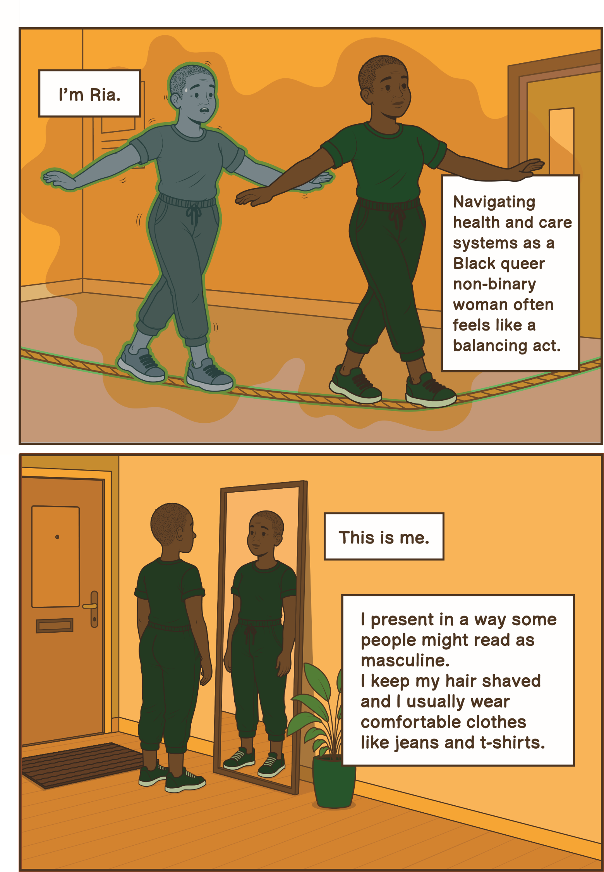

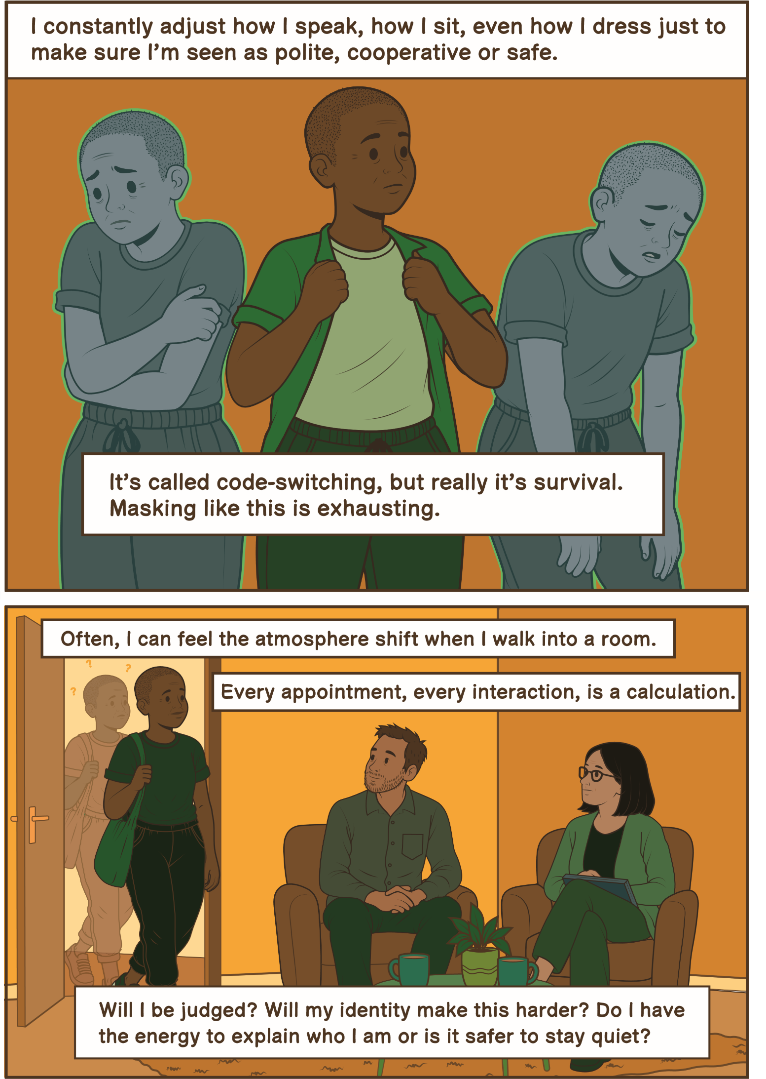

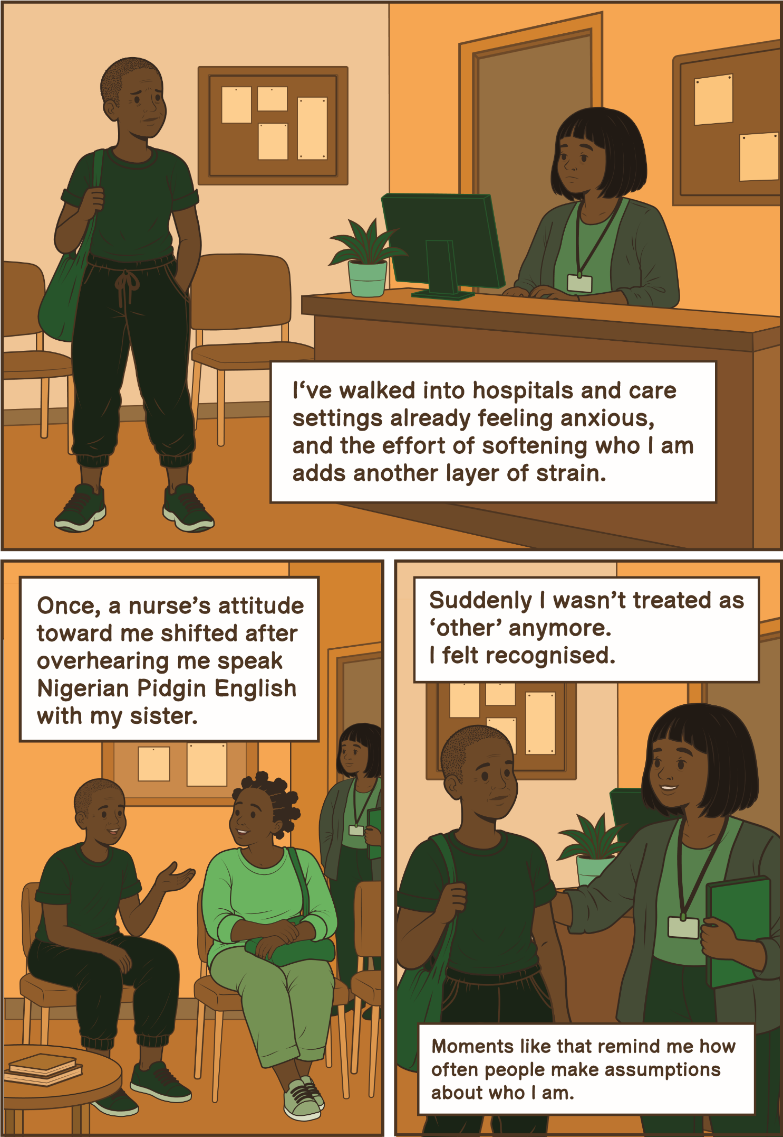

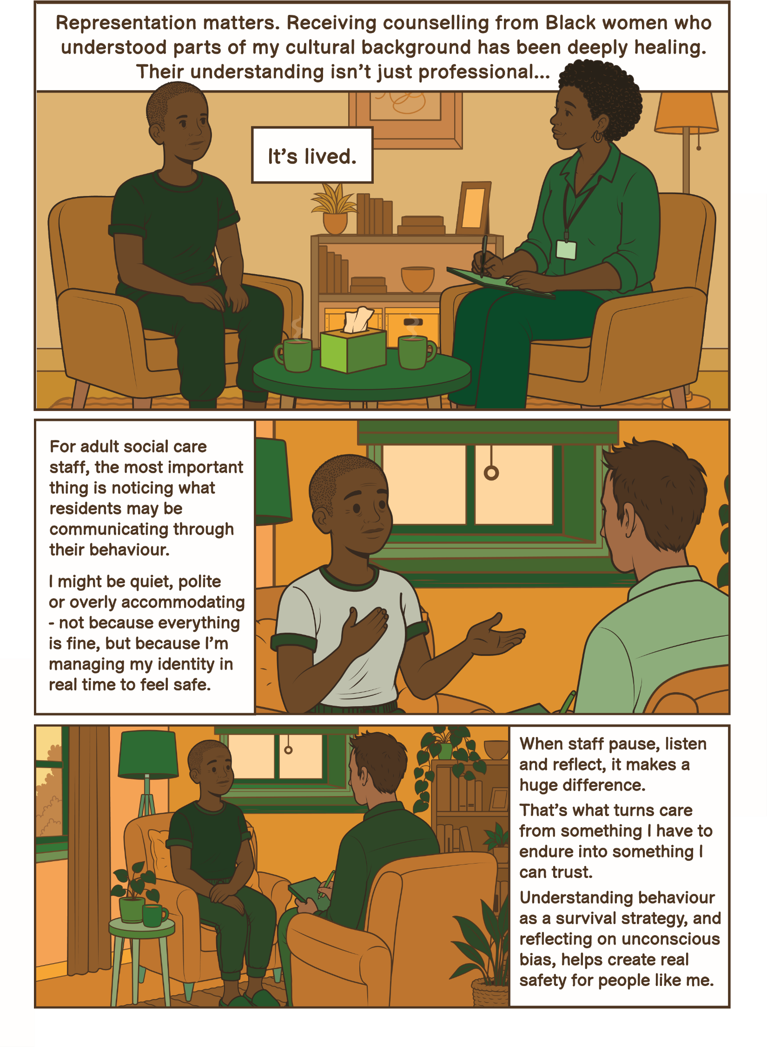

Richard
“I don’t need to be celebrated for being gay. I just need to know that if I’m vulnerable, the people supporting me will treat me with dignity and won’t let their personal beliefs affect the care I receive.”
I’m 58 and I’m gay. I’ve worked in and around social care for over twenty years, so I’ve seen both good and bad practice up close. Because of that, I think a lot about what would happen if I needed care myself one day. My biggest concern is safety. In social care, your experience often depends on the individual staff supporting you and staff change frequently. You might have a team who are kind, respectful and completely accepting, and then a few months later they’ve left and you’re left with people whose views are very different. That inconsistency makes me feel very vulnerable. I’ve seen situations where residents were told that being attracted to the same sex was dirty or immoral. I’ve seen how quickly cultures in services can change when managers or staff move on. So, if I were in a care home, I honestly don’t think I would tell people that I’m gay. I’d want that information kept off my records because it just doesn’t feel safe for it to be there.
That creates its own problems. If I had a partner, I might introduce them as a friend or relative just to avoid potential judgement or gossip. Hiding such a big part of your life is stressful but sometimes feels like the safer option. Part of this fear comes from my past. When I was younger, there was open violence against gay people where I lived. People were attacked simply for being in places known to be used by gay men. Those experiences stay with you; even decades later they continue to shape how safe you feel being open about who you are.
What would make a difference is not just policies or rainbow posters, but consistency and accountability. Training needs to be meaningful and repeated, not a one-off tick-box exercise. All staff need to understand that discriminatory attitudes are not acceptable, and organisations need to act when those attitudes show up in practice. I don’t need to be celebrated for being gay. I just need to know that if I’m vulnerable, the people supporting me will treat me with dignity and won’t let their personal beliefs affect the care I receive. Until that feels guaranteed, it’s hard not to feel that being open about my sexuality in care settings could put me at risk.

