Self-Directed Support in Northern Ireland and person-centred support planning
Summary of learning

IMPACT Demonstrator Project, 2025 to 2026

Dr Helga Sneddon and Dr Laura Doyle
August 2026

Contents
Executive summary 3
Self-Directed Support 3
About the project 3
What we did 3
Main findings 4
How the work was used 4
Priorities for the next stage 5
Full report 6
Introduction 6
What is Self-Directed Support? 6
About IMPACT and the Demonstrator project 6
How the focus for the project was agreed 7
The four questions addressed by the project 7
How we worked 8
What did we learn? 10
Question 1: What does the evidence tell us about what helps, and what gets in the way of, meaningful and outcomes-focused support planning? 10
Question 2: What does person-centred support planning currently look like across programmes of care and Trusts in Northern Ireland? 13
Question 3: What knowledge, skills, guidance and resources do practitioners need to deliver good person-centred support planning? 16
Question 4: What information do people using SDS and family carers need to take part confidently in planning and decision-making? 22
What did we learn about using evidence in adult social care? 27
What did we learn about co-production? 27
Learning for other adult social care projects 28
Summary and recommendations 29
Priorities for the next stage 30
Appendices 36
Appendix 1. How the project was carried out 36
Appendix 2: Project reports and selected sources 38

Executive summary

Self-Directed Support
Self-Directed Support, usually shortened to SDS, is the approach used in Northern Ireland to give people who are eligible for support more say over their social care. It starts with the person’s own life: what matters to them, what they want to achieve or maintain, the support already available through family and community, and where paid support could help.
There are four ways of arranging support in Northern Ireland. The Trust can arrange it, the person can receive a Direct Payment, a provider can manage an agreed budget, or these options can be combined. Each offers a different balance of choice, flexibility and responsibility. People need clear information about all four before deciding what will work for them.
Person-centred support planning connects these decisions. The person and practitioner agree the outcomes to work towards, consider the support that could help and set out how it will be arranged. The plan should be used and reviewed as the person’s circumstances change.

About the project
IMPACT is a £15 million UK centre funded by the Economic and Social Research Council and the Health Foundation. Its starting point is that “good support isn’t just about services, it’s about having a life”. IMPACT helps adult social care organisations use evidence, build skills and relationships, and understand what helps or hinders change in practice.
Demonstrator projects use research, practice knowledge and lived experience to work on an important issue in a local or regional system. This Demonstrator ran from September 2025 to August 2026. It was hosted by the Southern Health and Social Care Trust and supported by two part-time IMPACT Senior Strategic Improvement Coaches, Dr Helga Sneddon and Dr Laura Doyle.
The project worked with SDS Leads from all five Health and Social Care Trusts, the Department of Health, the Strategic Planning and Performance Group, Vela Microboards Northern Ireland, community and voluntary organisations, practitioners, people using SDS and family carers. Vela Microboards was a project partner with experience of personalised support. Although SDS also applies in children’s services, this Demonstrator focused on adult social care.

What we did
The project was organised around four questions:
- What does the evidence tell us about what helps, and what gets in the way of, meaningful and outcomes-focused support planning?
- What does person-centred support planning currently look like across programmes of care and Trusts in Northern Ireland?
- What knowledge, skills, guidance and resources do practitioners need to deliver good person-centred support planning?
- What information do people using SDS and family carers need to take part confidently in planning and decision-making?

We reviewed published evidence, surveyed practitioners across all five Trusts, examined current training, held regional workshops with SDS Leads, worked with the Voices and Choices groups and completed one-to-one interviews. We also worked with the British Deaf Association on accessibility and communication. The detailed methods are set out in Appendix 1.

Main findings
- Good support planning starts with what matters to the person. It should draw on the person’s priorities, strengths, relationships and preferred way of communicating. It should help them agree outcomes, consider different ways of achieving them and review whether the support continues to work.
- Practitioners wanted to work in person-centred ways. Ninety-four per cent said the time available for support planning needed to improve, and 97% identified workload or caseload pressure as an area requiring improvement. Recording, approvals, provider shortages and limited access to Managed Budgets restricted what they could put in place.
- People valued the independence and continuity that SDS could provide. Getting the arrangement in place could take a long time and was often exhausting. People described uneven information, repeated assessments, delays, form-led planning, recruitment problems and reviews that sometimes focused more on spending than outcomes.
- Information needed to begin earlier and follow the person’s SDS journey. Much of the existing information explained Direct Payment administration after a decision had been made. People first needed to understand what SDS was, what it might make possible, the choices and responsibilities involved and where to get help.
- Workforce development covered the whole system. The published workforce review considered practice, supervision, leadership and organisational systems. We used it to develop competencies, two training audit tools and a proposed five-tier workforce approach. The direction was supported at the SDS Roundtable and is informing continuing work across Trusts.

How the work was used
In this project we developed different layers of evidence and worked with various stakeholders to interpret and use these. The workforce review provided the basis for the training audits and regional workshop. The practitioner survey identified the pressure created by workload, systems and limited support options. Voices and Choices participants worked on the User Guide while it was being developed and changed its purpose, starting point, order, content and tone. The work with the BDA set out what would be needed for BSL and ISL information and for Deaf people to use SDS services more easily.

Priorities for the next stage
The findings suggest that regional partners should:
- agree ownership, timescales and resources for taking the unfinished work forward;
- agree shared expectations for good support planning and improve the clarity and consistency of information about the SDS options, particularly Managed Budgets;
- continue developing and testing the proposed five-tier workforce approach, including supervision, coaching and leadership support;
- review the organisational barriers identified by practitioners, including workload, recording, approval processes and limited support options;
- complete and test the regional User Guide and develop shorter, accessible information for different stages of the SDS journey;
- continue the accessibility work with the BDA and consider how independent advice, advocacy and practical support can be strengthened; and
- keep people using SDS and family carers involved and evaluate whether the next stage improves practice and people’s experience.

Full report

Introduction

What is Self-Directed Support?
Self-Directed Support is based on the principle that people should have choice and control over decisions that affect their lives. In social care, the starting point is the person and the life they want to lead. Practitioners work with them and, where appropriate, their family or other supporters to understand what matters and decide how support can fit around their life.
SDS affects both the support arranged and the way decisions are made. The person should be actively involved, receive information in a form they can use and understand the choices available. Planning should take account of strengths, relationships and community resources as well as paid services. It should also explain the responsibilities attached to different ways of managing support.
In Northern Ireland, support may be arranged by the Trust, paid through a Direct Payment, managed by a provider through a Managed Budget, or combined in a blended arrangement. Direct Payments are one part of SDS. People should hear about the full range of options and have enough help to decide which balance of choice, flexibility and responsibility suits them.
Person-centred support planning is a key element within SDS and where the ethos of choice and control becomes most tangible and practical. It is the process of agreeing what matters to the person, what they want to achieve or maintain, what support and resources could help, how that support will be arranged, and how everyone will know whether it is working. Done well, it is an ongoing conversation that keeps the person at the centre as their circumstances and priorities change.

About IMPACT and the Demonstrator project
IMPACT is a £15 million UK centre funded by the Economic and Social Research Council and the Health Foundation. Its starting point is that “good support isn’t just about services, it’s about having a life”. IMPACT helps adult social care organisations use evidence, build skills and relationships, and understand what helps or hinders change in practice.
Demonstrator projects use research, practice knowledge and lived experience to work on an important issue in a local or regional system. This Demonstrator ran from September 2025 to August 2026. It was hosted by the Southern Health and Social Care Trust and supported by two part-time IMPACT Senior Strategic Improvement Coaches, Dr Helga Sneddon and Dr Laura Doyle.
The project worked with SDS Leads from all five Health and Social Care Trusts, the Department of Health, the Strategic Planning and Performance Group, Vela Microboards Northern Ireland, community and voluntary organisations, practitioners, people using SDS and family carers. Vela Microboards was a project partner with experience of personalised support. Although SDS also applies in children’s services, this Demonstrator focused on adult social care.

How the focus for the project was agreed
The proposal submitted to IMPACT was to examine outcomes measurement in SDS. Before the main project work began, Obert Tawodzera reviewed academic research, policy and practice evidence on autonomy, outcomes, outcome measures and SDS implementation (2025).
The review showed that people value choice and control, independence, dignity, safety, relationships, community participation and support that allows them to live an ordinary life. Measuring these outcomes is difficult because they are personal, circumstances change and many factors outside social care can influence what happens.
The review considered the Northern Ireland Single Assessment Tool (NISAT), Scotland’s Personal Outcomes Evaluation Tool and the Adult Social Care Outcomes Toolkit. All offered useful learning. Northern Ireland would still need to be clear about the purpose of measurement, adapt any approach to the local system and develop it with the people who would use it.
In the early stages of the project, we presented the review findings to SDS Leads and Vela Microboards. The discussion showed that their main interest was in strengthening outcomes-focused and person-centred practice, rather than outcomes measurement alone.
SDS is based on people having choice and control over decisions that affect their lives. Their own outcomes first need to be identified through good support planning and then used to shape the support arranged. A more robust measurement tool cannot compensate for a plan that was not developed properly in the first place.
These discussions shifted the focus of the project from measuring outcomes to understanding how support planning could be strengthened as a way of supporting choice and control.
What we learnt
The early evidence review helped focus stakeholders on what was really important for us to understand. Outcomes focused practice is more than a just measurement issue: it requires a shift in practice to ensure person’s own outcomes to be identified and used to shape their support.

The four questions addressed by the project
We used four questions to organise the work:
- What does the evidence tell us about what helps, and what gets in the way of, meaningful and outcomes-focused support planning?
- What does person-centred support planning currently look like across programmes of care and Trusts in Northern Ireland?
- What knowledge, skills, guidance and resources do practitioners need to deliver good person-centred support planning?
- What information do people using SDS and family carers need to take part confidently in planning and decision-making?

How we worked
This was an evidence-informed change project. We used different activities to answer different parts of the four questions and compared the findings as the work developed.
The main activities included two evidence reviews, a regional practitioner survey, a review of Trust training, two half-day workshops with SDS Leads, the SDS Voices and Choices lived experience co-production groups, one-to-one interviews, accessibility work with the British Deaf Association, four Steering Group meetings and regular discussion through the Social Care Collaborative Board SDS Roundtable. The Roundtable brings together stakeholders involved in developing and using SDS.
Each activity was linked to a piece of work. The outcomes review helped us agree the focus for the project. The workforce review supplied the competencies and questions used in the training audits. SDS Leads used the audit results to compare current training and agree priorities. The practitioner survey provided a regional picture of day-to-day practice. Voices and Choices participants and the BDA provided insights into how people experience the current system and worked directly on developing the public information.
We discussed findings throughout the project with stakeholders and used the learning to plan the next activity. Comparing published research, practice knowledge and lived experience helped us see where the three sources agreed and where experiences were different.
The IMPACT Change Model was published near the end of the Demonstrator and was not part of the original design. Figure 1 uses the model to show how the project moved from agreeing the issue, through evidence and engagement, to practical action and regional ownership.

Figure 1. How the strands of work connect through the IMPACT Change Model.

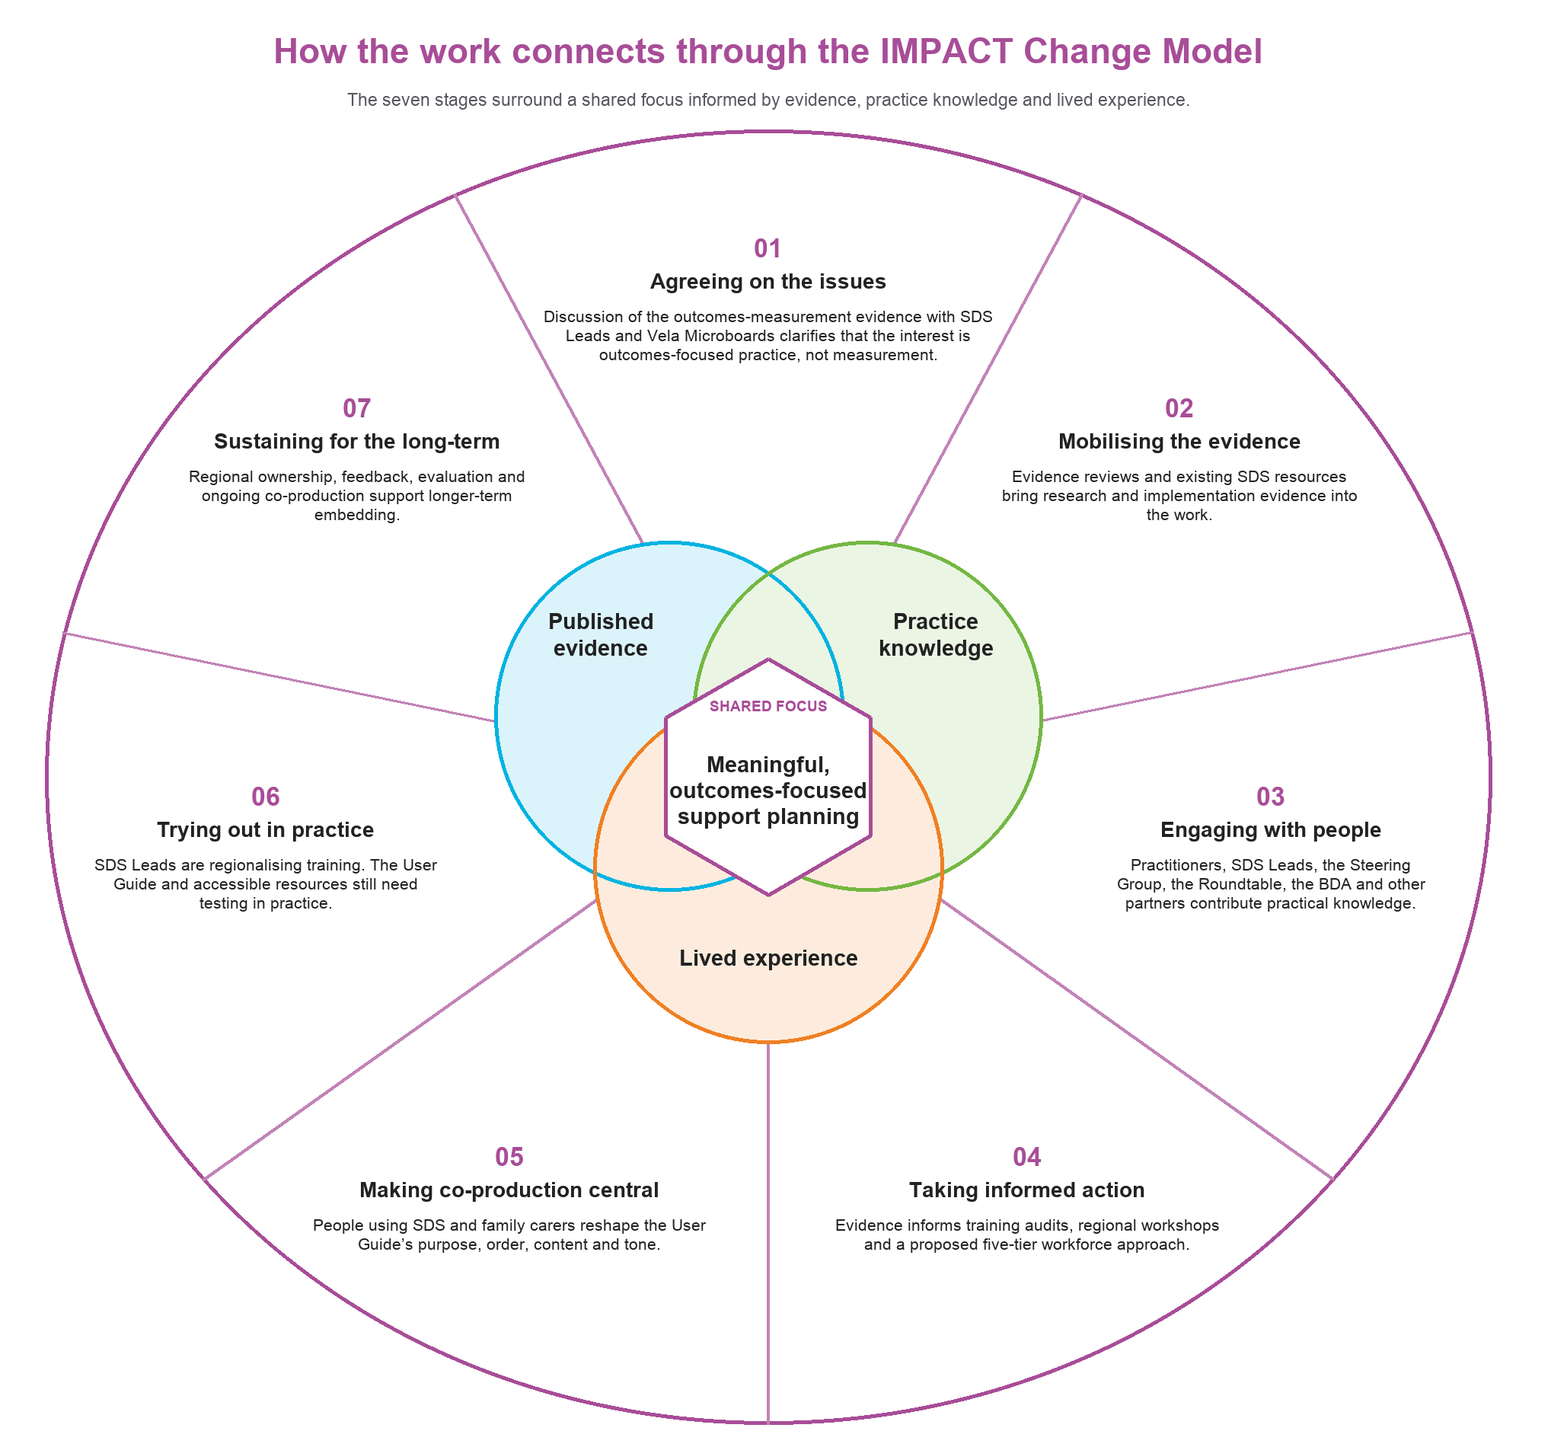

Appendix 1 provides further detail on the evidence reviews, survey, co-production groups, interviews, training audits, accessibility work, analysis and limitations.

What did we learn?
The next four sections follow the project questions. We begin with the published evidence, then compare it with current practice in Northern Ireland. Questions 3 and 4 describe the workforce and public information work that followed.

Question 1: What does the evidence tell us about what helps, and what gets in the way of, meaningful and outcomes-focused support planning?
Evidence used: Outcomes and measurement review; workforce-development review and briefing paper

What we reviewed
The outcomes and measurement review looked at the outcomes people value from SDS, how these outcomes are measured, and what helps or gets in the way of achieving them. The workforce review examined the values, knowledge and skills needed for SDS, as well as the supervision, leadership and organisational conditions that help staff put these into practice. We considered the two reviews together to identify the findings most relevant to person-centred support planning.

What helps
The evidence supports planning that starts with the person’s own life. Practitioners need to understand their priorities, strengths, aspirations, relationships and preferred way of communicating. Involving the person in decisions and arranging support around their agreed outcomes can increase choice, control, independence and community participation.
The outcomes review clarified the relationship between support planning and measurement. Meaningful measurement begins with outcomes that have been identified and agreed with the person. Without that groundwork, a robust measure may still miss whether support is making the difference the person wanted.
Trust and continuity also matter. People need enough time to explain what is important to them, and practitioners need time to listen and understand. Families and other supporters may hold valuable knowledge about the person and their circumstances. Their involvement can strengthen planning, but it should not replace the person’s own voice.
Clear information, independent advice, advocacy and practical help with navigating the system can all support people to take part in planning and make informed decisions. This is especially important for people who do not have strong family networks, who have particular communication needs, or who find complex systems difficult to navigate.
Practitioners need a working knowledge of SDS rules and processes, together with skills in person-centred communication, strengths-based assessment and collaborative support planning. They need to understand the different SDS options, risk enablement, safeguarding and partnership working. Advice, useful supervision and leaders who support professional judgement help staff apply this knowledge in practice.
A good plan also depends on what support is available locally. Choice remains limited when suitable providers, Personal Assistants who provide support arranged directly by the person, Managed Budgets or community supports cannot be found. Workforce development needs to be linked to work on the range and availability of support.

What gets in the way
The same barriers appeared across different parts of the evidence. Planning could remain service-led even when person-centred language was being used. Assessment, recording and approval processes could become the main task, leaving less time to understand the person’s life and explore different options. Risk-averse cultures could also make practitioners less confident about supporting positive risk-taking.
Shortages of time, staff and suitable support options narrowed what could be achieved. Practitioners could identify clear outcomes with the person and still end up with a plan shaped by the services already available.
Fragmented systems created further difficulties. Organisations could use different language, processes and expectations. Information might be available in one place but not another. People could be asked to repeat their story as they moved between teams or stages of the process. Practitioners could also become dependent on a small number of SDS specialists when they were unable to find clear or consistent answers elsewhere.
The reviews also raised questions about fairness. Direct Payments and other flexible arrangements may be easier to use for people who have family support, confidence in dealing with professionals, or links with independent organisations. Without accessible information, advocacy, brokerage and practical help, people with fewer informal resources may have less opportunity to exercise real choice and control.

Where the evidence was less clear
The reviews described the broad skills and working conditions needed for SDS in some detail. There was much less evidence comparing individual training courses or support-planning tools. Much of the workforce literature came from policy, inspection reports and implementation guidance, with few formal evaluations of particular learning programmes.
Legislation, funding and service structures varied between countries. We used the reviews to inform discussion in Northern Ireland and considered each approach in relation to the local context.
What we learnt
Meaningful support planning depends on capable staff, enough time, useful supervision, clear and accessible information, practical support options and organisational systems that can put an agreed plan into practice. Outcomes measurement becomes useful once the person’s own outcomes have been identified through good support planning.

The next question was whether these conditions could be seen in current practice across Northern Ireland.

Question 2: What does person-centred support planning currently look like across programmes of care and Trusts in Northern Ireland?
Evidence used: Regional SDS practitioner survey; Voices and Choices discussions; one-to-one interviews; Steering Group and SDS Lead discussions

The practitioner survey ran from February to April 2026. We received 101 responses and included 84 from practitioners currently working with SDS. All five Trusts and a range of adult programmes of care were represented. The full findings are available in the separate practitioner survey report and executive summary.
Practitioners generally supported the principles of SDS and reported confidence in many person-centred skills. Eighty-seven per cent agreed that their conversations focused on what mattered to the person, 76% said individuals were meaningfully involved and 72% said plans reflected people’s strengths and assets.
Confidence was lower when practitioners were asked about the different ways of arranging support. Eighty-seven per cent felt confident explaining Trust-arranged support, compared with 78% for Direct Payments, 62% for blended arrangements and 43% for Managed Budgets. Some practitioners described Managed Budgets as unavailable or unclear in practice.
The main difficulty was maintaining a person-centred approach after the initial conversation. Only 43% agreed that planning was driven more by outcomes than by tasks, time or existing services. More than half felt they had limited authority to work flexibly with people to achieve their outcomes.
Time and workload were the strongest concerns. Ninety-four per cent said the time available for support planning needed to improve, and 97% identified workload or caseload pressures as an area requiring improvement. Respondents also described duplicated recording, difficult electronic systems and approval processes that took time away from working directly with people.
Practitioners said that the support eventually arranged was often shaped by available services, budgets and approval requirements. Shortages of providers and Personal Assistants could restrict choice. Direct Payments could provide flexibility, but they also involved recruitment, employment, payroll, insurance and financial monitoring. These responsibilities could be difficult for individuals and families without practical help.
The survey was not designed to make firm comparisons between every programme of care. The responses suggested that Learning Disability practitioners were generally more familiar with SDS, while staff in Older People services raised particular concerns about the responsibilities placed on family carers. Experiences in Mental Health services were mixed. Workload, administration and limited support options appeared across all programmes of care.

What people using SDS and family carers told us
The separate Voices and Choices report provides the full qualitative analysis, including the methods, themes, case descriptions and quotations. Family carers formed the larger part of the groups, so their experiences are particularly visible in the findings. Individual interviews provided more opportunity for people using SDS directly to describe their experiences. These accounts should not be treated as representative of everyone using SDS in Northern Ireland.
People spoke positively about what SDS could make possible. They valued choosing who provided their support, keeping familiar routines, building trusted relationships with Personal Assistants, remaining at home and taking part in their communities:
“I was so glad to get the direct payments, which meant that my dad, who desperately did not want to go into a nursing home, that I could get him more care and it all worked out really well.”
Family carer
The route to this point could be difficult. People found out about SDS in different ways. Some were told by a social worker, while others relied on voluntary organisations, disability networks, other families or their own research. Access could depend on what people already knew, who they knew and whether they had the confidence or support to keep asking questions.
Experiences of support planning varied. Some people described conversations based on the person’s routines, preferences and goals. Others were sent a template and expected to complete it with little help:
“You’re basically given a PDF with all those questions on it, but you’re sort of left to fill it in yourself.”
Family carer
People judged support planning by what happened after the document was completed. A carefully prepared plan had limited value if approval was delayed, the budget was unclear, no one followed up or suitable support could not be found.
Participants experienced information, assessment, planning, funding, arranging support and review as connected stages of one journey. Changes of staff could mean repeating the same story, while delays at one stage affected everything that followed:
“One thing that struck me is that, in our case, because of changes with social workers, this continual need to retell your story all the time. Very exhausting.”
Family carer
Choice and control could also involve a great deal of work. Individuals and families described finding information, completing forms, recruiting and training staff, managing payroll and banking, arranging cover and chasing decisions. Reviews sometimes focused on expenditure and permitted tasks rather than whether the support was helping the person achieve their outcomes.
People using SDS directly and family carers did not always experience the same parts of the process. Direct users spoke particularly about independence, privacy, communication, choosing trusted support and having access to their own plan. Family carers made visible the work involved in setting up and maintaining an arrangement. A carer’s account should not be assumed to replace the preferences of the person receiving support.

What we learnt
Practitioners generally supported person-centred and outcomes-focused practice, and many planning conversations included important person-centred elements. It was difficult, however, to carry that ethos into reality through existing budgeting, approval, arranging support and review processes.
Individuals and carers using SDS valued the independence, continuity and flexibility that SDS could provide, but reaching that point could require considerable time, knowledge and persistence. Support planning therefore needs to be understood as part of the full SDS journey rather than as one form or one meeting. The detailed practitioner survey and Voices and Choices reports provide fuller accounts of these findings.

Question 3: What knowledge, skills, guidance and resources do practitioners need to deliver good person-centred support planning?
Evidence used: Published workforce-development review and Roundtable briefing paper; Trust training materials; Training Audit Tools 1 and 2; regional workshop with SDS Leads; practitioner survey; lived-experience findings

The workforce evidence review
Helga Sneddon carried out a separate review of published evidence on workforce development for SDS. It examined the knowledge, skills and values needed for good practice, how other systems had approached workforce development and the types of learning and workplace support most likely to influence practice.
The full review was published as a project output (Sneddon, 2026). A shorter briefing paper was prepared for the Social Care Collaborative Board SDS Roundtable so that the findings could be used in regional discussions.
The review drew on legislation, statutory guidance, workforce frameworks, inspection and audit reports, international policy and academic research. It covered the UK and selected international systems. We used these sources to identify common principles and approaches that might be useful in Northern Ireland, while recognising that differences in legislation, funding and services meant that no model could simply be transferred from elsewhere.

What good SDS practice requires
The review found that knowledge of SDS legislation, budgets and payment arrangements was necessary, but only one part of what practitioners needed.
SDS changes the nature of the practitioner’s role. Practitioners need to work alongside individuals and families to understand what matters to the person, agree outcomes and consider different ways of arranging support. This requires them to move beyond assessing needs and matching people to existing services.
The main areas of practice identified in the review as important for effective SDS implementation were:
- person-centred communication;
- strengths-based assessment;
- collaborative, flexible and outcomes-focused support planning;
- understanding SDS options and funding arrangements;
- risk enablement and safeguarding;
- working with families, communities and other supporters;
- recording and reviewing outcomes; and
- reflective practice and continuing learning.
These skills are often used together. For example, during one planning process, a practitioner may need to communicate in a way that works for the person, identify their strengths and relationships, explain the available options, support decision-making, consider risk and record agreed outcomes. Their approach also needs to reflect the person’s culture, identity, language and communication needs.
The review also showed that responsibility for SDS does not sit with frontline practitioners alone. Supervisors, managers, commissioners, providers and senior leaders all influence what practitioners can do. Independent advice, advocacy and help with navigation are also important, particularly for people without strong family or community networks.
Learning from other systems supported the use of shared standards and capability frameworks. It also showed the value of practical learning, communities of practice, brokerage and independent support. The main lesson was that training is more likely to influence practice when it is reinforced through supervision, coaching, leadership and organisational systems.

Workforce development beyond training
We used three implementation drivers to organise this part of the work: competency, organisation and leadership:
- Competency covers how staff are prepared and supported to carry out their role. This includes recruitment, training, coaching, supervision and feedback. We therefore looked beyond whether a topic appeared in a training presentation. We also considered who received the training, the level of learning, how it was delivered and what support was available afterwards.
- Organisation covers the systems around the practitioner, including workloads, recording, approval routes, budgets, information systems and coordination between services. The practitioner survey showed why this matters. Staff may understand person-centred practice but still be unable to use it fully because of limited time, restrictive processes or a shortage of providers and Personal Assistants.
- Leadership is needed to create the conditions in which good practice can be sustained. Some problems can be addressed by improving guidance or replacing outdated resources. Others involve professional roles, organisational culture, attitudes to risk and the amount of trust placed in professional judgement. Leaders therefore need to listen to practitioners and people using support, support learning and address the systems that pull practice back towards forms and processes.
Figure 2. The three implementation drivers used to examine workforce capability.
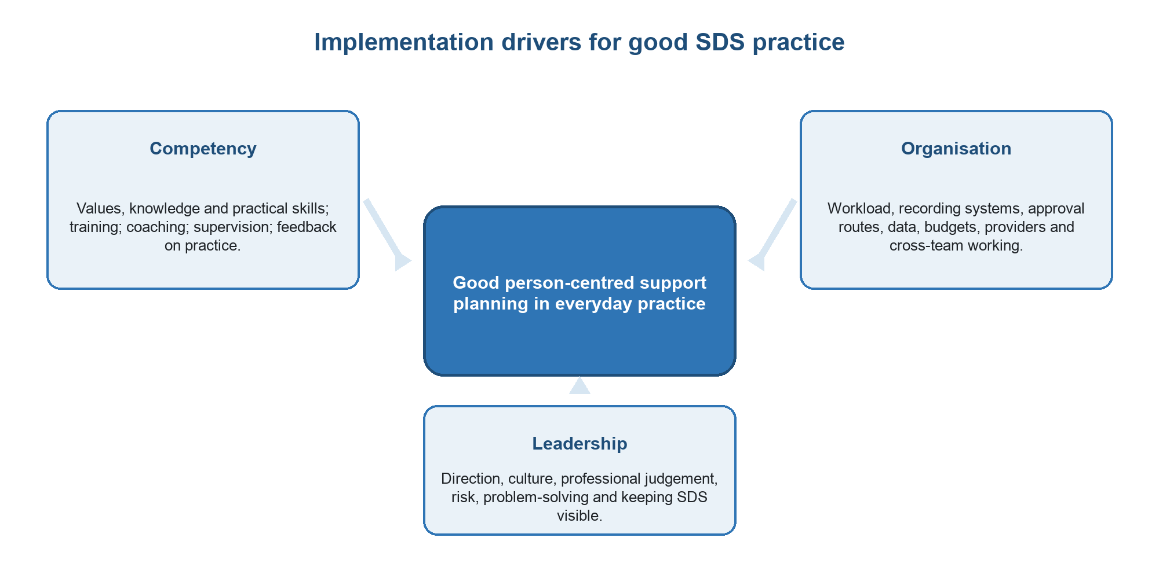

What we learnt
Training can improve knowledge. Whether that knowledge is used in practice also depends on coaching, supervision, useful systems, feedback and leaders who support person-centred judgement.

Reviewing the training already available in Northern Ireland
We obtained SDS training slides and materials from the five Trusts and used the published review to develop two audit tools.
Training Audit Tool 1 was completed for individual courses. It examined:
- who the training was for;
- the purpose and level of the course;
- the topics and competencies covered;
- how often it was provided;
- the learning methods used; and
- whether follow-up support helped staff apply the learning.
Training Audit Tool 2 asked each Trust to consider its full SDS learning offer. It looked at the workforce groups and topics covered, the main gaps and whether formal training was supported through coaching, supervision or other workplace learning.
The audits provided a structured regional picture of current SDS training and were used to inform discussion rather than as a formal evaluation of every course.
We discussed the review and audit findings during a half-day workshop with SDS Leads. The Leads compared the training available in each Trust, identified useful materials and considered where greater regional consistency would help.
There were existing strengths to build on, including case studies, practical exercises and locally developed resources that could be shared or adapted. There was also variation in course content, level, delivery methods and the staff groups being reached.
Awareness and practitioner training were the most developed parts of the existing offer. Learning for advanced practice, supervision and leadership was less consistently available.
Common gaps included:
- person-centred support planning;
- risk enablement and positive risk-taking;
- reflective practice;
- the cultural change required by SDS;
- leadership development; and
- help for staff to apply learning after a course.
Mentoring, coaching, reflective supervision and communities of practice were often limited or still being developed.
Figure 3. How the workforce review was used to inform regional development of training
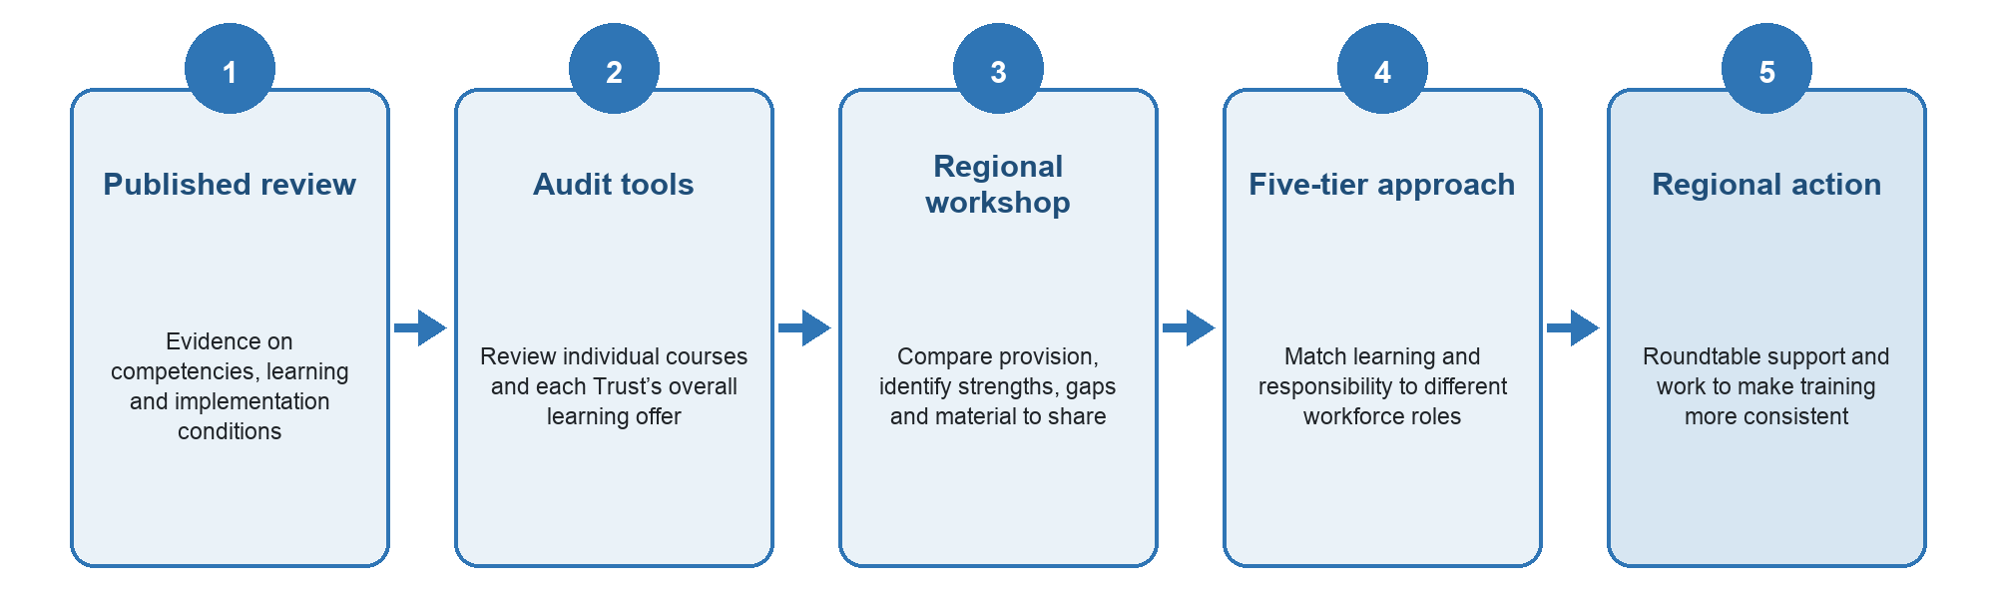
The workshop led to a proposed five-tier approach. This offers a more coherent route for workforce development than continuing with separate courses developed independently across Trusts. The first three tiers focus mainly on the knowledge and practice required in different roles. Tier 4 places coaching, supervision and consistent decision-making within management. Tier 5 addresses leadership, governance, commissioning and the design of the wider system.

Tier | Main focus
Tier 1: Whole-workforce awareness | Understand the principles of SDS, choice and control; recognise when SDS is relevant; and direct people to appropriate advice or support.
Tier 2: Practitioners | Use person-centred conversations, strengths-based assessment and collaborative support planning; explain SDS options; record outcomes; and work with risk and uncertainty.
Tier 3: Practice leaders and specialists | Model good practice, coach colleagues, support quality assurance and lead improvements in SDS practice.
Tier 4: Supervisors and managers | Provide reflective supervision, support professional judgement, oversee decisions and promote consistent practice.
Tier 5: Senior leaders, commissioners and governance | Align commissioning, budgets, governance, organisational culture and system design with the principles of SDS.

What practitioners and people using SDS told us about skills and training
The practitioner survey provided further evidence about the support staff needed. Full findings are available in the separate survey report (Sneddon & Doyle 2026).
Most respondents had attended Trust or regional SDS training. They were generally confident in communication and relationship-based practice but wanted more help with complex areas of SDS.
Their priorities for future training included:
- positive risk-taking;
- legal and statutory responsibilities;
- practical approaches to support planning;
- involving individuals and families;
- explaining and using the SDS options; and
- outcomes-focused assessment, planning and review.
Practitioners asked for realistic case studies, examples of completed plans and opportunities to discuss difficult decisions. Coaching and mentoring were less widely available than formal training.
People with lived experience also wanted staff who could answer practical questions, explain what would happen next and help arrangements move forward. Person-centred values mattered, but people also needed practitioners who understood the system and knew how to use it.

What was agreed regionally
The proposed tiered direction for developing a regional approach to workforce development was supported at the Social Care Collaborative Board SDS Roundtable in June 2026. It highlighted four immediate priorities:
- updated training content that reflects current challenges;
- clearer guidance and communication;
- a modular and tiered approach; and
- greater consistency across Trusts.
Trust SDS Leads are to continue redeveloping the training offer. The Roundtable discussed how to strengthen possible links with Northern Ireland Social Care Council development programmes, university learning and other regional opportunities.
This shows that the published review, competencies and audit findings were already being used to inform regional workforce planning before the project ended in August 2026.

What we learnt
Practitioners need practical learning that reflects their role and gives them access to advice when they need it.
They also need time, coaching, supervision, supportive leadership and organisational systems that make person-centred practice possible.
The workforce work concentrated mainly on the practitioner side of support planning. We then considered the information and practical help needed by people using SDS and family carers.

Question 4: What information do people using SDS and family carers need to take part confidently in planning and decision-making?
Evidence used: Review of SDS resources from Northern Ireland and elsewhere; half-day workshop with SDS Leads; practitioner survey; Voices and Choices discussions and interviews; discussions with key stakeholders

Reviewing the information already available
We reviewed the SDS information being used across the five Trusts, along with examples from elsewhere, including EqualD resources from England. We then held a half-day workshop with SDS Leads. They looked at the purpose, audience, timing, language, accessibility, strengths, weaknesses and use of the existing materials.
The workshop identified the need for a more substantial rewrite. Much of the information began by explaining the legal or administrative differences between the four SDS options. Updating contact details or producing one common leaflet would leave that problem unchanged.
The original Getting Started with a Direct Payment guide began after someone had already chosen a Direct Payment. It explained scheme agreements, bank accounts, payroll, insurance, employer responsibilities and financial monitoring. The guide assumed that the person already understood SDS and had made the main decision.
SDS Leads found differences between Trusts in terminology, eligibility information, descriptions of the process and signposting. Some materials were out of date and some QR codes no longer worked. They agreed a need for consistent regional messages, with each Trust adding its own contact details and information about local delivery.

Information should follow the person’s journey
One of the clearest workshop findings was that information should be organised around the stage the person had reached.
Someone hearing about SDS for the first time needs a straightforward introduction. Someone choosing between the options needs a fair explanation of choice, flexibility, support and responsibility. Someone setting up a Direct Payment needs detailed guidance about employment and financial management. Someone approaching a review needs to understand what will be discussed and how the review links back to their plan and agreed outcomes.
This led to a pathway approach. Information should follow the person through:
- finding out about SDS;
- assessment;
- eligibility;
- personal budgets;
- support planning;
- choosing an SDS option;
- arranging support;
- managing the arrangement; and
- review.
The detail can then be provided in stages. People receive what they need at the beginning and can find further guidance as they move through assessment, planning, arranging support and review.

Figure 4. What information is needed at each stage of the SDS user journey
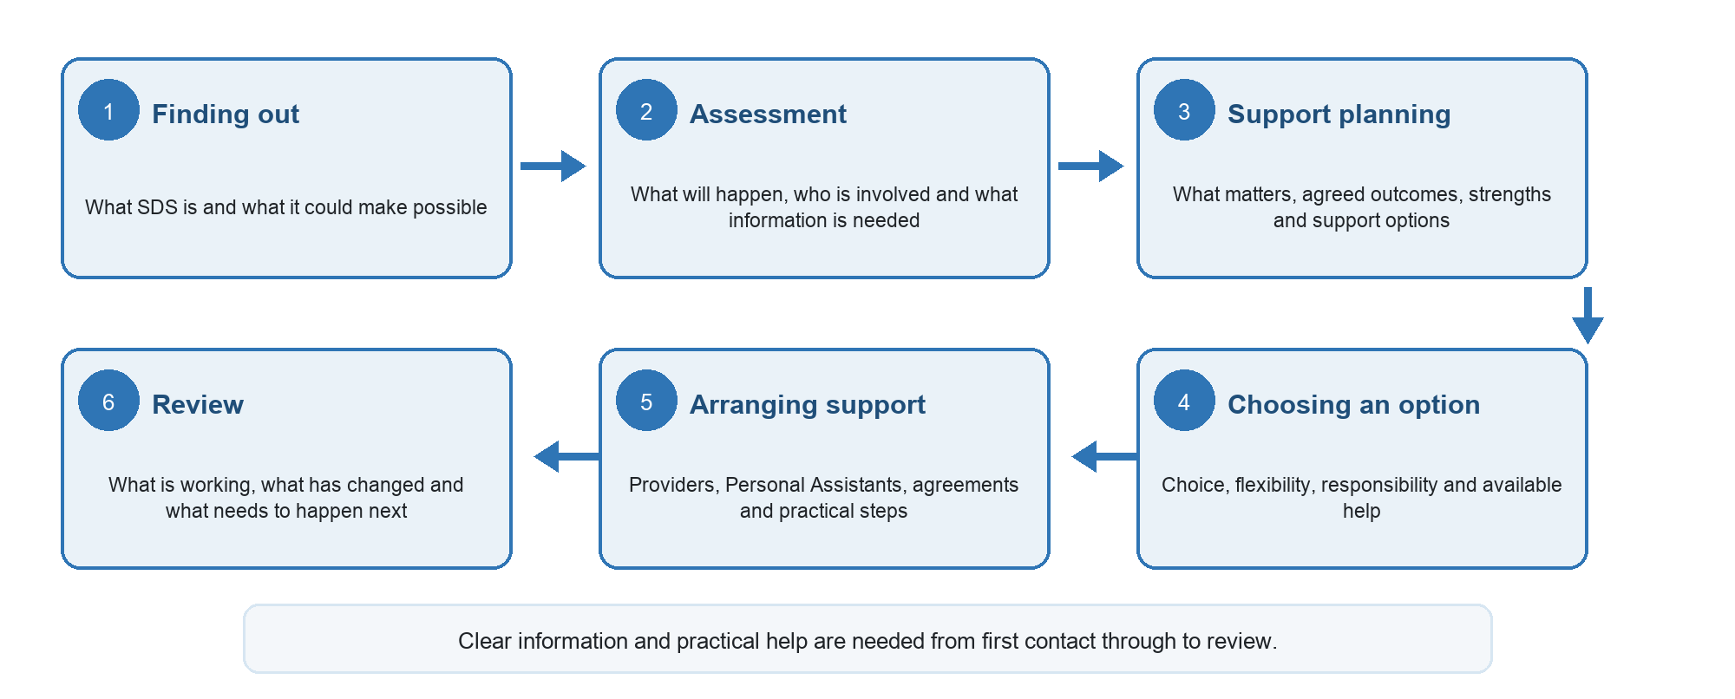

SDS Leads agreed that information should:
- begin by explaining the purpose and possible benefits of SDS, followed by the different budget options;
- explain choice, control and responsibility together;
- provide the right information when it is needed;
- use plain language and short, focused explanations;
- include practical examples, checklists and answers to common questions;
- be available in formats that suit different communication needs;
- use consistent, accurate and current messages across Trusts; and
- show clearly where people can get advice, advocacy and practical help.

What people using SDS and family carers asked for
The Voices and Choices report provides the full account of participants’ experiences and suggestions. The findings most relevant to public information were clear.
People wanted information that:
- explained SDS before asking them to choose an option;
- set out what would happen at each stage;
- described choice, flexibility and responsibility together;
- used practical examples and straightforward language;
- included checklists, process maps and answers to common questions;
- gave clear contact details and expected timescales; and
- explained where to obtain advice, advocacy and practical help.

Participants wanted information in stages rather than one large document provided at a single point. They also wanted help to use it, including someone who could explain the options, work through a support plan or answer practical questions about employing Personal Assistants and managing a Direct Payment.
The practitioner survey reached similar conclusions. Ninety-three per cent of respondents said that information and resources for individuals and families needed improvement, while 76% said access to impartial advice and advocacy needed improvement. Resources for finding providers and Personal Assistants were a particular gap.
These findings informed the structure and content of the regional User Guide. The following section explains how people using SDS and family carers helped change the guide while it was being developed.

How co-production changed the User Guide
People using SDS and family carers developed the User Guide through Voices and Choices. They reviewed existing information first and then commented on new versions while the guide was still taking shape.
At the beginning, participants reviewed information already in use and described what had helped or confused them. They then commented on developing versions of the guide. Their experiences and suggestions changed what the guide was for, where it began, how the information was ordered, what it included and the language used.
The revised guide begins with SDS, choice and control. It explains assessment, eligibility, personal budgets and all four SDS options before moving into the detailed requirements of Direct Payments. It follows the person through support planning, arranging support, dealing with difficulties and review.
The guide also includes case examples, checklists, key messages, frequently asked questions, practical tips and signposting. Responsibilities remain part of the guide, but they are explained alongside the flexibility and support available. Advice and advocacy are more visible, and the role of family carers and other supporters is recognised.
This work changed the purpose of the guide. The original was mainly an administrative handbook about Direct Payments. The regional redraft helps people understand SDS and follow the journey from first information through to review.
SDS Leads planned to use the regional redraft as a source of agreed content. It can support shorter leaflets, web pages, checklists, Easy Read information and resources for different points in the journey. This allows the main messages to stay consistent across formats and Trusts.
At the end of the Demonstrator, the guide remained a working redraft. Some sections contained placeholders or points requiring regional clarification, and the document was still long. It now needs a final policy and editorial check, user testing, and development into shorter and accessible formats. Braille, audio, Easy Read, BSL and ISL resources will each require further work.

How the guide changed
Original guide | Current regional redraft
Focused mainly on Direct Payments after a decision had been made | Begins with SDS, choice, control and the full range of options
Organised around administrative tasks | Organised around the person’s journey
Explained rules and responsibilities | Explains opportunities, responsibilities and available support
Used mainly operational language | Uses plain English and answers common questions
Contained limited practical examples | Includes case examples, checklists, tips and frequently asked questions
Assumed the reader understood assessment and eligibility | Explains what happens before support planning and what the person can expect
Focused largely on setting up and monitoring a payment | Connects assessment, planning, arranging support and review
Included limited information about advice and advocacy | Makes help, advocacy and signposting visible throughout
Was Trust-specific | Provides a regional source of content for Northern Ireland

Improving accessibility
Our work with the British Deaf Association showed that accessible information has to be planned from the beginning. Translating an existing written leaflet at the end of the process would not meet the needs of d/Deaf, deafblind and hard-of-hearing people.
The BDA team explained that British Sign Language and Irish Sign Language are distinct languages. Each resource needs its own script and production process. A word-for-word translation of written English would not produce clear or meaningful information. They suggested using QR codes to take people directly to BSL and ISL videos. The design of printed and digital material also needs to consider people who are deafblind, including the use of colour, contrast and layout.
Accessible information needs to be matched by accessible services. Staff involved in assessment and support planning need Deaf awareness and must know how to arrange suitable interpreters and communication support. People also need appropriate ways to contact services. Telephone and email will not work for everyone, so contact details should include alternatives such as a text number.
Examples shared by the BDA from England showed that some councils provide BSL videos and work with specialist Deaf organisations. In some areas, social care staff or Deaf managers meet people directly to explain assessment, Direct Payments and the available support options. This allows time for questions and for the information to be discussed in relation to the person’s own circumstances.
These points were reflected in an interview with one deafblind person, supported by an interpreter and Personal Assistant. The participant had first heard about SDS through contacts in Scotland and the BDA and felt that they had been left to carry out much of their own research. They wanted SDS to be introduced by someone who understood it, with enough time for interpreted communication and information provided in stages.
“Found it difficult to navigate at the time, but worth it now.”
Deafblind participant
The participant’s experience also showed why accessibility needs to continue throughout the SDS journey. Their support plan needed to record how they communicated and the particular skills required of a Personal Assistant. They reported waiting a long time for an accessible copy of the plan. They also described difficulty finding Personal Assistants with suitable communication skills and arranging cover when a Personal Assistant was unavailable. Family support and links within the Deaf community helped them make the arrangement work. In their view, independent advocacy was particularly important for people who did not have access to these networks.
This was one person’s experience and should not be treated as representative of every d/Deaf, deafblind or hard-of-hearing person. It shows how communication and accessibility can affect every stage of SDS, including finding out about the options, contacting services, taking part in assessment and support planning, receiving a copy of the plan, finding suitable support and dealing with problems after the arrangement begins.
The work led to an SDS Lead providing training to the BDA team for the first time. This strengthened the team’s understanding of SDS and helped establish an ongoing working relationship. This relationship will be important if the proposed resources are developed and tested with the communities they are intended to support.
The work also led to a draft plan for two resources. One would introduce SDS and the other would explain how to plan SDS support. The proposal included written information and captioned videos in BSL and ISL. IMPACT would agree the key messages with the BDA, while the BDA would lead script development, recruitment, interpreting, filming and production. The Demonstrator ended before this production work began, but the draft workplan provides a basis for taking it forward.

What we learnt
People need information before they are asked to make a decision. It should follow the full SDS journey and be supported by accessible contact routes, informed staff, suitable communication support and practical help.

What did we learn about using evidence in adult social care?
We used the findings as the project developed. Each strand helped clarify the next question, examine current practice or develop a practical resource.
The outcomes review helped establish the focus on support planning. The workforce review informed the competency framework, training audits and proposed five-tier approach. The practitioner survey identified the organisational barriers that needed attention alongside workforce development. People using SDS and family carers changed the purpose, structure and content of the public information. The BDA shaped the accessibility recommendations and the proposed approach to BSL and ISL resources. The table below records the outputs completed by August 2026 and the work still required.

What did we learn about co-production?
It was important that the Voices and Choices participants joined the work before the User Guide had been finalised. They talked about their experiences of SDS, reviewed information already in use and commented on developing drafts. Later versions reflected changes to the guide’s purpose, structure, content and tone.
“This document is proof for change.”
Voices and Choices participant
Participants valued hearing from people in different caring situations, using different services and living in different parts of Northern Ireland. They recognised common experiences across Trusts and programmes of care and shared practical knowledge with one another. Meeting online removed the need to travel and made it possible for people from across Northern Ireland to take part.
Feedback on the facilitation was positive. Participants said they felt listened to, were able to speak openly and had opportunities to contribute. Payment for their time was also appreciated. It recognised that sharing lived experience involves work and that this experience is a valuable form of evidence.
“There was no lack of conversation at any time. The facilitators ensured that everyone had the opportunity to have their say.”
Voices and Choices participant
There were limitations. SDS and Direct Payments are complicated and can raise difficult or emotional experiences. Participants wanted more time, smaller groups, additional breaks, more visual material and further opportunities for quieter group members to contribute.
The online format worked well for some participants and less well for others. A larger group could make it difficult to discuss personal experiences, and some communication support was easier to provide in another setting. We therefore offered individual interviews.
Participants wanted to know what would happen after the Demonstrator, what the project could realistically influence and who would take the work forward. Some wanted the relationships to continue through a community of practice and the SDS Network. For them, producing the draft guide was one stage of the co-production process.
“This is just the start... Community of Practice forming as well as the SDS Network.”
Voices and Choices participant
Participants wanted to know what happened because they took part. This means reporting back on what changed, explaining any suggestions that could not be taken forward and offering a way to remain involved. The people who will use the User Guide should continue to take part in testing and implementation.

What we learnt
Co-production had most influence when people were involved before the solution was fixed. Future work needs enough time, different ways for people to take part, and clear responsibility for reporting back and explaining what happens next.

Learning for other adult social care projects
The way this project was carried out offers useful lessons for other adult social care projects seeking to use evidence to improve practice.
- Allow the question to become clearer. The Demonstrator project began with a focus on outcomes measurement. Discussion of the review with SDS Leads and Vela Microboards showed that the more immediate issue was how people’s outcomes were identified and used in support planning. Responding to that discussion gave the project a clearer and more useful focus.
- Give each source of evidence a practical purpose. The published reviews showed what had been learnt elsewhere. The practitioner survey and training audits described the position in Northern Ireland. People using SDS and family carers showed how the system was experienced in everyday life. The workforce review was then used to identify competencies, develop audit tools and support decisions about regional training.
- Discuss the evidence with people who understand the context and can act on it. SDS Leads, the Steering Group, the SDS Roundtable, the BDA and people with lived experience considered the findings at different stages. Their knowledge helped us interpret the evidence, identify what was realistic and connect the work with regional decisions already under way.
- Begin co-production while the work can still change. Voices and Choices participants reviewed existing information and commented on developing drafts. Their involvement changed the purpose, starting point, structure, content and tone of the User Guide because the main decisions had not already been settled.
- Follow the person’s whole journey. Services may deal separately with assessment, funding, support planning, arranging support and review. People using SDS experienced these as connected stages of one journey. A problem at one stage affected what happened next. Organising the User Guide around this journey made the information more relevant and easier to follow.
- Consider the conditions around practice. Training can improve knowledge and skills. Staff also need time, supervision, useful systems, supportive leadership and realistic support options. The implementation drivers helped us examine these wider conditions and identify where organisational or regional action was needed.
- Projects need to be clear about the stage they have reached. A published review, draft guide or agreed workforce approach is an important output. However, further ownership, testing, revision and monitoring are needed before its effect on practice can be understood. People who contributed should also be told what happened as a result of their involvement and how they can remain involved.

Summary and recommendations
The Demonstrator began with a question about how the outcomes of SDS should be measured. The initial evidence review was useful in showing which outcomes people value and the challenges involved in measuring them. Discussion with SDS Leads and Vela Microboards then clarified the issue that mattered most in practice. Before outcomes can be measured, they have to be identified with the person and used to shape the support arranged. This led the project to concentrate on person-centred and outcomes-focused support planning.
The evidence reviews, practitioner survey and lived-experience work showed strong support for the principles of SDS. Practitioners generally wanted to work in person-centred ways and reported confidence in many of the skills involved. People using SDS and family carers described the independence, continuity and flexibility that good support could provide. They gave examples of support that helped people remain at home, maintain familiar routines, build trusted relationships and take part in their communities.
The main difficulties arose as plans moved through the wider system. Practitioners described limited time, high workloads, repetitive recording, approval processes and restricted authority to work flexibly. Managed Budgets were not consistently available or understood, while Direct Payments could leave individuals and families carrying substantial employer and administrative responsibilities. Shortages of providers and Personal Assistants could also mean that a good planning conversation did not result in the support originally discussed.
People using SDS and family carers experienced these issues as connected parts of one journey. Finding out about SDS, assessment, support planning, funding, arranging support and review affected one another. A delay or difficulty at one stage could shape everything that followed. Some people described having to find information for themselves, repeat their story, chase decisions and manage complex arrangements over a long period. This could be exhausting, even when the support eventually achieved was highly valued.
The project used these findings to develop practical work. The published workforce review identified the competencies and wider conditions needed for SDS and provided the basis for two training audit tools. The audits and regional workshop led to a proposed five-tier workforce approach, which was supported at the SDS Roundtable and is informing continuing work across Trusts. The practitioner survey provided a regional picture of current support-planning practice and showed why training needs to be considered alongside workload, systems, leadership and the availability of support.
The Voices and Choices groups worked on the User Guide while it was still being developed. Their contribution changed where the guide began, how it was organised, the information it contained and the language used. The guide moved from being mainly an administrative handbook for people who had already chosen a Direct Payment to a broader resource covering the full SDS journey. Work with the British Deaf Association also showed that accessible information has to be planned from the beginning and supported by accessible contact routes, interpreted conversations, informed staff and appropriate communication support.
By the end of the Demonstrator, the evidence reviews, practitioner survey, training audits and qualitative report were complete. The User Guide, accessibility work and regional workforce approach had reached a clear stage of development but were not yet fully implemented or evaluated. Their effect will depend on who takes responsibility for the next stage, how the work is tested and refined, and whether the wider barriers identified through the project are addressed.
The priorities that follow set out the areas where further regional work is most clearly supported by the findings.

Priorities for the next stage
The project identified several areas where further work is needed. These are presented as priorities for the next stage rather than as prescribed solutions. Some can be taken forward through the existing SDS structures. Others will require decisions about policy, resources, systems or service capacity at Trust or regional level.

1. Agree regional ownership and an implementation plan
The evidence reviews, practitioner survey and Voices and Choices report were completed during the Demonstrator. The User Guide, workforce approach and accessibility work had reached different stages of development but still required further work.
Regional partners should agree who will take responsibility for each area. The proposed SDS workstream under the Social Care Collaborative Board could provide a place for coordinating this work.
An implementation plan should set out:
- who will lead each action;
- which organisations need to be involved;
- what resources will be required;
- realistic timescales;
- how people with lived experience will remain involved; and
- how progress will be reported and reviewed.
This will help prevent completed reviews, audit tools and draft resources from becoming disconnected pieces of work.

2. Agree shared expectations for good support planning
The project found broad agreement about the principles of person-centred support planning, but more variation in how these were experienced and put into practice.
Northern Ireland would benefit from a shared regional description of good, outcomes-focused support planning. This may be able to build on existing standards rather than creating a new framework.
The agreed expectations should cover:
- starting with what matters to the person;
- identifying strengths, relationships, aspirations and communication needs;
- involving the person properly in decisions;
- explaining the available SDS options;
- agreeing the outcomes the person wants to achieve or maintain;
- recording how the proposed support relates to those outcomes;
- considering risk and responsibility in a balanced way;
- giving the person an accessible copy of their plan;
- following through after the plan is agreed; and
- using the plan as the basis for an outcomes-focused review.
This should establish a common standard without requiring every Trust, programme of care or individual to use the same conversation or planning tool.

3. Improve clarity and consistency about the SDS options
Practitioner confidence varied across the four SDS options. Managed Budgets were the least well understood, and some respondents described them as unavailable in practice. People using SDS and family carers also wanted clearer information about the choices available and the responsibilities attached to each one.
Further regional work should clarify:
- how each SDS option currently operates;
- when each option is available;
- how Managed Budgets are intended to work;
- how eligibility and approval decisions are made;
- what responsibilities come with each option;
- what practical help is available; and
- what people can do if their preferred option cannot be provided.
This information should be kept current and communicated consistently across Trusts.
The project also showed that choice is affected by the support available locally. Shortages of providers, Personal Assistants and community support can prevent an agreed plan from being put into practice. These issues sit beyond support planning alone and need to be considered through the wider regional SDS programme.

4. Continue developing and testing the five-tier workforce approach
The workforce review, training audits and regional workshop led to a proposed five-tier approach covering whole-workforce awareness, practitioners, practice leaders, supervisors and managers, and senior leadership.
The direction was supported at the SDS Roundtable. The next stage should define:
- what each tier needs to know and be able to do;
- which parts of the learning should be consistent across Trusts;
- which local examples or arrangements should be retained;
- who will develop and deliver the learning;
- how lived experience will be included;
- how staff will be supported after training; and
- how the effect on practice will be assessed.
The evidence supports practical and interactive learning. Case studies, worked support plans, discussion of risk and opportunities to work through difficult decisions should form part of the approach.
The five-tier model has not yet been implemented or evaluated. It should therefore be tested and refined as it develops.

5. Review the wider conditions affecting practice
The practitioner survey showed that knowledge and commitment were not the only issues. Ninety-four per cent of respondents said the time available for support planning needed to improve, while 97% identified workload or caseload pressures as an area requiring improvement.
Respondents also raised concerns about recording, duplication, electronic systems, approval processes, limited professional authority and shortages of support options.
Trusts and regional partners should examine:
- the time available for assessment and support planning;
- caseload and workload expectations;
- duplicated or task-focused recording;
- how electronic systems support or restrict strengths-based practice;
- the number and purpose of approval stages;
- access to advice when difficult decisions arise; and
- the authority practitioners have to develop flexible support.
The project did not test different workload, recording or approval models. Further work will therefore be needed to understand which changes are possible and likely to help. The survey provides a clear account of the areas that practitioners believe need attention.

6. Complete and test information organised around the SDS journey
The regional User Guide should be completed, checked against current policy and tested with people using SDS, family carers and practitioners.
The full guide can provide a regional source of agreed content. It should not be expected to meet every information need as one long document. The content can also be used to produce shorter resources for different stages, including:
- finding out about SDS;
- assessment and eligibility;
- personal budgets;
- support planning;
- choosing between SDS options;
- arranging and managing support;
- dealing with difficulties; and
- review.
Information should begin by explaining what SDS is and what it could make possible. Choice, flexibility, support and responsibility should be explained together. People also need clear contact details, likely timescales, practical examples and information about what happens next.
Testing should examine whether people can find the information they need, understand the available options and use the material at the point when a decision is required.

7. Continue the accessibility work
The work with the British Deaf Association identified the need for information and services that are accessible to d/Deaf, deafblind and hard-of-hearing people.
The proposed BSL and ISL resources require separate scripts and production processes. A direct translation of written English is unlikely to provide clear information in either language. Further work should be led with the BDA and members of the relevant language communities.
Accessible information also needs to be supported by accessible services. Future work should consider:
- Deaf awareness among staff involved in SDS;
- arrangements for suitable interpreters and communication support;
- accessible ways of contacting Trusts;
- sufficient time for interpreted conversations;
- accessible copies of support plans and decisions;
- colour, contrast and layout for people who are deafblind; and
- the communication skills required when recruiting Personal Assistants.
The deafblind interview provided one individual account. It illustrated how communication can affect the whole SDS journey, but it should not be treated as representative of everyone. Wider involvement and testing will be needed as the work develops.

8. Consider how independent advice and practical support can be strengthened
Seventy-six per cent of practitioner survey respondents said access to impartial advice and advocacy needed improvement. People using SDS and family carers also described relying on family networks, voluntary organisations or their own research.
Further work should consider how people can obtain independent help with:
- understanding the SDS options;
- preparing for assessment and support planning;
- asking questions about decisions;
- recruiting Personal Assistants;
- understanding employer responsibilities;
- payroll, insurance and financial records;
- finding providers and community support; and
- resolving problems after an arrangement begins.
This is particularly important for people who do not have family members or other informal supporters able to help them navigate the system. The project identified the need for this support but did not compare different models of advocacy, brokerage or navigation. The next stage will need to examine what is already available and where the gaps remain.

9. Keep co-production and feedback within the next phase
Voices and Choices had most influence because people became involved while the User Guide could still change. Their input changed its purpose, starting point, structure, content and tone.
People using SDS and family carers should remain involved while the guide, workforce resources and accessibility work are developed and tested.
Future co-production should provide:
- different ways to take part;
- individual conversations where these are more suitable;
- accessible and visual material;
- manageable group sizes and sufficient breaks;
- payment for people’s time;
- clear information about what participants can influence; and
- feedback explaining what changed and why.
Participants also wanted to know who would take the work forward after the Demonstrator. Reporting back should therefore be treated as part of the co-production process.

10. Check whether the next stage improves practice and people’s experience
The practitioner survey, training audits and lived-experience work provide a useful starting point for future monitoring.
Evaluation should consider whether:
- people receive clear information at the right time;
- the SDS options are explained consistently;
- people are involved meaningfully in support planning;
- people receive an accessible copy of their plan;
- plans reflect agreed personal outcomes;
- agreed plans can be put into practice;
- reviews focus on outcomes;
- practitioners feel better supported;
- workforce learning is being used in practice; and
- experiences become more consistent across Trusts and programmes of care.
This would return the work to the original interest in outcomes measurement. Measurement will be more useful once personal outcomes are being identified properly, used in planning and reflected in the support that people receive.

Appendices

Appendix 1. How the project was carried out
The Demonstrator was an evidence-informed change project. Different activities answered different parts of the four questions. We compared the findings and used them to develop resources and regional actions.

Evidence reviews
Obert Tawodzera reviewed academic research, policy and practice evidence on autonomy, outcomes, outcome measurement and SDS implementation. The review considered outcomes valued by people using SDS, existing tools and frameworks, and the conditions needed to use measurement in practice.
Helga Sneddon completed the published rapid review on approaches used for SDS workforce development: Evidence review and implications for Northern Ireland. It used targeted searches of UK legislation and guidance, national capability frameworks, inspection and audit reports, international policy frameworks and academic literature. It examined why workforce development matters, approaches used in other jurisdictions, core SDS competencies and learning approaches most likely to influence practice. A shorter briefing paper was prepared for the Social Care Collaborative Board SDS Roundtable.

Practitioner survey
An online survey was issued to practitioners in adult programmes of care across all five Trusts between February and April 2026. It explored SDS use, support planning, confidence, barriers, resources, workforce-development needs and priorities for change. One £50 Amazon voucher was randomly awarded in each Trust as an incentive.
The survey received 101 responses. Seventeen were excluded because the respondents did not currently work with SDS. The analysis included 84 eligible responses. Descriptive statistics and free-text responses were analysed and reported in a full report and executive summary.

Voices and Choices
Voices and Choices used online discussion groups and follow-up interviews with people who used SDS and family carers. Participants volunteered in response to an open call. Two online groups met over several rounds, with attendance varying between sessions. Eighteen people took part in the first round, while later attendance records show 15 participants. Four one-to-one interviews were also completed.
Attendance and interview records were spread across several project documents and were not linked at participant level. We have reported participation for each activity and have avoided giving one overall total for unique contributors.
The online sessions were co-facilitated by Helga Sneddon and Laura Doyle. The first session reviewed existing information. Later discussions covered finding out about SDS, assessment, support planning, arranging and managing support, review and the developing User Guide. Data included available transcripts, facilitator notes, chat comments, interview notes, resources discussed and a participant feedback questionnaire.
The material was reviewed across sessions and interviews to identify recurring patterns, differences and links between stages of the SDS journey. Quotations in this report were checked against the available transcript, chat, questionnaire or interview record. The separate Voices and Choices report provides the fuller qualitative analysis.

Work with SDS Leads
For the workforce strand, we collected existing training slides and materials from the Trusts. Two audit tools were developed from the workforce review. Tool 1 examined individual courses. Tool 2 examined the full Trust learning offer.
The audit findings and evidence review were discussed in a half-day workshop with the SDS Leads. SDS Leads compared provision, identified resources that could be shared and considered a tiered regional approach.
A separate half-day workshop examined existing SDS public information. SDS Leads reviewed the purpose, audience, timing, language, accessibility, use, strengths and weaknesses of resources and agreed principles for information organised around the user journey.

Accessibility work
The accessibility strand used feedback from the British Deaf Association, examples of resources from councils in England, a draft BDA workplan and an individual interview with a deafblind person using SDS. The interview was face to face and supported by an interpreter and Personal Assistant. The individual account is used as an illustration and is not treated as representative of every d/Deaf, deafblind or hard-of-hearing person.

Steering and regional engagement
A Steering Group met four times. It included representatives from Trust SDS Leads, Vela Microboards, SPPG, the Department of Health and a person with lived experience of SDS. Emerging findings and next steps were also discussed with the SDS Roundtable and through meetings and presentations with practitioners and managers. The Extended SDS Roundtable meeting on 22 June 2026 considered the practitioner survey, care and support planning, public information, accessibility, workforce development and regional next steps. The Managed Budgets pilot reported at that meeting was a separate workstream.

How we brought the evidence together
Findings from one activity informed the next. The published reviews informed the survey, competency work and audit tools. The audits tested the workforce evidence against current provision. The survey identified organisational barriers requiring action alongside training. Lived experience tested professional assumptions and changed the User Guide. Regional partners considered the findings alongside work already under way.
We compared the sources to see where they agreed and where they differed. Practitioners and people using SDS often described the same problem from different positions. Positive experiences, minority views and examples outside the main pattern were retained in the analysis.

Appendix 2: Project reports and selected sources
The following project documents provide the detailed evidence behind this report:
- Tawodzera, O. (2025). Self-Directed Support in Northern Ireland: review of autonomy, outcomes, outcome measurement and implementation.
- Sneddon, H. (2026). Approaches used for SDS workforce development: Evidence review and implications for Northern Ireland, and the accompanying briefing paper prepared for the Social Care Collaborative Board SDS Roundtable.
- Sneddon, H. & Doyle, L. (2026). IMPACT Self-Directed Support Practitioner Survey: main report and executive summary.
- Sneddon, H. & Doyle (2026). Voices and Choices: Learning from Lived Experience of Self-Directed Support in Northern Ireland.

The implementation section also draws on Fixsen, D. L., Naoom, S. F., Blase, K. A., Friedman, R. M. and Wallace, F. (2005), Implementation Research: A Synthesis of the Literature, and National Implementation Research Network material on competency, organisation and leadership drivers.
The IMPACT Evidence Informed Change Model for Social Care is available at: https://impact.bham.ac.uk/our-mission/impact-change-model/
Published project reports and further information are available at: https://impact.bham.ac.uk/delivery-models/demonstrators/self-directed-support-in-northern-ireland/

