Keeping Pets and People Together
A Charter for Pet-Inclusive Homelessness Accommodation and Support

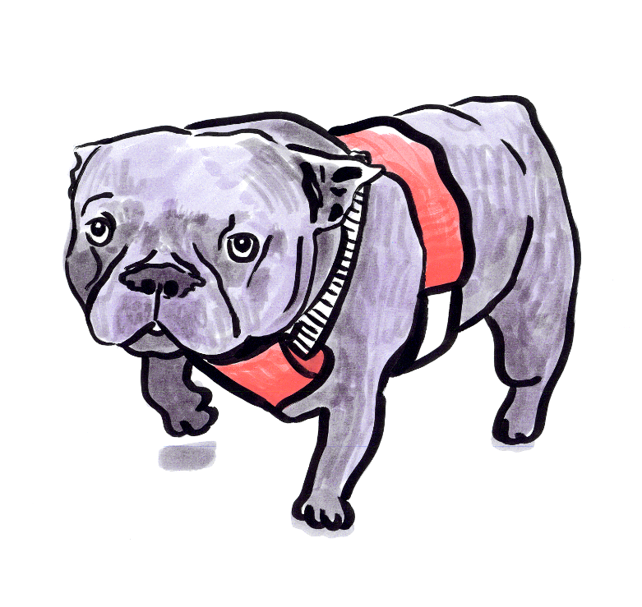

IMPACT in partnership with Newcastle University, Street Paws, Dogs Trust (Together Through Homelessness) StreetVet and Vets in the Community
‘I would not be here if it wasn’t for my dog’

Lee - Pet owner with experience of homelessness

Acknowledgements
We would like to express our sincere thanks to our host partners and our co-design group for their generosity, insight, and commitment throughout this work. Their willingness to share knowledge, experience, perspectives and connections has helped shape and strengthen this Charter in meaningful ways.
We are also grateful to others who contributed to this work through interviews, especially those people with lived experience whose voices set the important tone and direction for this Charter.
All images, photographs and short video clips are included with permission and were recorded as part of the IMPACT Facilitator project Raising Awareness and Driving Improvements Around Pet-Inclusive Homelessness Accommodation (2026).


 |  |  | 
 |  | 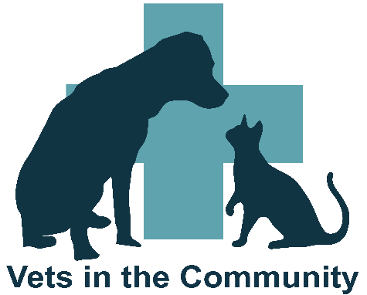

Contents
Overview 4
The vision 5
The aims 6
What pets make possible: the strengths we build on 7
Belonging 9
Hope 9
Purpose 9
Resilience 10
Who is this Charter for? 10
The case for change 11
The Charter 13
1. Pet inclusivity as default 13
2. No discrimination or forced separation 14
3. Consistency in documentation and recording 15
4. Keep animal welfare at the centre 15
5. Staff capability and support 16
6. Provision of back-up systems and safety nets 17
Summary 18
References 19
Appendix A Participants and contributors 20
Charter for Keeping Pets and People Together 21

Overview
For many people experiencing homelessness, companion animals are far more than pets. They are family, trusted companions, a source of emotional support, stability and purpose, and often the most enduring relationship in a person's life. The bond between a person and their companion animal can be a powerful protective factor, supporting mental wellbeing, reducing loneliness, creating routine, and providing motivation, hope and connection during some of life's most challenging circumstances.
Despite this, people with companion animals continue to face significant barriers when accessing accommodation, healthcare and support services. Too often, they are forced to choose between a safe place to stay and the animal that provides them with unconditional companionship and security. Faced with this impossible choice, many avoid services altogether, remain in unsafe situations, delay seeking support, or become further isolated from the help available. No one should have to choose between their own safety and the wellbeing of a companion animal.
This Charter recognises that keeping people and their companion animals together is not simply an issue of animal welfare; it is fundamental to person-centred, trauma-informed and strengths-based practice. By recognising the human-animal bond as an important source of resilience, services can remove unnecessary barriers, build trust, improve engagement and support better outcomes for people experiencing homelessness. It sets out a shared vision; a series of guiding principles and practical commitments to help organisations become more companion animal inclusive. It encourages collaboration across housing, health, local authorities, homelessness services, animal welfare organisations and community partners to create systems that value relationships, promote dignity and recognise the relationship between a person and their pet as a strength.

The vision
This Charter sets out a shared vision and practical approach for creating more pet-inclusive homelessness accommodation and support services. It has been developed by IMPACT in collaboration with Newcastle University, Street Paws, Dogs Trust (Together Through Homelessness), StreetVet and Vets in the Community along with 14 other stakeholder groups. It draws on evidence from current research, and engagement with pet owners with lived experience of homelessness, housing and homelessness services, animal welfare and pet charity organisations, commissioners and other partners. Together, these voices highlight the importance of companion animals in people's lives and the barriers that people continue to face when seeking accommodation and support. Evidence was gathered in 2026 from people with lived experience, commissioners, provider organisations and charities working across pet welfare and homelessness.
This Charter is designed for anyone involved in commissioning, delivering, influencing or supporting homelessness services. This includes commissioners, housing providers, housing options teams, homelessness accommodation organisations, animal welfare organisations, veterinary services and wider partners who have a role in supporting people experiencing homelessness.
The Charter aims to move pet inclusion from individual acts of compassion and goodwill to a more consistent, strengths-based and system-wide approach. It recognises that companion animals play an important role in belonging, hope, purpose and resilience, and that people should not have to choose between accessing support and staying with their companion animal. Strengths-based approaches focus on people’s strengths rather than their deficits, essentially, they emphasise what is strong, not what is wrong (Social Care Institute of Excellence, no date).
Pet-inclusive practice continues to evolve through ongoing learning, partnership and lived experience. The Charter supports organisations to create more pet-inclusive services, strengthen partnership working, and build services and systems that recognise and respond to the realities of people's lives. It supports ongoing reflection, discussion and improvement, rather than acting as a fixed set of rules. This will help to create the conditions for people and their companion animals to stay together, access support, and move forward from difficult times. It is intended as a catalyst for positive change.

The aims
The aim is to support services, commissioners, housing providers, animal welfare organisations and people with lived experience to work together towards a shared approach to pet inclusion. Specifically, our objectives are to:
- promote a strengths-based approach that recognises the positive role companion animals can play in supporting belonging, purpose, stability and hope.
- improve access to safe and suitable accommodation and support by reducing barriers faced by people with companion animals.
- support consistent practice through this Charter and the printable summary version (see page 21) that helps organisations make compassionate, informed and proportionate decisions.
- encourage collaboration between housing, homelessness, health, social care and animal welfare organisations.
- ensure that staff, managers and decision-makers feel confident in delivering pet-inclusive approaches and are able to respond to challenges when they arise.
- support system change so that pet inclusion moves beyond individual acts of flexibility and goodwill to ensure that policies, processes and commissioning arrangements embed inclusion as part of everyday practice.

What pets make possible: the strengths we build on
A strengths-based model sits at the heart of this Charter. It was developed through evidence from lived experience, interviews and co-design workshops involving people with lived experience of homelessness, commissioners, housing providers, homelessness services, animal welfare organisations and wider partners.
Pet inclusion is not simply about allowing companion animals into services. It is about designing systems around real lives, building on existing strengths, and creating more compassionate, effective and person-centred responses to homelessness. Recognition is needed that companion animals are not simply an additional need to be accommodated, but can be a source of belonging, hope, purpose and resilience. Rather than focusing solely on barriers and risks, the Charter seeks to recognise, protect and build upon the strengths that people and their companion animals already bring. Four interconnected strengths: belonging, hope, purpose and resilience emerged consistently during the co-development phase of the IMPACT project. Collectively, they describe what companion animals can make possible for people experiencing homelessness and the conditions that pet-inclusive systems should seek to recognise, protect and promote. These four strengths form the underpinning pillars of the Charter which in turn shape the commitments. The model and the pillars are explained below along with a series of short videos from the co-development workshops. This elevates the Charter from being a static document by incorporating the voice of lived experience, as a pet owner or support provider, throughout. You can click on the thumbnail to watch the video.

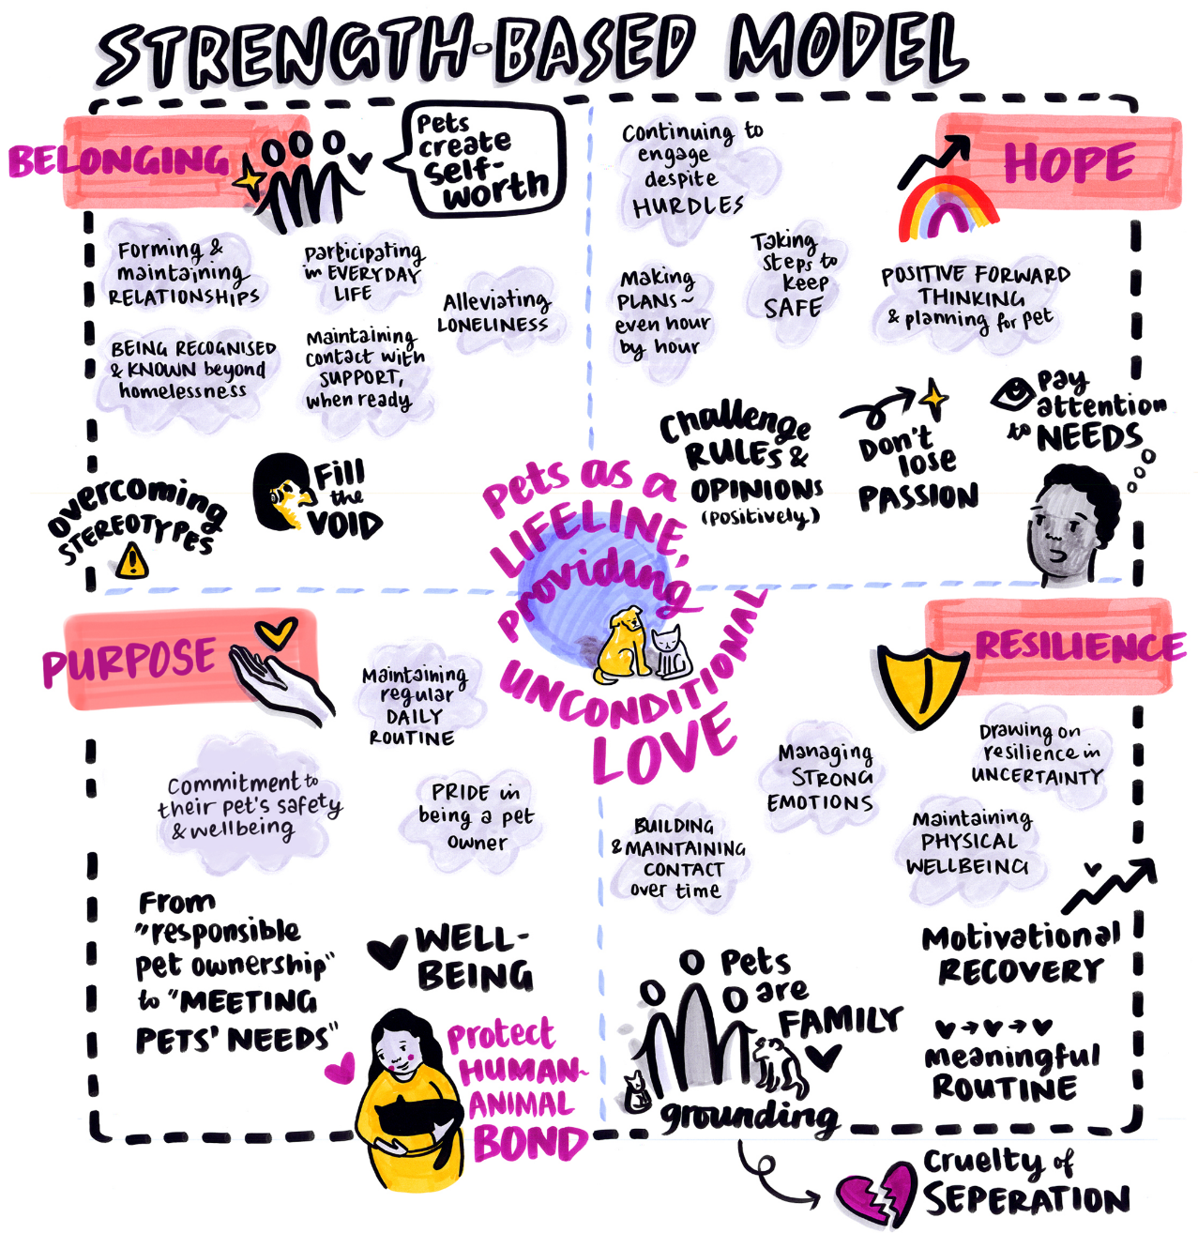
Figure 1. The Charter strengths-based model, illustrating the four underpinning interconnected pillars. Co-developed by IMPACT, Newcastle University, Street Paws, Dogs Trust (Together Through Homelessness), StreetVet and Vets in the Community.

Belonging
Pets create connection and open gentle, safe conversations that help break down barriers with others. They reduce loneliness, support the formation and maintenance of relationships, and enable meaningful engagement with support services when people are ready. |   Video 1. Dr Elizabeth Ormerod, BVMS CF – Chairperson, Society for Companion Animal Studies, talks about how dogs help create a sense of community (20 seconds)

Hope
Pets sustain people through difficult times with unconditional love, helping them continue to engage despite troubles. They offer grounding, routine, and safety, and motivate future planning and recovery. | 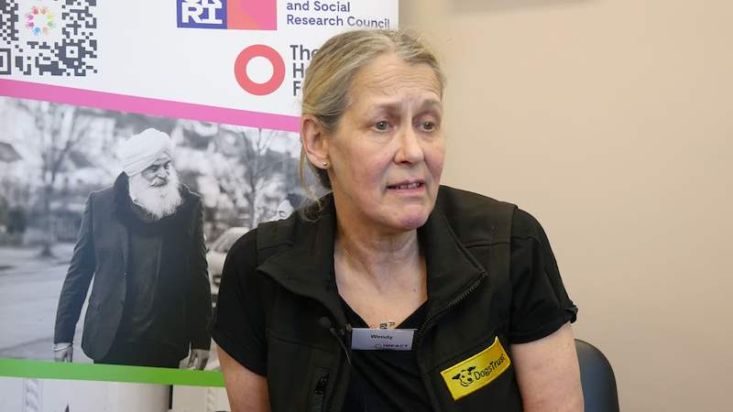  Video 2. Wendy Miller, Senior Regional Engagement Officer, Dogs Trust (Together Through Homelessness), talks about the importance of the human-companion animal bond and the motivation this brings (43 seconds)

Purpose
Commitment to a pet’s safety and wellbeing fosters purpose and gives meaning. Having pride and engaging in daily care tasks can sustain healthy routines. |   Video 3. Jenny Stavisky MRCVS BVM&S PGCHE FHEA, Clinical Research manager, Vets in the Community, talks about how keeping people and their pets together gives people a purpose (21 seconds)

Resilience
Pets help manage strong emotions and buffer trauma, offering stability amid chaos. Care routines (walking, feeding, grooming) structure days and motivate recovery. Separation is cruel and destabilising and can compound trauma and loss. |   Video 4. Justin talks about how his dog Rebel has supported him (39 seconds)

Who is this Charter for?
Audience | How it can be used
Commissioners | To inform commissioning intentions, service specifications, contract requirements and conversations with providers. It can help create greater consistency and support a shared vision for pet-inclusive services.
Housing providers | Housing providers can use the Charter to review current practice and identify opportunities for improvement. The accompanying summary Charter can support implementation and workforce development.
Housing access and assessment teams | To consider how policies, processes and decision-making can support people and their companion animals to access accommodation and support.
Animal welfare and homelessness charities | To support partnership working and identify opportunities to contribute expertise and strengthen collaboration.
Systems leaders and partnerships | As a conversation tool to bring organisations together around a shared understanding of pet-inclusion and the strengths people and their companion animals bring.
Bridging services | To bridge services where people experiencing services seek support and ensure reach, coordination, and person-centred support across the homelessness pathway, for example removing exclusion from access to medical care, including mental health support and drug and alcohol rehabilitation.
Table 1. Intended reach of the strategy

The case for change
The 12-month Improving Adult Care Together (IMPACT) Facilitator project, Raising Awareness and Driving Improvements Around Pet-Inclusive Homelessness Accommodation, was designed to explore how pet inclusion can be embedded within homelessness accommodation using a strengths-based approach. During the project, IMPACT repeatedly heard the same heartfelt message from people with lived experience: “I wouldn’t be here if it wasn’t for my dog.” This sentiment was shared almost universally, highlighting the profound role pets play in survival, stability and hope. This reinforces evidence that demonstrates how pets provide hope, joy, and a reason to live: owners described animals as “lifesavers” that deterred suicide or self-harm and provided daily motivation (Garland-Lewis et al. 2024), with dogs often being described as helping to “keep me going” or giving a sense of purpose to face each day (Cleary et al. 2021).
Findings from the Museum of Homelessness demonstrate that deaths among people experiencing homelessness are increasingly driven by despair and the cumulative effects of long-term street living. Yet, the National Plan to End Homelessness (GOV.UK, 2025) does not address the structural barriers, such as the lack of pet-inclusive accommodation, that keep some people on the streets for extended periods. This omission risks undermining the plan’s target to halve long-term rough sleeping.
Many organisations are already demonstrating that pet-inclusive approaches are both possible and effective, particularly when supported by pet charities such as Street Paws, StreetVet, Dogs Trust (Together Through Homelessness) and Vets in the Community. However, access often depends on individual discretion, local arrangements or exceptional efforts by staff and partner organisations. As a result, experiences remain inconsistent and unequal. Sector-led initiatives, such as ‘Street Paws’ campaign for national social housing standards on pet inclusion, highlight the urgent need for consistent, rights-based approaches. These efforts demonstrate what is possible but also underline the absence of clear national guidance or statutory expectations for local authorities and housing providers.
This reality is further reinforced by the Animal Welfare (Sentience) Act (2022), which recognises animals as sentient beings, capable of experiencing feelings such as joy, fear and distress. Yet within homelessness legislation and local authority duties, pets are still treated as property, which is both incompatible with the spirit of the Act, and disregards the depth and importance of these relationships to their human caregiver. Further developments such as the Renters’ Rights Act (2025) demonstrate growing recognition that people should not be forced to give up their companion animals to secure stable housing. However, these protections do not yet extend meaningfully into homelessness systems, where people continue to face rigid “no-pets” policies and limited accommodation options.

The Charter
We are advocating for pet-inclusive provision and support that is delivered consistently across all UK regions and propose the following principles that should be applied uniformly in order that pet owners receive equitable treatment in all nations and settings. Here we outline the commitments that organisations can make to enable pet-inclusive homelessness accommodation and support for action across homelessness housing and support services. See page 21 for a downloadable Charter for pet inclusion based on these principles. The Charter continues to be brought to life through the recorded reflections, experiences and insights of people with lived experience, commissioners, housing providers and partner organisations who contributed throughout the project. You can click on the thumbnail to watch the video.

Pet inclusivity as default
Pet-friendly accommodation and services should be a standard approach with pets recognised as integral family members and a normal part of family life, rather than an exception. Their inclusion therefore should not require special justification.
This involves:
- asking about companion animals from first point of contact
- sharing relevant information when people move between services
- considering pets when planning new accommodation and support

We will be getting it right when:
- people report that their pet has been considered in support planning
- fewer people are turned away because of a pet
- transitions between services are smoother and better coordinated
- we have pet-friendly communal spaces

Video 5. Justin reflects on experience of homelessness with his dog Rebel (37 seconds)

No discrimination or forced separation
A blanket ban on pets, including breed-specific bans, should not be permitted and pet owners should not be held to higher standards than non-pet owners.
Individuals and families must not be separated from their pets except in genuine emergencies, whilst any decisions made should respect individual agency and the importance of the human–animal relationships. The ongoing emotional support a pet can provide should not be underestimated.
This involves:
- having clear and fair expectations for pet owners
- considering individual circumstances when concerns arise
- seeking practical solutions before considering restrictions when pet-related issues arise
- supporting staff to respond consistently and confidently
- promoting the welfare and safety of both people and animals

We will be getting it right when:
- pet-related concerns are resolved fairly and proportionately
- people feel safe, respected and included
- staff feel confident putting these principles into practice
- exclusions related to pets reduce over time

Video 6. Stuart talks about his experience of homelessness along with his dog Castiel (14 seconds)

Consistency in documentation and recording
Service providers are required to maintain clear and accessible written pet policies ensuring that decisions start with and reflect individual situations. Care agreements should outline responsibilities for both providers and pet owners whilst tenancy agreements are required to assume pets as standard with fair terms protecting tenants, animals and property.
This involves:
- reviewing progress on a regular basis
- sharing information about organisational approaches and learning
- considering pet inclusion when reviewing policies and services

We will be getting it right when:
- pet inclusion is reflected in organisational policies and practice
- progress is reviewed and acted upon (ideally quarterly)
- people experience a more consistent and inclusive service
- the Keeping Pets and People Together Charter is displayed and adhered to across our services and settings


Video 7. Cath Meaden, Riverside Group (social housing). Cath talks about how care agreements can support (58 seconds)

Keep animal welfare at the centre
All decisions must prioritise the welfare of both the person and animal while considering the individual’s commitment to their pet's safety and wellbeing. Risk assessments must focus on individual circumstances, not assumptions about people’s capacity to provide care for their pet, or about breed or species (except where the dog is of a prohibited breed and is not subject to an exemption certificate). Compliance with the Animal Welfare Act (2006) is required with demonstration ensured through best practice such as pet inclusion policies.
This involves:
- prioritising non-separation solutions including room allocations or pet-friendly accommodation placements
- planning for crises such as temporary fostering with pet return plans in place

We will be getting it right when:
- we have predictable routines around pet care such as walks, feeding and vet care
- pets are used as anchors in safety and emergency plans

Video 8. Writtick Mazumder, volunteer at Street Paws, talks about how well people experiencing homelessness look after their pets (50 seconds)

Staff capability and support
Staff should feel supported by the provision of resources and training in pet inclusivity and animal welfare; this is required to make informed, unbiased pet related decisions. Clear escalation pathways should be in place for complex situations requiring specialist input.
This involves:
- providing guidance and training on pet-inclusive practice
- promoting understanding of the role companion animals can play in wellbeing, stability and engagement
- listening to concerns that staff have, for example about cultural issues or allergies, and devise plans to address this
- ensuring staff know where to access advice and support when challenges arise, sharing learning and examples of good practice

We will be getting it right when:
- staff report increased confidence in supporting people with pets
- decisions are more consistent across services
- people feel welcomed and understood
- good practice is shared and adopted across teams

Video 9. Michelle Southern OBE, Founding Chief Executive, Street Paws
Michelle talks about how charities such as Street Paws can support people experiencing homelessness and staff 1.21 minutes)

Provision of back-up systems and safety nets
Backup support through nominated emergency carers should be available when pet owners face temporary difficulties. Pet passports or similar tracking documents should record essential care information, such as vaccinations or microchipping which provides information to share when individuals move on. Many of the homelessness pet charities offer a version of this. It is important to recognise that early-response mechanisms should address any issues before they escalate.
This involves:
- building partnerships with animal welfare, veterinary and homelessness organisations
- responding to challenges early through proportionate, strengths-based support
- helping people meet the needs of their companion animals while maintaining safe and inclusive services

We will be getting it right when:
- staff know where to access advice and support when challenges arise
- people with companion animals are offered timely support before issues escalate
- partnership working clearly resolves challenges and reduces unnecessary exclusions
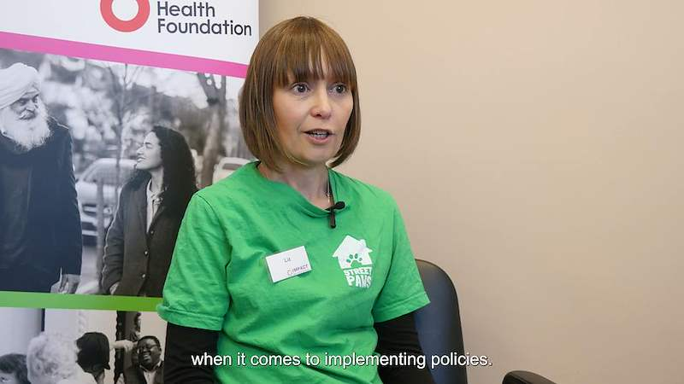
Video 10 – Liz Hardingham, Volunteer Coordinator, Street Paws
Liz talks about the importance of listening to people and partnership working

Summary
The Keeping Pets and People Together Charter is grounded in a strengths-based approach that recognises the human–companion animal bond as a powerful source of strength for people experiencing homelessness. The Charter seeks to support and protect this bond by building on four interconnected pillars - belonging, hope, purpose and resilience, which underpin every commitment and guide organisations towards more inclusive, relational and strengths-based practice.
Pet inclusion is not a special arrangement; it is part of designing services around real lives.

References
Animal Welfare Act (2006). Available at: https://www.legislation.gov.uk/ukpga/2006/45/contents

Animal Welfare (Sentience) Act (2022). C. 22. Available at: https://www.legislation.gov.uk/ukpga/2022/22

Cleary, M. West, S. Visentin, D. Phipps, M. Westman, M. Vesk, K. and Kornhaber, R. (2021) ‘The unbreakable bond: The mental health benefits and challenges of pet ownership for people experiencing homelessness’. Issues in Mental Health Nursing, 42 (8), pp. 741–746. https://doi.org/10.1080/01612840.2020.1843096

Garland-Lewis, G. Scott, E. Ramirez, V. Bove, F. Matus, C. Stiles, J. and Lem, M. (2024) ‘Shifting the focus: A Photovoice exploration of the benefits and barriers of having a pet while experiencing homelessness’. PLOS ONE, 19 (2), e0300161. https://doi.org/10.1371/journal.pone.0295588

National plan to end homelessness (2025). Available at: https://www.gov.uk/government/publications/a-national-plan-to-end-homelessness/a-national-plan-to-end-homelessness

Renters’ Rights Act (2025). Available at: https://www.legislation.gov.uk/ukpga/2025/26/contents

Social Care Institute of Excellence (no date) Strengths-based approaches. Available at: https://www.scie.org.uk/strengths-based-approaches/

Appendix A Participants and contributors

Pet owners with lived experience involved in co-developing this Charter and associated videos: Amy, Kerry, Justin, Ian and Stuart.

Name | Role | Area/Organisation
IMPACT
Rosie Ayub | Facilitator | IMPACT
Karen Watchman | Facilitator Delivery Lead | IMPACT
Irena Connon | Project Officer | IMPACT
Kimberley Coutts-Murray | Project Co-ordinator | IMPACT
Project Partners
Mackenzie Fong | Research Associate | Newcastle University
Michelle Southern OBE | CEO | Street Paws
Zoe Abbotts | CEO | StreetVet
Jenny Stavisky | Clinical Researcher | Vets in the Community
Harriet Page | Pets and Housing Manager | Dogs Trust (Together Through Homelessness)
Co-design group
Alex Anderson | Emotional resilience Officer | Tyne Housing
Dee Bonett | Co-production partner (Campaigner and Friend – The John Chadwick Pet Policy) | Maidstone
Mark Callis | Animal Welfare Services Manager | Richmond and Wandsworth Local Authority
Olivia Darbyshire | Team Leader for Emergency Accommodation | Manchester City Council
Liz Hardingham | Project Coordinator for Volunteering | Street Paws
Andrea Lester | Commissioning Manager | Homelessness directorate, Manchester City Council
Stuart Madden and Castiel | Co-production partner (lived experience of homelessness with companion animal) | Manchester
Jodie Mason | Growth and Engagement Project Coordinator | Street Paws
Wendy Miller | Senior Regional Engagement Officer | Dogs Trust (Together Through Homelessness)
Elizabeth Ormerod | Chairperson | Society for Companion Animal Studies
Jenny Roy | Policy Officer | Battersea
Sue Shaw | Community Manager | Emmaus Northeast
Joanna Turner | National Practice Development Project Manager | Homeless Link
Eleanor Watts MBE | Area Manager | Riverside Housing Group, Manchester

Charter for Keeping Pets and People Together
We make the following commitments as part of our pet-inclusive approach:
- We understand the importance of the human-companion animal bond.
- Our default position is to keep pets and people together.
- We have clear pet policies in place that support this Charter.
- We do not force separation except in genuine emergencies.
- We understand and respect, the emotional and physical support a pet can provide.
- We focus on individual situations and circumstances and do not make assumptions about ability to care for a pet.
- We have clear escalation pathways in place for complex situations and all staff understand this.
- We understand the importance of working in partnership with animal welfare, veterinary and homelessness organisations and are proactive in doing so.
- We have back-up plans in place should pet owners face temporary difficulties with a route to emergency care in place and this is understood by our staff.
- We welcome pets in this organisation.

You can download these Charter commitments here: https://impact.bham.ac.uk/wp-content/uploads/2026/07/Keeping-Pets-and-People-Together-Charter-Commitments.pdf

Improving Adult Care Together (IMPACT) https://impact.bham.ac.uk/
Newcastle University https://ncl.ac.uk
Street Paws https://streetpaws.org.uk/
Dogs Trust (Together through Homelessness) https://www.dogstrusthopeproject.org.uk/
StreetVet https://www.streetvet.co.uk/
Vets in the Community https://vetsinthecommunity.weebly.com/
Museum of Homelessness ‘Dying Homeless’ project https://museumofhomelessness.org/dhp
Street Paws’ campaign for national social housing standards https://streetpaws.org.uk/campaign

