Family Group Decision Making for adults affected by drugs or alcohol
IMPACT Facilitator Project 2024/25 (Scotland)
Lizzie Lane, September 2025

Project Background
IMPACT is a UK centre for implementing evidence in adult social care, with the vision that ‘good support isn’t just about ‘services’ – it’s about having a life’. In pursuit of this, the key objectives for the centre are to enable practical improvements on the ground and make a crucial contribution to longer-term cultural change. One way to achieve this is through Facilitator projects. Topics for these twelve-month projects are proposed by the agency, and a Facilitator is appointed to support bottom-up change. Based in the agency, Facilitators lead an evidence-informed Theory of Change project. Findings and outcomes are shared for replication across the sector.
The host of this project was the Family Group Decision Making (FGDM) team in the City of Edinburgh Council. FGDM, or as it is more widely known, Family Group Conferencing (FGC) is “a family-led decision-making process in which the family and friends network come together to make a plan” (Family Rights Group, 2024). Traditionally used in child welfare, the model was developed in the 1980s in New Zealand and is now offered in over 30 countries worldwide, including in some adult services in the UK. The FGDM team has been established in Edinburgh for over 20 years, providing FGDM in children’s services. A pilot from 2017 to 2019 offered FGDM in all areas of adult social care, but this was not continued. This second pilot is funded by Edinburgh Alcohol and Drugs partnership, through the Whole Family Approach funding stream, and runs from 2023 to 2026. The IMPACT Facilitator FGDM project took place from September 2024 to September 2025, so the pilot has another year to build on the work of the Facilitator. During the year of the facilitator project 134 referrals, that specified drugs or alcohol as an impact factor, were made to the team from children’s services. These referrals were out with the scope of the IMPACT project, which focused on referrals for adults, that would otherwise not have been made, thus are not included in the summary report.

Pre-Project Evidence

What Did the Initial Evidence Review Tell Us?
Adult FGDM
Professor Jerry Tew’s research (2023) suggests that FGDM can work for all adult service user groups. There is limited evidence of FGDM implementation within substance use contexts specifically, but these groups have been included in broader implementations of FGDM in adult safeguarding, such as in Camden, Hampshire, and Northern Ireland. These services highlighted the benefits of taking an FGDM approach, such as addressing complex family dynamics, service-users feeling more in control and respected after FGDM, and a greater understanding of the problem and needs. In all settings, it is noted that benefits of FGDM are not limited to the creation of a support plan, but that there can also be positive side-effects such as improved engagement with family, services, and community.
Outcomes and Measuring Success
The Evidence Review highlights that it has been difficult to analyse benefits and consequences of adult FGDM due to a lack of tracking data. In children’s settings, control group studies have shown that children whose family have a family meeting are more than twice as likely not to go into local authority care. In adult settings, De Jong et al. (2016) found that just over half of the 33 FGDM meetings they analysed could be considered successful, with quality and quantity of social support increased after the meeting.
Challenges and Barriers
Getting people to participate in FGDM is a challenge due to people feeling no need or wish to have FGDM, reluctance to involve the network due to shame, guilt, or difficult relationships, limited family or group network, or their willingness to engage. The person’s decision-making ability may also be a barrier, or a lack of confidence to voice their views. This has led to suggestions that advocacy could be helpful (Tapper 2010). The cultural background of the person, their family and community may also be a barrier due to varied power dynamics, values of respect and privacy, and of not showing or sharing vulnerabilities.
Professionals’ perceptions can also be a barrier as social care workers may not see the value of FGDM or may not understand it. Time pressures can also be an issue when agencies have short timescales for assessment and intervention plans.
Considerations and Recommendations
These include:
- The importance of meeting preparation
- Aligning FGDM with supported decision making and the United Nations Convention on the Rights of Persons with Disabilities; and other relevant support and carer policies.
- Use of advocacy to support the person’s participation.
- Advice on when not to use FGDM, such as when there is no network, and preconditions for safety are not met e.g. such as in some domestic abuse situations.

Project Aims
A theory of change was used to guide the project, and the aims were as follows:
- Encourage referrals from Health & Social Care (H&SC) and third sector,
- Consider the needs of adults impacted by drugs and alcohol alongside children’s needs when referrals come through children and families social work (the traditional route),
- Make links between FGDM with supported decision making that is now part of adult care service aims,
- Develop data collation tools for evaluation purposes.

Project Main Activities
The above aims were supported by the following activities:
- Increase awareness of the project by:
  - Making links with and visiting third sector agencies and health and social care,
  - Developing accessible information, where possible with people with lived experience,
  - Potentially mapping varied policy drivers and finding ways to visualise these effectively.

- Exploring outcomes by:
  - Seeking views of practitioners and people with drug and alcohol issues,
  - Codeveloping outcomes with people with drug and alcohol issues.

- Collating data and evaluating outcomes by:
  - Gaining learning from other FGDM services about what they are using for data recording and evaluation,
  - Attending learning events,
  - Developing and trying ways of capturing data.

How Did We Collect Evidence?
The initial focus of the project was to develop and trial data collection tools for adults with drug or alcohol issues and their families who had experienced the FGDM pilot. The data collection plan was developed (see Appendix 1) and aimed to:
- Capture and measure outcomes for the person referred to FGDM, their family or network members, and for social care services
- Understand who was being referred and why, and by whom
- Gain the perspectives of those who participated in the FGDM process
- Identify and quantify work undertaken by the coordinator
However, there were significant barriers to this data collection plan, as throughout the year of the facilitator project, few referrals were received. Of the meetings that did take place, it was only possible to speak to two people who had participated in FGDM and in both cases this was not the central person, whom the plan had been made to support (a breakdown of referrals and their outcomes are presented page 10). Additionally, the piloting of the pre and post measurement survey highlighted the need to take the context of people being referred to FGDM into account and be mindful of the potential impact of questions on people. For example, the coordinator felt that asking the person to rate their substance use, wellbeing, and connectedness raised their expectations of what might be achieved by FGDM and overlooked the long-term nature and impact of their struggles with substance use. This has led to consideration of how best to capture the difference FGDM has made to the person referred and its outcomes.
Given the lack of referrals, the scope of the facilitator project was expanded to include a review of perspectives on why few referrals were received, and worker and client perceptions of FGDM. The Facilitator spoke to a total of 21 people (see Table 1) who gave their views and topics raised.

Table 1: Group Views and Topic
Group Situation | Topics Raised
Conversations with people who have experience of adult FGDM for people with lived experience of drugs or alcohol.  N.B. both people in this category were family or network members and not the central person. | - Hopes and concerns about FGDM  - Experience of FGDM  - Desired outcomes | 2
Insights from professionals with lived experience of alcohol or drug use, who were not offered FGDM.  One discussion was facilitated by a team leader with their staff team of five people, while the other was a one-to-one conversation. | - Involvement of family  - When might FGDM work or not work  - Perceived benefits and concerns of FGDM  - Personal experience of recovery | 6
One-to-one conversations held with people who were offered FGDM and who declined. | - Perceptions of FGDM  - Benefits of FGDM  - Barriers to FGDM  - Practical considerations of FGDM- timing, privacy, family dynamic  - Involvement of family  - Professional barriers  - Advice on project | 2
Conversations with workers who have referred clients to FGDM. | - Impact on their client (changes in family involvement, circumstances, drug or alcohol use, local authority involvement)  - Perceptions of FGDM  - Barriers and enablers to FGDM  - Hopes for FGDM  - Experience of FGDM | 3
Conversations with workers who have not referred a client to FGDM. | - Perceptions of the service  - Family involvement  - Desired outcomes  - Barriers and enablers to referring | 4
Conversations with other FGDM service providers and researchers. | - Raising awareness  - How to encourage referrals  - Cost considerations  - Worker reticence | 4
Total number |  | 21

Additionally, two Microsoft surveys were circulated, one asking for the opinions of people with lived experience of alcohol and drugs on FGDM, and one asking for professional opinions on FGDM.
Finally, an end of project knowledge exchange event hosted by the Edinburgh FGDM team took place in September 2025. The event was attended by 26 people, contributors included the manager and person with experience from the established Camden FGC service, an FGC researcher, a local commissioner, alongside the Facilitator and Edinburgh Coordinator. This proved to be an effective way of confirming the common challenges of establishing adult FGDM, the strengths of the approach and how outcomes might be captured.

Project Outcomes

Raising Awareness and its Effectiveness
The Facilitator contributed to promoting the new FGDM pilot throughout the project year. In total 16 presentations have been given to social work and substance use teams in Edinburgh during the FGDM pilot. It is estimated that this method has so far promoted FGDM with 180 social workers and health and social care workers. Five of the presentations resulted in a referral, and one resulted in two, raising questions about the effectiveness of this approach to promoting the use of FGDM.
Information about FGDM was also shared in other ways. It was promoted in the Health and Social Care bulletin, reaching approximately 3000 people, and the service was also listed on the Council webpage and intranet. FGDM was also listed on the Addiction Recovery Companion (ARC) Edinburgh mobile application, and emails were sent to housing and family support teams.
Six local health and social care networking events were attended, two of which were in the duration of the facilitator project. A discussion was convened with the chairpersons of adult support and protection case conferences to promote FGDM as an option for adults at risk of harm. Links were made with the senior social workers in a justice service to request that FGDM was raised regularly during social worker supervision.
It has not been possible to track the effectiveness of these wider methods, however, the low referral numbers throughout the year indicate that these methods may not be effective. However, analysis of referrers who were not part of the teams visited, suggests practitioners might be more likely to refer if they had existing working relationships to the FGDM project team or who had been aware of the first pilot in adult social care. This has led to pilot staff attending recovery hubs and spending time in the team room to test whether building relationships with hub staff will lead to greater consideration of and referrals to the FGDM pilot.

Who is Referred
The Facilitator analysed the data collected by the FGDM team to explore who was referring to the pilot and by whom. The following charts demonstrate the characteristics of the 21 referrals received during the FGDM pilot 2023-2026.
Graph 1: Age of individuals referred to FGDM

The average age the of person being referred was 43 reflecting that people had often experienced several years of problematic substance use.

FGDM Process
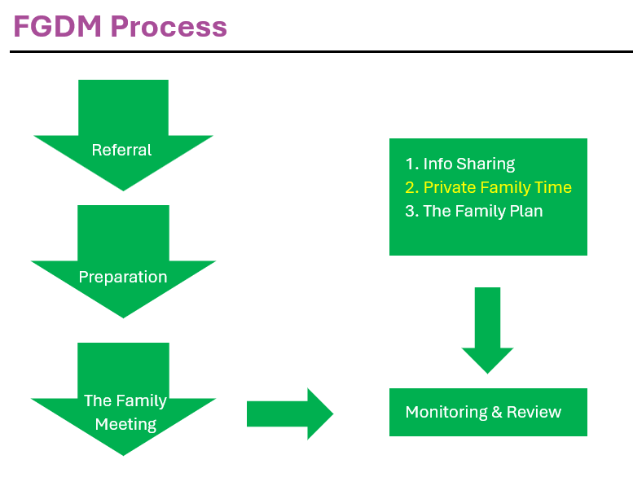

The FGDM process has several stages: referral, preparation, family meeting, agreeing the plan, and possibly review. Twenty-one referrals have been received, seven of which are ongoing, while the remaining have been closed. Of the seven ongoing cases, three have gone to family meeting and remain open as preparation for a review is underway. Graph 2 provides the service outcome for those referred.

Graph 2: Service Outcomes for Individuals referred to FGDM

Referrals
The referral begins through the FGDM contact taking the information from the referrer. Where the referrer is not sure if the person is suitable or has not yet gained consent from the central person, this is recorded as a ‘consultation’. It can be seen above that two such consultations resulted in the no further action. In these instances, it was because consent was not given.
Also, a referral can come in for one purpose but progress for a different reason. For example, a mother declined FGDM for her newborn baby, which was offered to help find alternative care options for the baby should this be needed. However, the mother accepted FGDM for herself, to bring her network together to plan to support her.
The most striking feature of the referrals demographic data was the gender imbalance as highlighted in this pie chart below. Two thirds of those referred were female, in contrast, men are more likely than women to misuse substances and are more likely to engage with support services, though the gap is narrowing (McHugh et al 2018).

This raises questions about whether women are more open to FGDM, or whether workers who refer hold gendered assumptions about the willingness of men to talk about their situation with family and friends. Of the 15 women referred, most had adult children.
The graph below shows who made the referral.

Graph 3: Person or Team who made the original referral to FGDM

Preparation
If the referral proceeds, the coordinator will contact all the network members, explain the process and collect their views, sharing them with the network as they go. This stage is where the bulk of the work takes place, as all network members are supported to share their views. Information sharing around substance use signposting of resources and signposting of services for support may also take place. The coordinator has to be skilled in working with members’ emotions, hopes and anxieties, so that everyone has a mutual understanding of the issues, and is able to come to the meeting, be blame-free, focused on the central person, and future-focused. Where there have been relationship difficulties and painful experiences involving the referred person and their network members, it can take significant time and effort to come to this point, and sometimes this point may not be reached. Yet often this work has been impactful for one or more of the people involved, an outcome which may not be recorded through a traditional evaluation approach that excludes those who did not go through the whole FGDM process. For this reason, ‘significant piece of work’ refers to outcomes which have occurred as a result of the preparation work undertaken which may not have otherwise been considered. So far, six ‘significant pieces of work’ have been recorded. For example, a parent wished to attend residential treatment, so childcare options were explored for their children. Though a meeting did not take place, the process of preparation showed both the parent and the referrer that there were several reasons why residential treatment was not possible. In this way, the preparation contributed to the process of change as the person referred, and the referrer gained a clearer understanding of what was or was not possible.
Six referrals were made by children and family’s social workers where the adult was the focus of the referral. It highlights the potential of an adult FGDM to undertake work that contributes to the long-term recovery of the parent, whilst another network focuses on the welfare of the child. In the 12 months from June 2024 to 2025, the children’s FGDM team worked 46 children’s cases in which alcohol was a factor, and 88 cases in which drug use was a factor. When alcohol or drugs are a factor in a child’s referral, even though the child is the central person, many aspects of the plan will relate to support for the adult, and these can be very similar to plans developed in adult FGDM. Given the high number of referrals in which the child is the central person, where drugs or alcohol were involved, adults in these cases could be routinely offered their own meeting. This dual offer - to adult(s) and child/ren - would vary case by case but may mean that different plans are made or that different networks are invited. This is something that might be considered in the final year of the adult FGDM pilot.

Meeting and Review
As noted above, only three network meetings have been held and as yet there have been no reviews. A neutral venue such as a community meeting place is agreed with the network member taking account of their transport and accessibility needs. Whilst there have been too few network meetings to draw conclusions on their effectiveness, the Facilitator was able to gain the views of two people who had been part of the referred person’s network and the referrer, which are explored below.

‘Sam’
There were no noted changes to the person’s substance use, involvement of services, or number of social supports involved. The quality of social support may have improved, with the family member noting that they ‘liked that [we] were getting everything out there’, and that previously, conversations with their loved one had been negative and argumentative. They found it useful to come together in the presence of the coordinator and hoped that they could make a clear plan together, and their loved one could see them all working together. This family member also valued that the process meant they met their loved one’s recovery worker, and they felt ‘really part of it’.
The referrer noted that the process allowed everyone to be on the same page, and that a plan was made. The plan in this case involved a return to education or employment and for the family to spend quality time together. The referrer noted decreased contact from the family member following the meeting, which they suggested may have been due to being on the same page, and that the family had reported spending good time together. At the time of writing, it is not known whether the plan has been followed.

‘Jack’
There were no known changes to this person’s substance use following FGDM. The friend noted that they were not sure if their drug use had changed, while the referrer noted that it was likely their drug use increased briefly, as some disappointing news was clarified during the FGDM process. Their friend provided feedback, noting that they had a ‘good plan’. They felt very involved in the process and that their friend, the central person, was still the main person ‘in charge’.

The plan in this case involved exploring whether contact could be regained with another family member. This was not possible, but the referrer suggests that this was a helpful outcome in terms of the decision-making regarding future plans. As above, the referrer found the process helpful to ensure that everyone was given a consistent message about what was happening. The referrer found the process useful in demonstrating who were supportive friends amongst their client’s peers.
The referrer has noted a decrease in the number of contact requests for support since the meeting and they suggested that the client’s friends, who were part of FGDM process, are helping them. This shows the potential of FGDM to increase the quality of social support.

The pivotal role of the coordinator was highlighted. Sam’s family member described FGDM an ‘excellent process’, ‘useful’, and ‘the best thing’. Sam’s referrer said that the coordinator was ‘on the ball really quickly’ which aided the process. The referrer said that the coordinator clearly had good discussions and established positive rapport prior to the family meeting, which made the meeting ‘flow well’ and created a nice environment. Jack’s friend said that what they had to say was taken as ‘valid’ and that the coordinator was ‘really easy to speak to’ and ‘non-threatening’. The process was described as ‘straightforward, reassuring, effective’ and they liked that it was informal. Sam’s referrer said that FGDM has been ‘really helpful’.

Wider Perspectives on FGDM
The following themes emerged from conversations with 21 people that explored people’s understanding of adult FGDM and when and why it might or might not be helpful.
- Family relationships
  - The nature of an individual’s family was raised frequently, with workers saying FGDM suitability depends on the family, and individuals who declined FGDM stating that they might have accepted the offer ‘if [they] had [their] friends and family around’ and advising it ‘depends on the person and family’.
  - The importance of family was prevalent in discussion. A professional with lived experience of alcohol or drugs shared that families and networks play a massive role in recovery, and any approach to tighten those family and friend bonds would probably have positive outcomes. This professional shared that in their personal experience, their family stepped in and offered support without being asked, and that this was massive in giving them a sense of self-worth back and reminding them of their role as a parent, a child, and a sibling. This idea was echoed by other professionals stating that they are glad to have access to FGDM and that it is a ‘powerful thing for people to see that there are people around them who want to help’.
  - Families’ differing priorities could cause issues. Timelines for seeking help may not match up, with either families or individuals not being ready at the same time, family involvement can be felt as controlling, and families can feel frustrated and that they have done all they can. Family may attempt to direct the recovery process in ways which do not align with the individual’s needs or autonomy. Professionals with prior drug or alcohol use shared that in their experience, the early stages of recovery can be particularly strained when family involvement is added to the mix.
  - One individual with experience of drug and alcohol use raised that she, as a woman, would be there for her brothers, but that she felt her brothers would not be able to be there for her. This again highlights the role gender can play people’s support networks.

- Nature of drug and alcohol use
  - Substance and alcohol use can often involve the loss of relationships, with most groups referencing ‘burnt bridges’, not having ‘anyone’, or losing touch with family. This is related to the element of time, with people with lived experience and workers noting that often significant time has passed without contact. One person with lived experience noted that in their view, their age made them less suitable for FGDM, as they were in their 40s, and it had ‘been years’ of addiction and those still around them would not be helpful. Several groups mentioned the origins of drug and alcohol use, with the perception that addiction can originate from family issues and that the ‘family might be the whole issue’. The case studies above highlight that a FGDM network is not restricted to family members. It has the potential to reconnect the person referred with friends and other significant people in their life.
  - Shame and embarrassment were mentioned by different groups as a barrier to involving families in FGDM.
  - Similarly, the theme of secrecy was highlighted as an element of alcohol and drugs, with one worker noting that on average people take 10 years before reaching out, and another interviewee noted that wanting to hide the extent of the problem is a common issue. In a similar vein, one person with lived experience said that it is possible some people using substances may lie about their use or abuse the help offered to them. Another person with lived experience noted that when she used drugs, her brother would not have her at his home for fear that she would steal from him.
  - The practical considerations of drug or alcohol use were considered, and one person with lived experience noted that ‘things like appointments at doctors don’t happen’ as using is the ‘most important thing’. The ‘cycle’ of drinking or taking drugs every day means that logistically, getting everyone together may be difficult. Alcohol or drug use may also involve a less linear progression than other diseases.
  - Recovery models vary and may be at odds with involving family at various stages. Many recovery models emphasise personal responsibility and taking ownership of behaviour. There was no consistent belief around when FGDM would be helpful, with some believing it should be offered to people in recovery or having finished treatment, to younger people, or to people in active use.

- Service generated issues
  - Risk was raised both by people with lived experience and workers. One worker stated they are ‘wary of situations with domestic violence’ while another offered FGDM to a client, only to realise that coercive control was present in the family dynamic. Workers also expressed ‘reservations’ around bringing family and friends into planning.
  - Wariness of services was raised, with people feeling concerned about what health or social services may do, including that children may be removed.
  - The feelings engendered by bringing people together were explored, with people suggesting they would find this an intrusion, patronising, and scary. On the other hand, it could also be experienced as a ‘wake-up call’ and that it could be powerful to know people will come together to help them. This highlights the importance of a skilful coordinator to identify and navigate the emotional dimensions of the FGDM for the person referred and the people who are invited to be part of the process.

- Worker barriers
  - Workload was raised by workers as a reason for not referring clients, with several mentioning that they are busy and that they may not offer FGDM and / or seek advice about it if they were uncertain because this would take more time. This was closely related to issues of priority, with some workers stating it is not in their role to discuss FGDM with other tasks taking precedence.
  - Some workers were aware of assumptions they make about clients’ peers and families, focusing more on risk than the potential for pro-social support.
  - Workers highlighted a lack of clarity about the model. Not knowing when to refer and not knowing where to find this information meant that FGDM was not offered. People with lived experience advised that workers need to be enthusiastic and need to understand the process fully to share this with clients and generate enthusiasm. Similarly, workers may not see the depth and intensity of the work that can be achieved in FGDM and therefore do not see its contribution. One client who declined FGDM shared that they had not known that a coordinator goes out and meets individually with all members of the network.
  - There may be a perception that FGDM is not different to social work practice. This was primarily raised by workers experienced in other adult FGDM services, but one worker in drugs and alcohol raised that staff and clients may not see the benefit of involving family, until ‘it gets to something like guardianship’.

- Implementation
  - Workers and managers from other adult FGDM services emphasised the importance of good first impressions. Sharing positive case studies can be helpful to show how and why FGDM is working well. The benefits to workers should also be shared to encourage referrals. People with lived experience highlighted that rules are essential to ensure it is a positive experience, and clarify that it is a ‘safe space, no judgement’.
  - There needs to be clarity on what information is shared. However, there was no consensus on this, with some workers feeling coordinators may benefit from knowing background information, so clients do not have to repeat themselves, while some people with lived experience feel uncomfortable with information being shared openly with everyone in the network.
  - Other adult FGDM services in the UK advised that attendance at multidisciplinary team and allocations meetings are essential to keep FGDM in workers’ consciousness and allows it to be offered at the earliest opportunity.
  - These other FGDM services advised that adult FGDM can have a ‘slow start’ and requires constant promotion, involving presentations, attendance at meetings, and liaison with workers. Relationships with workers can be central to this, and finding champions and allies to promote FGDM in their area can boost uptake of the service. Similarly, these services advised that senior management needs to be on board for staff buy-in. The comparison with FGDM in children’s services was made, with some noting that FGDM in children’s services did not receive prominence until it was put into legislation in 2006 in England.
  - Opinion was split on whether to highlight cost savings, with some professionals highlighting that this can be a significant draw for budgeting local authorities, while others saw it as ‘dangerous’ to view improving social care as a cost-cutting exercise. While FGDM could result in less contact with services, it can also result in more contact as people have their wider health and social care needs met.
- Evaluation and Outcomes
  - At the time of writing, three initial networks meetings had taken place, and reviews were being planned. What we did learn was that positive change can happen at different stages of FGDM for the person referred, referrer and the family and friends who made up the person’s network. Therefore, it is important to capture and record these hidden process outcomes as well as the longer-term outcomes that might be sought after the FDGM intervention has been completed in full. The pilot demonstrated that hidden process outcomes could address whole family wellbeing.
  - Hidden outcomes could be captured in a systematic way to strengthen the evaluation of the pilot. For example, whether involvement in any part of the FGDM process:
    - Led to a deeper understanding of substance use and its impact on people.
    - Improved assessments of the referrer.
    - Clarified feasible options for the person referred.
    - Lead to person(s) in the network accessing a service.
  - The following process outcomes were suggested by one of the network members:
    - Plan-focused questions, such as whether the plan is clear, inclusive and feasible,
    - Whether the central person and network are happy with the plan,
    - Whether the central person felt in control of their meeting,
    - Whether everyone felt that they had a voice during the meeting and were able to participate.
  - Feedback from the two network members who went to a family meeting said that their ideal outcome was very plan-focused and person-specific. This may indicate that for the referred person having a meeting, individual goals are more important than more generic longer-term goals such as reduced substance or alcohol use or more social connection. This suggests measuring outcomes on an individual basis will be an important part of any evaluation.
  - Longer term outcomes could be measured by tracking individuals on a case-by-case basis. The referrers could be asked to compare the referred person’s current situation, if known, with their situation prior to FGDM. This could include whether and how their pattern of engagement with services had changed.

End of Project Event
A joint event hosted by Edinburgh City Council and IMPACT entitled: Edinburgh's Story: Family Group Decision Making for Adults Affected by Drugs or Alcohol was held on 4 September 2025 at the City Chambers in Edinburgh. The event was attended by members of the social care workforce including a service commissioner, service manager, team managers and social care practitioners. Kareen Caldwell, FGDM Team Manager, chaired the event with key talks from Neil Stewart, Edinburgh Drugs and Alcohol Commissioner, Dr Mary Mitchell, Senior Lecturer in Social Work, and Sean Ahern, Manager of FGC in Camden. The event also welcomed a guest from Camden with lived experience of FGC.
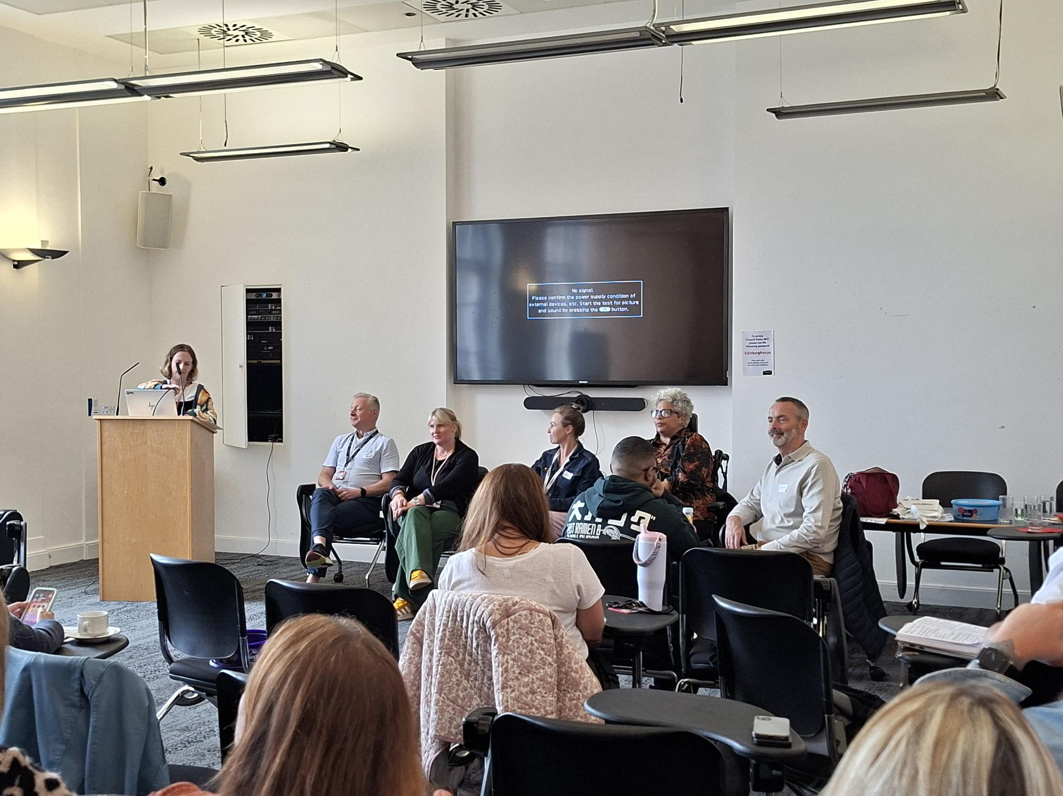

Photo: Q&A Panel at the end of project event
The event was opened with a presentation from the Edinburgh FGDM Coordinator and IMPACT Facilitator highlighting work from the project and the findings to date. Each subsequent talk/presentation emphasised the value of FGDM, from ongoing research (Research | Family and Group Conferencing) to establishing a successful FGDM service, and offered suggestions to help overcome the challenges noted above. A Q&A panel was held with panel members: Pamela Dudgeon, FGDM Coordinator; Neil Stewart, Commissioner; Vicki Murray, Edinburgh Health and Social Care Service Manager, and then Sean Ahern and Michaela Calvert, from FGC Camden. Each member shared their views and experiences of FGDM and answered audience questions that had been submitted via Menti Meter (see Appendix 2).
Whilst this event marked the end of the IMPACT Facilitator project, it was also a platform to promote the FGDM service as it entered its third and final year of funding.

How Did we Make a Difference?
The following changes have been initiated and are ongoing. It is hoped that they will be useful resources or strategies which will encourage uptake of FGDM and generate more interest in the final year of the adult FGDM pilot.
- A partnership with one of the locality recovery hubs has been established. This involves attendance at the weekly multidisciplinary meeting, forging relationships with nursing, social work, and third sector staff, and a physical presence in the hub, which will allow for consultations and clinics to be offered.
- New pathways for referral are being developed. A carers pathway will involve development work with the Social Work Carer Support Team to integrate FGDM as part of their planning. FGDM has been added to the discharge planning form from residential rehabilitation. It is hoped this will prompt consideration of FGDM for every person leaving rehab. Ongoing development work is also underway with this team with further training planned and offers for consultations made. Automatic processes to offer FGDM are important in generating referrals and embedding a service improvement. Examples of scenarios which prompt automatic consideration of FGDM in children’s services in Edinburgh include when notifications are received for unborn babies who may require a social work service, when a child has been referred for substitute care, when new interagency referral discussions are raised by the child protection resource team, and during assessment of risk and need.
- Discussions are ongoing about creating a short training course on adult FGDM on Edinburgh City Council’s learning and development platform, which may increase workers’ understanding of and interest in the FGDM model.
- A number of outputs are being created, which can be shared with workers making referrals and individuals, families and networks considering FGDM. These will include a blog and a timeline mapping the policy drivers which support the use of FGDM in a drug and alcohol context, and a Q&A document outlining frequently asked questions about FGDM.

Conclusions
Awareness of this adult FGDM pilot was increased across the city of Edinburgh, through presentations and other forms of promotion as discussed above. The low number of referrals has limited the scope to try different methods of evaluating the impact of FGDM in people’s lives. Whilst referral numbers limited this aspect of the project, a lot has been learnt about how FGDM might be better evaluated. Standardised pre and post intervention measurement tools were found to not fit well with the FGDM process. The project identified three different types of outcomes: hidden, process and longer-term outcomes. It is important that all three can be identified and recorded to strengthen the evaluation of the FGDM project. It is also important to recognise that different participants may view or value outcomes differently such as when the two participants of family stressed that the success of their loved one’s individual goals would be the most important outcome for them. This learning also reflected the perspectives of the Camden FGC service and the most recent research in this area, shared at the end of project knowledge exchange event.
The wider conversations with people with lived experience of alcohol or drugs, managers and practitioners, support the findings of the evidence review, in terms of the barriers to using FGDM. These include professional scepticism, lack of understanding of the model, complex family dynamics including loss of relationships, shame and embarrassment, and concern about risk.
Finally, the low number of referrals in Edinburgh aligns with the experience of more established adult FGDM services and with the evidence review highlighting that the foundation of a new service can be slow and requires significant and ongoing promotion to be embedded within the local social care landscape. This core challenge, identified by IMPACT, creates a strong argument for the continued funding of adult FGDM to allow sufficient time and numbers to properly evaluate its impact.

References
De Jong, G., Schout, G., Meijer, E., Mulder, C. L., & Abma, T. (2016). Enabling social support and resilience: outcomes of Family Group Conferencing in public mental health care. European Journal of Social Work, 19, 731-748. doi:https://doi.org/10.1177/1468017314547675
Family Rights Group. (2024). Family Group Conferences. Retrieved August 10, 2025, from Family Rights Group: https://frg.org.uk/family-group-conferences/
McHugh RK, Votaw VR, Sugarman DE, Greenfield SF. Sex and gender differences in substance use disorders. Clin Psychol Rev. 2018 Dec;66:12-23. doi: 10.1016/j.cpr.2017.10.012. Epub 2017 Nov 10. PMID: 29174306; PMCID: PMC5945349.
Tew, J. (2023). Setting the Scene: A Brief Introduction about FGCs in Adults and the Research Project. Retrieved from Community Catalysts: https://www.communitycatalysts.co.uk/fgcforadults/research/

Appendix 1: Data Collection Plan

Data type | Outcome | Indicator | Measurement tool | Method
Outcome | Improved wellbeing | Wellbeing score | Self-report | Survey at start and phone call post meeting
Outcome | Reduced local authority involvement | Local authority involvement pre and post FGDM | Observational Questions to the social work referrer(s) | Phone call with referrers
Outcome | Improve family participation | Level of family participation | Observational question to the social work referrer(s)  Self-report from service user | Referrer phone call  Pre post survey  Phone call post meeting with person referred
Outcome | Reduced alcohol/substance misuse | Level of alcohol/substance misuse | Self-report &  question to the referrers | Survey  Post phone call  - person referred  -referrers
Referred population | Who is being referred  Who is referring in and why |  | Descriptive statistics | Referral form
Process feedback | To gain insights about what did and didn’t work from service users/ referrers/coordinators | Level of satisfaction with stages of FGDM and advice how to improve | Observational Questions | 1:1 call post intervention with service users and family members  1:1 call with referrers  1:1 call with coordinators
Output | To understand the work undertaken for each person referred | Level of engagement with each stage  Work undertaken  Reasons | - Mapping referral, planning, meeting and review activity  - Quantifying work in tasks and hours | 1:1 calls with coordinators

Appendix 2: End of Project Event Menti Meter
