DRAFT

Developing an internal monitoring and inspection process: enhancing choice and control for people with a learning disability.

IMPACT Facilitator Project (Northern Ireland)
Laura Doyle, August 2025

Project Background
IMPACT is a UK centre for implementing evidence in adult social care, with the vision that ‘good support isn’t just about ‘services’ – it’s about having a life.’ In pursuit of this, the key objectives for the centre are to enable practical improvements on the ground and make a crucial contribution to longer-term cultural change.
IMPACT Facilitators are focused on supporting bottom-up change. They work within a local organisation leading an evidence-informed Theory of Change project. Findings and outcomes are shared for replication across the sector.
The local organisation involved in this twelve-month facilitator project was Positive Futures. Positive Futures are a leading charity based in Northern Ireland and Republic of Ireland who support people with learning disability, acquired brain injury and autism.

The focus of this 12-month Facilitator project was supporting Positive Futures to develop and enhance their internal monitoring and inspection process. The aim was to inform practice by identifying how to meaningfully increase the involvement in this process by individuals with a learning disability. The intention was to support Positive Futures, and other organisations, to formalise their internal monitoring processes and to support preparation for, and involvement in, external inspection.

Pre-Project Evidence
One of IMPACT’s core values is that evidence should include different types of research evidence in addition the lived experience of people using services and the practice knowledge of social care staff. This section provides a summary of the initial research evidence on the topic of enhancing choice and control for people with a learning disability.

What did the research evidence tell us?
The concepts of choice and control have become central to disability policy and practice, particularly for individuals with learning disabilities. This shift reflects a move away from care models, which often positioned individuals with a learning disability as passive recipients of services, towards a framework that emphasises empowerment and human rights. Within the UK this has been reflected in legislation, policies and practice schemes that have emerged to enhance choice and control for individuals with learning disabilities including Personalisation (through mechanisms such as Personal Individual Budgets and Direct Payments), Supported Living, and Person-Centred Practices.
The Department of Health in Northern Ireland has been a key advocate, defining personalisation in social care as enabling service users to have "choice and control over the care and support they need to achieve their goals, to live a fulfilling life, and to be connected with society" (Department of Health, 2012). Such models are part of the broader movement toward empowering people with learning disabilities to live independently and fully participate in society.
However, while the principles of choice and control have been widely accepted in the literature, challenges remain in terms of implementation into practice. The IMPACT review identified minimal evidence, especially from the perspectives of individuals with learning disabilities of active involvement in decision making and realisation of choice and control in everyday interactions (Bigby et al., 2017; Bond & Hurst, 2010). Service providers within adult social care have a legal duty to meet regulatory responsibilities and provide high quality service provision for individuals with a learning disability. Yet, there is a lack of published evidence on how best to support the active involvement and inclusion of individuals with a learning disability in regular monitoring and statutory inspection processes. This is a significant gap, hence the rationale for the current IMPACT project.
Current monitoring and inspection practices in Northern Ireland
The current practice of regulatory external inspection in Northern Ireland (NI) is largely through questionnaires and formal reporting mechanisms. Recent developments within the regulatory inspection process have included co-produced user-friendly questionnaires and reports with people with learning disabilities which have contributed to good practice in this area. However, it was noted by regulator inspectors that current Northern Ireland regulations for supported living are outdated and in need of imminent review.
The host site, Positive Futures, already provided opportunities for people with learning disabilities to share their views through one-to-one monthly monitoring visits, annual consultation focus groups, annual surveys and opportunities to provide feedback through an electronic form and via electronic Q codes. However, to support organisational learning and development, Positive Futures were keen to work with IMPACT, particularly in terms of developing their knowledge on co-produced evidence-based principles to ensure that their monitoring practices were meaningful to the people they support.

Project Engagement

Project aims
- To increase involvement of people with a learning disability from minimal towards planned, regular (monthly) co-produced/ developed involvement in the monitoring of internal quality of support.
- To start a co-production process that would enable Positive Futures to develop their own internal tool to guide the above process and to inform annual regulatory inspections.

Co-production in action
The people involved in the project included individuals with a learning disability, front line support workers at Positive Futures and elsewhere, managers, learning disability service providers and regulatory inspectors. Aligned to IMPACTs co-production approach, people with learning disabilities and their support staff were involved from the outset of the project. An expert by experience monitoring group, who named themselves ‘The Incredibles’ consisted of six regular members and different support staff who joined the group each month. Images 1 and 2 show the group who later collaborated with an artist to help the group visualise their lived experiences and relationship with monitoring in a way that was meaningful to them. Appendix A visually demonstrates the group's roadmap to inclusion in monitoring.

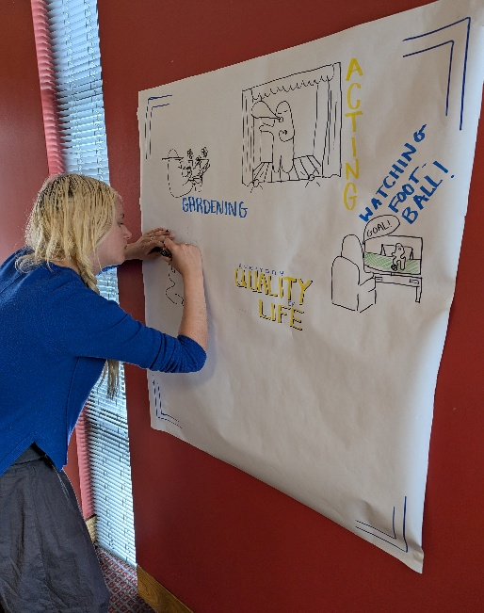
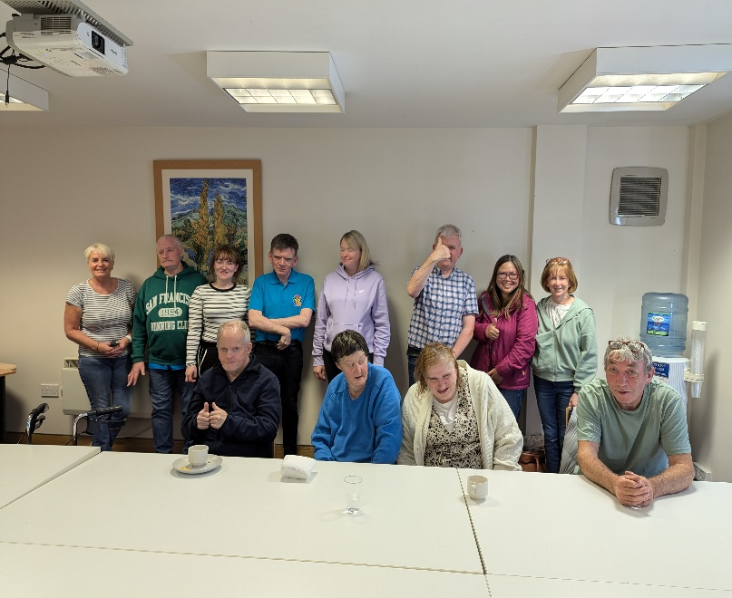
Image 2: Graphic artist recording co-creation of the group’s messages
Image 1: Picture of expert by experience co-production group

Engagement activities
The purpose of the focus groups and one to one engagement was to gather local evidence from people who draw on care and support, to identify what their enablers and barriers were in the specific context of choice and control in relation to the monitoring and inspection process. Additionally, Positive Futures has an advisory board (which includes people with learning disabilities). The Board meets four times a year to provide advice and leadership to Positive Futures leadership team and Directors. The IMPACT facilitator worked with this group by gathering their views on monitoring and providing progress reports over the 12-month period.
In total there were 18 focus groups and 20 one-to-one interviews conducted between November 2024 and May 2025:
- 3 Positive Future focus groups with Advisory Board (Positive Futures has an advisory board which includes people with learning disabilities). People with a learning disability (n=7), support workers (n=7)
- 3 focus groups from external peer monitoring groups (this included other learning disability organisations) (n=5); including people with a learning disability (n=9) and their support staff (n=10) who attended the group.
- 1 focus group with IMPACT Co-production advisory group (n=5)
- 10 focus groups with an expert by experience monitoring group from Positive Futures, The Incredibles, - People with learning disabilities (n=6), Support Staff (n=7)
- 1 focus group with only frontline support workers from Positive Futures (n=9)
- 20 one to one interviews with Positive Futures front line staff (n=2), Positive Futures Management (n=15), Regulation Quality and Improvement Authority (RQIA) Inspectors (n=3)

Project Findings
Findings are broken down into points to note before, during and after internal monitoring activity.
BEFORE
Preparation for Monitoring & Inspection
People with a learning disability told us:
People with a learning disability spoke of not fully understanding the monitoring/inspection process and their subsequent lack of interest in participating. For example, the terms ‘monitoring’ or ‘audits’ were difficult to understand. This impacts on confidence and ability to feel informed and participate fully in the process. Feedback suggested that monitoring should be linked to an individual’s everyday experiences and life goals in order to develop a shared understanding and readiness for participation. Image 3 shows what mattered to The Incredibles and what they believed the monitoring process would include as part of providing individualised support.
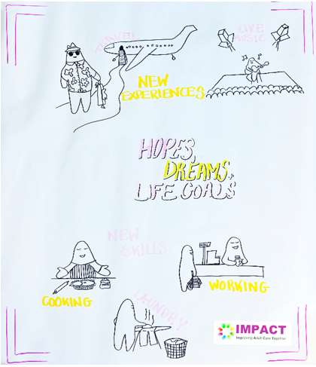
Image 3: Knowing the person was identified as important before involvement in the process

Staff told us:
Positive Future staff provided positive examples of practice such as using easy-to-read language resources, for example PhotoSymbols, to share information for the people they support. Regulatory inspectors reported sharing information about the inspection process through visual posters. They also highlighted the development of co-produced user-friendly questionnaires and reports within the inspection process.
The IMPACT evidence review told us:
There were minimal points raised within the evidence review in relation to the experience of people with a learning disability of preparation for monitoring and inspection suggesting that a person-centred approach was less evident at this stage of the process. Findings from our Facilitator project support the points raised in the evidence review that individuals with learning disabilities need access to relevant information about the process and recognition of their rights to help them make informed choices for full participation.

DURING
Participation in Monitoring & Inspection
People with a learning disability told us:
The 14 individuals we spoke to with a learning disability from Positive Futures told us they liked others to listen to their stories and experiences and viewed monitoring visits as a space for this to be valued. Examples included the importance of being connected with their community, to help support with meeting new friends, to have social outings and acknowledgement of their hopes and aspirations whether that be going to concerts, traveling or working. Some people told us they enjoy visiting other people’s homes, with one person reporting they had been involved in visiting another supported living service to talk to them about their experiences of living in their home. Others told us they like to come together regularly as a group to share their experiences of the support they receive and share ideas for improvement. Different people had different views on how they liked to share their experiences. One person preferred to give feedback on their life by drawing, another by taking and sharing photographs. Singing, writing a letter, or mood boards were expressed as other options that people liked and felt was valuable when being asked about their preferences and opinions. Most people agreed that their support staff were helpful in improving their understanding and participation of monitoring, but not everyone agreed that technology was a helpful way to participate, as it was not always accessible or easy to use for all. Images 4 and 5 provide further visual representations of the discussion.
Image 5: Everyday Quality of Life
Image 4: Community Support Networks

Staff told us:
Frontline support workers and management from Positive Futures identified focus groups as a helpful part of the monitoring process for the people they support who have the skills and confidence to express themselves verbally. However, this approach will not always be appropriate for individuals with specific sensory needs. A frontline Positive Future staff member highlighted the importance of allowing both people with learning disabilities and staff to provide anonymised feedback with internal monitoring processes, “Especially when you have an issue that you don't want to share within a group setting”. Therefore, personalised and a variety of options are important to use in this context.
Positive Future frontline staff noted that they currently use a range of methods to support adults with learning disability to participate in everyday decisions including whiteboards, roadmaps, PECs boards, Makaton, social stories and communication boards. However, they also informed us that they would be keen to develop their capacity and skill to include interactive technological methods e.g. iPad, and personalised individualised systems through technological apps.

The evidence review told us:
Similar to Person Centred Planning (PCP) and Person-Centred Active Support (PCAS), personalisation for people with learning disabilities should offer choice and control over the way they wish to provide feedback on the support and services they receive. The evidence indicates that this requires a move away from standardised solutions to an approach that tailors to a person’s individual preferences, active participation and daily engagement in meaningful activities. For example, small or brief stories and photographs can promote inclusive practices for people with specific sensory needs. This can be achieved by using a combination of words and pictures to animate the perspective of someone and help to understand body language and facial expression which are also forms of communication.
As reflected by people with a learning disability and staff at Positive Futures, the evidence further suggests that staff and family members play a critical role in encouraging participation and decision-making in a person’s life. Staff can make significant contributions to monitoring, capturing, observing and documenting individuals’ preferences and interests. However, it was noted that professionals and family members can sometimes unintentionally undermine the autonomy and participation of a person with a disability. For example, by speaking on their behalf, or speaking for them. Ongoing engagement and observation was identified as significant in identifying new skills and areas of interest that support the person’s interests, goals and preferences in addition to involvement in a one-off monitoring or inspection meeting. The evidence suggests use of communication aids are often lacking in organisations. Similar to findings from staff, this supports the need for additional resources and training in helping support staff develop their knowledge and application of technological tools in helping to understand the unique wishes and interests for the people they support.
AFTER
Closing the Feedback loop in Monitoring and Inspection
People with a learning disability told us:
Most agreed that any feedback from monitoring should be explained and agreed with the person as part of an ongoing feedback loop, others felt if it was an immediate issue, it should be resolved quickly through action and communicated with the person.
Staff told us:
They would like to have more information about any outcomes or changes they needed to action in their role following monitoring feedback, and that this was in accessible formats. Some support workers perceive monitoring as a senior role and responsibility. Others viewed it as part of observing and their daily work. They discussed that through routine interactions relationships were built with the people they supported. This includes being aware of small changes in a person’s life, improving positive risk taking or tailoring support to the person.
The evidence review told us:
Whilst evidence was limited about feedback from an inspection process, findings indicate that individualised feedback approaches are important and need to be in a way that is meaningful for the person. As part of ongoing monitoring promoting people with a learning disability as core decision makers is a helpful strategy as this ensures involvement after a one- off monitoring activity. For example, involvement in democratic citizen juries or time banking or through strengthen self-advocacy training and support through co-production. Overall, the evidence suggests that there is often not a clear feedback loop, in accessible formats which is a targeted area for improvement.
Barriers to Implementation
People with a learning disability told us:
People with lived experience reported their struggles with long forms. They viewed them as complex and ‘daunting’. Equally the move towards digital capturing of data was viewed as problematic and not always accessible for all.
Staff told us:
Frontline staff at Positive Futures spoke of the challenges and dynamic nature of a support worker role, that can impact on internal monitoring processes. As one support worker highlighted “Things don't always go to plan”. It was important to operational managers in Positive Futures that monitoring was not just a process of “Having a tick box to fill in”.
External stakeholders (RQIA)/other learning disability providers told us:
Other learning disability providers highlighted organisational time and constraints that impacted on monitoring. For example, their capacity was limited within internal monitoring visits to cover all individuals across all schemes, thereby a sample of people’s voices was often heard instead. Wider workforce challenges within the adult social care sector and high turnover of staff impacted on formal monitoring processes. For example, visits sometimes had to be proposed or cancelled due to staff absences. To overcome such barriers, learning disability providers highlighted the benefits of a peer evaluation model within monitoring. For example, a person with a learning disability is trained to peer review the quality of other supported living services. This was reported as helping the person giving the feedback to feel more at ease from speaking with their peers.
Inspectors highlighted challenges, particularly in terms of unannounced visits. For example, some people were out of the home or did not always want to participate on the day. When inspectors did engage with people with a learning disability in inspection visits, they felt that sometimes the presence of staff within monitoring and inspection may impact on a person’s independence and autonomy to feel completely comfortable sharing their full range of experiences. Largely, issues tend to be raised by people with a learning disability or staff within monitoring and inspection when they felt the quality of life of a person was not what it should be, as one regulatory inspector highlighted: “It is important not to always look at the deficits but to capture the good stuff. How do we capture the good stuff?”. Highlighting the need for a positive feedback loop within monitoring and inspection processes.
The evidence review told us:
The gap between "choice in principle" and "real choice" is often shaped by resource limitations and budget constraints, infringing on the rights of people with disabilities to access clear information, particularly in times of austerity.

Where change would make the most Impact
In response to some of these barriers, practical calls for action have been provided in the IMPACT project output, a guidance document Guide to Including people with Learning Disabilities in an Internal Monitoring Process: Co-developed Guidance for Service Providers. This provides practical, evidence informed solutions for change within monitoring and inspection processes.
In summary, meaningful and inclusive monitoring for people with learning disabilities requires an approach that includes:
A shared understanding of what the monitoring process means and how they may be involved in it. Developing easy read/visual resources and communication aids on the purpose of monitoring. Relating monitoring to a person's everyday activities and life goals and creating and sharing options of how to get involved.
Recognition and respect for individuality in opinions, lifestyles and communication. There was agreement that everyone is unique. To support such diversity there needs to be a shift from standardised monitoring solution tools towards bespoke, personalised tools. This includes a range of options, such as focus groups, small stories, photographs, one to one and technological tools. Monitoring involves continuous observation, from staff and family, to support an individual's unique lifestyle.
Building capacity for staff to ensure the active involvement of people with a learning disability in both hearing the voices and in ensuring closure of the feedback loop. Self-advocacy initiatives and co-production are important factors in building capacity both for staff and a person with a learning disability. This can be strengthened through self-advocacy training and co-production practices and peer to peer monitoring practices. Creative positive feedback loops, such as simplifying paperwork and communicating concrete actions with both staff and a person with a learning disability through visuals and other accessible methods is key.
This summary report and guidance document have the potential to be used by other learning disability providers and regulatory inspectors interested in meaningful and inclusive monitoring for people with learning disabilities.

Appendix A – Co-developed roadmap
