Case studies for

Boosting employment for people with a learning disability

Case Study: Seimon
Background:
Seimon is a 50-year-old man living in supported accommodation in Gwynedd. He previously held a full-time paid role in construction but stopped due to a health change. He now receives extensive support from Seren and is very active in day services.

Challenges:
- Lives with epilepsy (though seizure-free for 16 years) and diabetes.
- Wary of benefits being affected if he returns to paid work.
- Feels underchallenged in day services and seeks variety and purpose.
- Wants work under 16 hours to retain benefits.

Support and Progress:
- Identified career interests in construction and builders’ merchants.
- Will begin a course with Academy Adra including classroom and placement components, followed by 16 weeks of paid work.
- Undertaking a practical volunteering placement rebuilding a day service facility in Dolgellau.
- Receives structured support from key worker and social services.

Impact:
- Seimon feels excited and empowered by the opportunity to contribute meaningfully again.
- Has grown in confidence and sees a path forward that doesn’t risk his benefits.
- Enjoys variety and having tangible goals like training and placements.
Journey through the Supported Employment Programme
Seimon has a rich work history in building and maintenance but was signed off following serious epileptic seizures. For years, he attended day services but remained restless. When referred to the programme, he was clear: “I want paid work. I don’t need to volunteer. I’ve got experience.”
The Employment Pathway Coordinator’s assessment highlighted both ambition and caution. Seimon needed work under 16 hours to retain ESA. Most employers wouldn’t accommodate that. The programme sourced specialist opportunities and referred him to a tailored course with Academy Adra; two weeks classroom, six weeks placement, and 16 weeks paid work with a contractor.
While waiting for the course, the Employment Pathway Coordinator and Job Coach arranged a time-limited unpaid placement with Gwynedd Council’s day services team in Dolgellau, rebuilding a facility for adults with learning disabilities. Here he will gain a UK-wide accredited reference.
The programme’s flexible response, balancing benefits concerns, skill level, and motivation, has given Seimon a real path back into paid work. He feels proud, purposeful, and listened to.

Case Study: Steven
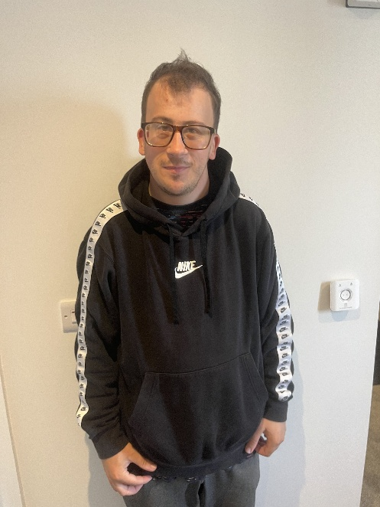
Background:
Steven is a 30-year-old man who recently moved from living with family to supported living and now to independent living in Valley. His goal was clear: he wanted paid employment, specifically in mechanics.

Challenges:
- No prior paid employment history.
- Nervousness and anxiety when starting new environments - he initially cancelled mechanic training sessions due to nerves.
- Low aspirations on his work potential from everyone around him.
- Struggled with rejection from job applications and lacked confidence.

Support and Progress:
- Was supported to complete an introductory mechanics course.
- Faced a setback when a garage rescinded a work placement.
- Was encouraged to try volunteering as a stepping stone. He resisted at first, wanting only paid work, but eventually agreed to a role in a charity shop.
- Began volunteering one day per week, which expanded due to his performance. There are now discussions about potential paid employment.

Impact:
- Steven's confidence has grown significantly.
- He feels valued at his volunteer role, which has positively affected his mental health.
- He now sees possibilities beyond mechanics, demonstrating openness and adaptability.
- He has helped encourage others to join the supported employment project.
Journey through the Supported Employment Programme
Steven was referred to the programme by his social worker, who shared that Steven found it very hard to commit and changed his mind frequently. There was a sense that if he ever managed to get a paid job, it would be a real win. However, Steven had other ideas. He was living in supported housing and absolutely clear that he wanted paid work, and specifically, to be a mechanic.
After an initial assessment by the Employment Pathway Coordinator, Steven was supported to try a short introductory mechanics course. His anxiety made attendance difficult at first, and he cancelled several sessions. In response, job coach staff from Agoriad arranged a tour and accompanied him to the first session, building familiarity and confidence. He later attended independently.
The programme supported job applications and searched for garage placements. One garage offered experience but then withdrew. Facing repeated knock-backs, Steven’s morale dipped. He was reluctant to volunteer but eventually agreed to try a charity shop role in Holyhead. The Employment Pathway Coordinator and Job Coach framed this as a stepping stone, not a diversion from his goals.
Steven’s success there changed everything. He started with one day a week and was quickly offered more. The charity now discusses paid hours. His confidence, mood, and motivation have significantly improved. Once seen as a “non-starter,” Steven is now an informal ambassador for the programme.

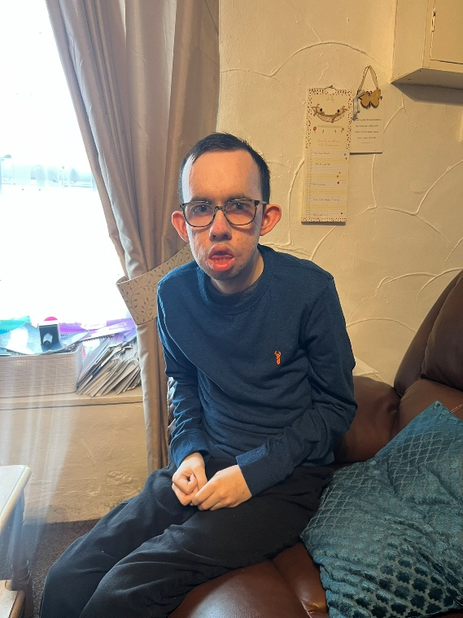
Case Study: Rhodri
- Age: 22
- Location: Llanberis, Gwynedd

Employment Journey
Rhodri completed the Pathway 4 programme at Ysbyty Gwynedd where he gained practical work experience and developed strong time-management skills. He is highly motivated, knows what he wants, and manages his own calendar. His mum initially had concerns about his independence, such as using public transport and managing early starts, but Rhodri has gradually overcome these barriers.

Volunteering Experience
- Cancer Research, British Red Cross, Slate Museum.
- Strong performance and initiative, with a preference for varied tasks and social interaction.
- Wants volunteering roles to lead to paid work.

Strengths
- Articulate, motivated, and socially engaged.
- Takes control of his schedule.
- Interested in working in schools or other people-facing roles.

Barriers
- Cannot stand for long periods.
- Experiences anxiety and fatigue; benefits from structure and familiarity.
- Would need support with new routines initially.

Journey through the Supported Employment Programme
Rhodri was one of the first to join this programme. He already had a packed week (drama, volunteering, Pathway 4 work experience at Ysbyty Gwynedd) and was managing his own calendar. The Employment Pathway Coordinator’s assessment confirmed that Rhodri was enthusiastic, ambitious, and ready.
The programme quickly linked him with Agoriad, where he became a peer ambassador - someone who models what is possible and encourages others. His volunteering at the Red Cross and hospital continued as Rhodri really enjoyed these, with the goal of finding additional paid work alongside.
Challenges weren’t skill-based but emotional; family anxiety about travel and his own fatigue. The programme worked with Rhodri and his family to build confidence around independence and transport. Rhodri is now applying for paid jobs and exploring roles in schools or other team environments. He remains an advocate and ambassador for supported employment.

Case Study: Leo
- Location: North Wales

Employment Journey
Leo is at the start of his working life and has demonstrated entrepreneurial spirit, selling home-baked cakes door to door. He’s received strong support from family and school, including his mum, arranging tree-surgery work experience and staff supporting his placement in a bakery (Kiko). He was offered paid work at Kiko over the summer.

Interests
- Baking and food-related work.
- Keen to try a variety of roles to explore what suits him.
- Open to trying other sectors - he’s not fixed on staying in bakery work.

Strengths
- Driven, with strong family encouragement.
- Willingness to try new things.
- Previous informal experience shows initiative and communication skills.

Barriers
- Shyness and inexperience.
- Still in school; availability limited to term breaks or structured placements.

Journey through the Supported Employment Programme
Leo joined the programme as a school student with no formal work history but lots of enthusiasm and natural entrepreneurial skills, he was already baking cakes at his grandma’s and selling them around the estate. He was referred jointly by his school and Mum.
The Employment Pathway Coordinator met Leo and family at school to build trust. Leo completed a work experience placement at Kiko Bakery, supported by the programme. He was offered paid summer work based on performance. His mum also arranged a tree-surgery taster, highlighting the collaborative, whole-family approach encouraged by the programme.
Leo is shy, but capable and curious. The programme continues to support him to try different roles and develop confidence. The message has been consistent: explore now, don’t settle early. Leo now sees work as something exciting, not scary, and is actively considering his next steps.

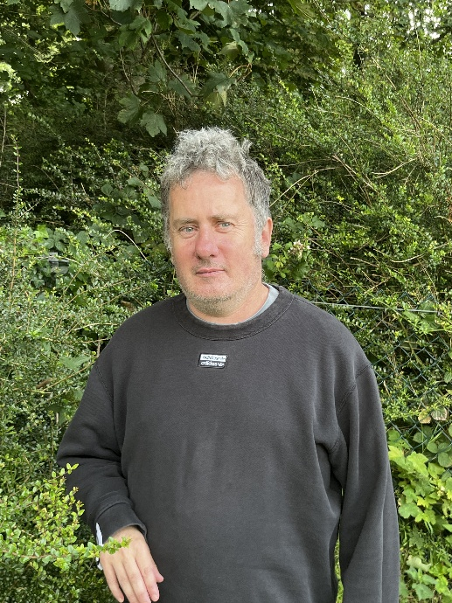
Case Study: Carwyn
Background:
Carwyn is a 50-year-old man living with his parents in Llangefni. He is passionate about sports, especially football, and previously volunteered at Jewson’s. He is supported by Anheddau for 16 hours a month.

Challenges:
- Limited independent travel; he relies on his father for transport.
- Father is ageing and questioning whether resources like the car are being used effectively.
- Low aspirations from some family members.
- Struggles with literacy, weak legs, and some health challenges.

Support and Progress:
- Now volunteers in three settings, including a football club and two charity shops.
- Thrives in the football club environment, where he is naturally confident and social.
- The charity shop role stretches his abilities and supports skill development.
- Carwyn has identified sports-related work as his long-term goal and would be delighted to work in any sport-based role.

Impact:
- Volunteering gives Carwyn identity and purpose outside the home.
- He is making friends and developing transferable skills.
- The family is more optimistic now but remain cautious due to benefit concerns.

Journey through the Supported Employment Programme
Carwyn was referred by social care as someone with limited aspirations and complex needs. His Dad’s view was simple: “He needs to get out the house a bit more.” The Employment Pathway Coordinator’s initial assessment revealed a deep passion for sport and a desire to do something meaningful.
The programme secured three volunteering placements: a football club (his ideal environment) and two charity shops. Carwyn excelled at the football club, making friends and engaging naturally. The charity shops stretched his comfort zone (different people, different routines) but with support, he managed.
Transport remains a challenge. Carwyn has a car in his support package, but he can’t drive and relies on his dad, who is ageing and becoming less available. The Employment Pathway Coordinator raised the possibility of reassessing transport funding to better match his work goals.
Crucially, the programme is supporting Carwyn to translate his sporting interests into employment possibilities, rather than steering him into generic roles. He’s now considering further opportunities in sport-based settings, with long-term aspirations for paid work.

