From Gaps to Growth: Co-Producing Better Transitions for Disabled Young People and Families
IMPACT Demonstrator Project, September 2024 – August 2025

Led by Amanda Barr Senior Strategic Improvement Coach from Improving Adult Care Together (IMPACT) and hosted by Mencap Northern Ireland.

Executive Summary

This report documents a 12-month co-produced transition project led by IMPACT and hosted by Mencap Northern Ireland, working in collaboration with families, disabled young people, and community partners, including The Orchardville Society and The Cedar Foundation. The project sought to explore the lived experiences of transitions from childhood to adulthood for young people with additional needs and their families, identify gaps in the current system, and co-produce practical solutions rooted in lived experience.

Over 100 people contributed directly through surveys, interviews, focus groups, and workshops. This was not just consultation but meaningful co-production at every stage. The findings are sobering but powerful, offering a clear call to action: disabled young people and their families need earlier planning, clearer information, coordinated support across services, and real choice in their futures.

Key findings include:
- Only 15% of families had access to the right information at the right time.
- 68% of young people said they had not been asked about their goals for adult life.
- 72% of families said transition planning increased their anxiety.
- Only 10% knew who to contact about adult services.
- More than half of parents relied on other parents for information, identifying this as their most reliable source.

The emotional weight of the transition process is significant, with families feeling isolated, exhausted, and let down by fragmented systems. Despite these challenges, stories of resilience and peer solidarity also shine through. The report presents the full findings alongside visualised data and practical recommendations for systemic improvement. These include:
- Amplifying existing digital resources like the STARS website
- Piloting co-produced roadmaps and checklists in special and mainstream schools
- Securing protected funding for post-19 provision, including flexible options.

Introduction and Project Rationale

The transition from childhood to adulthood should be a hopeful, empowering stage in life. For young people with additional needs, however, it is often a time of anxiety, confusion, and disruption. Many young people spoke of being "left behind" without clear options and parents and carers described it as "falling off a cliff". This project emerged in response to growing concerns from Mencap families and other community partners that existing systems were not meeting the needs of young people with learning disabilities or complex support requirements.

We aimed to understand:
- What is working and what is not in current transition processes.
- What matters most to young people and families.
- What practical, person-centred improvements could look like.

The overarching goal was to amplify lived experience and use it to shape a better system, one that supports young people to have not just services but full lives.

The Process We Followed

This project ran from September 2024 to August 2025 using a phased, co-produced methodology. Our approach was intentionally designed to move beyond traditional consultation to a model of genuine collaboration at every stage. The project's structure was based on the principles of co-production, ensuring that disabled young people and their families were not just recipients of services but active designers of the solutions.

Phase 1: Listening and Gathering (Sept to Dec 2024)
This initial phase was focused on establishing a robust evidence base. We began with a review of existing literature, frameworks, and previous reports to understand the current landscape and identify gaps in knowledge. This research was supplemented by attendance at stakeholder events, such as a Stormont session with Caleb’s Cause NI who are campaigning to introduce equivalent post-19 legislation in Northern Ireland to bring it in line with England. This ensured our understanding was both academic and politically current. In parallel, we collaboratively developed consultation tools with families to ensure our language and questions were relevant and sensitive to their experiences.

Phase 2: Co-Production (Jan to June 2025)
This was the core of our co-production work, where we actively engaged with young people and families across a variety of formats to gather rich, qualitative data. Our engagement included:

- Focus Groups: We held multiple focus groups with families and young people from Mencap, Cedar Foundation https://www.cedar-foundation.org/, and Orchardville https://www.orchardville.com/. These sessions allowed us to explore shared experiences and challenges in a supportive group setting.
- One-to-One Interviews: For individuals who were less comfortable in a group environment, we conducted one-to-one interviews with parents and young people. This provided a safe space for them to share their personal stories in detail.
- Online Questionnaire: We launched an online questionnaire titled "Your Experience of the Transition Process." This quantitative tool for families and young people was sent via email to young people and parents within Mencap NI, Orchardville and Cedar Foundation. Responses were gathered electronically and provided statistical data on key indicators like access to information and anxiety levels.
- Narrative Analysis: The qualitative feedback from interviews and focus groups was subjected to a detailed narrative analysis, allowing us to identify common themes, emotions, and personal journeys. This process helped us understand the "why" behind the statistical data.

Phase 3: Validation and Reporting (July to Aug 2025)
In the final phase, we brought the findings back to the community for validation, where families and young people reviewed the initial findings and helped us to draft the final recommendations. This ensured the report's conclusions were a faithful representation of their lived experience. We then visualised the statistical data to make it accessible and integrated external literature for comparison and context. This final step allowed us to compile a comprehensive report that was both evidence-based and rooted in the direct voices of those it seeks to help.

Key Findings: The Voices of Families and Young People

Our findings share the lived experiences of individuals navigating a complex and often frustrating system.

a. Inconsistent Information and Parent-Led Navigation
Families repeatedly described the transition system as unclear, with fragmented responsibilities and limited proactive contact from professionals. A recurring theme was the absence of a single, reliable source of information. "We didn’t even know who to call. It was other parents who told me what to do". More than half of parents said they relied on each other for information through WhatsApp groups, informal networks, or social media. Many stated this was the most reliable source they had. This point was raised across nearly every consultation session and should be considered a core insight. This is consistent with other research that highlights a lack of clear and accessible information as a major barrier to successful transitions.
The narrative analysis revealed the depth of this issue. A parent shared, "I was told by a professional that I had been given a leaflet, but I honestly couldn't remember getting it. I think I would remember getting something that important!". This highlights a disconnect between the perception of information being provided and a family’s ability to absorb and retain it during a time of high stress. Another parent recounted, "I was given a generic folder of information, but it wasn't relevant to my child's needs. I ended up putting it in the bin because it was overwhelming and not helpful". These stories demonstrate that the issue isn't just a lack of information, but a failure of information to be timely, relevant, and accessible.

b. Emotional Weight and Isolation
The emotional toll of transition was deeply felt. Parents spoke of sleepless nights, depression, and feeling overwhelmed by the responsibility to advocate alone. "Parents are left to do the groundwork. It shouldn’t be like this". Another parent of a school leaver remarked, "It’s terrifying, you know it’s coming, but no one helps you prepare". Young people, too, expressed grief at leaving familiar school settings without clear paths forward. "I’m ready, but I’ll miss my friends and teachers. It’s sad".

The narrative analysis further illuminated this emotional burden. A parent described the constant fight for services as "like walking through treacle". Another spoke of the emotional labour involved, stating, "I'm the person that they [professionals] all talk to. I'm the one that has to coordinate everything. It's exhausting". This emotional weight is compounded by a sense of isolation. "You feel like you're the only one going through it". This sense of being alone is a significant challenge for families.

c. The ‘Cliff Edge’ at 18
A critical issue raised in every session was the sudden drop-off in services when a young person turns 18 or 19. This phenomenon, often described as "falling off a cliff," results from a lack of coordinated planning between children's and adult services. "No one had taken ownership after Children’s Services ended. Adult services didn’t even know who we were". The delay in support can be significant, leaving young people vulnerable and without structure. "She left school in June. Support didn’t start until November". These gaps affect essential services like transport, medical care, and day opportunities. The Ulster University report on future planning highlights that while parents find themselves less able to cope with caregiving as they age, traditional service models are no longer fit for purpose, nor are they a sustainable option to meet the demands of this population.

d. Young People Want to Be Heard
When asked what would help, young people emphasised being included, informed, and supported. "Teachers made the decisions, not me". "I want to know what’s coming, not be told too late". This desire for autonomy and agency is a powerful theme. The narrative analysis noted that young people felt their views were often tokenistic and not genuinely listened to. One young person expressed frustration that they were not consulted about their own future, stating, "They just tell me where I'm going. I want to have a say in it". This is a direct challenge to the idea of person-centred planning, where the young person should be at the heart of the decision-making process.

Insights from Survey

Based on the questionnaire responses:

Indicator | Result
Had access to the right information at the right time | 15%
Had a named contact to support transition | 10%
Young people asked about future plans | 32%
Families who said the process made them more anxious | 72%
Families who relied on other parents for information | Over 50%
Knew who to contact in adult services | 10%
Used legal support to navigate system | 31%

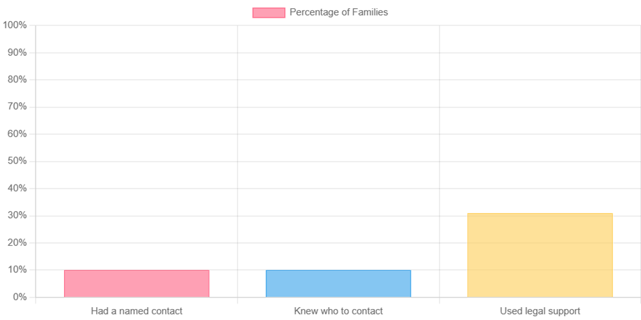

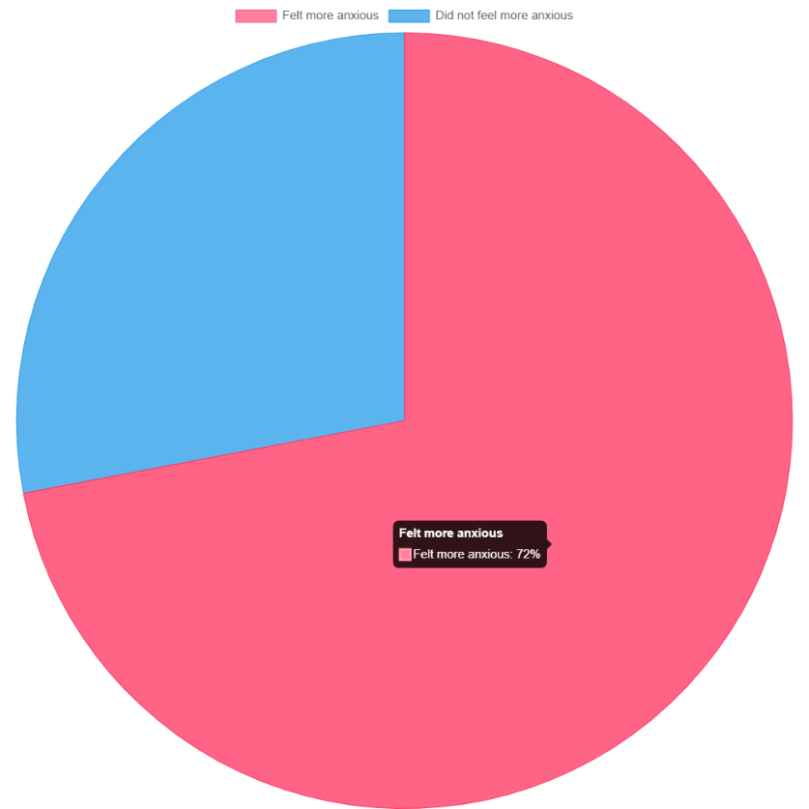

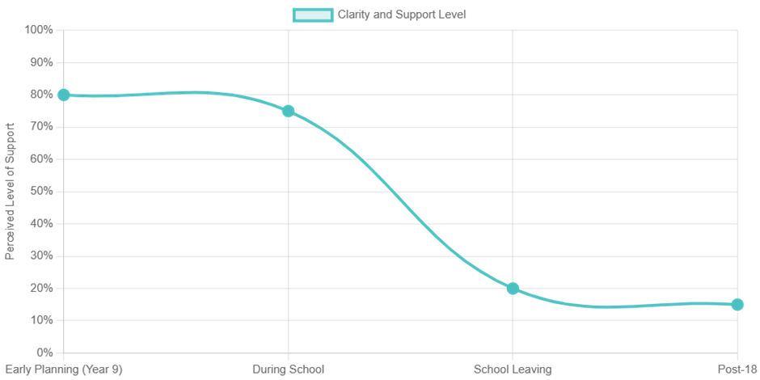

The survey results paint a stark picture of a system that is failing to provide the basic infrastructure for a successful transition. The low percentages for access to information (15%), having a named contact (10%), and young people being asked about their plans (32%) are particularly concerning. This data provides a strong foundation for the qualitative findings, demonstrating that these are not isolated incidents but systemic issues affecting a majority of families.

Comparison with Wider Literature

Our findings are consistent with major reviews and surveys, reinforcing that these challenges are not unique to Northern Ireland but are part of a broader, systemic issue.

Scottish Government Literature Review (2023)
This review, prepared for the Scottish Government, reiterated a lack of coordinated planning and emphasised the need for person centred, early preparation. It highlighted common challenges that mirror our findings, including:

- Stress and uncertainty for the young person
- Difficulties transferring from child to adult services
- A sharp drop in support, often described as a "cliff edge"
- Inadequate transition planning and a lack of clear information
- Stress and difficulties for family members

The Scottish review also identifies a consensus on best practice, which includes early and sustained planning, holistic and coordinated support, and designated keyworkers as a point of contact.¹

Caleb’s Cause Report (2025)
The Caleb’s Cause report, focusing on special educational needs reform in Northern Ireland, found that 96% of families want post 19 legal protections, and over 60% were unaware that SEN statements end at 19. This underscores the critical need for a named contact and clear information, as identified in our research. The report highlights that the current system's lack of clarity around the cessation of support at age 19 creates significant stress and uncertainty for families.²

Pivotal Youth Voices Report (2023)
This report highlighted structural inequality and poor transition planning, finding that 77% of young people with additional needs felt they had unequal opportunities. This aligns with our findings on young people feeling their voices are not heard and that decisions are made without them. The report’s focus on the young person’s perspective is a vital complement to our own findings and reinforces the need for person centred approaches.³

Ulster University Reports (2015 & 2023)
Research from Ulster University on future planning further supports our findings. A 2015 report by Taggart and Thompson found that front line staff acknowledged the difficulty of talking to families about future planning, and that not all family carers had a carers' assessment completed. It also highlighted that parents often have different wishes for their children’s futures and that accommodation and direct payments were often difficult topics.⁴

A more recent 2023 report by Taggart and Mulhall notes that Northern Ireland has a higher proportion of people with learning disabilities living with family carers than elsewhere in the UK and Ireland, and that despite decades of research, the needs of these carers continue to remain unmet. These reports confirm that the issues of poor planning and the emotional burden on families are long standing and well documented.⁵

Emerging Principles for Better Transitions

Based on our findings and the wider evidence base, a set of key principles has emerged to guide future systemic change:

- Start early, ideally from Year 9 onwards. This provides a long lead-in time for planning, reducing the "cliff edge" effect.
- Provide each family with a named keyworker. This person would act as a single point of contact, coordinating across services and providing continuity.
- Co-create visual transition tools and timelines. Accessible, co-designed tools can help young people and families understand the process without being overwhelmed.
- Embed young people’s voices at every stage. True person-centred planning requires listening to and acting on the aspirations and choices of young people.
- Establish peer support and parent networks. These informal networks are already the most trusted source of information and should be formally recognised and funded.
- Coordinate services across health, education, and care. Break down the silos between services to create a holistic, wrap-around support system.
- Support emotional readiness, not just practical planning. The emotional toll on families and young people is significant and needs to be addressed with dedicated support.
- Provide options beyond college or day centres. Young people's aspirations are diverse, and the system must offer a range of flexible opportunities for employment, independent living, and community participation.

Recommendations

To move from a fragmented system to a collaborative, co-produced one, we recommend the following actions. It is crucial to note that while the initial impetus for this project was the perceived lack of information, our research revealed a more complex problem: valuable resources do exist, but there is a significant disconnect between where this information is held and the people who need it. Furthermore, much of the information is not presented in an accessible format for young people, creating an over-reliance on their parents to navigate the system on their behalf. Our recommendations therefore focus on bridging this gap.

- Amplify existing digital resources like the STARS website. The STARS website (School Transition to Adult Responsibilities and Services), created by a partnership including Orchardville, is an example of an invaluable, existing resource that many people are unaware of. It contains a wealth of information, worksheets, and training activities for young people and their families on topics such as options, healthy living, and independence. Our research highlighted that the challenge is not the absence of this information, but the lack of awareness and accessibility. This resource should be promoted more widely through schools and service providers. Consideration must be given to how it can be collectively kept up-to-date to ensure the information remains relevant and accurate.
- Consider creating a centralised digital hub for transition information, co-designed by young people and their families/ carers. This hub would act as a single source of accurate information for all things transition-related. This would include details on available services, rights, and support contacts, all in one accessible, user-friendly place. The hub should be a living document, regularly updated and co-managed by a panel of young people and families to ensure its relevance and accessibility.
- Fund peer-to-peer support networks in every local area. Our research shows that parent-to-parent support is the most trusted source of information. This should be leveraged by providing formal funding and training to empower these networks to grow and operate effectively. These networks can be a powerful tool for reducing the isolation and anxiety felt by families.
- Introduce statutory keyworkers to coordinate across services. This recommendation is supported by the Scottish Government's review which identified designated keyworkers as a characteristic of positive transitions. The keyworker would be a single point of contact for the family, responsible for coordinating the multi-agency response, bridging the gap between child and adult services, and ensuring the young person's voice is at the heart of the process.
- Pilot co-produced roadmaps and checklists in special and mainstream schools. These tools would provide a visual timeline and clear checklist of actions to be taken from Year 9 onwards. Co-designed with young people, these tools would empower them to take an active role in their own transition planning.
- Secure protected funding for post-19 provision, including flexible options. The "cliff edge" at 18 is a critical failure of the current system. Funding must be ring-fenced to ensure a smooth, uninterrupted transition of support, and to develop a wider range of post-19 opportunities that go beyond traditional day centres, such as supported internships, volunteering, and community-based activities.
- Invest in training professionals in rights-based and trauma-informed approaches. Professionals must be equipped to listen to and work with young people in a way that respects their rights and acknowledges the potential for trauma associated with the transition process. Training should focus on person-centred communication, co-production principles, and a deep understanding of the legal and emotional landscape of transitions.
- Track and report transition outcomes with regular audits. To ensure accountability and measure success, a system for tracking and reporting on transition outcomes is essential. This would involve regular audits of transition plans, feedback from young people and families, and public reporting on key performance indicators.

Conclusions: Towards a Life, Not Just a Service
This report does not call for yet another consultation. It is a product of lived experience, co-produced insight, and evidence-based recommendations. It is a call to act.
The system must move from reaction to prevention, from fragmentation to collaboration. Families and young people are already doing the work of coordination and advocacy. The role of services must be to listen, respond, and walk beside them, not stand in their way. The goal is not just to provide a list of services but to support disabled young people to build full, meaningful lives. Together, services, professionals, young people and families can develop a powerful collaboration for change.

Prepared by IMPACT and Mencap, with contributions from young people and families across Belfast, Ards and North Down.

References
1. The Diffley Partnership, *Literature Review: Transitions to Adulthood for Disabled Young People*, Report prepared for the Scottish Government, February 2023.
2. SEN Reform NI & Caleb’s Cause, *Lived Experience Influencing Change: SEN Reform and Caleb’s Cause Executive Summary 2025*, June 2025.
3. Pivotal, *Youth Voices: Life, Work and Study in Northern Ireland*, Belfast: Pivotal Public Policy Forum, 2023.
4. Taggart, L. & Thompson, A., *Development and Testing of a Manual and Training Programme on Future Planning for Front-line Staff across Northern Ireland*, Ulster University, March 2015.
5. Taggart, L. & Mulhall, P., *Planning for the Future: Developing a Community Model to Support Family Carers of People with Learning Disabilities within the Southern Health and Social Care Trust*, Ulster University, August 2023.

