IMPACT Network – Involving people with lived experience in decision-making (Strategic Commissioning)

This leaflet is in Easy Read

What is the issue? Why should services involve people with lived experience in decision making?

How are different places doing co-production? Look at different ways of involving people in decisions and case studies.
What do you think? Questions for your network to think about before our meeting.

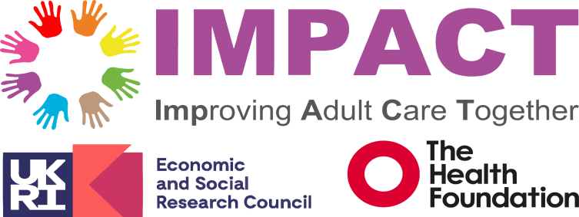
This leaflet has been made for the Impact local network meetings.


It is to discuss involving people with lived experience in making decisions about what care they and people like them get.


A person with lived experience is someone who uses their knowledge and life experience to speak about what they need and want.


This leaflet is in Easy Read. Easy Read makes information accessible for people with Learning disabilities. We do this by using Plain English and pictures.

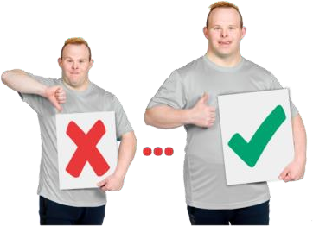
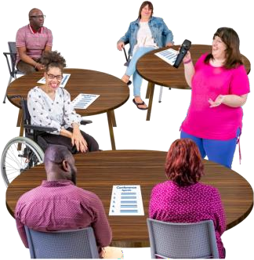
In this leaflet we talk about reports of services getting better when people who use them are involved in designing them.

We also talk about different ways people can be involved. One of these ways is using something called the ‘ladder of

participation’.

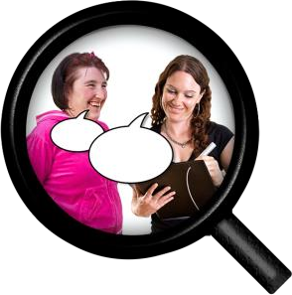
This leaflet also includes three case studies about this issue for you to discuss.

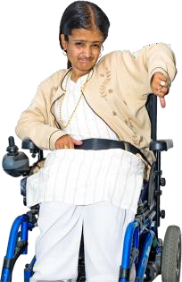
We will also discuss what barriers co- production has, and how we might do things differently.


We would like everyone to read this leaflet before our session. At the end of the leaflet, there are questions you may want to make notes on.

What’s the issue?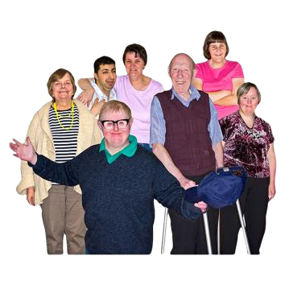

People with lived experience want to be involved in helping to make services better for everyone.

People with lived experience are becoming more involved in working in research and being paid for their time.


There are also more people with lived experience working in health and social care. This includes the commissioning team.

A commissioning team is part of the council. They give money to services that support people.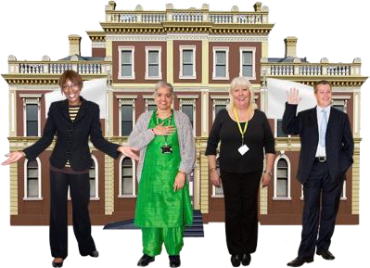

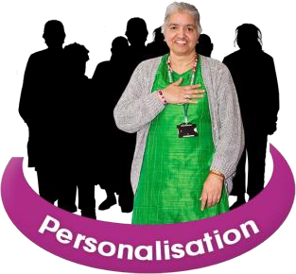
This team should work with people with lived experience to help them have choices and control over their lives. This is called personalisation.

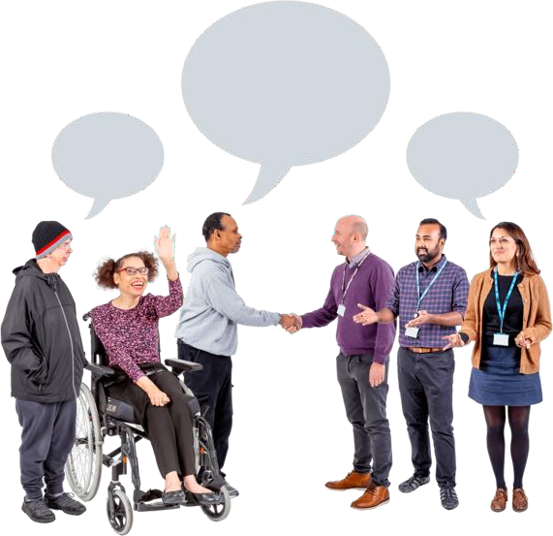
What’s the issue?
Working together in this way to make
services better is called co-production.

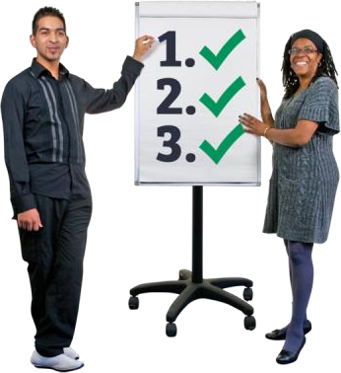
Co-production is where people work with services and are involved in all decision- making stages.

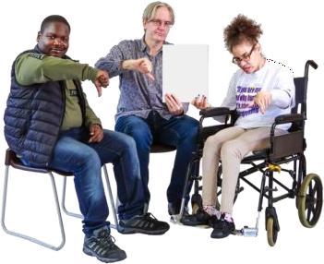
There are many different ways people can co-produce services. If this isn’t done correctly, it can feel tokenistic.

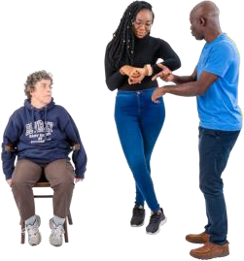
Tokenistic means that services involve people with lived experience, but they
don’t really listen to them or involve them in every step.

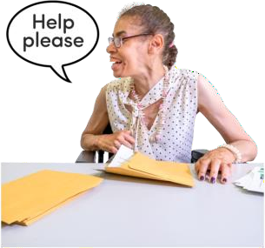
Coproduction can be hard. It can be hard to manage the needs of different people and have a budget to support people properly.

Services need to make sure people have what they need to take part, and that their voice is listened to.


Everyone thinks coproducing commissioning is good, but different places are doing things differently.


There isn’t a set of rules we can use to make it work in the same way. This makes it hard to know which way works best.

England
There was a study called ‘People at the Heart of Care’ in 2021. It was about people who use care, unpaid carers and families.

It talked about the importance of involving people in health and social care decision- making.

There was also talk about working with lots of different services, as well as people with lived experience, to make sure services improve.

But there is not a guide of how to do this. Each place in the UK uses different approaches to working.
England

Having no set rules means things can be personal to the people involved. But it also makes things difficult to make sure they are done in the best way.

Scotland
Scotland
The human rights framework Scotland uses is something that includes people being involved in decision making.
People have said they feel welcomed, and their voice is heard.
The Scottish Government introduced rules around coproduction in health and social care in 2016.
The National Care Service (NCS) uses co- design of their services and wants to do more co‐production in the future.
.


Even though Scotland has good ideas, there are still issues in getting co- production in place throughout the country.


The biggest problem is that while the guidance is there, people find putting this into practice and making co-production work difficult.

Northern Ireland
Co-production in health and social care has
been one of the main goals since 2016.
A review called ‘Power to People’ said how important it was to include people in decision-making.
Northern Ireland
This repeated the importance of having people who use different services involved in their design from the start.

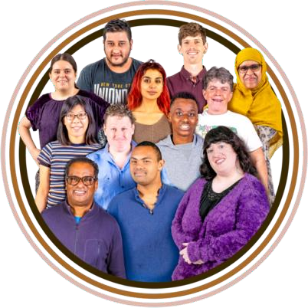
Health and social care in Northern Ireland has included the voices of people who use their services since the 1970s.


But there has been unstable government and disagreements, meaning rules are slow to change

Wales

Co-production is part of the Social Services and Wellbeing (Wales) Act 2014.

The Act gives people legal rules about coproduction.

It also gives people a clear explanation of what co-production is in practice.
Wales


Wales co-produced a set of guidelines on how to do co-production well. This was included in an IMPACT study in 2023.

Services and people who use them want to do more co- production, and do it well. But why is it important?


Research shows that people want to be involved in making important decisions about their care, and the care of people like them. They also want to be able to point out problems and help services improve.

Services say their work improves because;

People have said being involved with services helps them feel:

- They have a purpose
- Valued
- Feel listened to
- They have a job
- Better social connections and peer support
- Better health and
wellbeing
- Happier with services
- They have a better understanding of people’s needs
- They think ‘outside the box’. Which means thinking differently and finding new ways to solve problems.
- They build services that are more about individual people.

Research also tells us that the wider community benefits when people with lived experience get involved.

Services feel more Inclusive and have a better mix of people which we call diversity.

Services spend money where it’s needed, making savings where it isn’t.
This helps everyone from different cultures and backgrounds to have a voice.

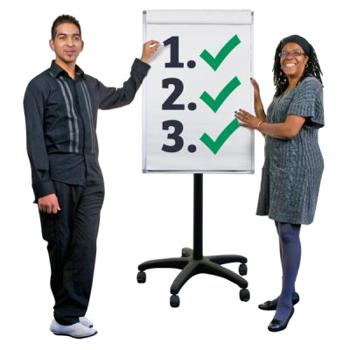
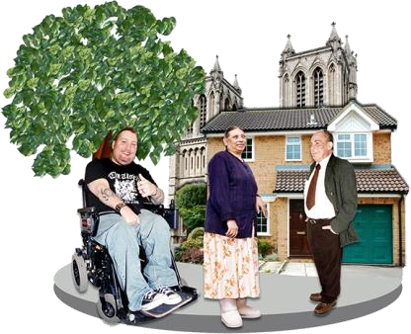
Helps people feel a sense of ownership
Better quality of life for people involved and their peers.

Helps people come together and strengthen their community.
involved?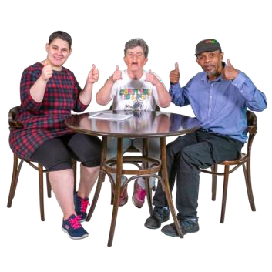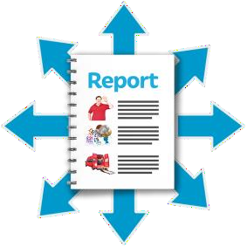

There are lots of different ways to involve people with lived experience in decision- making.

There is something below called the
‘Ladder of Participation’. This comes
from a report called ‘Seeing is Believing’.

Taken from ‘Seeing is believing: Co-production Case studies from Wales’

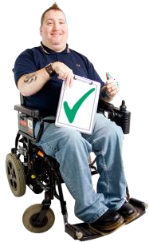
We explain each part of the ladder on the next page. With good co-production, we should always aim for the top part, even if that takes more work.

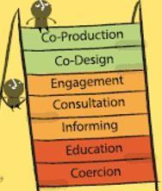
On the first two steps of the ladder are

coercion and education.

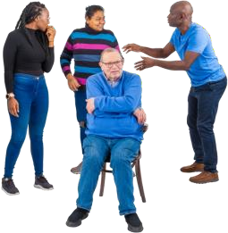
Coercion is another way of saying someone is having things done without involving them.
Education is being told about things happening

without having a say.

The middle of the ladder is about consultation and engagement.

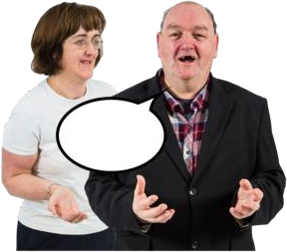
Here people are involved but it isn’t equal. This is about doing for someone based on what they want.

While this can be good, it risks not getting it right or being tokenistic like we mentioned earlier.

On the highest levels of the ladder, we ﬁnd co- design and co-production, which is more equal. This is doing things together.

This next table shows that even though co- production is about sharing of power and responsibility, there are other ways to do things.

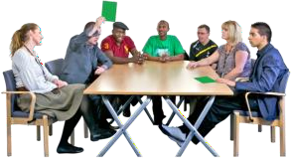
Self-organised community provision is where things are done and led by communities rather than professional people.

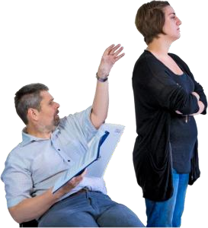
Things known as ‘traditional provision’, which is how things have been done by services for a long time, don’t always involve people with lived experience.


Co-designed and co-delivered services is where people with lived experience are involved in decisions, but professionals are still in charge.

This can work well for a lot of services and people, especially people who are new to co- production. But there is still a power imbalance.

Co-production is different because it is about being equal. It’s about everyone involved in designing and delivering a service.

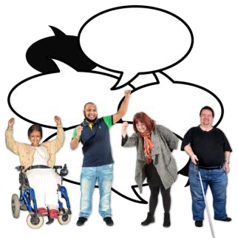
The highest level of equal control is self- organised community provision. This is where services are planned, delivered and under the complete control of people in their community.
Involving people with lived experience in strategic commissioning
Commissioning is where local councils decide which services support people in each area. They look at everyone’s needs, and what can be better.

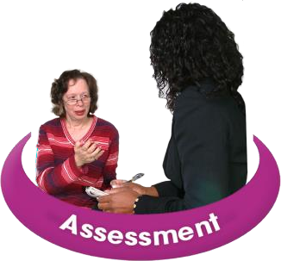

Commissioning
includes:
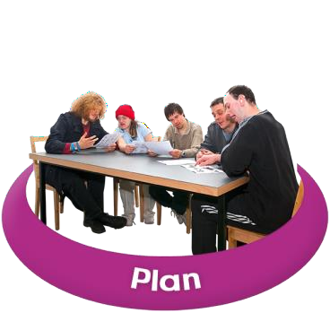
Assessing someone’s
needs

Planning services that are

right for people
Deciding what’s important
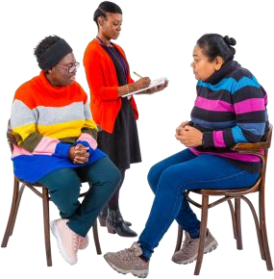
Checking to see if those
services work

All these things should work together

Sadly, research says that in the past, commissioning in the UK has not been good at involving people with lived experience. This needs to change.
Case studies

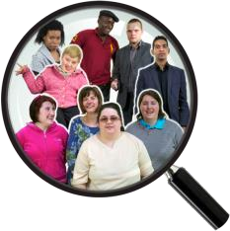
A case study is where we look at a situation closely in real life and see what we can learn.

There are three case studies we are looking at. Each case study looks at how people with lived experience have been involved in decision-making.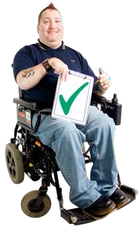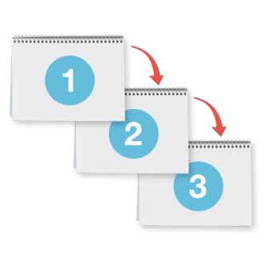

Case study one: Consultations and Steering Groups.

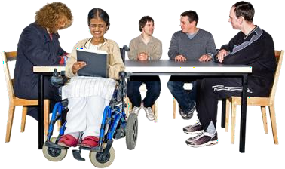
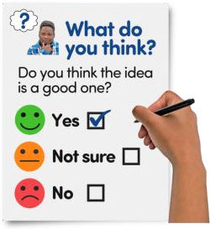
A consultation is when people are asked their opinions. A consultation can be a good way for people to choose ideas. But people are not always able to give their own ideas.

Consultations can be done by using surveys. This is where questions are sent out to lots of people to get a wide range of views.

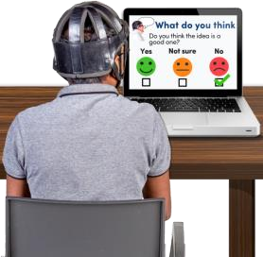
They can be done in person or online, on your own or in a group.

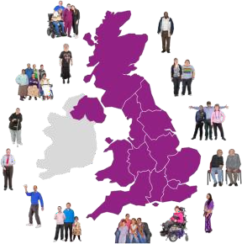
This case study found Different areas in the UK

do things differently.

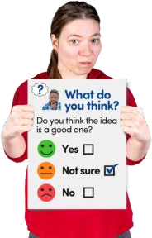

While people were asked about their opinions on things like the Learning Disabilities, Autism and Neurodiversity Bill, Consultations can also feel tokenistic.

This is because consultations often do not tell the people who took part what was done.

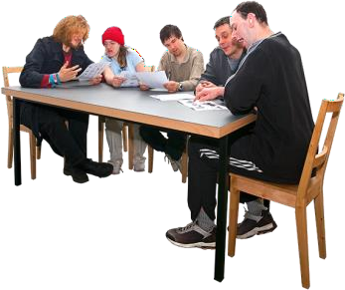
Steering groups
Steering groups are another way to involve people in coproducing services.

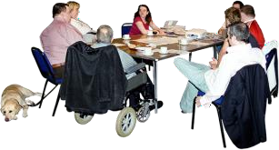
This is where a group of people who have different backgrounds and experiences, come together and have regular meetings.

Steering groups are good because people attend several meetings and get to know each other. They also have a lot of say in how things are done.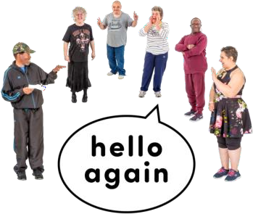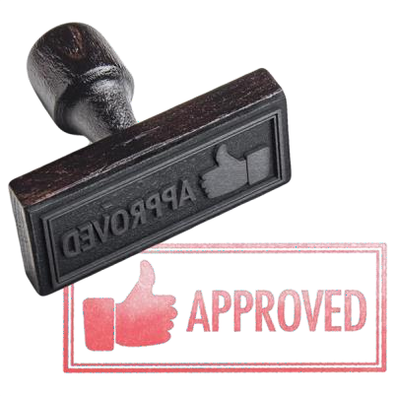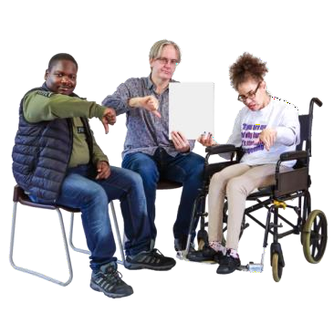

Steering Groups can be used to help design services that the council commissions.

It is easy to see what changes have been made because steering groups track them and are reported back to. Their job is to make sure people do what they say.


However, steering groups are often organised without people with lived experience, which can make them harder to stay equal

People in steering groups also don’t always have the power of final decisions. This can again feel tokenistic.

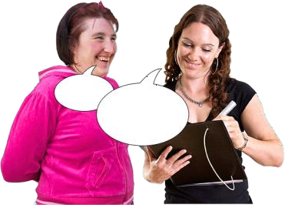
Advocacy is when someone speaks for someone else and works with them to find out what they want and need beforehand.

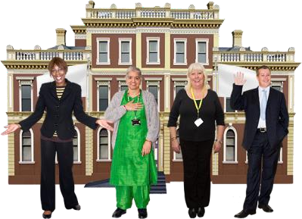
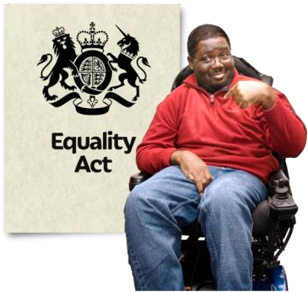
Independent Advocates are people who do not work for the council, also known as the local authority.

They help people talk about what they want. They also make sure that people's rights are protected.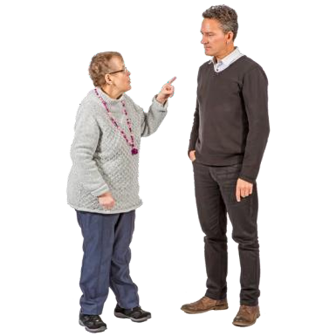

By commissioning independent advocates, the job of supporting someone and protecting their rights is done by someone impartial.

Impartial means that because they don’t work for the council or other services, they can tell them when they’re doing things wrong.

This case study found that good commissioning
works with advocates when they:


Remove barriers for people accessing services.
Work with people on a one- to-one level to understand what is important to them




Support providers to work together and with local communities
Make sure these services are funded over at least three years to help them plan properly.

This study focuses on two ways commissioning can involve co- production in public services.

Commissioning coproduction is when councils ask people who provide services to work with people who use those services in an equal way.
Co-producing commissioning is when people who use services, and their communities are equally involved in the commissioning of services.

In co-producing commissioning, people will be helped to:

  - Explain what they need and want
  - Make important decisions about how to make sure people have better lives
  - Decide which providers are chosen to provide services and support
  - Check and feedback about how well providers are doing and how they could do better

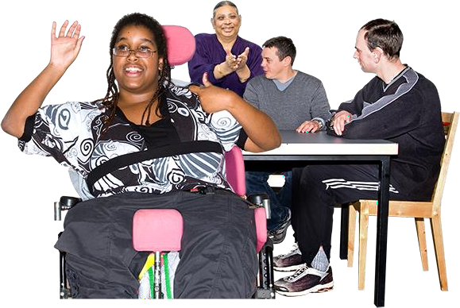
Co-commissioning is where people’s voice is in the centre of what’s done. They have ownership of the services they work with.

There are four key parts of co-commissioning

Analyse
This means to look at information, what the needs are and why people are doing it
Plan
Look at where there are gaps and think about how to solve problems
Co-commissioning
Do
To do the things that have been planned
Check
To make sure what you have done is working


Good coproduction is also when people are paid well for their involvement


People can be involved over a long period of time, and everyone knows feels they are a valued part of a team.


We have talked a lot about good things about coproduction but let’s look at when things do not work so well.

There are some barriers to good coproduction when thinking about commissioning services. Some of these are: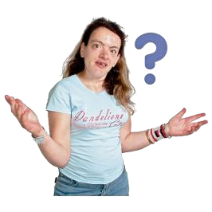

not enough training
- Not being able to communicate properly
- Unequal power between people and professionals

Not having enough money or time to
involve people properly
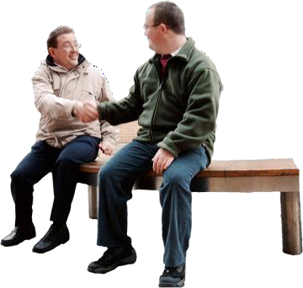
- Not being clear about what everyone is doing

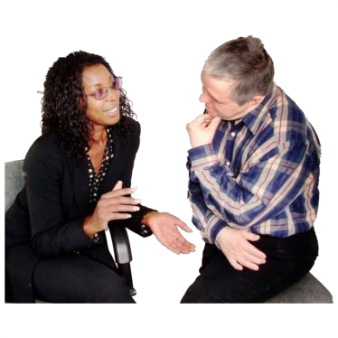
To make co-production work properly, people need to be listened to and feel like they can change things.

People need to have meaningful feedback about what councils have done with the information they have shared.


Some of the other barriers are:

- Not having the time or the resources needed.
This could be money.

- Tokenistic involvement of people with lived experience

- Not getting the right information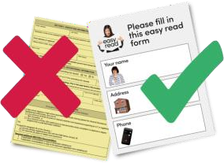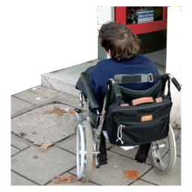

- Not being able to find an accessible meeting room

- Not being able to adapt to different cultures.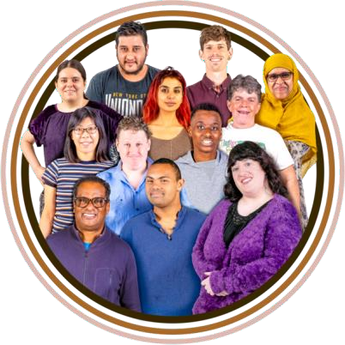

- Not everyone getting the same money for being involved

- People with lived experience and community members getting too tired

While co-production is seen as the best way for services to work for the people using them, its not perfect either.

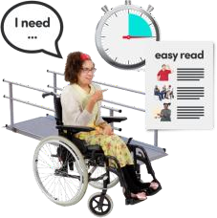
Researchers have said that they are worried that councils don’t have as much power to change services that people need.

Other researchers are worried that co- production might make big changes hard to really happen.

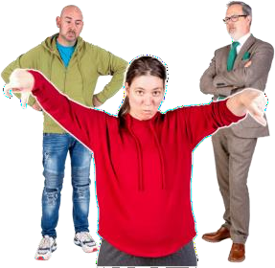
They think that sometimes people aren’t given true control over changes, and the people with lived experience feel used.

While co-production and involving people is good, the real solution is to change how the systems work. More focus should be on public control of services, and community-led decisions.

Having read the material above, in the first Local Network Meeting, we’d like you to talk about these points in your groups. You may like to take notes before the next meeting.

Your experiences…
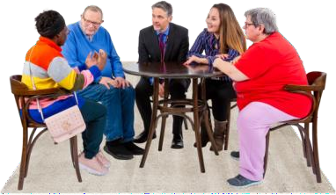
  - Would anyone like to share their experiences of being involved in services as someone with lived experience?


  - What helps or makes it difficult to involve people with lived experience in decision-making?

Thinking about this Leaflet
    - Do you have any experience of different ways to do co-production?

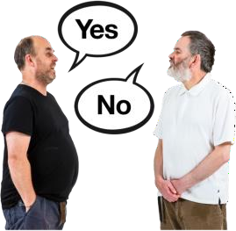
    - Were there any ideas in this document that you think could help people be involved in decision making access social care services?

    - Was there anything in the document you didn’t agree with or didn’t match your experience?

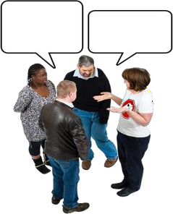
Are there any next steps you’d like to agree as a group?

Anything else you’d like to discuss?

Do you think there is anyone else who should be

involved in your meeting?

Is there anything you need from our team at Impact?
Extra information and Contact details



There are some details from the strategy not in this Easy Read booklet to keep it accessible.


A full version of this leaflet, including a source list, is available on request.

Thank you to Sheffield Voices for
translating this into Easy Read.



