Title of review | Hospital Discharge  (Pilot product – initial question set by IMPACT LT to help develop the Ask IMPACT approach)
Linked IMPACT activity (e.g. Facilitator on topic of x, with location) | ASK IMPACT
Date of review | May 2023
Authors of review | Christian Bohm and Rachel Posaner
Type of review (syntheses, gap or full) | Full review ( Social Policy & Practice, SSCI, Medline, HMIC and ASSIA- 2017-22) + additional search of grey literature (2021-23) (Google search, with separate searches for each of the four nations and a later background search for any key resources from outside the care sector)
Title of database and dates covered | Name of the database provider / host (e.g. OVID) | Date search conducted and dates covered by the search (e.g. 1990- February week 3, 2016) | File Name | Results
HMIC | Ovid | 20072023 | Hospital Discharge HMIC 18052023 | 36
Social Policy & Practice | Ovid | 20072023 | IMPACT HOSPITAL DISCHARGE_MAY 2023 | 220
SSCI | Clarivate | 20072023 | Autosaved | 61
Medline | Ovid | 20072023 | Hospital Discharge MEDLINE 18052023 | 59
ASSIA | Proquest | 20072023 | Hospital Discharge_22052023 | 322
Results |  |  |  | 698
FINAL SEARCH RESULTS (after de-duplication) |  |  |  | 622
Social Policy and Practice | attitudes.de.  user views.de.  user participation.de.  education.de.  carer views.de.  lived experience.ti,ab.  (attitude$ or priorit$ or perception$ or preferen$ or expectation$ or choice$ or perspective$ or view$ or satisfact$ or inform$ or experience or experiences or opinion$ or education$).ti,ab.  service user experience$.ti,ab.  qualitative research.de.  1 or 2 or 3 or 4 or 5 or 6 or 7 or 8 or 9  (lesson$ or positive$ or learn$ or success$ or win$ or evaluat$ or effective$ or innovation$ or best practice$ or good practice$ or case stud$ or good outcome$ or positive outcome$).ti,ab.  (case studies or evaluation or outcomes).de.  11 or 12  "people who draw$".ti,ab.  (famil$ or carer$ or service user$ or ageing or very old$ or geriatric$ or older$ or frail$ or vulnerab$ or weak or infirm$ or elder$ or old$).ti,ab.  (familes or carers or service users or family members or consumers).de.  older people.de.  (ageing or very old people).de.  (elder or elderly or elderly patients).de.  14 or 15 or 16 or 17 or 18 or 19  (discharge planning or delayed discharged or hospital discharge or patient discharge or inpatient or hospital stay or "length of stay" or patient discharge or patient transfer or reablement or service transitions or blocked bed or blocked beds or bed blocker or bed blocking or bed management or bedblocking or bed availability).de.  (appropriateness of stay or discharge$ or bed turn$ or blocked bed or bed block$ or bedblock$ or continuity of care or delay$ or DTOC$ or hospital stay or length of stay or transfer$ or service transition$ or treatment duration).ti,ab.  ((prob$ or contest$ or co-ordinat$ or coordinat$ or premature$ or delay$) adj4 discharge).ti,ab.  ((prob$ or contest$ or co-ordinat$ or coordinat$ or premature$) adj4 delay).ti,ab.  ((patient$ adj2 discharg$) or (hospital$ adj2 discharg$) or (discharg$ adj2 plan$) or (supported adj2 discharg$) or (discharge$ adj2 assess$)).ti,ab.  (length adj2 stay).ti,ab.  21 or 22 or 23 or 24 or 25 or 26  10 and 13 and 20 and 27  (adult social care$ or social care$ or social work$ or social service$ or "care and support").mp.  28 and 29  limit 30 to yr="2017 -Current"
HMIC | exp Attitudes/  exp Consumer feedback/ or exp Consumer views/ or exp Patient satisfaction/  exp User participation/  exp education/  exp views/  lived experience.ti,ab.  (attitude$ or priorit$ or perception$ or preferen$ or expectation$ or choice$ or perspective$ or view$ or satisfact$ or inform$ or experience or experiences or opinion$ or education$).ti,ab.  service user experience$.ti,ab.  exp qualitative research/  1 or 2 or 3 or 4 or 5 or 6 or 7 or 8 or 9  (lesson$ or positive$ or learn$ or success$ or win$ or evaluat$ or effective$ or innovation$ or best practice$ or good practice$ or case stud$ or good outcome$ or positive outcome$).ti,ab.  exp Case studies/  exp Evaluation/  exp Outcomes/  11 or 12 or 13 or 14  "people who draw$".ti,ab.  (famil$ or carer$ or service user$ or ageing or very old$ or geriatric$ or older$ or frail$ or vulnerab$ or weak or infirm$ or elder$ or old$).ti,ab.  exp Families/  exp carers/  exp Consumers/  exp Family care/  exp older people/  exp Ageing/  16 or 17 or 18 or 19 or 20 or 21 or 22 or 23  (appropriateness of stay or discharge$ or bed turn$ or blocked bed or bed block$ or bedblock$ or continuity of care or delay$ or DTOC$ or hospital stay or length of stay or transfer$ or service transition$ or treatment duration).ti,ab.  exp Discharge planning/  exp Delayed discharge/  exp Patient discharge/  exp In patients/  exp hospital stay duration/  exp "Continuity of patient care"/  exp Blocked beds/  exp Bed blocks/  exp Bed occupancy/  exp Bed management/  exp Bed availability/  ((prob$ or contest$ or co-ordinat$ or coordinat$ or premature$ or delay$) adj4 discharge).ti,ab.  ((prob$ or contest$ or co-ordinat$ or coordinat$ or premature$) adj4 delay).ti,ab.  ((patient$ adj2 discharg$) or (hospital$ adj2 discharg$) or (discharg$ adj2 plan$) or (supported adj2 discharg$) or (discharge$ adj2 assess$)).ti,ab.  (length adj2 stay).ti,ab.  25 or 26 or 27 or 28 or 29 or 30 or 31 or 32 or 33 or 34 or 35 or 36 or 37 or 38 or 39 or 40  10 and 15 and 24 and 41  (adult social care$ or social care$ or social work$ or social service$ or "care and support").mp.  42 and 43  limit 44 to yr="2017 -Current"
Medline | exp Attitude/  exp Patient Satisfaction/ or exp Patient Participation/  exp Education/  lived experience.ti,ab.  (attitude$ or priorit$ or perception$ or preferen$ or expectation$ or choice$ or perspective$ or view$ or satisfact$ or inform$ or experience or experiences or opinion$ or education$).ti,ab.  exp Qualitative Research/  1 or 2 or 3 or 4 or 5 or 6  (lesson$ or positive$ or learn$ or success$ or win$ or evaluat$ or effective$ or innovation$ or best practice$ or good practice$ or case stud$ or good outcome$ or positive outcome$).ti,ab.  exp Case Reports/  exp Evaluation Study/  8 or 9 or 10  "people who draw$".ti,ab.  (famil$ or carer$ or service user$ or ageing or very old$ or geriatric$ or older$ or frail$ or vulnerab$ or weak or infirm$ or elder$ or old$).ti,ab.  exp Family/  exp Caregivers/  exp "Aged, 80 and over"/ or exp Aged/ or exp Aging/  12 or 13 or 14 or 15 or 16  (appropriateness of stay or discharge$ or bed turn$ or blocked bed or bed block$ or bedblock$ or continuity of care or delay$ or DTOC$ or hospital stay or length of stay or transfer$ or service transition$ or treatment duration).ti,ab.  exp Patient Discharge/  exp Inpatients/  exp "Length of Stay"/  exp Patient Transfer/  exp Transition to Adult Care/  exp Bed Occupancy/  ((prob$ or contest$ or co-ordinat$ or coordinat$ or premature$ or delay$) adj4 discharge).ti,ab.  ((prob$ or contest$ or co-ordinat$ or coordinat$ or premature$) adj4 delay).ti,ab.  ((patient$ adj2 discharg$) or (hospital$ adj2 discharg$) or (discharg$ adj2 plan$) or (supported adj2 discharg$) or (discharge$ adj2 assess$)).ti,ab.  (length adj2 stay).ti,ab.  18 or 19 or 20 or 21 or 22 or 23 or 24 or 25 or 26 or 27 or 28  (adult social care$ or social care$ or social work$ or social service$ or "care and support").mp.  exp United Kingdom/  exp England/  exp Scotland/  exp Wales/  (Great britain or GB or UK or United Kingdom or England or Northern Ireland or Scotland or Wales).mp.  31 or 32 or 33 or 34 or 35  7 and 11 and 17 and 29 and 30 and 36  limit 37 to yr="2017 -Current
SSCI | 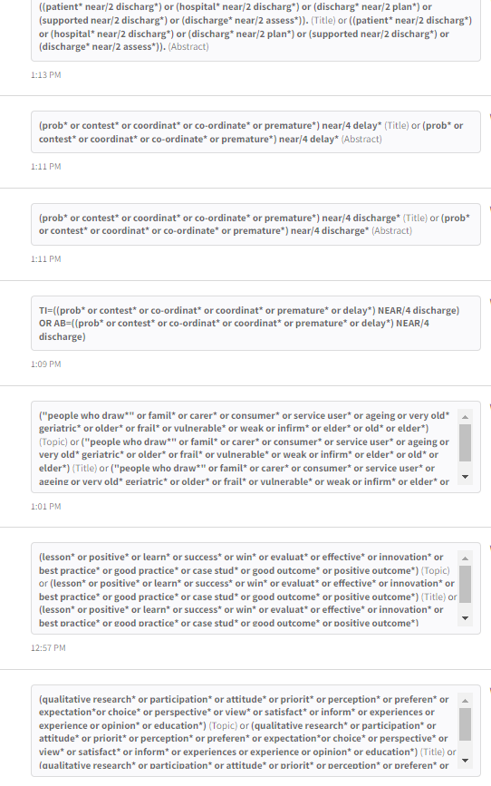
 | 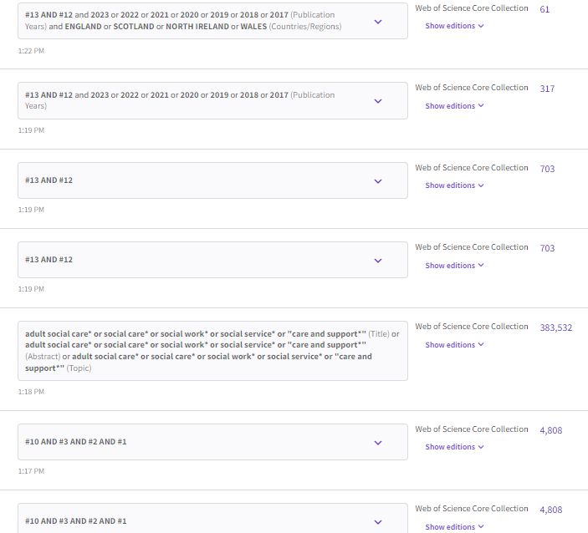
ASSIA | 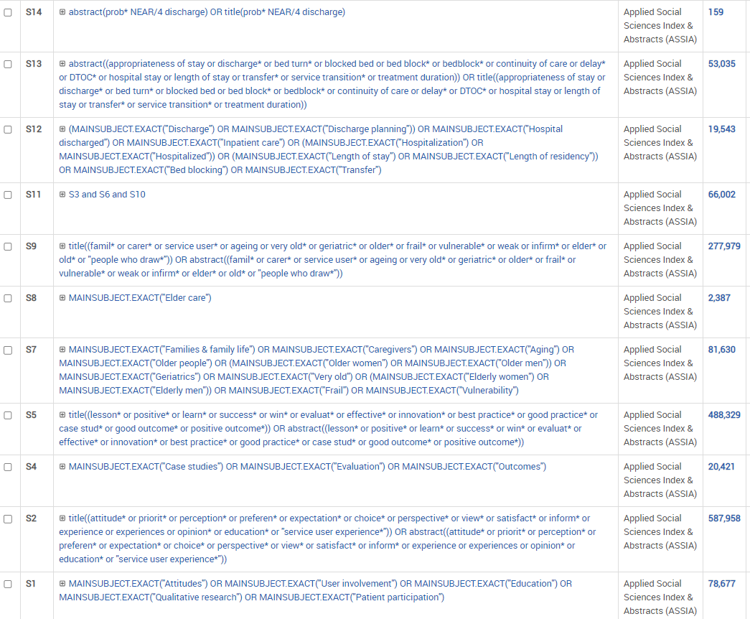
 | 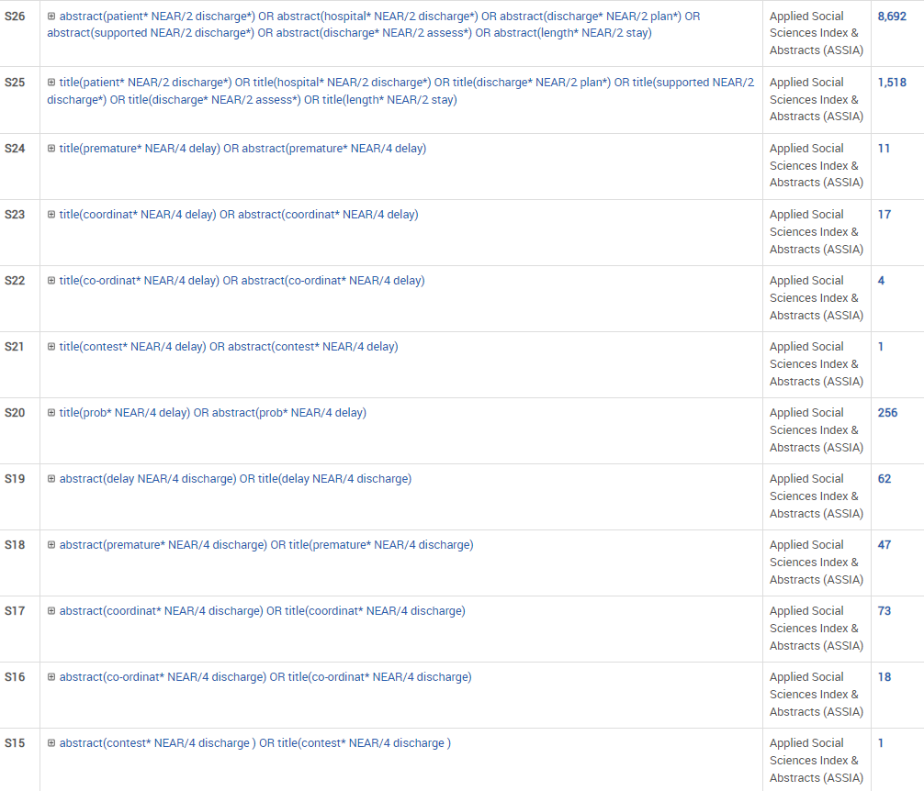
 | 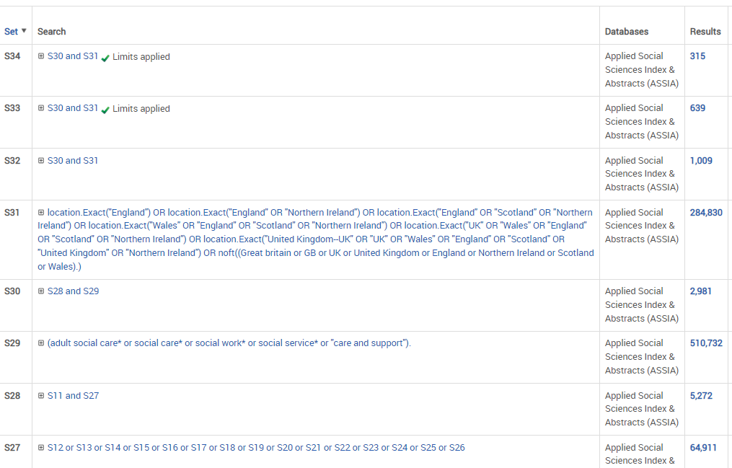
Review panel members and experience and how they were recruited
Criteria for including items | Inclusion:  - Older adults only;  - UK only;  - experience of hospital discharge (as patient, as hospital or care worker, as informal care giver);  - interventions for improvement;  - published 2017 onwards  Exclusion:  - extended length of stay not in relation to older adults (e.g. with a focus on the homeless, or non-age specific conditions such as traumatic brain injury, Covid-19);  - economic studies;  - studies focusing on integrated care working or collaboration across disciplinary boundaries generally;  - data analyses;  - studies focusing on the delayed transfer from care home to hospital or on transfers of care generally
Comment on whether evidence overall included perspectives of people who draw on care and support or carers and if so, how effectively
Comment on whether evidence overall included perspectives of people who work in services and if so, how effectively
Comment on equality, diversity and inclusion as addressed in the review
Summary of key conclusions of this review and implications for practice (please itemise)
Number of items included | Items included in review (layout as downloaded from database prior to editing for IMPACT house style):  - All-Party Parliamentary Group on Social Care (2019) Elevation, registration and standardisation: the professionalisation of social care workers. London: APPG Social Care.  Grey Literature  - Northern Ireland Social Care Council (2017) Social care matters: Challenges and opportunities for the social care workforce in Northern Ireland (online). Available at: https://niscc.info/app/uploads/2020/12/FINAL-designed-Social-Care-Matters-report.pdf (Accessed 11 July 2022)

