Working together to find better ways to manage waiting lists in the East Midlands

Summary of information gathered from people, carers, staff and relevant literature

Contents
Introduction 3
Factors contributing to waiting times 5
Staffing 5
Increasing demands 5
Systems and/or processes 5
Other Organisations 6
Impact on people and carers 8
Stress and frustration 8
Impact on mental health 8
Difficulty coping 9
Effect on independence 9
Financial impact 9
Impact on staff 11
Stress 11
Staff feel they are not doing a good job 12
Low morale 12
What is working well, and what can we do differently? 14
Better communication 14
Better processes and ways of prioritising people 14
Staffing 14
Work more closely with other organisations 15
Glossary 16

Introduction

In September 2023 we invited people who draw on care and support, informal carers and staff from the East Midlands to join online meetings to talk to us about their experiences of waiting lists. We also circulated two surveys, one for people and carers, and one for staff, across the East Midlands.

This document is a summary of what everyone told us in those meetings, and in the surveys.

It has been divided into four themes:
- Factors contributing to waiting lists in the East Midlands – this includes staffing issues, the causes and impacts of increasing demand, systems and processes and other organisations
- Impact on people and carers – including financial impacts, difficulty coping, impacts on mental health, stress and frustration and decrease in independence
- Impact on staff – including morale, stress and staff feeling they are not doing a good job
- What is working well? What could be done differently? – this includes better communication, staffing, working more closely with other orgaisations and better ways of prioritising

Each theme has a front page which shows the main things that people said. After the front page there is some more detail about what everyone told us.

Please use this information to prepare for the workshop, where we will ask you to share your thoughts on the themes.

We have included a glossary at the end of this document.

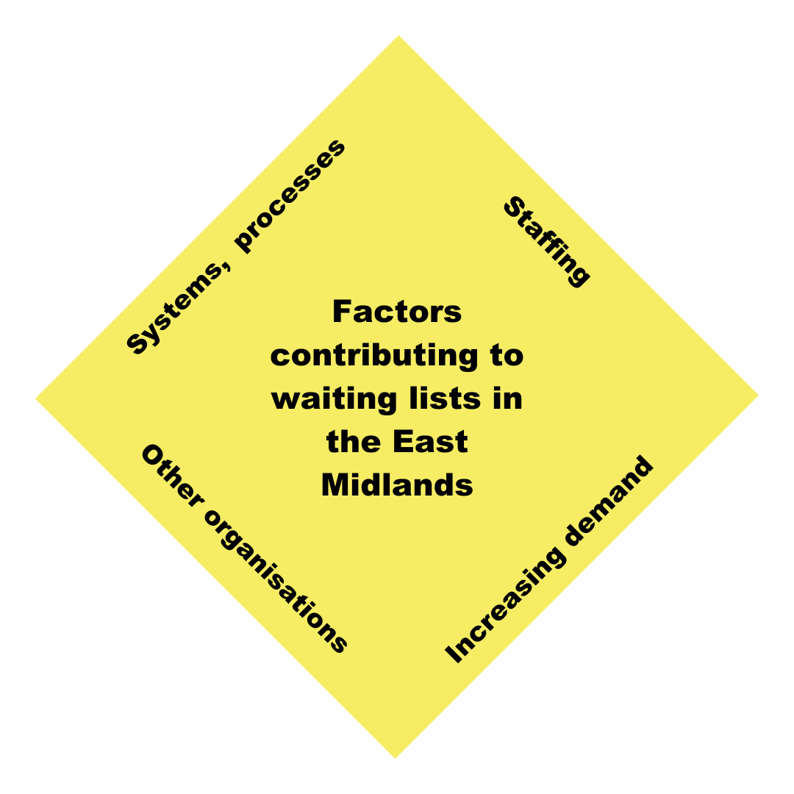

Factors contributing to waiting times

Staffing

- Not having enough staff was the main reason given for social care assessment waiting lists.
- A lot of staff are leaving social care.
- There is a shortage of qualified staff.
- A lot of staff are off sick, putting pressure on those still at work.
- Several people are worried about the ageing workforce in social care, and what will happen in the future.
- Providers are struggling to recruit staff, which means a shortage of support for people in the community.
- Several areas have difficulties attracting new staff.
- People are not attracted to social care work because of the low pay.

Increasing demands

- The number of referrals for social care assessments has gone up.
- More people are living for longer and need support in their later years.
- More people are surviving at birth so the number of young people who need support is increasing.
- Peoples’ needs are increasing, so it takes longer to understand and arrange the support they need.
- Safeguarding referrals often take priority, so the waiting list for social care assessments gets longer.
- People are discharged from hospital earlier and need support from social care.
- More people are being supported to stay at home rather than moving to residential care. This can be more complicated and can take longer to arrange.
- When people wait for an assessment their needs increase.
- Most referrals are urgent.
- The number of referrals for support with mental health and substance misuse issues has increased.
- Peoples’ expectations are higher.

Systems and/or processes

- Local authorities have over-complicated, lengthy processes and systems that takes staff away from spending time doing assessments.
- There should be more online and digital options for people who need a social care assessment.
- Members of the public have difficulty contacting the adult social care department.
- People and staff should explore other options such as community groups or voluntary sector support.
- The timescales for completing assessments are unrealistic.
- Staff must make sure there is an advocate in place when required, but there can be a delay in getting an advocate.

Other Organisations

- Pressure on the NHS means that health services are not always able to meet peoples' needs, leading to an increase in social care referrals.
- High waiting lists for health support means that peoples’ needs increase while they are waiting.
- The support from health and housing organisations is varied and can lead to pressure on social care.
- There are not enough organisations in the voluntary sector offering support.
- Other organisations make referrals to social care when this is not the help that people need.

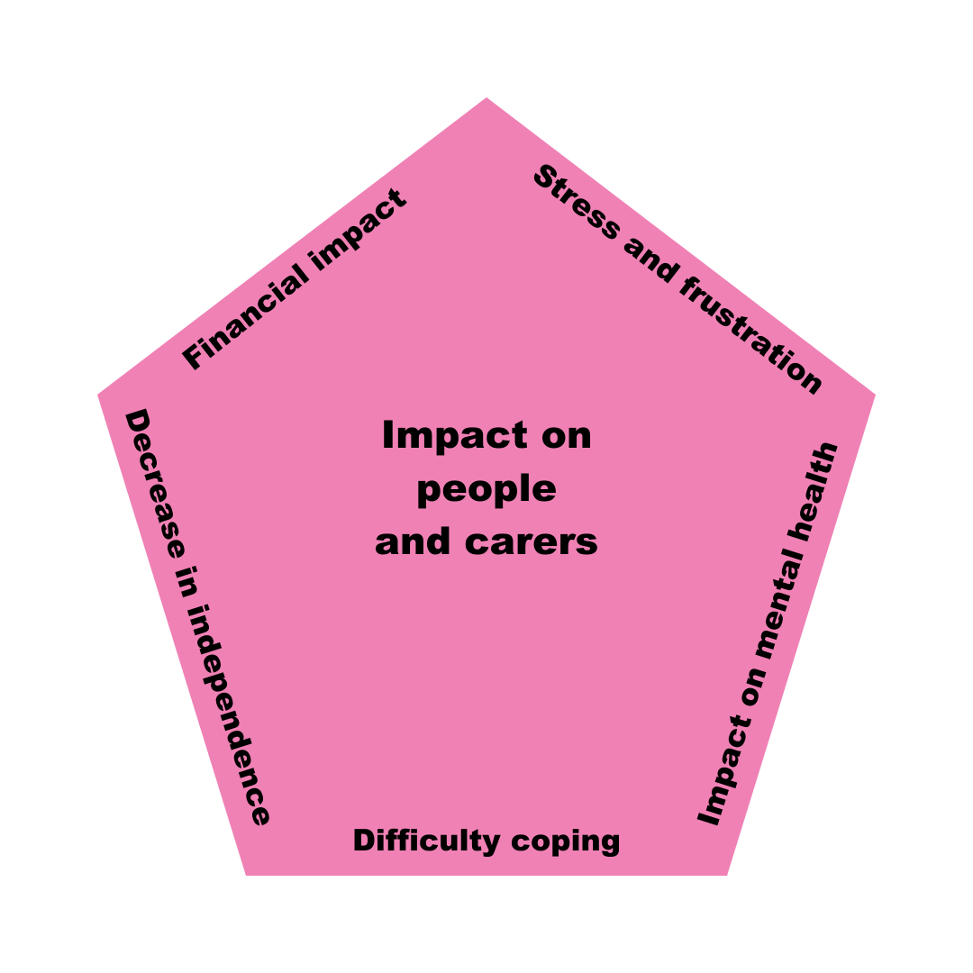

Impact on people and carers

Stress and frustration

‘I personally, found the whole process […] to be totally inhuman and frustrating.’

‘Very stressful - issues occurring when caring for someone are often urgent and you have no- one else to turn to.’

‘It added to the stress of the situation. And cost money we don't have. Additional stress for the carer at a time when you are trying to get your head round the new reality.’

‘I could not leave the house for all but the shortest shopping trip which was full of worry about mum.’

‘Stress, anxiety and exhaustion. Mum and I waited for a year to have a social worker allocated - in the end this never happened’.

‘There is a lot of information and aspects to the type of information you may require as a carer both practical, financial and getting help (employment rights, financial, obtaining care for a loved one, mental health etc), but the information appears fragmented and a lot of time is wasted trying to find out, what is needed, desired and legally required. All of this is happening whilst you are trying to care for someone and everything has to be dealt with, the stress is often great, impacting on one’s own health.’

‘Stressful just waiting and not knowing if or when contact would be made’

‘It impacted me badly. I applied for a carers assessment back in June 2021 and it took until May 2022 and a formal complaint to the Council to end up with a cheque for a personal budget of circa £400. It was a stressful experience with missed promises, deadlines and council employees simply not doing what they said they would do. It added significantly to what was already a stressful time looking after my wife who had severe mental health challenges.’

‘It has been an extremely stressful time for mum and myself. We were left feeling frustrated, anxious and distressed, not knowing who to turn to for support or what to do for the best to keep mum safe in her own home. We feel very let down by the system.’

‘Mum has become more and more anxious - feeling she was becoming a burden and was stupid because she couldn’t cope. Having spent a lot of time persuading mum it was okay to ask for help, we were really disappointed with the lack of support offered.’

Impact on mental health

‘I coped by sacrificing everything, including my mental health’.

‘It caused added strain on not just my husband’s physical health but the mental health of the whole family’.

‘It's impacting on my mental and physical health’.

‘I feel that it has resulted in a deterioration in my mother’s mental wellbeing, increased her depression and feelings of loneliness and possibly accelerated her dementia’.

‘Waiting has caused detrimental anxiety and mental health’.

Difficulty coping

‘We didn’t really cope, just one day at a time and it has ruined our relationship with each other.’

‘It impacted hugely, as every day waiting stacks on top of a struggling situation already overwhelming.’

‘Didn’t cope went into shut down mode…affecting the whole family’s relationships and ability to cope.’

Effect on independence

‘I gave up driving and brought myself a scooter to maintain my independence but could not use it due to waiting for a ramp at my property. I have lost my independence.’

‘It’s very distressing for my mum not to be able to shower and clean herself properly – she is used to showering and washing her hair every day.’

‘I am struggling to do things at home. My mobility is stopping me from getting out.’

Financial impact

‘I have had to purchase equipment myself due to waiting for an OT assessment. This has had an impact due to the cost-of-living crisis.’

‘I have had to purchase my own temporary ramp with has caused problems due to the price of everything and now I wonder if I can afford to put the heating on.’

‘I was at the stage of thinking of paying for the equipment myself even though I couldn't really afford it due to the time waiting.’

‘I spent £500 on a bed and bedding to enable [my husband] to come home.’

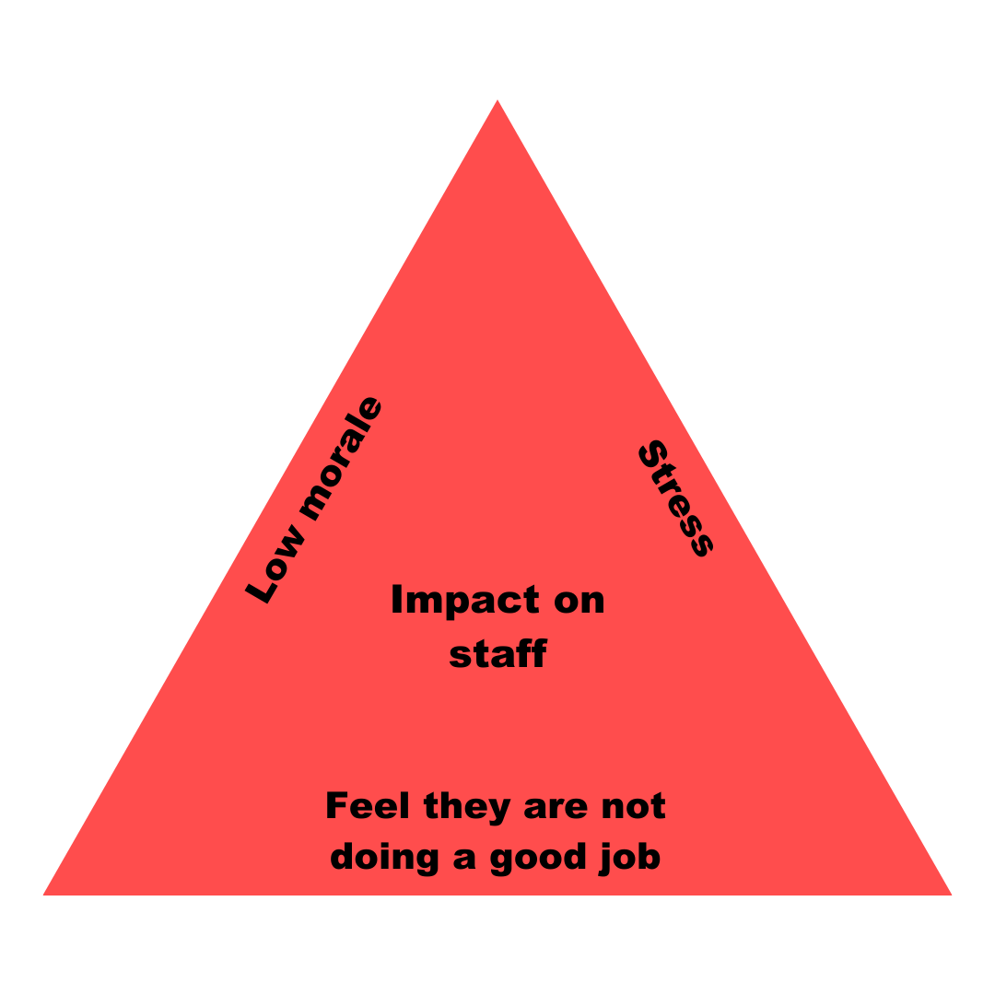

Impact on staff

Stress

‘At times it can get overwhelming when waiting lists are high, it can feel relentless when you are already working at your maximum capacity, it can negatively impact your own wellbeing.’

‘I feel stressed, don't feel like I am doing my job well, it is affecting my health and wellbeing. I worry about how it affects the people that are waiting for an assessment too.’

‘Feeling constant pressure’.

‘It causes a lot of stress for me personally to speak to a person in need, and tell them that we will get back to them in weeks or months.’

‘It increases stress and anxiety for myself and the team due to managing increased risk and people entering into crisis as they are not getting the right support at the right time. This is causing workers to feel burnt out.’

‘It is a constant pressure that adds to a feeling of stress but also concern for the individuals that are waiting as I can empathise with them.’

‘I find it very difficult having to walk away knowing a person simply doesn't get what they need, especially in regard to their emotional wellbeing.’

‘Very stressful trying to prioritise need and competing demands. Increasing complaints and angry families.’

‘It has added unnecessary pressure to an already pressurised job.’

‘Feels like there is never a light at the end of the tunnel - however many cases to allocate, the same number appear back on the list from new referrals. You feel pressured to move on your own cases quickly as other are waiting to be seen. This affects job satisfaction, feel like you are not able to do your best for your service users/carers.’

‘Staff struggle with stress, impacts on whole system. We are here because we care – very significant impact on staff.
Significant impact on team and me. Guilt of not being able to provide what we want to provide.’

‘You come into this line of work because you care and seeing people wait when you have a long-term relationship with them and/or you can see them in crisis, it’s really difficult.’

‘My mental health worsening with increased demand and slower processes with additional forms now in place.’

‘It causes everyday stress, particularly when ringing clients to advise them there is a 'long wait' & having to respond to their disappointment, frustration & sometimes despair that we are unable to act to meet their needs in a timely way.’

‘Stress! The constant pressure of managing risky situations. The impossible task of having to decide which crisis is more urgent. Staff turnover has been significant due to work pressures.’

‘Caused stress and anxiety due to the risk of managing this and the awareness of the difficulties people are continuing to experience while waiting for a response.’

Staff feel they are not doing a good job

‘Just makes us feel we are failing the person.
Waiting too long can then result in us having to deal with people in a crisis or more hospital admissions. Added stress from management to complete care act assessments.
Feel that we do not have enough time to write up assessments in a person-centred way and not able to spend as much time with the person to get a full holistic view.’

‘I experience an increased personal pressure relating to the responsibility for risk for those people waiting. There has become an expectation of fault/blame due to those people waiting upon my team/service.’

‘It makes you feel that you can’t do your job properly, it puts pressure on workers to work longer to get things done.’

‘I always feel guilty if I don't have the time for clients who need more support or extra home visits. I try to fit in as much as possible but sometimes I don't feel I am providing a good service. ‘

‘Made to work faster instead of focusing on improvement and quality.’

Low morale

‘Affects morale - concerns around the risk and people waiting’.

‘Less enjoyment of role’

‘Can be disheartening to see the waiting times.’

‘Affects staff morale knowing people are waiting a long time to be seen.’

‘Waiting lists are not good for staff morale, and customers waiting to be seen are frustrated or angry when they do get seen, so it's more pressure on staff’.

‘Disillusioned and feel so many service users are being given a poor service or dying/admitted to hospital before they are seen. Job has become too difficult’.

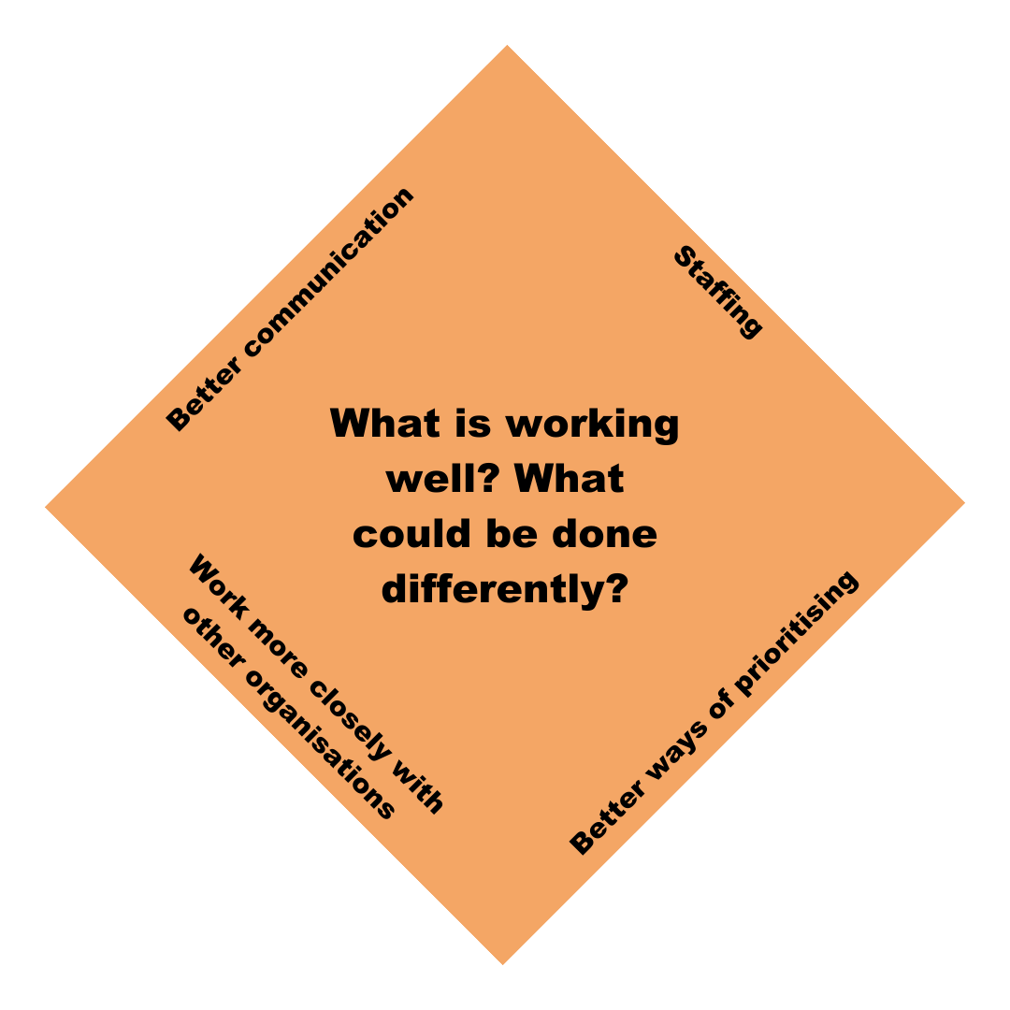

What is working well, and what can we do differently?

Better communication

- Send a letter about the waiting times with a number to call for any queries, or in case needs increase.
- Have a dedicated person to contact/who contacts the person and family. This person must be professional and compassionate.
- Pro-active communication to give regular updates: ‘The worst thing is not knowing what’s happening’.
- Telephone advice line
- More information about the process and how long things will take.
- ‘Being told you’re not forgotten.’
- Use outside support to help manage waiting lists. Managers do not have the time to do this effectively.
- Having the time / staffing resource to make regular contact with people on the waiting list.
- Increase awareness about what social care can provide so that referrals are appropriate.
- Use a strengths-based approach to assessments, ensuring that people and carers are at the centre.

Better processes and ways of prioritising people

- Reduce the level of administrative work for frontline staff and managers.
- Use prioritisation and risk tools to ensure people in most urgent need are seen first.
- Consider that those with lower-level needs may have been waiting the longest.
- Less forms for people to fill out.
- ‘The entire thing is far too bureaucratic and stressful both for the patient and the carer if they exist, I feel sorry for those that have to go through this on their own.’
- Data driven monitoring and improvement

Staffing

- Several participants commented that once a worker from social care has become involved, they have been very helpful and very good.
- Use staff resources effectively and efficiently – e.g. could admin workers be used to complete some of the computer tasks that social workers do so that social workers have more time to spend on assessments.
- Targeted recruitment campaigns
- Use some of the temporary funding available to recruit more staff to reduce waiting lists.
- More staff, less staff absences, better working conditions to attract staff.
- More staffing or retaining experienced staff. People leave the role as they feel burnt out due to high volumes of complex work.
- Good morale in the team is very helpful for staff. This is helped by staff spending regular days in the office together. This boosts morale.
- Good team support
- Feeling supported and that this is a ‘corporate responsibility’.
- Try to keep work and home life separate.
- Move staff around the service to respond to demand.
- Split team in two. One team takes urgent work, the other works with people who have ongoing needs and require an assessment or review.
- Telephone assessments
- Planning work so that staff are not travelling too far.
- Have a good duty system where people are risk assessed and prioritised, but also where people can get information about other organisations.
- Use strengths-based approaches and empower staff to make decisions.

Work more closely with other organisations

- Some participants identified that more support for carers is needed.
- Organisations providing dementia support and support for carers have been helpful.
- Social prescribers and community connectors have been helpful for some people.
- Increase knowledge of community groups and organisations so that people are encouraged to look at other types of support.
- Make more use of reablement and enablement services.
- Work on getting better communication between social care and health so that it is more quickly identified when someone needs support.
- Voluntary sector organisations have provided support for some people e.g. 'Age UK arranged a home visit and guided me re applying for the attendance allowance and a blue badge, registering me as a carer too.’

Glossary

Administrative work
Examples of administrative work are filling in forms, filing documents, sending and answering emails and arranging meetings.

Advocate
Advocates in social care are independent from the local authority (local council) and the NHS. They are trained to help you understand your rights, express your views and wishes, and help make sure your voice is heard.

Bureaucratic
For the purposes of this document, bureaucratic means systems that have a lot of processes and rules that sometimes seem to get in the way of being efficient and using common sense.

Burnout
Burnout is not the same as feeling overworked but being overworked can contribute to burnout. Every individual may experience slightly different symptoms of burnout, but the main features usually include a loss of interest in your work, finding it difficult to focus or a lack of interest, and exhaustion.

Carers Assessment
If you care for someone without being paid to do it, you can ask for a carer’s assessment. A carer's assessment means social services will look at your situation and see if you are entitled to any services that could make your caring role easier for you.

Enablement
Enablement services help people to learn new skills to help them to have more independence and control over their lives.

Pro-active
Making change happen rather than just reacting to something. For example, rather than waiting for the bus and getting frustrated, you could be pro-active and look up when the next bus is coming.

Providers
Providers are the organisations who support people with their daily lives. This could be in a care home, or providing support to help someone stay at home.

Qualified Staff: Staff who have a qualification in a profession such as Occupational Therapy or Social Work.

Reablement
Reablement services help people to re-learn skills they have lost because of poor physical or mental health.

Safeguarding referrals
A safeguarding referral is made to adult social care if someone is worried that they, or someone they know is not being looked after properly, or is being abused.

Social Care Assessment/Care Act Assessment
You can ask for an assessment from adult social care where it appears that you may have need for care and support. You can ask for this yourself, or someone can ask for this on your behalf (such as a friend, family member or professional).

Strengths-based approaches
Strengths-based (or asset-based) approaches focus on individuals’ strengths (including personal strengths and social and community networks) and not on their deficits. Strengths-based practice is holistic and multidisciplinary and works with the individual to promote their wellbeing. (SCIE website)

Substance misuse
Substance misuse is the use of alcohol, illegal drugs, or over the counter or prescription medications in a way that they are not meant to be used and could be harmful to you or others around you.

Voluntary sector
The voluntary sector means organisations that do not make money and are not run by local or national government. Many of these organisations are charities, and focus on a particular need or issue, such mental health. Some voluntary sector organisations provide support to people in need, and they also campaign for change. The voluntary sector is sometimes called the ‘Third’ sector or the ‘Not for profit’ sector.

