IMPACT Local Network - IMPACT Local Network on people with learning disabilities / autistic people leaving long-stay hospitals
Final Report
Easy Read

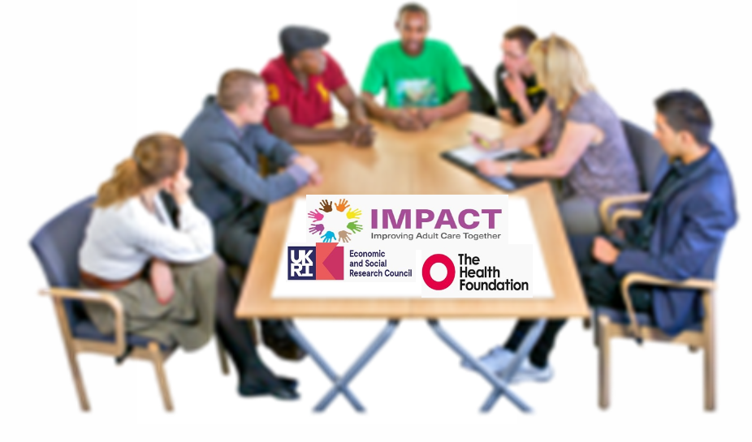
The IMPACT Local Networks met across the four nations of the UK to discuss the topic of people with learning disabilities / autistic people leaving long-stay hospitals with the aim to learn together from each other's experience and create change.

IMPACT Networks met four times to develop an action plan based on what they have learnt together from:

- The evidence review IMPACT provided in their first meeting.
- Evidence from people working in adult social care.
- Evidence from people with lived experience of disability and/or learning disabilities and carers.

IMPACT values all of these types of evidence equally, and aims to ensure that all voices are listened to bring positive change.

This document puts together the main points discussed, and it presents the final action plans that each local network has co-produced during these four meetings together.

Evidence review:

Professor Jon Glasby reviewed the evidence on the subject and wrote a discussion material for the first IMPACT network meeting.

Some of the main points were:
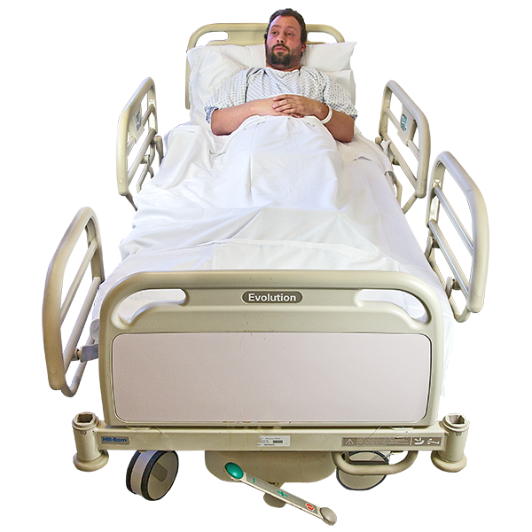
- A high number of people with learning disabilities and autism are admitted in long stay hospitals in all 4 UK nations. Some people stay in the hospital for 3 years (and more).

- Discharges are delayed because there is a lack of adequate community services.
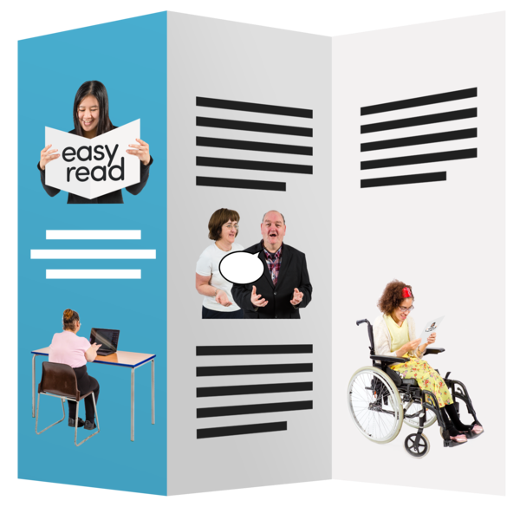
- There are few studies on why people with learning disabilities and/or autistic people spend so much time in hospitals. In particular, previous research has not talked directly to people with learning disabilities/autistic people, their families and front-line staff to know their experiences.
- The review identified a guideline developed with people with lived experience for coming out of hospitals.

About the local networks:

All Networks included a different mix of people who draw on care and support, care workers, front-line staff, providers and commissioners of services and other stakeholders from the adult social care sector.

There were five local networks:
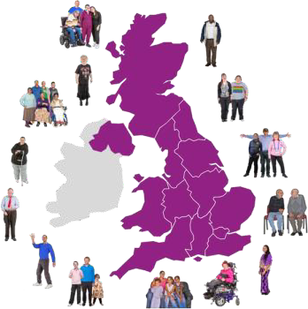
- In Control Scotland coordinated one network in Scotland,
- Bild ran a network covering all England,
- St Andrews Healthcare coordinated a network based in Northamptonshire, England.
- MacIntyre coordinated two networks:
- one in Manchester, England (This network concluded early)
- one in Wrexham, Wales.

Key themes from across the UK Local Networks

Networks identified some causes of why people are not discharged from long-stay hospital:

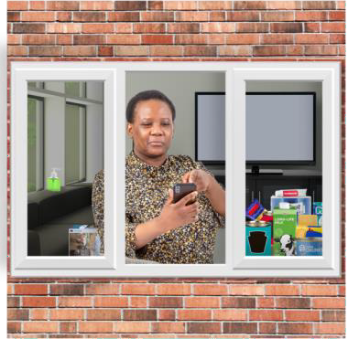
- Lack of alternative accommodation for people to move into.

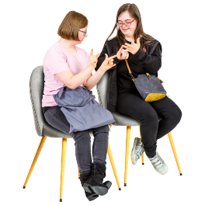
- Lack of communication between professionals / organisations.

- Organisations do not take responsibility for the discharging plan. Families are not involved in the planning process.

- Lack of understanding of the individual needs of each person. Each person’s autism, for example, is different.

- The person needs to be much more involved in the choices in the plan about what happens to them.

- Lack of information: in one network in particular, which was attended by people with learning disabilities who never experienced hospitalisation, participants were ‘shocked’ about the statistics on long-stay hospitals.

- Lack of funding.

Other challenges included:

Needing the right staff with the right skills: right motivation, compassion and the ability to understand and follow often very complex support plans is a real challenge.

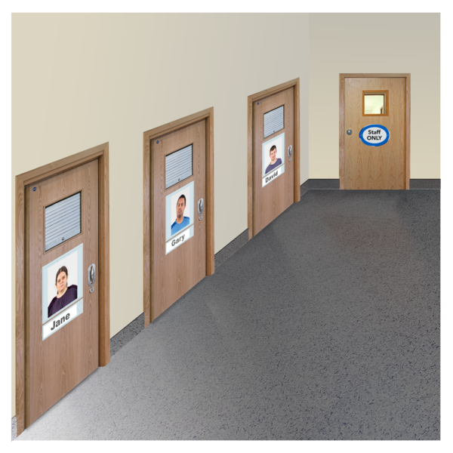
Staff in the hospitals are often afraid that people who have been admitted in the hospitals cannot change and are not able to live in the community.

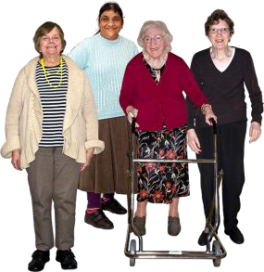
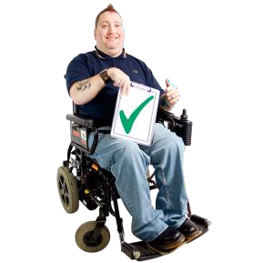
Hospitals do not support people in their social skills and people while hospitalised lose the skills to live well in the community.

Lack of a good person-centred planning for discharge and pressures to move quickly in the community can lead to re-admission.

Many people who have lived in a hospital have experienced significant trauma. It is very difficult to develop trusting relationships again.

Areas where change would make the most impact:

Language: There needs to be more emotive language to acknowledge the fact that this is a human rights and an inequality issue.

Early intervention, including in childhood and prevention.

The importance of planning: It is important to make the person ready to go back in the community and to make sure the person being cared for understands the plan.
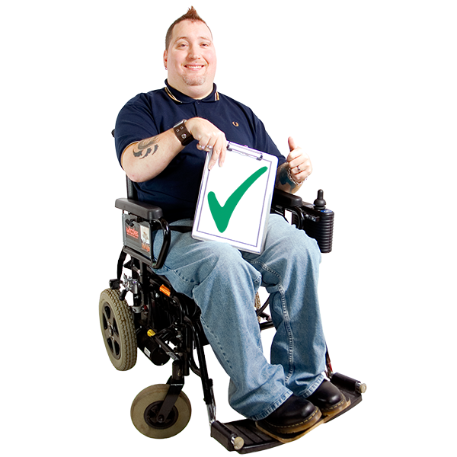
Evidence sharing and examples of what works well: Lessons learned from one person’s situation are not often carried over to other situations, the only way to make real change is to try different approaches.

Labels which are used in hospital settings are often a barrier to understand the real needs of the person. Knowing the person and understanding why they are distressed would be more helpful.
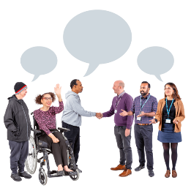
It is important that professionals involved in a person's care in the hospital collaborate with the people who care about them (eg. the person being cared for, their family etc.)

There is clear and evidenced inequality for people with learning disabilities and autistic people in rates of admission and length of stay.

‘Call for Collective Action’
Each network has chosen an area to change. However, there are some actions that the IMPACT networks would like to change together.

Common themes:

- Collective action around prevention of admission to long stay hospital

During IMPACT network meetings, participants decided that there are issues and challenges across the 4 nations. Networks agreed working together is the best way to raise awareness and encourage local and national action.

- Equality and human rights
The networks decided to take an equality and human rights approach. Changing practices is important but it is also important to change the language used by professionals around hospital admission.

It is important to highlight the negative consequences of the risk management culture and the unmet needs when a person stays in the hospital for too long.

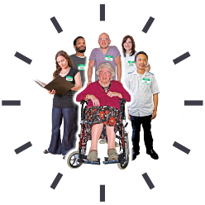
- Co-production
Another aim of the networks is to ensure that the voice of people with lived experience is heard and included on the local and national level.

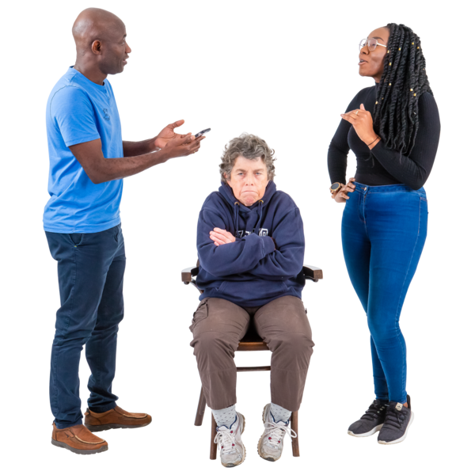
People using services are often not involved in their treatments, plans and in the creation of services. Networks will look for innovative ways to get everybody involved and listened.

These themes were linked to one main and shared Activity:

- To launch an awareness raising campaign across the all 4 nations networks about:

- Human rights violations in long stay hospital settings
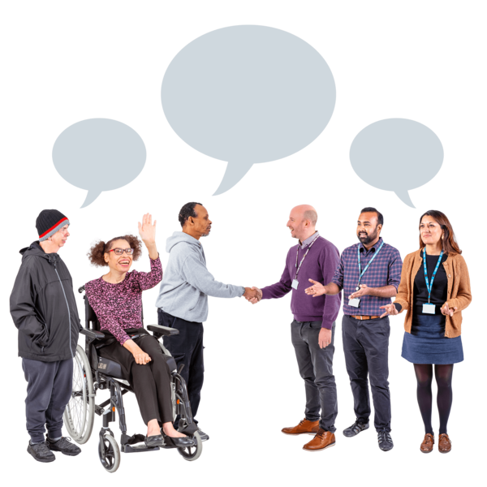
- The human impact on people’s lives and their families
- The importance of language when talking about patients in hospital
- Sharing examples of good practise alternatives to ineffective ways of working

We want to create:

- Videos

- Case studies - preventative and effective examples
- A community of practice

Local Networks’ action plans

Bild, England

What are you trying to change?

- Create awareness about the problem
- Working to ensure the problem is included in other political parties manifestos
- Focus on stories and human rights with a focus on prevention.

What are the main activities?

- Develop a video of 3 peoples’ stories
- Create events to share the video and create awareness about prevention

In Control, Scotland
What are you trying to change?

- Raise Awareness about the problem in Scotland - bring and maintain the problem on the top of the political agenda
- Change the Language from being based on risk to focus on prevention.

What are the main activities?
- Gather evidence on good practices. Put this evidence together in a way that can be shared easily.
- Half day conference and protest at the Scottish Parliament.

St Andrews Healthcare, Northamptonshire, England

What are you trying to change?

Improve internal practices in the organisation - focusing on two areas:
- Care plan for discharge in the community
- Improving Care Planning Approach template

What are the main activities?

Two main projects:
1) Self-assessment against best practice guidelines

2) Care Programme Approach project

MacIntyre, Wrexham, Wales

What are you trying to change?

Engaging providers and providers able to deliver really good Positive Behaviour Support to develop a network.

What are the main activities?

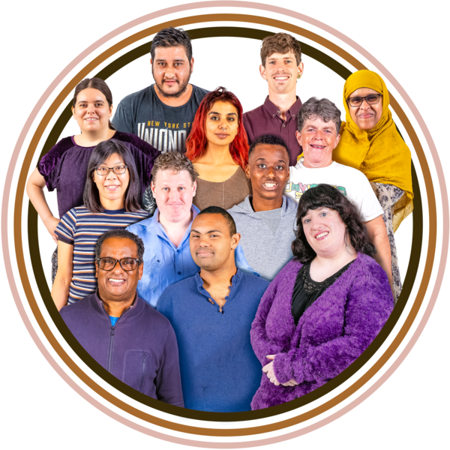
- Stories / glimpses of the future / co-production
- Campaigning
- Positive Behaviour Support (PBS)
- Relaunch 2019 Commissioning Guidance

Medium term benefits?

Overcoming barriers to bring health and social care together around behaviour (‘behaviour is a health thing’).

Compass, Northern Ireland
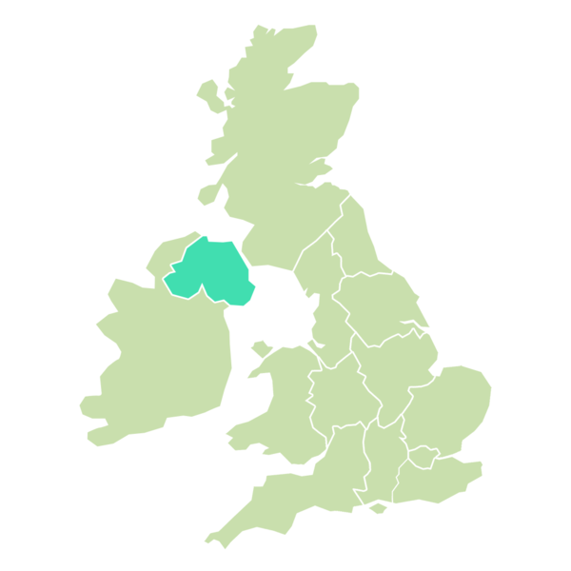
What are you trying to change?

Raise awareness about what people with learning disabilities want across professionals.

What are the main activities?

A video: where participants to the network can express who they are, what are the real needs and the importance of having their voice heard.

Thanks for reading this document. What happens next?

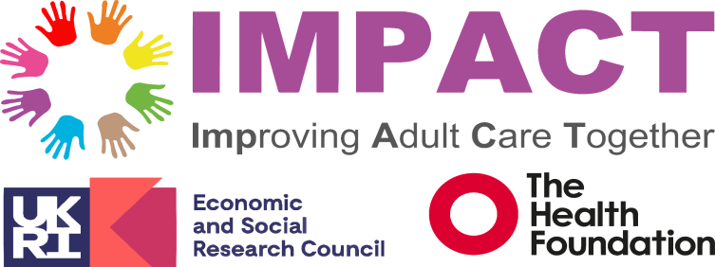
IMPACT survey completed by all network members for feedback (link)

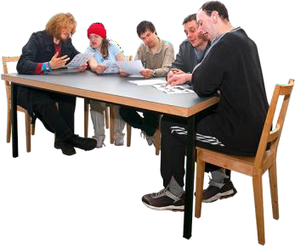
The IMPACT team will continue to review material and evidence submitted by networks and identify key messages to share to a range of audiences.
The IMPACT communications team will create a webpage for the topic and share the evidence collected in the networks, alongside the initial evidence review
The IMPACT Networks team will follow up with IMPACT network coordinators after 6 and 12 months

Ways to keep in touch with us
- IMPACT Newsletter
- IMPACT Twitter/X
– IMPACT LinkedIn
- IMPACT Website
-IMPACT Assemblies (North and East England, South England, Scotland, Northern Ireland and Wales).

Final thoughts

Some of this document has been shortened for our Easy Read version. If you want any further information on different sections, please let us know.
A full version of this leaflet, including a source list, is available on request.

