IMPACT Network- Remodelling the Front Door
Discussion material
Prepared by Maria Teresa Ferazzoli (September 2023)

You can use this discussion material that summarises evidence – research, practice and lived experience knowledge – to open up conversations between people who are interested in thinking about ways to change how people first make contact with adult social care- sometimes called the ‘front door’ to services.
This material outlines the issue in terms of the challenges people face when trying to navigate the adult social care system, and explores some different ways to support people to do this.
The aim of this material is to spark discussions in your groups about your experiences and ideas for change.

Summary
- This document is about ‘Front Doors’ in adult social care. There are different terms used for this service across the four UK nations (e.g. ‘gateway’ or ‘single point of access’)- we mean the service where people first ask for information and access social (care) services.
- As in any home, the ‘front door’ to adult social care services plays the important role of making the first impression and making people feel welcome when in need of help. The ‘front door’ is also the place where potential problems and needs are assessed in order to refer the person to services that can address those needs.
- There is a general acknowledgement across policy makers and social care experts about the importance of ‘front doors’ in terms of equal access and providing prompt and appropriate support to people. However, the evidence review highlighted access to social services is still unequal and delayed leading to unmet need.
- Following an overview of how to access social care services in the four UK nations, the document provides some examples of the different models of ‘front doors’ implemented in the UK including the ‘3 conversation model’ in England or the ‘frailty at the front door collaborative’ in Scotland).

What is the issue we’re looking at?
The first point of contact with services is very important for adults looking for support. When talking about ‘front door’ in this document, we refer to the information and advice services that people encounter when they access social services. However, we acknowledge the existence of different terms (e.g. Gateway; single point of entry; IAA) and models across the four UK Nations.
The ‘front door’ in the context of social care is the arrangement that local authorities have in place to respond to an initial contact from a professional or member of the public in relation to an individual need. At the front door, local authorities provide information about services provision, assess these needs and then, they should provide a care plan to address those needs.
While there are diverse models applied across the four UK nations, access to adult social services has been recognised as a priority across the four UK nations – in all the main national policy papers for the reform of adult social care. Evidence shows that prompt access to services and the right assessment can allow receiving the right support and enhancing choice and control for the person in need of care and their carer. Additionally, when this is in place, it leads to continuity of care (Freeman and Hughes, 2010) and more cost-efficient service delivery (LGA, 2014; Rees et al., 2019). Studies have also suggested that adequate access to social care can reduce demand on secondary health services amongst older adults (Spiers et al., 2019). The LGA Adult Social Care Efficiency Programme - final report has reported how effective models of front doors can bring important savings to the local authorities reducing inappropriate referrals. More specifically, the report showcased two projects: Calderdale’s ‘Gateway to Care’ and People2People in Shropshire County Council. According to the report, Gateway to Care was acknowledged as the main approach that allowed Calderdale to save £1.025m per year in adult social care from 2014/15 – 2016/17. The focus of Gateway to Care is on prevention, early intervention and safeguarding. Over 97 per cent of contacts are diverted to solutions delivered within the community or receive short-term support that reduces the need for longer-term care.
People2People is a social enterprise that delivers the front-end adult social care service for Shropshire County Council. According to the report, this innovative new model, which is rooted firmly in the community, managed to save £800,000 in its first year.
However, reports across the four UK nations have identified a series of shared barriers to equal access (Freeman and Hughes, 2010; BCP, 2019) to social case services:
- A complex system that is difficult for people to negotiate.
- Lack of a consistent point of contact to speak to or liaise with.
- Lack of consistency across the country in what people can access (the postcode lottery).
- Lack of "portability" of care packages/plans if people need to move around the country.
- Application of eligibility criteria.
- Lack of a national practice model that will provide a single planning process.
- No single adult's plan or pathway.
- A system that is not flexible to reflect changing needs.
- A system which focuses on acute and crisis support rather than prevention and early intervention (Scottish Government, 2021).

A report from Adult Social Care has also highlighted that “the front doors do not systematically promote independence for residents, and there are opportunities to prevent, reduce and delay the demand on adult social care” (BCP Council, 2019). Research has also highlighted barriers which are specific to certain groups, such as ethnic minorities (Greenwood et al., 2014; Malzer, 2013) or adults with learning disabilities (Flyn and Hatton, 2021).
Another issue is linked to the assessment process, which is an essential element of the front door’s service. Although there is limited evidence looking at the assessment process, the commissioning brief from the 23/47 Adult Social Care Needs Assessment (HSDR Programme) has highlighted high variation in practice in the assessment (NIHR, 2023), and how inefficient or late assessment can lead to long waiting times to access services (Human Rights Watch, 2019) and unmet needs impacting on older people (AgeUK, 2019).
For these reasons, IMPACT has selected this subject as one of the topics that is going to be explored by the IMPACT Network delivery model.

How does adult social care work right now in England, Northern Ireland, Scotland and Wales?
In Scotland, the local authority's social work department has the duty to arrange the assessment of a person's need and to call for provision of any [community care] services under the 1968 Social Work Act (section 12A). This assessment is a care management process, in which a care professional meets with an individual to explore and observe their support needs. During this process, the practitioner also assesses any existing care arrangements, strengths, with the aim to provide the best care possible. The assessment should include discussions with the individual and their support network to discuss how the person's needs can best be met and how they would like their care and support delivered. The Social Care (Self-directed Support) (Scotland) Act 2013 was introduced as a way of providing support that means people are given choice and control over how their care and support can be delivered. Since 2011, the Scottish Government has funded a network of independent support organisations to provide advice and advocacy to help people understand their rights to social care and to support them to access the care that is right for them. The current Support in the Right Direction Programme funds various projects providing advice and help with pre-assessment to understand the SDS process. They aim to provide an "end to end" service for people throughout their journey through social care and they can work with families and unpaid carers as well as people accessing support.
In Wales, the Children's Services Contact and Referral Team (C&R Team) and the Adults Services Duty and Information Team (ASDIT) have been amalgamated to form the Information, Advice and Assistance Service (IAA) under the Social Services and Well-being (Wales) Act 2014. The Local Authority has a duty to establish an IAA Service.
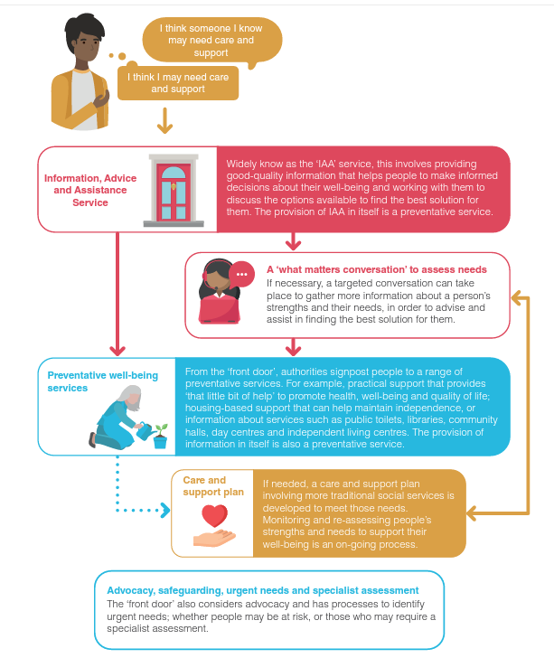

Source: Audit Wales/ Archwilio Cymru (2019). The ‘front door’ to adult social care
In England, to get access to social care, the first step is to get a needs assessment from the local council. The needs assessment is free and anyone can ask for one. Following the Adult Social Care Efficiency Programme 2012-14, local authorities identified the ‘front door’ as a way to improve the efficiency of services. Many local authorities explored new models for people to access adult social care (e.g. ‘strengths-based’ approaches; People2People; Gateway to Care). In 2022, Policy paper People at the Heart of Care: adult social care reform, stressed again the role of access to adult social care to improve the quality of service provided to people with long-term conditions.
In Northern Ireland, health and social care services use “a single point of entry”. The system is moving in the direction of an integrated care system. The local health and social care (HSC) trust has a duty to assess the needs of people who may be in need of support. A health and social care assessment with the social services department of the local trust is often the first step towards getting the help and support a person needs. They also have a duty to provide services to meet these needs. When requested, they must carry out a community care assessment (also referred to as a care assessment or a needs assessment).

Front door models
As seen in the previous section, the four UK nations are characterised by a diverse system where people can access social services. In England, there is a high level of differentiation across the nation, while in the other UK nations there is an attempt to create a more integrated system of access to social services. Here, we have identified some of the directions taken in the attempt to remodel the front doors.

Needs assessment vs asset-based approach:
Strengths-based (or asset-based) social care is a theory of practice in social work which encourages social workers to support people by building on their strengths. It is often contrasted with a traditional approach to social care in which social workers focus on identifying where people have problems or needs and then identifying outside services or sources of support that can ‘address’ that need; a process which strengths-based practice advocates would see as harming people's independence, wellbeing and sense of autonomy. Strengths-based approaches are now considered the mainstream in adult social care and the 2014 Care Act requires social care assessments to take a strengths-based approach. In strengths-based social care, ‘strengths’ can be seen as individual or social; people’s friends, family and social relationships are all considered as assets which can be built on to help them maintain a good quality of life and independence.
Case studies
3 conversation model: The 3 Conversations (3Cs) is a particular strengths-based approach to providing services that work collaboratively with people seeking support, including carers. 3Cs is being tried out in more than 25 local authorities. Those delivering and receiving services using the 3Cs approach have described better-appreciated, more appropriate and less costly supports being put in place, potentially leading to improved quality of life for those requiring support. Workers describe increased job satisfaction and managers suggest there have been reductions in provision of long-term care packages. However, concerns have been raised about strengths-based approaches. Some argue that it is merely a way to withhold services or make more demands on the families of those with care needs. Rigorous evaluation is therefore needed.

Let’s Talk Local: It is an approach in Adult Social Care to help support the aims of the Care Act 2014 in terms of preventative services and community support. Let’s Talk is an strengths-based, person-centred approach that puts staff in the driving seat and has required us to make big changes to our existing practices and test our cultural norms and behaviours. Let’s Talk supports people to become more independent, more resilient and as a result their health and wellbeing can improve.

Multi-agency team:
Specialist support, guidance and assessment for customers with complex service requirements, often needing a multi-agency approach with decisions made based on richer evidence, often from multiple sources. The idea at the core of a team with multiple expertise allows a more efficient needs’ assessment, to prevent admission in hospitals and a more coordinated system, which avoids cross referrals and multiple assessments. The idea of multiagency team at the front door was initially introduce to prevent risk of child abuse (see MASH).

Decision making, training and behavioural factors:
To reduce costs of inappropriate referrals to adult social care, Leeds City Council has worked with the Behavioural Insights Team (BIT) to increase the efficiency of their Contact Centre. They developed a new process for CSOs to follow to identify calls that were more likely to be inappropriately referred than others. Following a first process of research, the Behavioural Insights Team designed a behaviourally-informed intervention in which CSOs were given training and a prompt sheet to help them implement a new process while handling adult social care calls. This was known as the ‘OAT’ process.

Digital Transformation:
The aim of a digital portal is to allow customers to self-serve wherever possible by accessing guidance and real-time information relating to their services. Giving information in a way that is accessible to as many people as possible. This follows the example of the process of digitalisation started by the NHS and Digital health and care Scotland.

Case studies:
The Digital Front Door in Scotland: is part of the Digital Health and Care Strategy. It has the aim to deliver a platform for people to get access to their health and care information and to health and care services, directly. It will allow people to access, self-manage, and contribute to their own health and care information online. It has a strong focus on citizen engagement, person-led care and addressing inequalities.
Worcestershire Adults Portal: The Worcestershire Adults Portal is a system used to allow users to submit referrals safely and securely. The portal’s primary role is to receive enquiries and referrals into Adult Services. To access the portal, the person has to complete an online form and submit it to Adult Social Care. Users will be asked to register for a unique account which allows them to view submitted forms and receive feedback about their referrals. The benefit of the portal is that it is available 24/7 and it is part of a larger process of digitalisation aimed to support frontline staff and avoid duplication of data and referrals.

Organisation Design Operating Model:
Following the analysis of the ‘front door’ current practice and analysed best practice nationally (England), the Adult Social Care (ASC) Team developed a new model for operating the front door, which is going to be implemented in the Bournemouth, Christchurch and Poole Council (BCP Council). This model is going to integrate most of the innovation described in the previous sections. The implementation is based on the following four workstreams:
1. Rationalise, Standardise and Improve Contact Channels;
2. Digital Transformation;
3. Asset Based Working;
4. Data.
See below the graphic of this future innovative model.

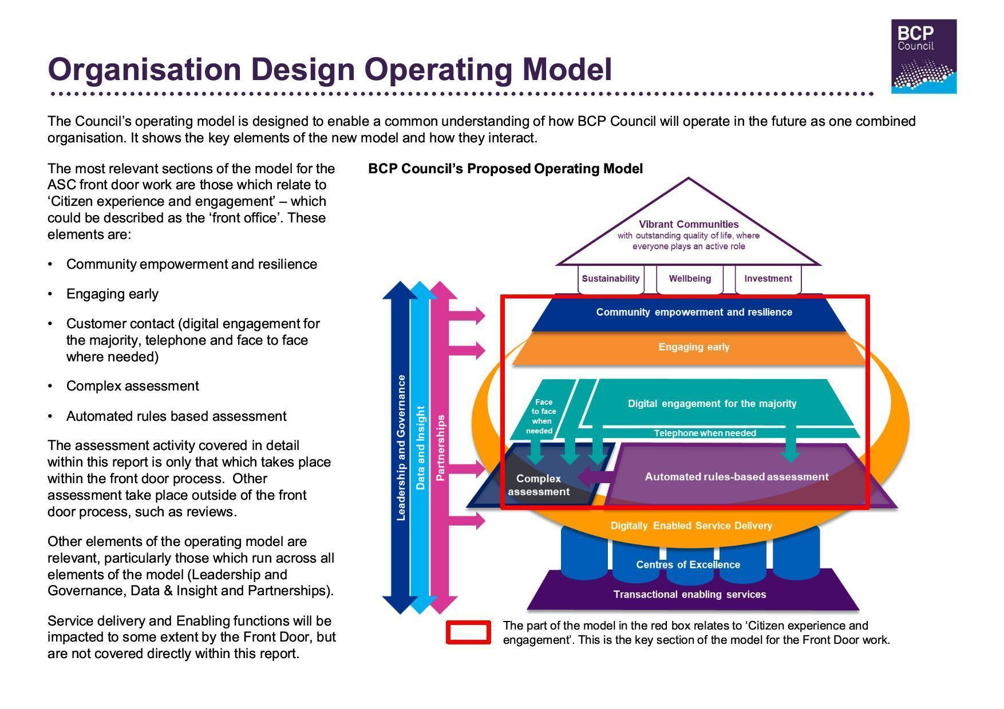
Source: BCP Council (2019) Organisation Design Operating Model
Having read the material above, you could discuss:
Your experiences…
- Would anyone like to share their experiences of ‘front door’ or accessing adult social care?
- What helps or hinders people having (or during) their first contact with services?
Thinking about this discussion document…
- Does anyone in the group have experience of any of the innovative models of ‘front door’ included in this document (e.g. Digital front door; Multi-agency teams, Asset based)?
- Were there any ideas in this document that you think could facilitate people getting access and information in adult social care?
- Anything in the document you didn’t agree with, or didn’t match your experience?

References and other sources of interest
- AgeUK (2019) Briefing: Health and Care of Older People in England 2019. Available at https://www.ageuk.org.uk/globalassets/age-uk/documents/reports-and-publications/reports-and-briefings/health--wellbeing/age_uk_briefing_state_of_health_and_care_of_older_people_july2019.pdf
- Alzheimers’ Society (2013) Community care assessment in Northern Ireland: Factsheet. Available at https://www.alzheimers.org.uk/sites/default/files/2018-10/northern_ireland_factsheet_community_care_assessment.pdf
- BCP council (2019) Adult Social Care Front door design Summary report. Available at https://democracy.bcpcouncil.gov.uk/documents/s14581/Appendix%20BCP%20Council%20Adult%20Social%20Care%20Front%20Door%20Design.pdf
- Benger, J. (2022) What does creating a ‘digital front door’ mean? Available at https://digital.nhs.uk/blog/transformation-blog/2022/what-does-creating-a-digital-front-door-mean
- Calderdale Forum 50+ (no year) Gateway to Care. Available at https://calderdaleforum50plus.com/calderdale-forum-50-plus/advice-hub/gateway-to-care/
- Department of Health and Social care (2022) People at the Heart of Care: adult social care reform white paper (CP560). Available at https://assets.publishing.service.gov.uk/media/6234b0a6e90e0779a18d3f46/people-at-the-heart-of-care-asc-reform-accessible-with-correction-slip.pdf
- Digital Health and Care Scotland (2023) Digital Front Door. Available at https://www.digihealthcare.scot/our-work/digital-front-door/
- Flynn, S. and Hatton, C. (2021) ‘Health and social care access for adults with learning disabilities across the UK during the COVID-19 pandemic in 2020’, Tizard Learning Disability Review, 26(3), pp. 174-179. https://doi.org/10.1108/TLDR-06-2021-0014 Freeman, G. and Hughes, J. (2010) Continuity of care and the patient experience. The King’s Fund. Available at https://www.kingsfund.org.uk/projects/gp-inquiry/continuity-of-care
- Greenwood, N., Habibi, R., Smith, R., and Manthorpe, J. (2014) ‘Barriers to access and minority ethnic carers’ satisfaction with social care services in the community: a systematic review of qualitative and quantitative literature’, Health and Social Care in the Community, 23(1), pp. 64-78. doi: 10.1111/hsc.12116
- Health and Social care (2023) Integrated Care System NI. Available at https://online.hscni.net/our-work/integrated-care-system-ni/
- Human Rights Watch (2019) Unmet Needs Improper Social Care Assessments for Older People in England. Available at https://www.hrw.org/report/2019/01/10/unmet-needs/improper-social-care-assessments-older-people-england
- Ihub (2019) The frailty at the front door collaborative. Impact report. Available at https://ihub.scot/media/6870/201912-frailty-at-the-front-door-collaborative-impact-report-v10.pdf
- Inetwork (No year) Trafford Council. Available at https://i-network.org.uk/trafford-council-19/
- Inspiring Scotland (no year) Support in the Right Direction. Available at https://www.inspiringscotland.org.uk/funds/support-in-the-right-direction/
- KPMG (2019) BCP Council Organisation Design: Summary Report. Available at https://democracy.bcpcouncil.gov.uk/documents/s13552/Appendix%201%20-%20KPMG%20Organisation%20Design%20Report.pdf
- LGA (2014) LGA Adult Social Care Efficiency Programme The final report. Local Government Association. Available at https://www.local.gov.uk/sites/default/files/documents/lga-adult-social-care-eff-ca6.pdf
- LGA (2016) People2People service for adult social care. Available at https://www.local.gov.uk/case-studies/people2people-service-adult-social-care#:~:text=Shropshire%20Council%20has%20developed%20the,solutions%20to%20meet%20their%20needs
- LGA (No year) Reducing inappropriate referrals at the front door of adult social care services in Leeds. Available at https://www.local.gov.uk/sites/default/files/documents/Leeds%20City%20Council_BI_Executive%20Summary.pdf
- Malzer, S. (2013) A Report On Barriers to Accessing Health and Social Care Services for Older People from Black and Minority Ethnic Backgrounds in South Glasgow. The Advocacy Project. Available at https://www.researchunbound.org.uk/bme/executive-summary/
- NHS (2022) Getting a care needs assessment. Available at https://www.nhs.uk/conditions/social-care-and-support-guide/help-from-social-services-and-charities/getting-a-needs-assessment/
- NICE (2023) What to expect during assessment and care planning A quick guide for people using adult social care services. Available at https://www.nice.org.uk/about/nice-communities/social-care/quick-guides/what-to-expect-during-assessment-and-care-plannin
- NIHR (2023) 23/47 Adult Social Care Needs Assessment (HSDR Programme) - commissioning brief. Available at https://www.nihr.ac.uk/documents/2347-adult-social-care-needs-assessment-hsdr-programme-commissioning-brief/32900
- Partners for Change (No year) The key to the door of a new way of working. Available at https://partners4change.co.uk/the-three-conversations/
- Rees, H., Selwyn, N., Frank, S., Lake, E., Brushett, M., Dixon, P., Palmer, K. and Leahy, S. (2019) The ‘Front Door’ to Adult Social Care. Audit Wales
- Scie (2017) Asset-based places: A model for development. Available at https://www.scie.org.uk/future-of-care/asset-based-places/model
- Scie (2023) Assessment and care planning: 3 conversations. Available at https://www.scie.org.uk/future-of-care/asset-based-places/case-studies/three-conversations
- Scottish Government (2021) A National Care Service for Scotland: consultation. Available at https://www.gov.scot/binaries/content/documents/govscot/publications/consultation-paper/2021/08/national-care-service-scotland-consultation2/documents/national-care-service-scotland-consultation/national-care-service-scotland-consultation/govscot%3Adocument/national-care-service-scotland-consultation.pdf
- Scottish Government (2021) A National Care Service for Scotland: consultation. Available at https://www.gov.scot/binaries/content/documents/govscot/publications/consultation-paper/2021/08/national-care-service-scotland-consultation2/documents/national-care-service-scotland-consultation/national-care-service-scotland-consultation/govscot%3Adocument/national-care-service-scotland-consultation.pdf
- Shropshire Choices (2023) Let's Talk Local sessions. Available at https://www.shropshire.gov.uk/shropshire-choices/i-need-help/getting-the-help-you-need/lets-talk-local-sessions/
- Social Care Wales (2023) Competency Framework for the Information, Advice and Assistance (IAA) Workforce. Available at https://socialcare.wales/qualifications-funding/competency-framework-for-the-information-advice-and-assistance-workforce#:~:text=Competency%20Framework%20for%20the%20Information%2C%20Advice%20and%20Assistance%20(IAA)%20Workforce,-Last%20updated%3A%2022&text=The%20Competency%20Framework%20for%20the,assistance%20for%20care%20and%20support
- Spiers, G., Matthews, FE., Moffatt, S., Barker, RO., Jarvis, H., Stow, D., Kingston, A. and Hanratty, B. (2019) ‘Impact of social care supply on healthcare utilisation by older adults: a systematic review and meta-analysis’, Age and Ageing, 48(1), pp. 57–66. https://doi.org/10.1093/ageing/afy147
- Worcestershire.gov (no year) Get in contact with Adult Social Care. Available at https://www.worcestershire.gov.uk/council-services/adult-social-care/get-contact-adult-social-care
- Claire Field (2018) Senior Business Analyst - Worcestershire County Council. Available at https://www.youtube.com/watch?v=iBlT4a5H-mg&list=PLfh5E6HY1oDeyTSTftXs3qTlAA_c7FCdy&index=5&ab_channel=mH
- Local Government Association (2018) Leeds City Council- reducing inappropriate adult social care referrals. Available at https://www.youtube.com/watch?v=T435fbrHPoE&ab_channel=LocalGovernmentAssociation
- Audit Wales (2019) The ‘front door’ to adult social care. Available at https://www.youtube.com/watch?v=jAAsGNtj-p4&ab_channel=AuditWales
- Partners for Change (2023) Time to Act. Available at https://www.youtube.com/watch?v=15uNzMN41uY&ab_channel=The3ConversationsChannel

