IMPACT Co-production Advisory Group Annual Report

Contents
Foreword 2
Introduction 3
Membership 3
Members 3
Skills and assets of the group – in development 3
Meetings and Outcomes 4
Internal Collaboration 7
Guiding documents 8
Away Day Co-Design 9
Conclusion and Priorities for 2024 10
Key priorities for 2024 11

Foreword

“What is co-production?” I asked.

I had just joined the local Parent Carer Forum and people were talking about co-production, but I didn’t understand the word.

“Parent Carer Forums are groups run by parents and carers of disabled children from their local area throughout England. The aim of the forum is to make sure that services in their area meet the needs of disabled children and their families”

Co-production was explained to me as “everyone working together” but I didn’t see how this was working. What I saw was parents and carers being consulted.

However, things began to change not long after, because it became more evident that it was important for us all to work together, to get the best that we could get for the person we cared for, but this had some restraints due to lack of funding.

I am a carer of a young man who has Down’s syndrome, Autism and no speech, and it was important that his views were heard just as much as mine were.

Years later, I joined one of England’s IMPACT Assemblies that meets to help shape IMPACT’s priorities and work plan, because I was fed up with the ‘tick box’ exercise that was being done in social services. I wanted changes to be driven by those using the services including carers like me. This is something that is at the heart of IMPACT.

I was asked to join the IMPACT’s Co-production Advisory Group – CpAG with the aim to develop, support, monitor, and review IMPACT’s co-production activity. Since joining the CpAG we have become more involved in what IMPACT does from recruitment to delivering workshops. This has proven successful not only for the group but for individual members.

That was over a year ago, and I have seen members of CpAG grow and flourish - no longer being the shy quiet individual who joined the group, but strong vocal characters not afraid to voice their opinions and participate on various levels. This has also given them the confidence to speak up when they had outgrown the care package given or when it was no longer suitable.
The CpAG has, and is, giving members a purpose!
Jacqui Darlington BEM, England North & East Midlands

Introduction

This annual report documents the work of the Co-production Advisory Group (CpAG) for 2023. It reports on progress made during the year, areas of good practice and areas for further development.

Our vision is: “Good support isn’t just about ‘services’– it’s about having a life.”

Our values are Equality, Diversity, Accessibility and Reciprocity (adopted from the SCIE Co-production Principles).

Membership

Membership of the CpAG is drawn from each of IMPACT’s five Assemblies. We have two Assemblies in England and one each in Northern Ireland, Scotland and Wales. Each Assembly meets twice a year to help shape IMPACT’s priorities and work plan. Membership of Assemblies is made up of a variety of stakeholders from the adult social care sector including people who draw on care and support, carers, practitioners, providers, commissioners, researchers/national bodies.

There are 10 members with lived experience of drawing on care and support or as an unpaid carer, supported by Lived Experience Engagement Lead, Karen McCormick.

Members
- England South & West Midlands is represented by Isaac Samuels and Ceri Davis BEM.
- England North & East Midlands is represented by Jacqui Darlington and Luke Nash.
- Northern Ireland was represented by Caroline Kelly and Orla Fitzsimons and will be represented by Deena Nimick and Hilda Hope in 2024.
- Scotland is represented by Ann Marie Penman and Natalie Patterson
- Wales is represented by Jo Phillips and Terence Davies.

We represent a diverse intersection of lived experience and are always open to improvement in our efforts for equality, diversity, and inclusion.

Skills and assets of the group – in development

We actively invested time to get to know each other, recognising the importance of acknowledging the skills and assets of the group as individuals and as a collective. We have begun mapping and documenting these.
Developing a mechanism for sharing information on available skills and assets of the group will be a key priority in 2024.

We are proud that one of our members has moved off the group and brings her lived experience into an IMPACT Facilitator role in Northern Ireland.

Meetings and Outcomes

Under each meeting heading, we set out what was covered in the meeting, who attended and contributed, outcomes from the perspective of group members and contributors and some observations.
Planning meeting
This was co-produced and co-delivered with Orla Fitzsimons, NI (Northern Ireland) Assembly Member

Outcome: agreed workplan for 2023

Meeting 1
Feedback from Leadership Team via Jon and Facilitator Models with Karen Watchman.

Question to CpAG:
It is important that outcomes from the Facilitator projects reach individuals who draw on care and support and carers, both in the host nation and across the UK. What should we be considering now for this to happen, and do you have any advice?
Outcome from Karen Watchman: We asked the wrong question in the context of the 3 models. Having reflected on the fact that pilot project agencies all had a very low or no co-production platform upon which facilitators could build, facilitator leads are discussing co-production possibilities before the facilitators start to do preparatory and planning work to enable facilitators to achieve quality co-production within their 12-month period.

What we could do differently
Every project will be unique but discussing the range of creative approaches that have or might work in terms making contact, initial conversations and then the more formal working together with the CpAG.

Meeting 2
Understanding evidence with Alison Bowes took place on Tuesday 13th June. This session was co-designed and co-facilitated by Ceri Davies BEM.

On realising that facilitator contracts were ending, we extended our meeting and extended an invite for Esme, Marie and Leanne to join us for a learning session on if and how the CpAG could better support co-production approaches as projects come online.

Question to CpAG

IMPACT defines evidence as consisting of research of various kinds, practice knowledge and the lived experience of people who draw on care and support. How do we ensure that our various audiences all buy into that definition and accept the evidence-base of our work?

Outcome: Consideration of how we effectively communicate what we mean by evidence, the different types of evidence and the language we use to communicate this with people.

Meeting 3
We were joined by Ask IMPACT with Rachel Posaner and Izzy Kennedy.

Question to CpAG

Aware that the output on managing change during COVID is going to focus on the practice setting, we will share the headings and crowd source information from different perspectives, discuss our future topics and ask for anymore.
We will review the first output also.

Outcome: - when we promote Ask IMPACT we have to be transparent/foster an understanding with regards to the ”evidence” and how we source it, i.e, when we say we have a lived experience perspective, this is still coming through academic/grey literature.
- we got lots of links during that meeting to sources we otherwise wouldn’t have found. It was helpful to crowdsource additional resources! We used these for the Covid report and it’s something we would be grateful for with other projects!
- one of our Ask IMPACT topics for 2024 came directly from a member of the Co-production Advisory Group!

Development Session 1
Recruitment training and information session was held on Wednesday 19th March. This session was led by Sophie Sinclair and supported by Karen McCormick.

The outcome of this session was a change in IMPACT recruitment and selection practice.

7 people went on to participate as lived experience panel members in IMPACT recruitment and selection process.
A feedback session has also taken place with those who took part to understand their experience of the process. This was positive from the group’s point of view.

Hi Karen
Thanks for this. It was a great session yesterday. I'm so glad that there is genuine involvement for us in the recruitment process. I feel that we as a group are listened to and there is real action taken from our comments.
I am really looking forward to being part of the panels!
Best wishes
Ann Marie

Development Session 2
Development session 2 was held on Thursday 14th December. It was a review of 2023 and planning for 2024. We welcomed new members Hilda Hope and Deena Nimick, both from Northern Ireland. We discussed areas where we could do better and priorities for 2024 – listed in conclusion and priorities.

Co-production Story
We continue to tell our personal stories (carefully) to support the work and brand of IMPACT. Examples of this include but are not limited to:
- Blog from Jacqui Darlington “No one gave me a job description”
- Various blogs by Karen McCormick
- Video interview with Jo Phillips for Carers Week 2023
- Workplace culture: positive change for PAs blog – Isaac Samuels wrote for Skills for Care
- Cross posting on social media channels of the involvement of members in advocacy work, social enterprise and coproduction.
- Karen McCormick attended and spoke at events in Birmingham, Antrim, Manchester, Stirling and Sheffield directly representing IMPACT.

Graphic report of PA Employment Summit, Sheffield December 2023
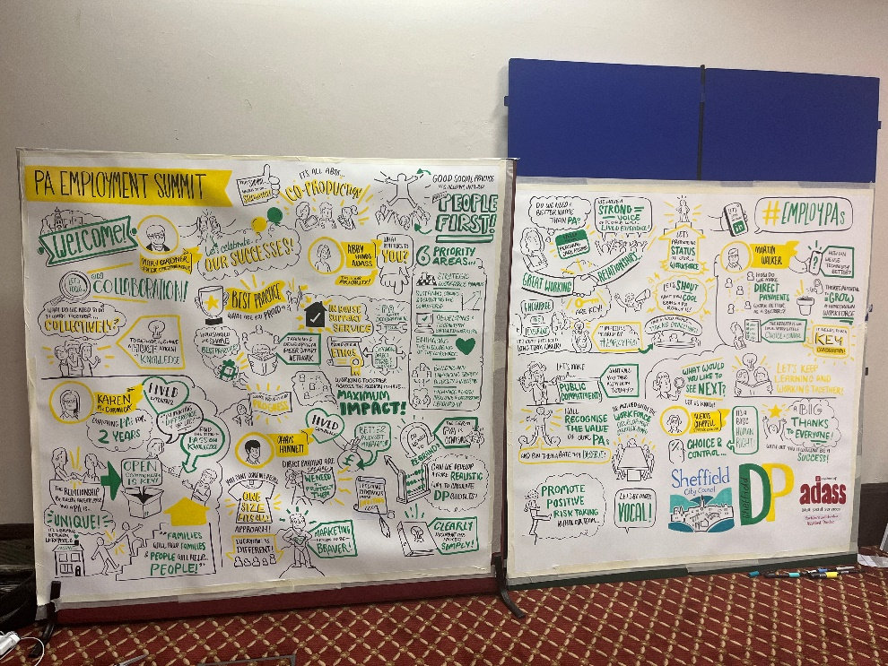

Internal Collaboration

We set a deliberate intention to increase paid engagement opportunities to the Co-production Advisory Group. We have increased our engagement by 83% from 2022-2023. We are proud to have worked across all IMPACT’s workstreams including:
- Embedding strategy
- Accessibly communications and website re-development
- Evaluation strategy
- Recruitment processes
- Developed co-production induction materials
- Marketing communications
- Co-design and delivery of IMPACT Staff Away Day on Co-production
“I wanted to update you as well as I have taken up so much of the advice from the coproduction group for the policy and practice roundtables wanted to thank the group for their insights. It has really transformed the focus of the events and we have much more of a focus on a) lived experience b) how lived experience makes it into policy, practice, and c) making the format accessible and available to more people. I found it such a useful addition. We have also had some input into the planning of the events from the group but also lived experience from outside of IMPACT”, Laura Griffith, Deputy Head of National Embedding.

Guiding documents
The Charter outlines the commitment of the group, schedule of meetings, recognising contributions, teamwork and online meetings. We work hard to create a warm, fair and friendly atmosphere. We take our role seriously. This is an area where we want to focus on in 2024, finding a way to measure the value and impact of the group.
X post from Co-production Advisory Group Member
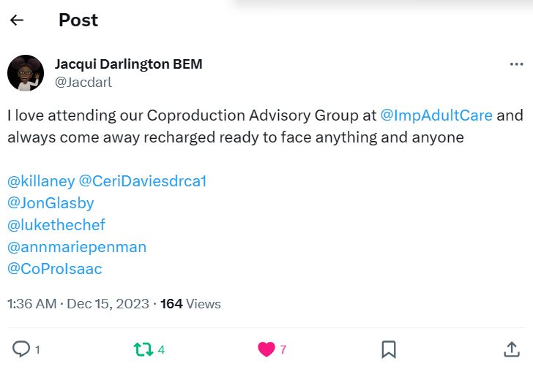
The Reflections Document covers eleven (four new) ‘you said, we heard, we propose and outcome’ flows. It continues to document what we hear across IMPACT and proposals/ideas around practical steps that can be taken to improve co-production approaches across IMPACT both at strategic level and operational level. It is a good measure of the actions that are suggested and acted upon. We propose these in the full knowledge that some may not be appropriate or possible to achieve/deliver upon. Here is an example:
Example of Reflections
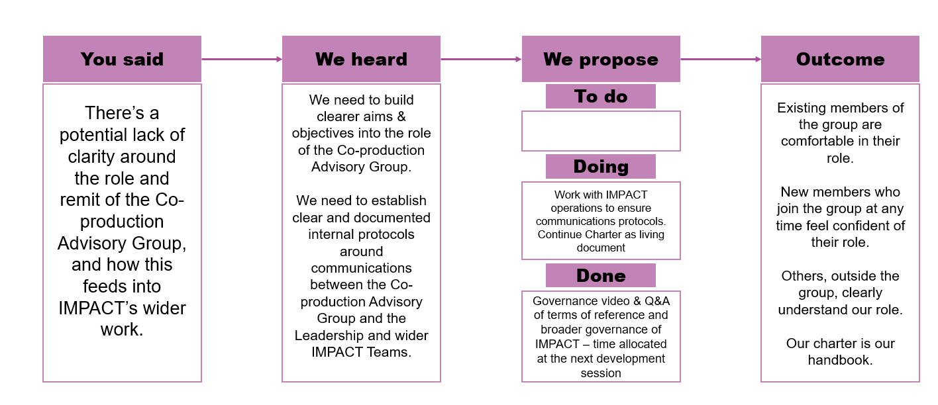

Away Day Co-Design

The Co-production Advisory Group co-designed the IMPACT staff away day themed on Co-production along with staff members. Scottish members Natalie Patterson and Ann Marie Penman co-delivered the day with Karen McCormick. Our digital communications officer beautifully captured the essence of the day through a live blog. You can read it here.
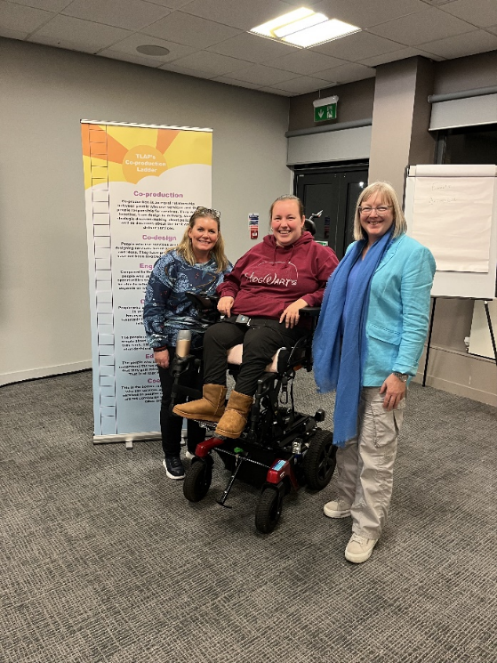

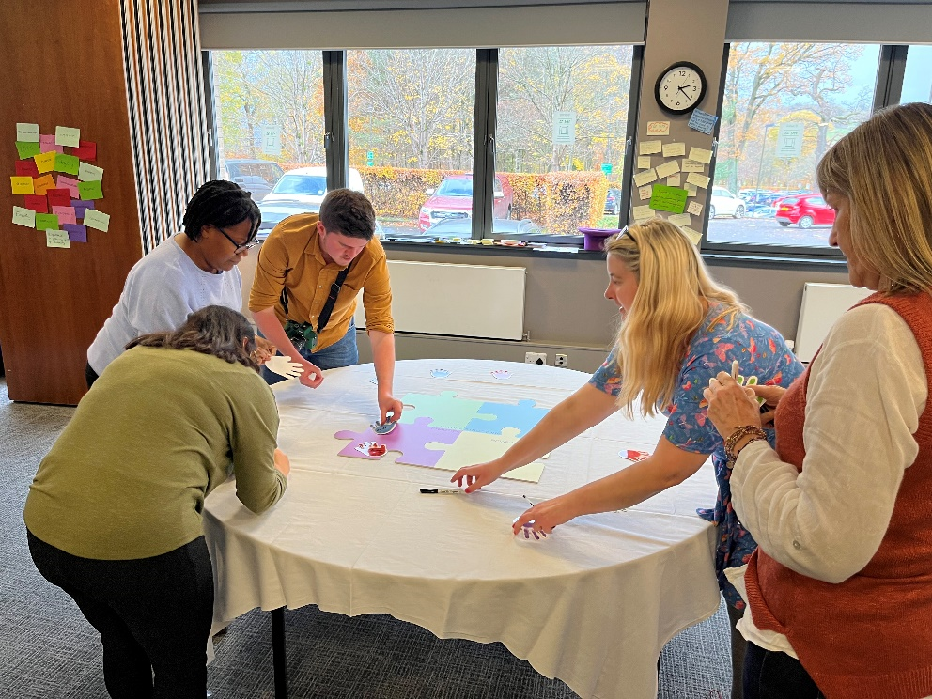

Conclusion and Priorities for 2024

Building and maintenance of relationships and mutual respect continues to be the fundamental success of the Co-production Advisory Group in 2023. We have achieved our intention of developing from our initial scope to increase paid participation of members across the IMPACT work programmes by 83%. We continue to stretch the co-production conversation in a safe and authentic way.

We believe that we can better connect to and support the working of the Assemblies with more visibility of lived experience members in each of the regions. We believe we can support the work of promoting and embedding IMPACT through regional lived experience networks. This is an area we would like to explore in 2024.

We have a methodology that works for our meetings. However, we acknowledge that we need to find a better way of measuring the outcomes of the workplan and how this helps with strategic co-production and practice.

We are proud of the fact that a suggestion from our reflections in 2022 was endorsed by senior leadership and we co-designed and led the delivery of the Co-production Away Day in Stirling in November.

“There are a great range of people working on IMPACT and there is varied understanding of co-production and its possibilities- I think we now have a more a more collective understanding”. (anonymous feedback)

We continue to tell our co-production story on social media, at online and in person events. We believe that we have a positive role to play in supporting the brand development and embedding work of IMPACT across the UK. IMPACT has made progress on accessibility and work is ongoing in this area to ensure that all the IMPACT message is understood by all stakeholders.

We have made progress on feedback loops, and we acknowledge that we need to do more work on this supported by wider IMPACT staff in terms of reciprocity of effort. If we can develop a way to measure the value and impact of the contributions of the work of the Co-production Advisory Group, we believe this will be of mutual benefit, not only to team members but also of strategic benefit to IMPACT. We are looking forward to having administrative support for our work in 2024.

Key priorities for 2024
“From the report you can see there has been a lot of development from the first year. I think what needs to happen is more consistent opportunities for group members to develops skills for their CV.

We need more information on the projects as they are happening.

Members of our group need to be given paid opportunities on a more regular and planned basis. The result would be more people would be more keen to get involved. They would know what they would earn in advance and be able to give more time for impact. I think this is important in promoting equal roles”. (Ceri Davies, BEM)
Our reflections over the year have shaped our recommendations and priorities for 2024. Working with others and with IMPACT, they are:
- Establishing a formal mechanism for engaging the CpAG (with internal IMPACT stakeholders initially) is a key priority of 2024.
- Developing a dedicated space/channel for the Co-production Advisory Group to support communication between CpAG and the wider IMPACT team.
- Developing a team CV to enable staff to understand the skills and assets of the group.
- Supporting the improvement of payments processes for lived experience contributions across IMPACT.
- Capacity building of the group – personal and professional development plans for members.
- Maintaining the safe, honest and supportive environment we have created, developing it further and identifying channels and mechanisms to share this good practice for wider learning.
- More transparency and dedicated communication of the co-production work across IMPACT.
- Measuring the value of the CpAG group within IMPACT and using this to publicise IMPACT.
- More involvement in marketing communications such as through co-pro coffee sessions, podcasts, blogs, event contributions and building on content created at Co-production Away Day.
- Extend the engagement offering further to short-term or project-like commitments rather than one off consultations.
- Building links with other co-production networks across the four nations (including groups of people particularly seldom heard).
- Create a library of resources and explore steps to develop online training and development resources/opportunities for IMPACT and wider stakeholders (perhaps linked to forthcoming Demonstrator around Lived Experience and strategic commissioning).
- More co-production, deeper, shared understanding of excellence in co-production and identification and implementation of plans to achieve this for IMPACT.

