Older People and Loneliness in Rural Areas Mapping Report

IMPACT Facilitator Project 2023- 24 Health And Social Care Moray Nicola Watson, November 2023

Introduction

IMPACT is a UK centre for implementing evidence in adult social care, with the vision that ‘good support isn’t just about ‘services’ – it’s about having a life.’ In pursuit of this, the key objectives for the centre are to enable practical improvements on the ground and make a crucial contribution to longer-term cultural change.
Facilitators are focused on supporting bottom-up change. They work within a local organisation leading an evidence-informed change project. Through close collaboration, Facilitators review evidence, lead local change and evaluate. Findings and outcomes are shared for replication across the sector.
In Moray older people make up a higher percentage of the population than the Scottish average (32% compared to 24% are over 60) and this figure is expected to increase in coming years. Additionally, 42% of the population in Moray live in rural areas.
Research evidence shows that loneliness increases the risks for older adults of physical health conditions such as cardiovascular disease and stroke and for mental health conditions such as cognitive decline and dementia. It can be expected that as the ageing population continues to grow in Moray demands for approaches and services which tackle loneliness are likely to increase too. In a national and local climate of budget cuts and policies which promote personalisation and prevention this project seeks to make recommendations for future service development surrounding older people, loneliness and rural areas.
This project is based within Moray Shared Lives. Moray Shared Lives offer day support, short breaks and long- term homes for people with a variety of needs and is part of Health and Social Care Moray. The majority of those who draw on care and support from Moray Shared Lives are older people drawing on day support.
This mapping exercise was undertaken to explore the range of approaches available in Moray to reduce loneliness for older people whilst also gaining insights into what causes and prevents loneliness in rural areas.

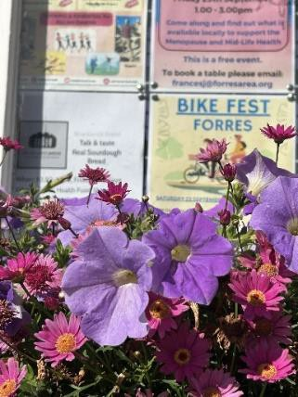
Methods

Mapping was undertaken via web searches, visiting communities (exploring notice boards and in conversation with local people) and speaking with people involved in delivering services and approaches (local authority, NHS, church and community).
An example of one community visit is below:
- Visit to Buckie Hub and speaking with volunteers: exploring their service, perceptions of causes and preventative approaches to loneliness in the area.
- Walk with older person from Buckie Hub to the Salvation Army’s Warm Bank.
- Cullen Community Lunch with 50+ people, informal chat with older people on their experiences of loneliness and what helps reduce loneliness for them.
- Walk in Findochty and Portknockie- exploring notice boards and discovered monthly ‘Cuppa and Company’ which I then attended to find out more.
Those spoken to from services and community approaches include:
- Laurie Anne Davidson- Self-Directed Support (SDS) Community Collaborator- Health and Social Care Moray
- Michelle Flemings- Day Opportunities, Unpaid carers and SDS Team Manager- H&SC Moray
- Gillian Pirie- Volunteer Development Officer- H&SC Moray
- Angela Keegan- Day Services Manager- H&SC Moray (alongside visit to Day Services)
- Patricia McKelvey- Mental Health and Wellbeing Practitioner- NHS Grampian.
- Moray Shared Lives Team, carers and people that draw on support.
- Julie McIntosh- Programme Manager in the Transformation Team- NHS Grampian.
- Jill Sowden- Community Development Officer- Cullen Community Centre
- Sandi Downing- Service Co-ordinator- Quarriers Carers Support Service
- Heather Roy- Community Inclusion Coordinator- North East Sensory Services (NESS)
(a full list is available in Appendix 2)
Drawing on local knowledge has been particularly valuable, for instance the ‘Third Sector Interface (TSI) Moray’s Health and Wellbeing Forum’ gave a wide insight into third sector and community approaches to loneliness, many of which are detailed in Appendix 1 and can be drawn on for the next phase of this project.
It should be noted that as a consequence of this snowballing approach the results of this mapping exercise can only be presented as a snapshot during the period July- October 2023.

What’s happening where, why and for whom (See Appendix 1 for full list)
Approaches specifically catering to older people have been marked with
How people access support- the routes to reducing loneliness
Mental Health and Wellbeing Practitioners, are available in each GP practice in Moray (bar one) and anyone over the age of 18, can ask for an appointment. Mental Health and Wellbeing Practitioners complete a mental health assessment and find out what people’s main concerns are. Then, working together, create a plan for how people can help themselves, which often involves social prescribing and signposting.
Making Every Opportunity Count is an NHS initiative, currently being trialled for use with older people in Grampian. Once rolled out across the area training will be available to all those working with older people to enable them to signpost to services for various issues including linking to the Community Wellbeing Team.
Buckie Hub and Moray Wellbeing Hub offer drop in opportunities and signposting in differing ways. Buckie Hub has a garden and indoor space for people to make connections, enjoy a cup of tea and has a variety of services ‘drop ins’ which people can access. Moray Wellbeing Hub offers peer mentoring and the support of a Community Connector to help people access community groups. As a virtual hub they have ‘drop in’ sessions in Forres and Elgin.

Access Care Team- Health and Social Care Moray
The Access Care Team’s ‘First Contact Advisors’ receive emails and calls from professionals, family members and people wishing to draw on care and support. The advisors make referrals and signpost to other services. For social isolation referrals are often to the Community Wellbeing Team. Those with more care needs or limited mobility, a referral is made to the Day Opportunities Team. Occupational Therapy referrals are appropriate for those whom physically getting out of the house is an issue.
Health and Social Care Moray Services (in ascending level of needs)

Day Opportunities Team
The Day Opportunities Team receive all the referrals from the Social Work Teams in Moray. After someone has had a Social Work Assessment, and if they meet the eligibility criteria for an SDS budget, the Enablers in the team speak with families and the person wishing to draw on support and signpost to community approaches or refer them onto the appropriate service. Support workers may work with people on a short-term basis, assessing their level of needs or supporting them to try different community approaches. This is a relatively new team (having been established in January 2022) but the aim is more effective referrals to services and to help people make more community connections.

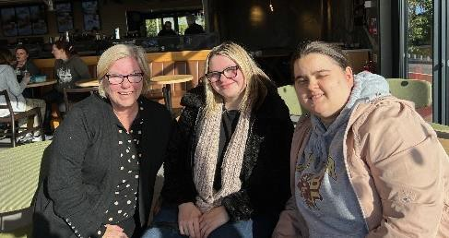
In the first 4 months the Day Opportunities Team reported approximately 13% of those they supported attending a traditional building-based day service whilst the other 87% were supported to engage in their own local community either independently or with support.
“We had someone referred from the social work team for a day service. He didn’t want formal services and his wife wanted a break from her caring role. The Enabler found out that he used to be involved in history and would like to continue doing this. He now volunteers for Forres Area Community Trust giving talks on history and genealogy. He is connecting with people based on shared interests.” Day
Opportunities Team Manager

Social Volunteers/ Moray Calls
There are currently 102 people drawing on support from 159 volunteers, with 98 people waiting on a social volunteer (in September 2023).
The purpose of the service is “to ensure that no one is left behind in our community and we are committed to reducing social isolation, and re- connecting people back into their communities.”
Social volunteers are matched with people in their local communities with the aim of equal exchange, helping people to do things for themselves and to engage with the community. It can be intergenerational, for example one older gentleman helps a young person learn the skills needed for food shopping.
Moray Calls offers a short-term service for those awaiting a social volunteer or for who a phone call from a volunteer suits their preferences. Moray Calls is currently in a pilot phase.
There are limited social volunteers in Speyside.

Shared Lives
“I used to be on the farm and not see many people. Now I’m out with Liz and Jade every week and I feel more confident.”
94 people draw on over 600 hours of day support provided
by 29 self-employed Shared Lives carers from the carer’s home and community. Shared Lives match people with Shared Lives carers based on mutual interests and choice.
“Shared Lives is all about time. Other services are time limited, but we have time, there is no rush. Time to get to know one another and try different things.” Shared Lives carer
Shared Lives carers support people to continue/become part of their local community and enables friendships to develop between carers and those they support. For

instance, one partnership are now a member of an art class that neither would have joined on their own. Both making connections in their local community.
Two people can be supported by one carer (depending on level of need and matching) at any one time. Following the pandemic, the needs of people referred to Shared Lives has risen (‘Substantial’ and ‘Critical’ Need as defined by H&SC Moray’s Eligibility Criteria Policy), meaning fewer instances of two people being supported at one time- reducing capacity and the opportunities for friendships to develop between people drawing on care and support.
Shared Lives carers also support people to maintain and develop relationships and connection with friends and family. For example, one person was supported to
attend her son’s wedding by her Shared Lives carer and is currently planning Christmas presents for the family, something she said she wouldn’t have done on her own. For another older person, Shared Lives has meant she can continue to attend the Bingo once a week which is her main goal and chosen social activity.
Shared Lives carer recruitment has reduced following the pandemic and there are currently no carers in Speyside or Forres.

Personal Assistants
In 2021/22 65 people aged over 65 in Moray made use of Self-Directed Support (SDS) Option 1 (Direct Payment) to arrange their own care. This is 5% of those who draw on care and support and falls to 3.7% for those over 85. In comparison 21% of those aged 18-65 make use of SDS Option 1.
Due to the high waiting times for services at present, making use of SDS Option 1 to recruit a Personal Assistant is beginning to actively be presented to people as an option for taking control of their care and support. An awareness and recruitment drive is currently underway in the community as well as Social Work Teams being given additional support to have transparent discussions with people about this option.

Day Services (buildings based)
These services, of which there are 3 in Moray (Elgin, Keith and Rothes), provide day support to people with the highest (Critical) level of needs. Under 60 people currently access these services where meals and transport are provided. The capacity of these services has greatly reduced following the pandemic with local services closing in some of the most rural areas (Tomintoul and Dufftown). Moray Resource Centre is unable to provide a full day service to those unable to weight bear.
Staff at the day services feel that, while there are issues with getting people out into the community due to travel and the high level of support people require, they use innovative ways to bring the community into the services whilst also giving an opportunity for people to “reconnect and make new friends”. Day Services also allow

unpaid carers to have the time to connect with their social networks reducing their own loneliness.

Examples of other services which may be applicable for older people experiencing loneliness include:
Learning Disability Day Centres: eg. Burnie Centre (Buckie), Cedarwood (Elgin)
Greenfingers: Social and Therapeutic Horticultural Project for adults with learning disabilities, older people and those with mental ill health.
Befriending/ Companionship/ Social Support
Paid services or volunteer support to help people connect to their community.
- Cameron Project, Forres
- Buckie Buddies: Buckie, Portsoy, Keith, Fochabers, Cullen
- Moray Firth Befriending Service
- Nightingale Home Support: Elgin and Forres
- Core Befriending
- Moray Wellbeing Hub: Community Connectors
- Crossroads
- T & I Professional Services: Elgin and surrounding areas.
Community Approaches

Alongside community resources such as libraries and the mobile library service, which some older people may utilise to reduce loneliness, the following approaches are examples of what is available in Moray. These can either be accessed with the above supports or independently.

Men's Sheds  Findochty, Fochabers, Buckie, Lossiemouth, Elgin, Forres, Cullen and Keith.  Social and workshop spaces for men of all ages. | BALL Groups (Be Active Life Long)  20 Groups across Moray with 600 members.  Initially supported by the Community Wellbeing Team but then run by the community themselves. | SET Groups (Singing, Exercise and Tea)  Elgin and Lossiemouth. A progression from the BALL groups for those whose needs may be greater.

“It’s not the 2 hours the BALL groups are on that matter, it’s what happens outside. People make really good friends, check on one another and help each other out.”

The Friendship Club in Buckie  Coffee and Games in Fochabers  Mosstoddloch over 60s Club  Fly and Friendship Group in Keith  Community Drop-In Coffee Mornings in Tomintoul  Aberlour Senior Citizens Association  Royal Voluntary Service-Darby and Joan Clubs in Elgin and Lossiemouth  Ageing Gratefully in Forres  Coastal Connections- social hubs in Burghead, Spynie and Hopeman  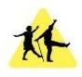  Re-engage tea party in Elgin | Interest Groups  Fochabers Community Sing  Craft Groups: eg. Knit and Yarn in Cullen, Crafty Cuppie in Drummuir  Volunteer Gardening Groups: Buckie Roots, Friends of the Biblical Garden  Cullen Heritage Group  Exploring Archaeology and History- Keith Library  Scrabble Club in Keith  Moray and Nairn Floral Art Club  Kinloss and Forres Model Club  Sigma: Moray Astronomy Club  U3A: encourages older people to keep their minds active. | Health and wellbeing  Health Walks across Moray: Tomintoul, Forres, Cullen and many more.  Steady Steps Move it or lose it  Walking Football and Netball  Elgin City FC Walking football and ‘Standing  onside’ coffee morning  Nature Walks for Wellbeing in Aberlour  Indoor and Outdoor Bowling  Tea Dances in Elgin  Silver Saplings Adventures  Silver Swans Ballet Class
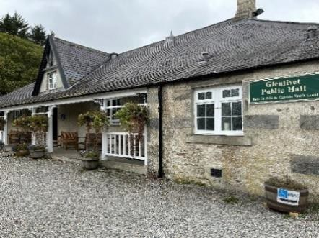
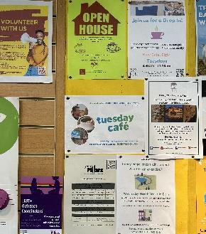
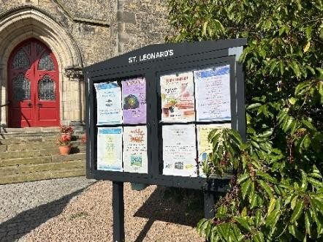

Community meals  Fishermans Hall Community Lunches, Buckie  Cullen Community Lunch  ROMEO (Retired Old Men Eating Out) in Elgin  Over 60s Lunch Club, Elgin  Lhanbryde Community Challenge Cookery Sessions  Clochan Coffee Morning | Church Based Forres Baptist Church Warm Space Riverside Church Soup and Sweet Burghead Social Warm Hub  Keith North Church Coffee and Company  Bellie Church Cosy Café and Men’s Breakfast  Cuppa and Company at Portknockie  Soup and Sandwich Lunches, St Leonards Forres

For specific groups
North East Sensory Services: The ‘Connect Include Support’ service provides accessible travel and support for people with sensory loss to attend NESS social and craft groups in Elgin, Forres, Buckie and Keith.
Quarriers: Alongside providing carer assessments, which may result in a referral for the person drawing on their care to the above approaches, carer cafes (in Elgin, Fochabers and Forres) give unpaid carers the chance to meet with others who share their experiences of caring.
For those with dementia, and their families, Alzheimers Scotland and Moray Monday Club provide opportunities to meet socially and enjoy music, art or a chat. Though people must attend with a companion if support is required for travel or whilst at the groups.
4inclusion is a social group for those who identify as Lesbian, Gay, Bisexual, Transgender (LGBT+). The group meets once a month and aims to build relationships, improve quality of life and meet with others. However, engagement for this group is low with no older people attending.
Caring Community Circles provide signposting and link neighbours willing to volunteer their time etc. to support the Findhorn Ecovillage Community. There is a recognition that their community is wider than the Ecovillage.

Project Neuro in Elgin provides opportunities for those with a neurological condition to exercise alongside family and friends.
Veterans: The Royal British Legion and The Western Front Association provide social support for those who have retired from the forces, as well as Age Scotland and Royal Air Forces Association providing support nationally. With the RAF base and Army Barracks situated in Moray there is a real need for this support in the area.
Approaches which may reduce loneliness for those older people with a learning disability include,
- Moray Reach Out
- Out of the Darkness Theatre
- Greyfriars Social Club
- Findhorn Care Farm
Rural Environmental Action Project (REAP)’s Therapeutic Gardening Project is specifically for people experiencing isolation as well as mental health conditions, mild physical disabilities.

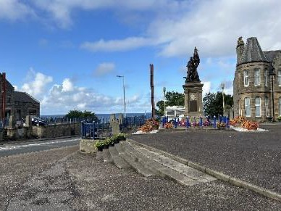
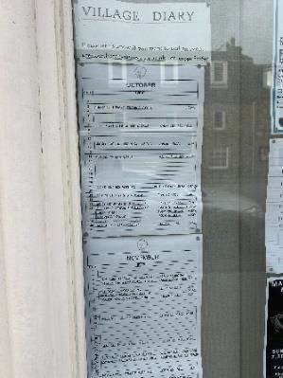
Key Issues

From speaking with social work professionals, people providing services and informally with people in the community the following issues have been identified thus far:
Accessible travel: One person spoke of it taking 3 hours to get from Lossiemouth to Buckie via public transport. Another that the m.connect on demand bus service is unreliable and difficult to book, especially for groups of people or those not comfortable or able to use technology.
Speyside Community Car Share seeks to reduce social isolation with their volunteer- based transport scheme. Some groups and services provide transport but in many cases this is dependent on volunteers. For some approaches volunteers are not reimbursed for mileage, meaning those in the most rural areas are less likely to get support with travel.

Geography:
“There used to be more in Tomintoul before the pandemic but now there isn’t much for older people.” Shop worker in Tomintoul.
25% of the population in Keith and Speyside is over 65; with Aberlour having the highest percentage of individuals aged 75+ in Moray suggesting there may be a need for these services.
Attracting Shared Lives carers and volunteers proves particularly difficult in Speyside and some services (eg. Quarriers, BALL group) no longer have groups in these areas due to poor attendance or lack of people willing to support the group.
Meaning people need to travel North to access services. Lack of engagement may be due to low population density or some have suggested a strong self- reliant community.
In contrast Buckie and Forres are known to be areas with a lot to offer older people.
“Buckie is good at looking after people, all people not just older people.” Volunteer at Buckie Hub.
For instance, the Buckie Locality has 4 Men’s Sheds currently operating (with only 4 others available elsewhere in Moray), and ‘Peoplehood’ offer opportunities for connection in Buckie to their members.
In Forres FACT’s (Forres Area Community Trust) Cameron Project offers befriending, gentle exercise and a number of courses and activities (many of which are free) aimed at older people who are feeling lonely or isolated.

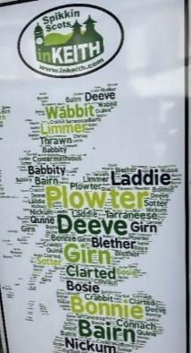
Waiting times: The number of people waiting for a social work assessment has reduced (112 in April, 62 in June) but the number of those waiting for a social care package has increased (147 in April, 192 in June). Social Work Teams are reporting that people with social isolation can wait up to 6 months for an assessment from their team. A referral for social support is made to the Day Opportunities Team after this. In total the wait could be as long as 16 months from contacting the access team to a service being in place.
Covid: Following the pandemic community groups have seen their numbers attending decline as people have lost confidence and are worried about the health implications of being around groups of people.
People moving to the area: Anecdotally people have spoken of Moray having many people who have retired to the area with no family support, others may have worked in the forces and stayed, younger people are moving away from the area and there are some whose families have moved them closer to them but have no shared interests with their new community. In some cases, people moving into Moray from outside Scotland struggle to understand the local dialect. Areas with high numbers of holiday homes mean less community for some. With no shared history people can feel lonely in a group.

Ruralness:
“Some people are very isolated but a volunteer would need a suitable vehicle to drive up a farm track”. Volunteer Development Officer.
The winter months mean those in the most rural areas are unable to travel to the services they rely on. The Day Service in Rothes spoke of one gentleman who has no phone and lives alone. Living in an extremely rural area means he has no contact with anyone, and is unable to attend Day Services, for weeks at a time.
Low number of men attending has been observed at the majority of the community groups/ lunches, with exception of those specifically targeting men eg. Men’s Shed.
“Men don’t want to get involved (in groups). Women will go to tea parties, lunch clubs but men don’t. When their wife dies they don’t have someone doing the socialising for them.” Re-engage
Budget and financial constraints: With economic pressures locally and nationally and Moray Community Planning Partnership 10 year plan 2017 focus on “empowering and connecting communities”. The emphasis is very much on enabling people to use free, or reduced cost, community resources rather than costly building- based services. While, from speaking to the First Contact Advisors within H&SC Moray, this appears to be wished for by older people in general, it brings issues connected to recruitment, retention and sustainability of services and approaches.
For instance, the Shared Lives carers spoken to have reported that attracting new carers is difficult as “no one will go through a lengthy assessment process to be paid

so little”. In a cost-of-living crisis this is becoming more evident. Many of those who are involved in the running of groups are older themselves and as time goes on are often less able to continue in this role impacting on the continuity of community groups.
Eligibility Criteria: Only those who are eligible for a SDS budget can receive the support of the Day Opportunities Team which poses a barrier for those requiring initial support to access community approaches. Those not assessed as having a critical or substantial need are not eligible for Shared Lives or Day Services.
Additionally, many groups specify that people come along with support as required meaning while waiting for social support some are excluded.

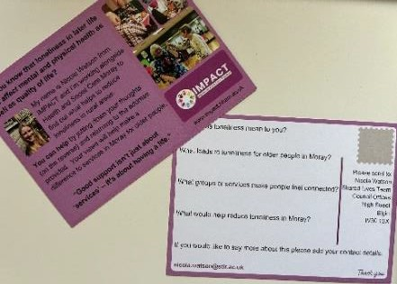
Next Steps

The next steps for the project are to purposefully talk with older people about loneliness, including what helps address loneliness for them. As well as speaking to people from the established approaches above and hearing their stories I hope to engage with those underrepresented eg. men in the most rural areas.
This may involve visiting:
- Mobile library or Big Blue Pantry van in the most rural areas.
- Vaccination Centres
- Food banks
- Veterans Support Day (Cullen)
- Speaking to older people (men in particular) who visit the pub in response to loneliness.
- Football Clubs

In the coming months it will be beneficial to explore what approaches are used across Scotland to tackle loneliness, including intergenerational approaches.

Additionally, I hope to engage with other groups of people, those with learning disabilities, mental ill health, unpaid carers etc. to explore what reduces loneliness for them.

