IMPACT Network – Remodelling the Front Door

Discussion material for local Network session 1
Easy read version
Who is this for?
This leaflet has information for our Local Network session one.

Before our first session, we’d like everyone to read this leaflet.

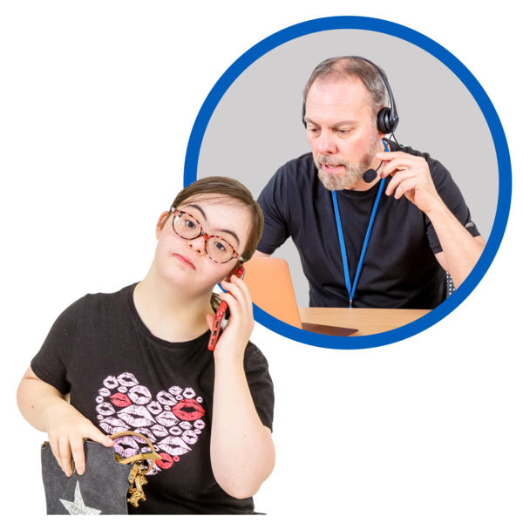
This leaflet is an introduction to the issues when people first contact adult social care. These are called front door services.

This leaflet talks about people’s lived experiences and challenges they face while trying to go through the adult social care system.
We also talk about different ways to support people through this process.
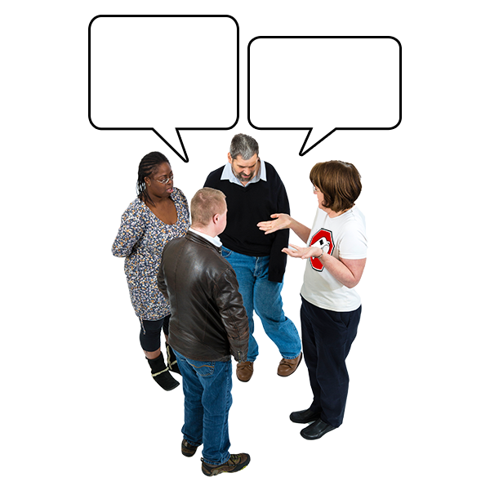
This leaflet is to help you start discussions in your groups. We want you to talk about your experiences and ideas for changing how the system works.
What is the issue?
The first time people contact social services is very important for anyone looking for support.

Depending on how this goes, it can be the first step to getting someone the support they need. Or it can leave people feeling more confused than before.

Front door services are set up to respond when someone first contacts social services.

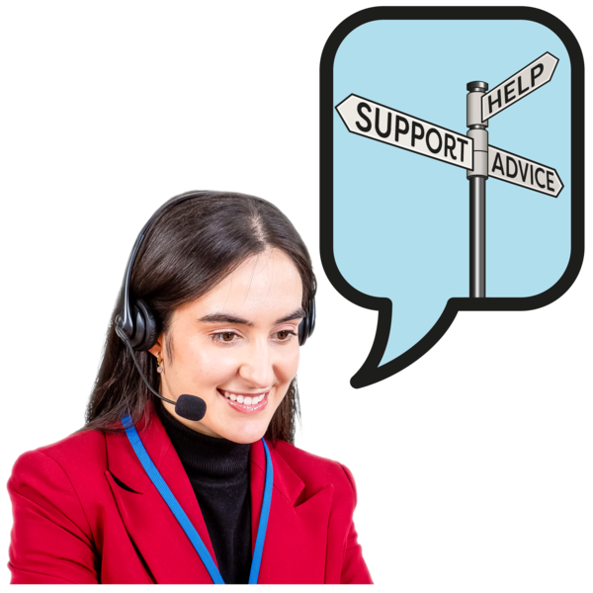
They are known by different names in the UK. For example; Gateway, single point of access or entry, and information, advice and assistance service.
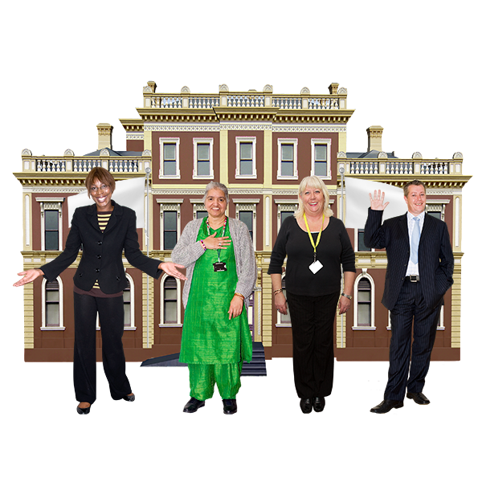
At the front door, local authorities like your council provide information about services and assess people’s needs.
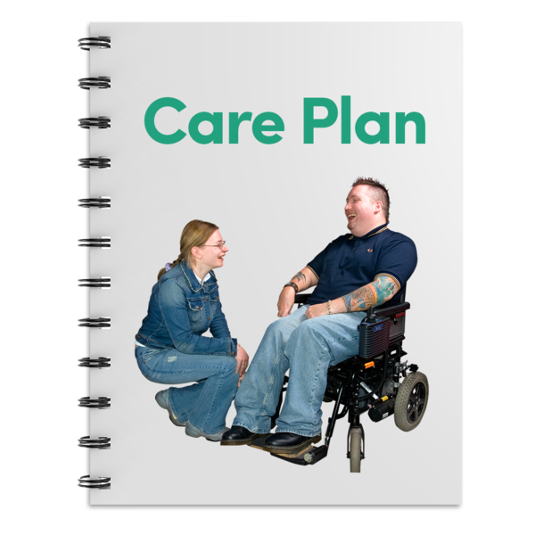
That service should then provide a care plan if needed so someone can get those needs met.

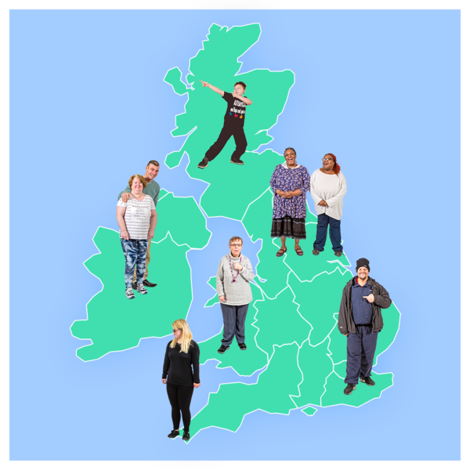
There are different services across the UK that do this. England, Scotland, Wales, and Northern Ireland all have different ways to help people access social care.

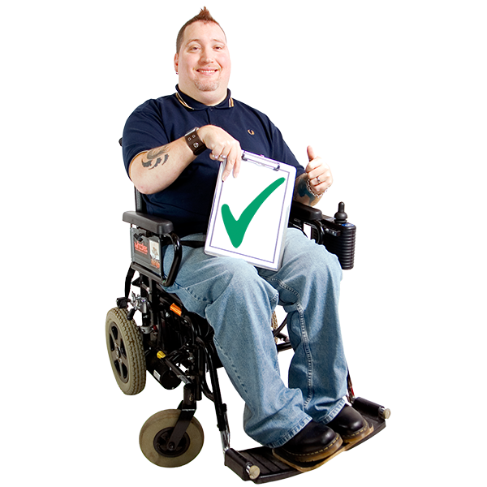
What is the same across the four nations is that this service is seen as essential and a priority.
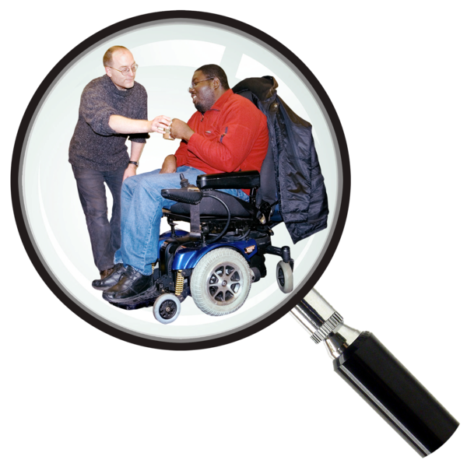
Research shows that easy access to services and the right assessment leads to getting the right support sooner.

It promotes choice and control for the person in need of care and their support system. It also leads to better and continuing care.
It also saves money compared to more expensive services, like crisis care or hospital admissions.

A report from 2014 wrote about how good front doors can save local authorities money. It also showed how this reduced the number of people being sent to the wrong services.

However, reports across the four UK nations since have found different barriers to social care.

Some of those barriers are:
Complicated systems that are difficult for people to understand and navigate.
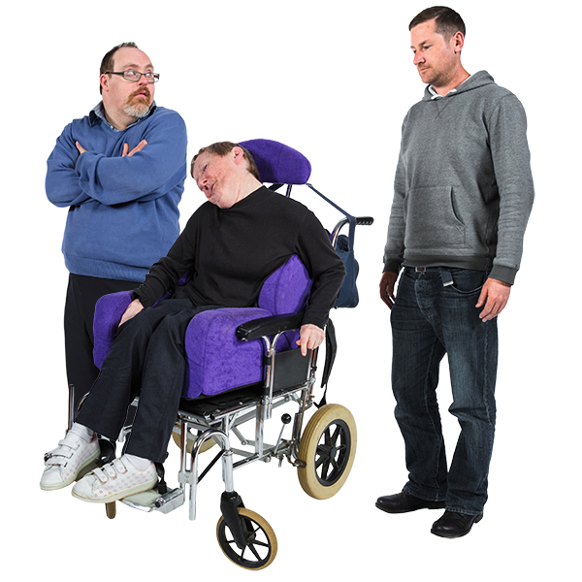
When there isn’t one worker who knows your situation to contact. Having to explain your situation to different people each time.

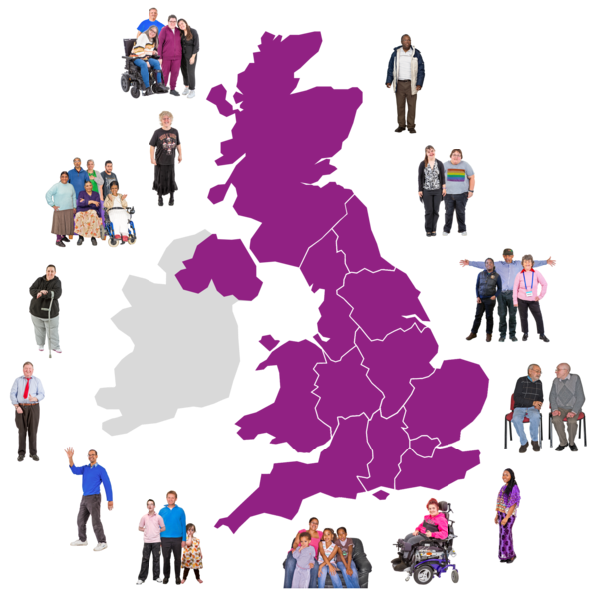
Services and how they work are very different across the country. This is sometimes referred to as a ‘postcode lottery.

There are problems transferring people’s care packages if they move to a different area of the country.

Unclear and inconsistent rules on who can get social care and how much they can have.
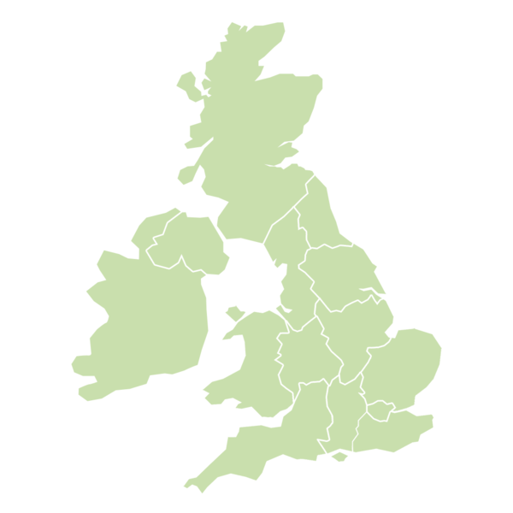
Not having UK-wide guidelines that help plan people’s care.

A system that is not flexible when people’s needs change from day to day.
A system that spends a lot of time and resources on crisis support, and not enough on preventing the need for crisis support.
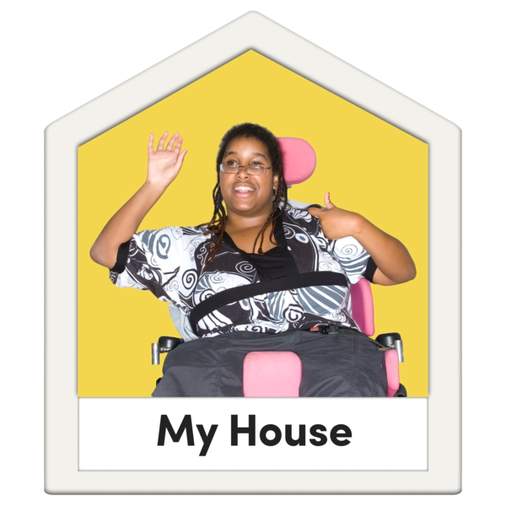
A report from Adult Social Care also said that these front doors do not promote independence for people enough.

The report also said that there are opportunities to prevent, reduce and delay the demands on adult social care that aren’t being used.
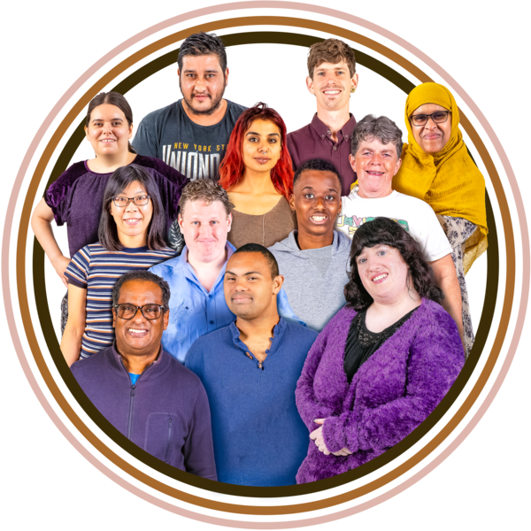
Research has shown barriers that are specific to certain groups too. For example, people from ethnically diverse communities or adults with learning disabilities.
There are also problems when assessing people’s needs. This is a big part of all front-door services.

Research has found lots of differences in how assessments are done in different places.
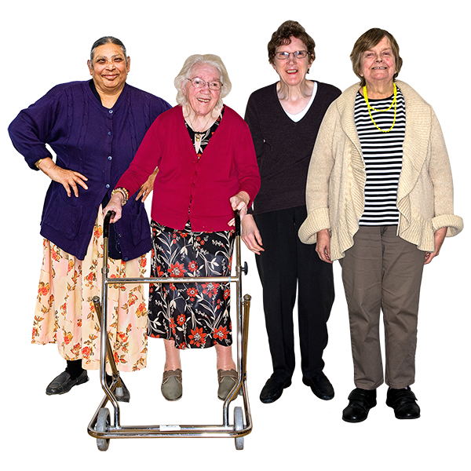
The research also shows how late or badly done assessments can lead to long waiting times and unmet needs. This affects older people a lot.

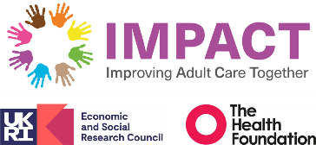
For these reasons, Impact has chosen this topic to be talked about in our Networks.

How does adult social care work right now in England, Northern Ireland, Scotland and Wales?
Wales
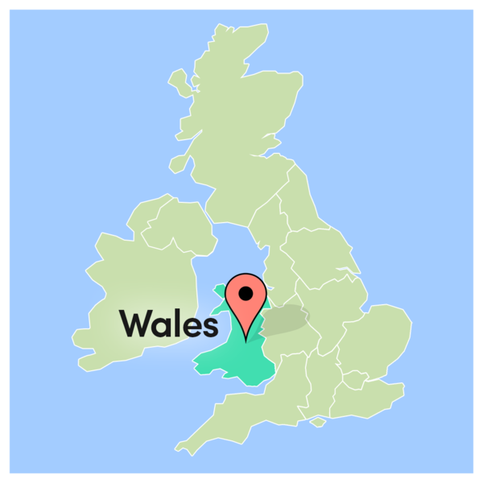
In Wales, both the children and adult teams use something called the Information, advice, and assistance service. This is often shortened to ‘IAA’.
When someone thinks they or someone they know needs care and support, they contact the IAA Service.

It is the responsibility of the local authority to run this service.
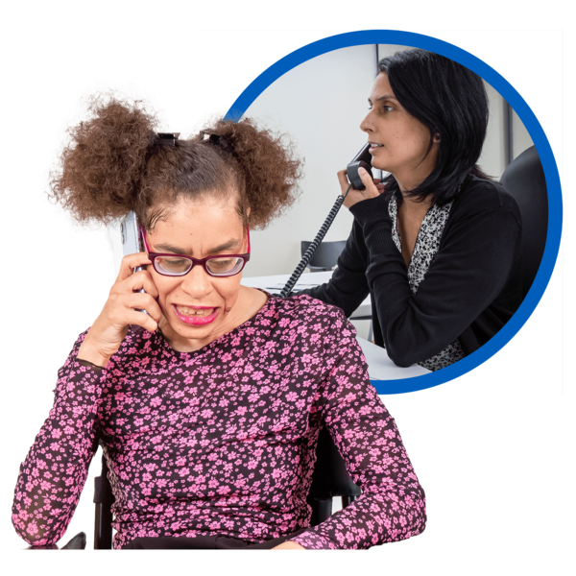
This service gives people information that helps them make decisions about their care and well-being. They discuss people’s options to find the best solution for them.

They can also, if needed, have a more in-depth conversation with the person to assess their strengths and needs. This is called a what matters conversation.

The IAA then signposts people to services that would suit them. This could be housing support to help keep them independent or information about day services in the area.
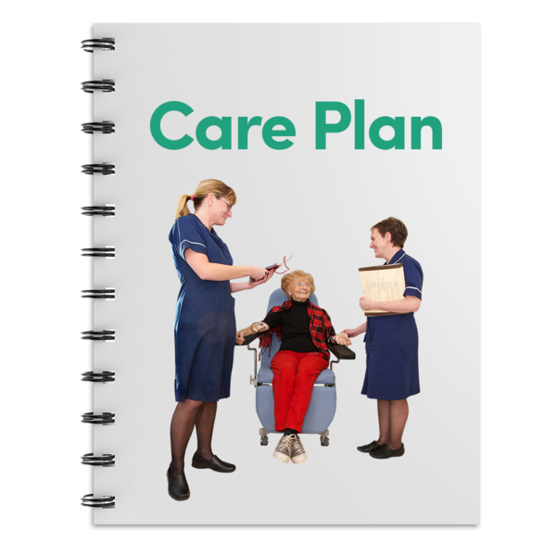
If needed, they will also help someone set up a care and support plan. This may involve more traditional social services that will monitor someone’s needs for a longer time.

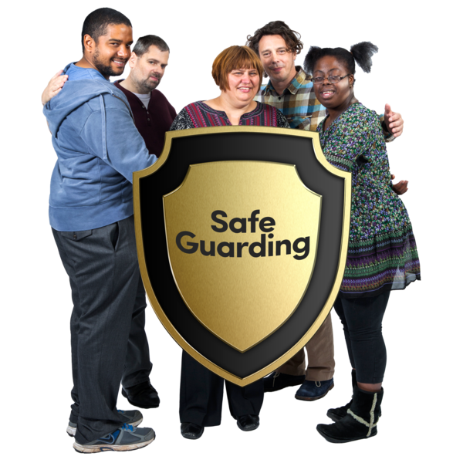
The IAA also works with safeguarding, specialist needs, and advocacy teams when needed.

England
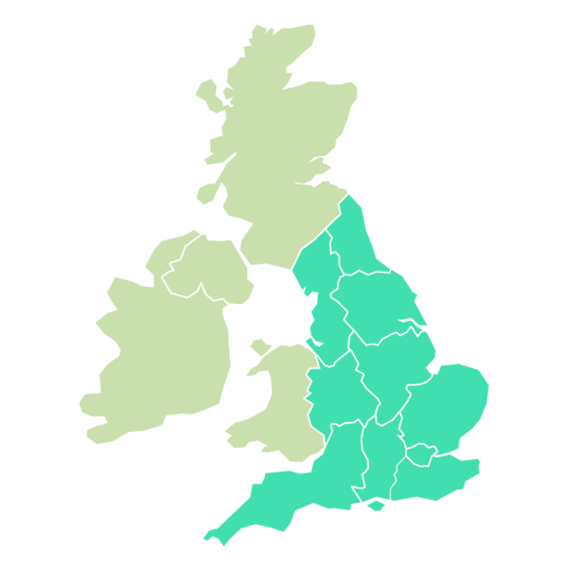
To access social care in England the first step is to get a needs assessment from the local council.
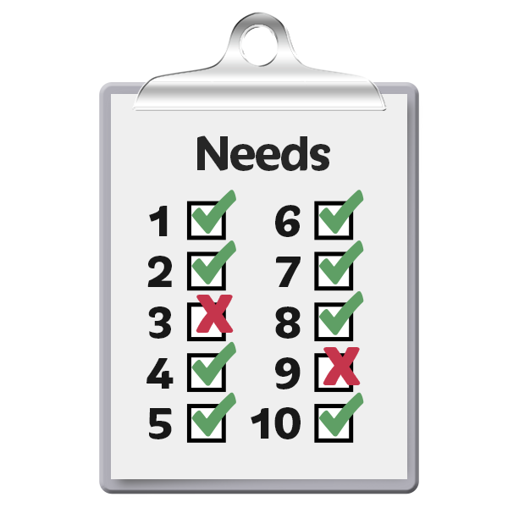

A needs assessment is free, and anyone can ask for one.

Local authorities in England said that front door services are a way to improve how they help people.

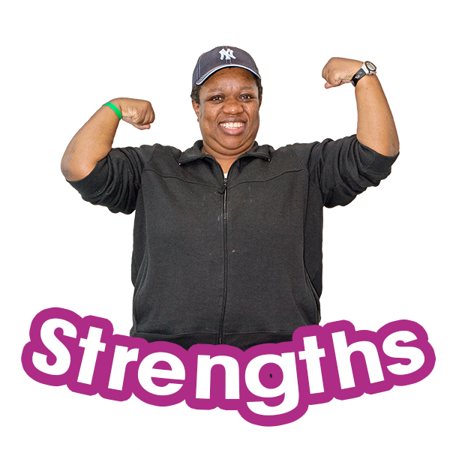
Many local authorities explored new ways for people to access adult social care. For example, the strength-based approaches like Gateway to Care and People2People.

In 2022, research found that better front-door services improve the quality of care provided to people with long-term conditions.

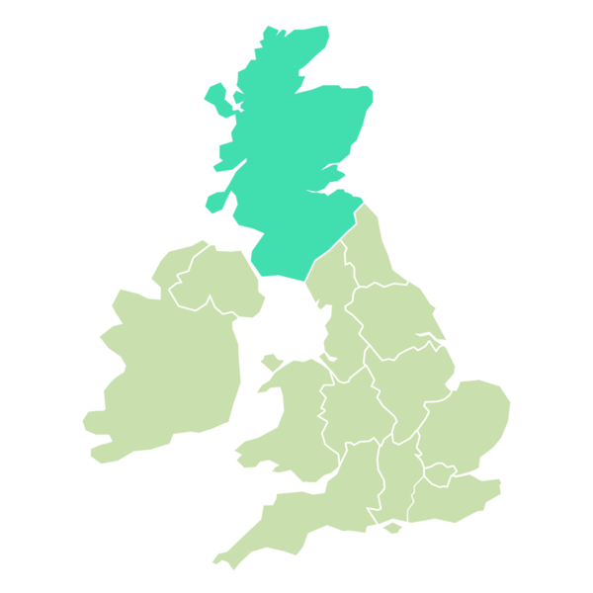
Scotland
In Scotland, the local authority's social work department is in charge of assessing people’s need for social care.
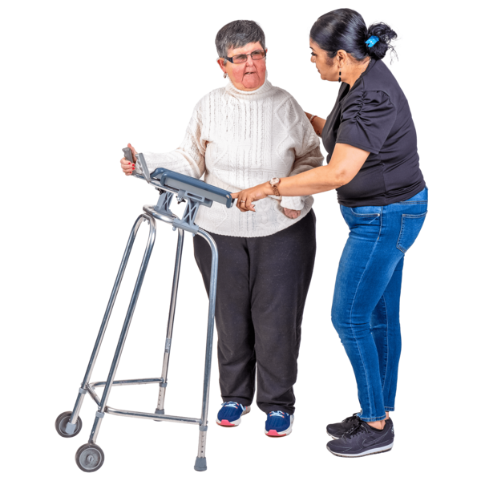
This assessment is where a care professional meets with someone to explore their strengths and support needs.
During this process, this professional also looks at any existing care they have in place.
The assessment includes talking about how the person's needs can be met and what they want their care and support to look like.
The Social Care Act was introduced in Scotland in 2013. This focuses on ways that people are given choice and control over their care and support.
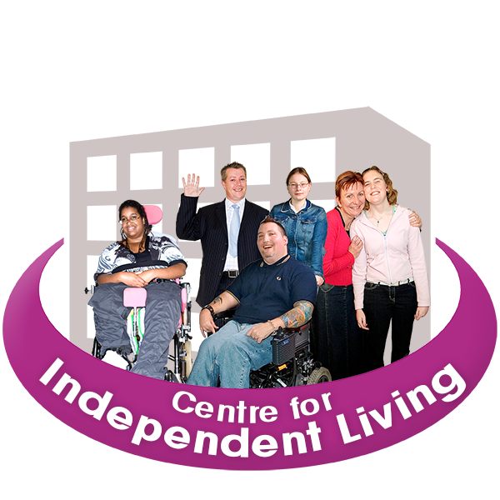
Since 2011, the Scottish Government has funded a network of independent support organisations.
They provide advice and advocacy to help people understand their rights to social care. They also support them to access the care that is right for them.

The current Support in the Right Direction Programme funds different projects providing advice. They also help with pre-assessment to understand the process.
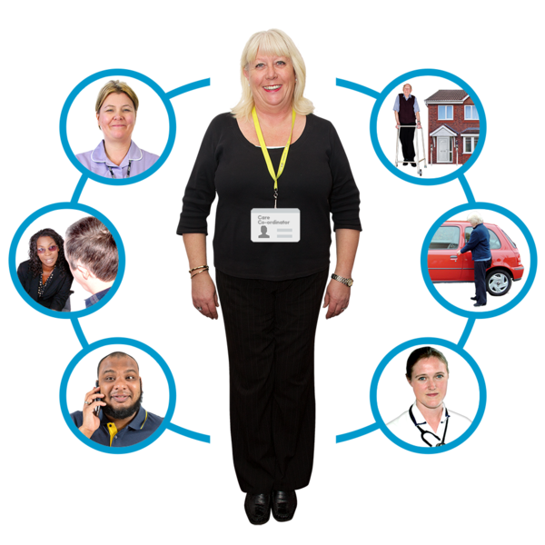
These services aim to support people through their journey from first contact with social care until everything is settled.
They work with families and unpaid carers as well as people accessing support for themselves.

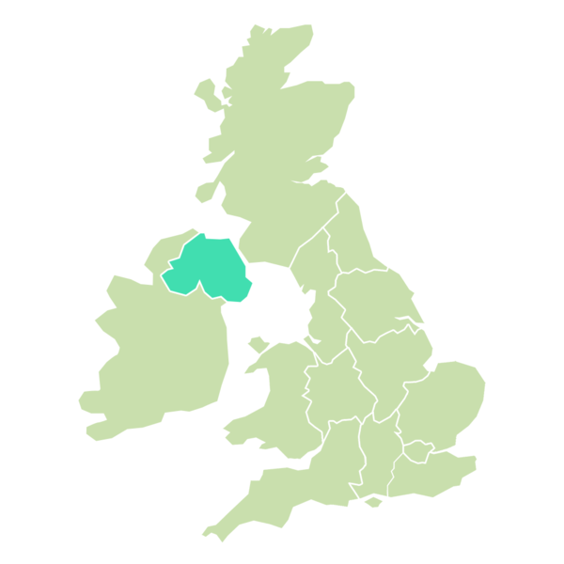
Northern Ireland

In Northern Ireland, health and social care services use a service called single point of entry.
This means that when someone needs help, they always start at the same place.

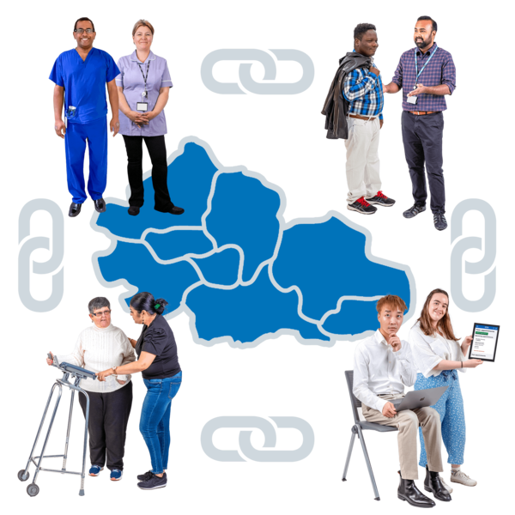
The system is going towards being an integrated care system. Integrated means that all services work together to best fit people’s needs, not having someone fit around the services instead.
Health and social care trusts in Northern Ireland also assess people who need support.
The local trusts also have a duty to provide services to meet these needs.

When asked, they must also carry out a community care assessment. This is also referred to as a care assessment or a needs assessment.

Front Door Models
As seen in the previous section, the four UK nations have different ways for people to access social services.
In England, there are lots of differences in different parts of the country as well.
In other parts of the UK, there is work being done to create more integrated systems in social care.

In this section we will talk about some of the different ways services are trying to remodel the front doors.

Needs assessment vs asset-based approach:
Strengths-based or asset-based social care is the name of one way to work in social care.
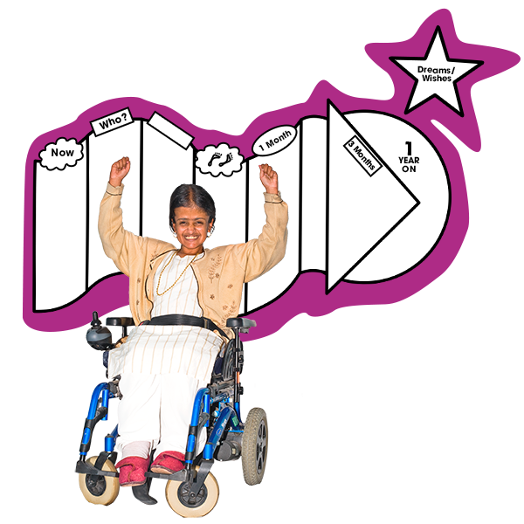
Strengths-based means that social workers support people by making plans around their strengths, not just what their needs are.
It is often compared to older ways of doing social care. For example, when social workers only think about solving people’s problems.

Social workers used to only look at ways to find outside support for people. The strengths-based approach argues this can take away people’s independence.
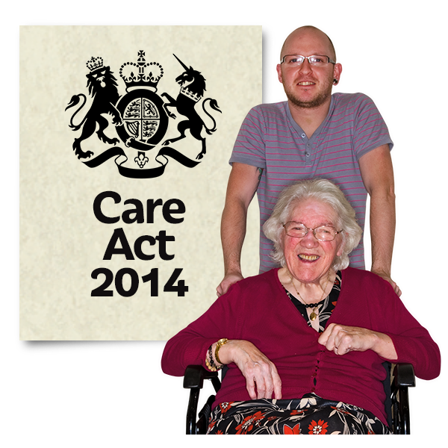
Strengths-based approaches are used a lot more now in adult social care. The 2014 Care Act means social care assessments have to take a strengths-based approach.
People’s friends, family, and social relationships are also seen as essential in strengths-based social care.

One case study of strengths-based approaches is a three-conversation model, also known as 3Cs.
These three conversations are: Initial contact, if people are at risk, and if long-term support is needed.
This approach has services that work with people who need support, rather than doing things for them.

3Cs is currently being tried out by more than 25 local authorities.

People who are using the 3Cs approach have said there is better-suited and less costly support being put in place.
Workers describe more job satisfaction, and managers suggest there has been less need for long-term care packages.

But, there are some concerns about strengths-based approaches. Some people argue that it could be a way to withhold services or make demands on the families of those with care needs.

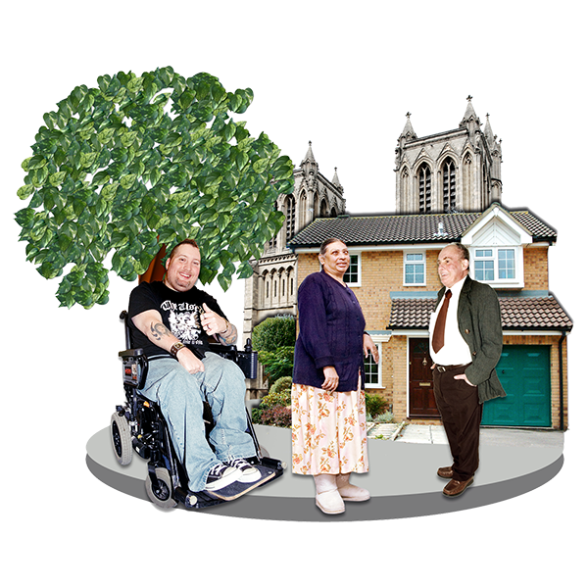
Another example of a strengths-based approach in action is Let’s Talk Local.
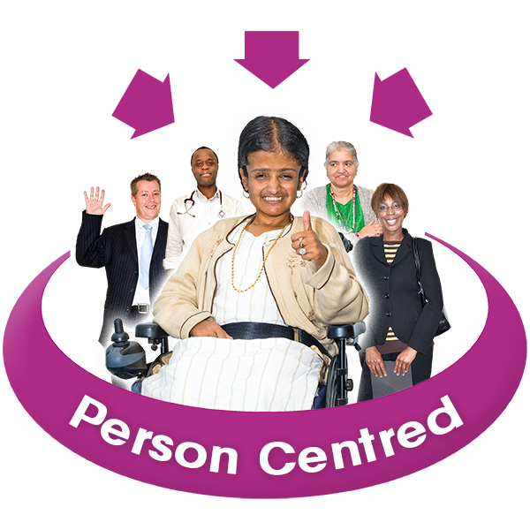
Let’s Talk Local uses a person-centred approach. Staff can fit around people’s needs rather than have people fit into what services there are.

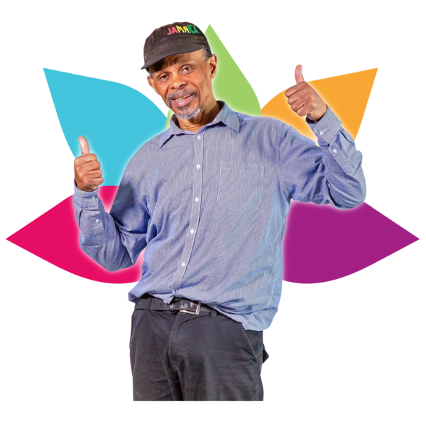
Let’s Talk Local supports people to become more independent and able to cope with changes. People said their health and well-being improved.

Multi-agency team:
Another way of working is by using a multi-agency team. This means each team has people experienced in different types of work.
This helps people who may need specialist support or who have complex support needs.
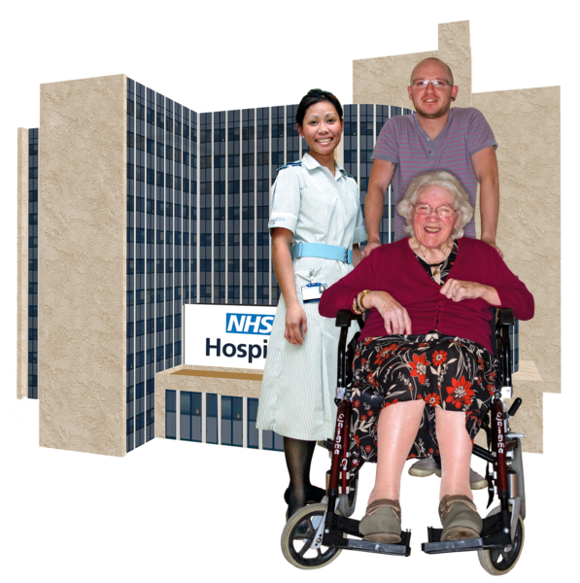
Working this way to get people the help they need can help stop admission to hospitals. It also avoids extra referrals and multiple assessments.

A case study for this model was called the frailty at the front door collaborative.

This group of workers in the collaborative is part of Healthcare Improvement Scotland’s hub, also known as IHub.
This was launched as an 18-month improvement programme in December 2017.
They worked with five NHS boards to test different ways to improve care for people living with frailty. This can affect older people a lot.
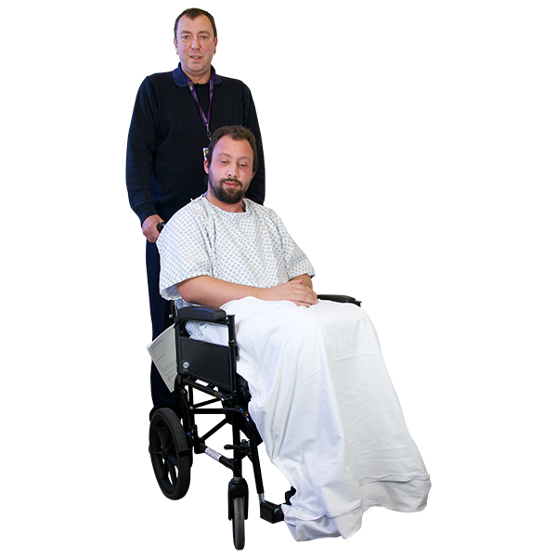
They wanted to improve by:
        - Assessing someone’s frailty when they are in acute services, like A and E or taken to hospital.
        - Coordinating people’s needs to determine the best way to provide care.

        - Different teams working together to make changes.

        - Better communication to avoid someone being told different things from different teams.

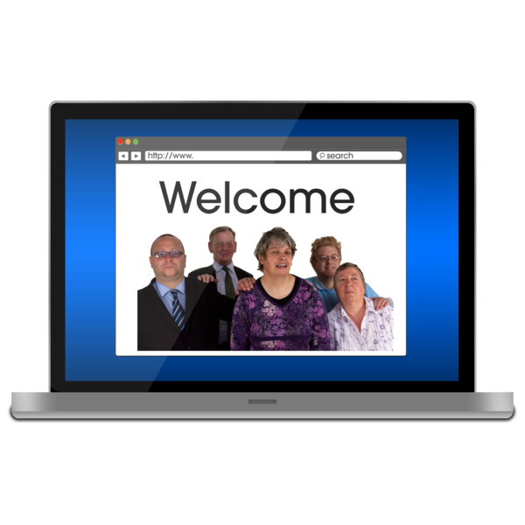
Digital Transformation:
This way of accessing social care uses online systems and a digital portal.

It allows people access to guidance and up-to-date information. It is self-directed, promoting people’s independence and choices.

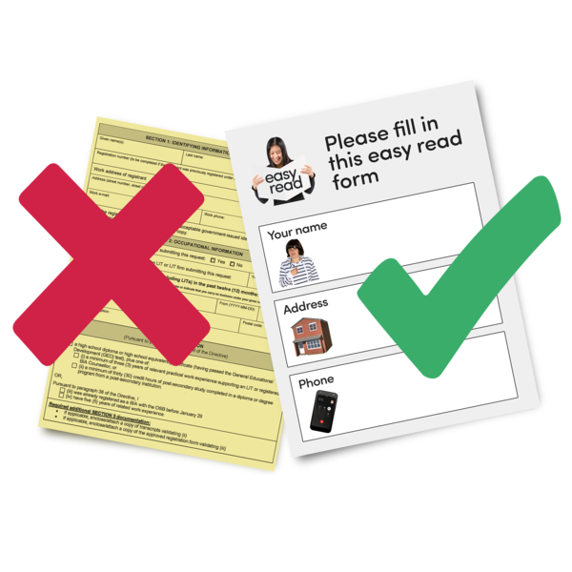
The website shares information in a way that is accessible to as many people as possible.
A case study was done on digital services in Scotland called The Digital Front Door.
The website provides a platform for people to access services directly.

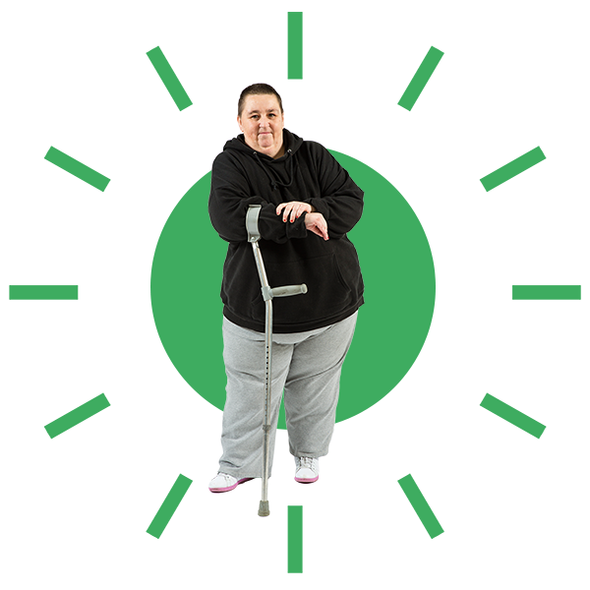
It allows people to access, self-manage, and add to their own health and care information online. It has a strong focus on person-led care and removing barriers.
Another case study is the Worcestershire Adults Portal.
The Worcestershire Adults Portal is a system that allows users to submit referrals for themselves or someone they are supporting.
The portal’s main role is to process referrals and questions about adult Social Services.
To access this portal, you have to complete an online form and submit it to Adult Social Care.
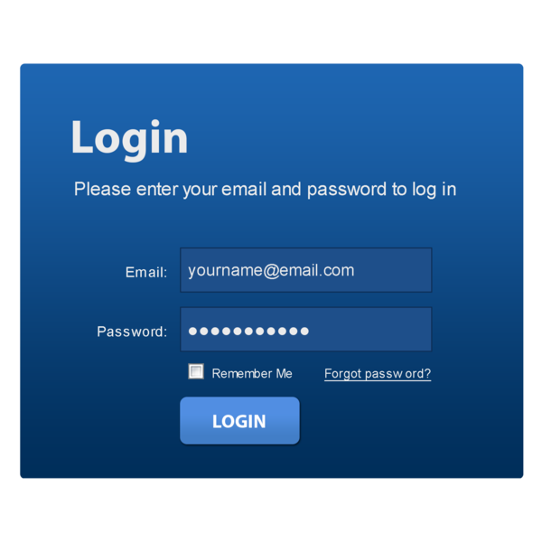
Users are asked to register for an account which allows them to view submitted forms and receive feedback about any referrals.

The good thing about this portal is that it is available 24/7. It is also aimed to support frontline staff and avoid multiple referrals.

Decision-making, training and behavioural factors:

Leeds City Council worked with a behavioural insight team to make their contact centre better.
They developed a new process to identify calls that were more likely to be wrongly referred.

This included giving people in the contact centre a prompt sheet to help them while handling adult social care calls.

Organisation Design Operating Model
The Adult Social Care team in England has developed a new model for operating a front door service. This is going to be trialled in Bournemouth, Christchurch, and Poole Council.

This model is going to put together some of the new ways of working described in the previous sections.

This will work by looking at four different points:
- Improving ways people can contact the service. This includes making sure people get the same experience each time.

- Working with digital technology.

- Strengths-based working and assessments.

- Making sure people’s data is secure and able to be looked at by different teams to help them.
Key questions for your meetings
Here are a few questions to discuss in your meeting. You do not have to write anything down before the meeting, but you may find making notes useful.

Your experience
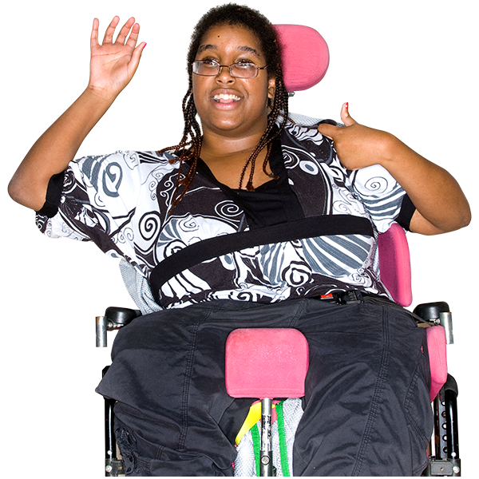
Would anyone like to share their experience of front door services? Or anything else about accessing social care?

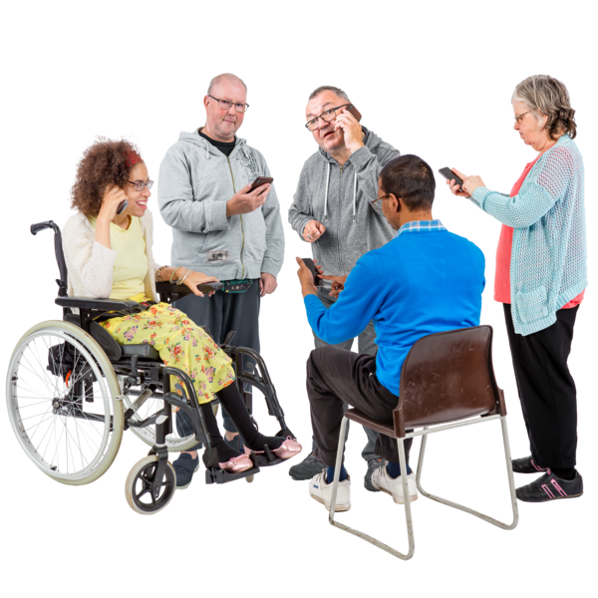
What helps or stops people from having their first contact with services? What helps or makes things difficult during their contact with services?

Does anyone in the group have any experience with the new ways of working we have talked about?

Was there anything in this document that you think could really help people access and get information in social care?
Is there anything you didn’t agree with, or thought didn’t match what you have experienced?

Next steps
Are there any next steps you’d like to agree on as a group?
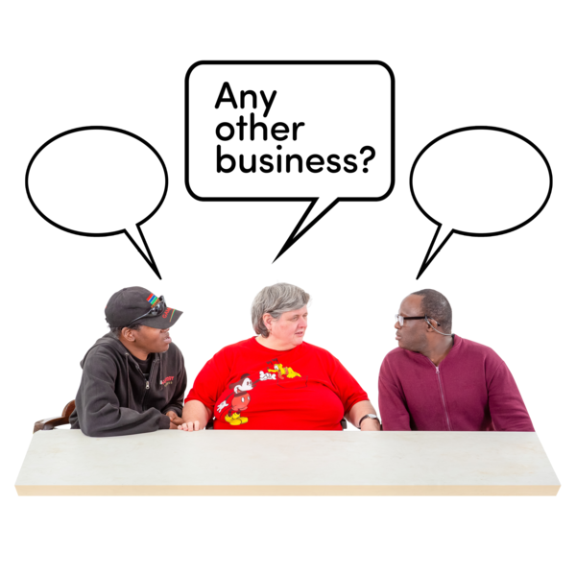

Is there anything else you want to talk about?

Do you think there is anyone else who should be involved in your meetings?

Is there anything you need from the Impact team?

Final thoughts
Some of this document has been shortened for our Easy Read version. If you want any further information on different sections, please let us know.
We can also provide a reference list for our sources, please message or email if you would like this sent to you.
This document was translated into Easy Read by Sheffield Voices.

