‘It takes a lot of strength to fight’ - lessons from the Choice and Control Network

Action to reinvigorate the drive towards greater choice and control in adult social care

June 2023

Background

This report describes the key learning, and policy and practice implications, from IMPACT’s choice and control Network, which ran in 2022.

Networks are one of four main models of evidence implementation which are being developed by IMPACT, the UK-wide centre for implementing evidence in adult social care.

Networks work with complex but everyday practice issues and consist of a series of local groups across the UK – all working on the same practical issue in their local area. Each local Network is made up of eight to ten people who draw on care and support, carers, practitioners, providers, and decision makers, who meet to work on the issue at stake using a set of pre-prepared materials. They meet regularly over a period of six months, with the learning from each meeting collated across all the groups and shared back out before the next session. This way of working was developed very successfully by a national carers organisation in Sweden – NKA – and has been adapted for use in the UK by IMPACT.

Some local Networks might finish when the immediate task in hand is complete; others may go on meeting over the long-term and become more of an ongoing resource on behalf of their local area.

This Network ran as a pilot in 2022 and sought to explore choice and control (often also referred to as ‘personalisation’) for adults with mental health conditions and/or learning disabilities. There was a particular focus on: approaches in between directly commissioned services and direct payments; ‘Individual Service Funds’ (where the person chooses to use their personal budget with a trusted provider and works with them as to how this is spent on their behalf); and/or more co-operative models (where people come together to pool their payments and work as a group). There were five local Networks – two in England, and one in each of Scotland, Wales and Northern Ireland, as shown in the figure below. The group in Northern Ireland was slightly different to the others, as ‘managed budgets’ (the focus of the group) exist on paper but seemed to be much less of a reality in practice. This group therefore met across the whole of Northern Ireland to explore learning from the other three nations and to work together to get this back on the agenda.
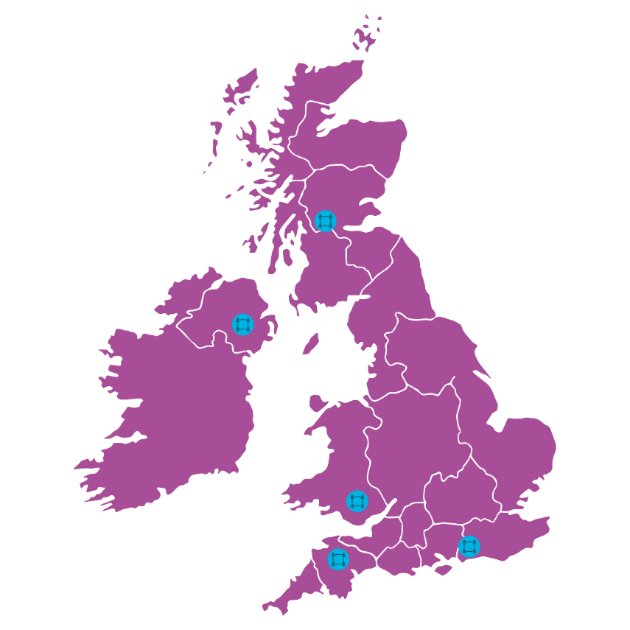
The aims of the Network were to:
- Explore the barriers, opportunities and evidence needed to enable greater progress on choice and control locally.
- Explore practical solutions at the community level to facilitate greater levels of choice and control experienced by people who draw on care and support.
- Identify scalable solutions to challenges around choice and control which that can inspire and inform change.

Key messages

There is a small but growing research base about choice and control, but less about how the specific mechanisms – such as Individual Service Funds and managed budgets – can best support people to exercise choice and control. People who draw on care and support continue to find it very challenging to access good support to give them greater choice and control: one person said, “I feel I constantly have to fight for it.”

- A gap has opened between national rhetoric and policy intention, and the outcomes people experience in local communities; progress on implementing choice and control is felt by many to have stalled.
- Locally, communication is key and regular meetings between commissioners, social workers, providers and people who draw on care and support to share and explore problems and practice are important. In one sense, being part of an IMPACT Network provided a structure for this and an incentive to meet regularly and in an action-orientated way.
- Effective co-production – that is, when people who draw on support are equal partners in designing and planning their own care – and co-creating accessible information is essential to developing high quality personalised care.
- There are gaps in national and local education and training of people working in care on personalised care, and on specific mechanisms which support people to have choice and control, such as direct payments. Very few people know about Individual Service Funds or co-operative models, and it can be difficult to overcome an initial lack of knowledge, distrust and cynicism.
- Nationally, information and advice strategies and information sites need to be refreshed to include more information on how to support people to have more choice and control.
- Commissioning guidance needs have clearer explanations of how to commission person-centred services and utilise direct payments/managed budgets/co-operative approaches to people accessing support.
- Engaging colleagues in functions such as procurement, legal services and finance can be important in helping them understand the importance of personalisation and help design more flexible systems.

Above all, decades on from the introduction of direct payments, people still found that personalised ways of working were the exception rather than the norm and could be very counter-cultural to the rest of the social care system – they had to be really passionate about this agenda and to really fight to make personalisation a reality. There is an opportunity for decision-makers at all levels to make sure that personalisation happens because of our systems and processes rather than in spite of them.

Policy context

All four nations of the UK are trying to make sure that people who draw on care and support can have greater choice and control over the support they receive (see Box 1 and 2). In the last ten years, there have been landmark legislation and policy frameworks in all four nations which have sought to create a social care system which is more person-centred and supports people to have more choice and control.

Box 1: What do we mean by choice and control in adult social care?

Choice and control is often associated with the umbrella term ‘personalisation’, which is a way of thinking about care and support that puts the person who draws on support at the centre of the process of working out what your needs are, choosing what support you need and having control over your life. It is about the person as an individual, not about groups of people whose needs are assumed to be similar, or about the needs of the organisation. Key interventions which have been implemented to support more people to have choice and control include direct payments and personal budgets. There are different ways that personal budgets can be used, including managed budgets and Individual Service Funds. There might also be scope for people to receive individual funding but to choose to pool such funds as a small group, perhaps even forming a co-operative.

A large part of the future ambition for better social care disseminated by UK national governments rests on shifting away from the current model of commissioning a narrow menu of often higher cost services such as care homes and building-based day care to creating a much wider range of support that is more personalised and more firmly rooted in local places, communities and economies.

Consequently, there continues to be a strong focus on person-centred care in recent government policy. In England, for instance, People at the Heart of Care, the Adult Social Care White Paper wants to see more people having ‘choice, control and support to live independent lives’; in Wales personalised care, is one of ten national design principles to drive improvement in health and care ; in Northern Ireland, a recent consultation on adult social care reforms, highlighted the public interest in choice and control being at the heart of any future reforms; and in Scotland proposals for a National Care Service are underpinned by a desire to place the person at the heart of decision making, and personalisation will be a key measure of quality.

Box 2: Approaches to choice and control

- In England, ‘Individual Service Funds’ or ‘ISFs’ have been argued to move away from traditional hierarchical relationships between commissioners, providers and people who receive support. They have been used for more than 20 years but were formally included in policy in the 2014 Care Act.
- In Scotland, ISFs are one way of managing an individual budget available under ‘Option 2’ of the Social Care (Self-Directed Support) Act 2013 where funding is allocated to a provider of choice or other third party. Though explicitly referenced in policy in the past 10 years, ISFs have been used for over 25 years in areas of Scotland.
- In Wales, Direct Payments can be used to enhance voice and control, such that the Social Services and Well-being Act 2014 has an explicit commitment to 'giving people a strong voice and real control over the decisions that affect them'. In addition, Section 16 of the Act places a duty on Local Authorities to promote cooperative, mutuals, user-led services and this can include the potential to pool their Direct Payments to organise joint activities or services by taking some or all of their Direct Payment and adding these funds together to jointly purchase services by establishing their own cooperative.
- In Northern Ireland, the introduction of self-directed support in 2014 included the option of receiving a direct payment as a ‘managed budget’, with the Trust, broker, care provider or another organisation holding the budget for a person who would ultimately be in control of how it is spent.

However, concerns have been raised in recent reports and through this Network, that momentum has been lost in relation to personalised care, and indeed, some progress may have been reversed. In England, for instance, The King’s Fund reported in March 2023 that the number of recipients of direct payments has fallen for each of the past five years. The 2021 Independent Review of Adult Social Care in Scotland found that ‘Many people did not feel they had the opportunity to be a partner in the decision-making process about their care and support, and nor did their unpaid carers or families’; in England, the Association of Directors of Adult Social Services’ most recent Spring Survey indicated that Directors feel that choice has reduced in care and support. Similar concerns have been raised in Scotland and Northern Ireland. A review by the Auditor General in Wales revealed that based on data from 2018-19, only 5% of recipients of adult social care had a direct payment, although there were significant variations in levels across Wales.

Evidence

Evidence suggests that providing choice and control promotes independence, well-being and a sense of empowerment, as well as enabling people to be more creative and to find ways to meet their needs that are flexible, responsive and help them lead chosen lives.

It is crucial that people can decide what sort of control they want over the funding that is available to help them meet their care and support needs.

We have heard various rumours of situations where some areas say that lots of people have a personal budget, but where the person does not know how much is available to spend, can’t exercise choice over how the money is spent and isn’t asked about what sort of control they want over this funding.

If true, this is just the old system reasserting itself under the guise of new language. It is not about choice and control, and it makes a mockery of claims to be seeking greater personalisation.

However, we know a lot less in formal terms about particular mechanisms such as Individual Service Funds or co-operative models. These might work well where someone does not have the capacity to, or does not want the responsibility of, managing a direct payment. In these cases, a person would work with a trusted service provider or other organisation, who might receive money on the person’s behalf, but then work with them on a flexible basis as to how the money is spent. Other people might want to receive a personal budget, but work with others to spend some of the funding as a group (perhaps via a co-operative model).

To help fill gaps in the evidence, members of IMPACT are involved in new research, led by the University of Sheffield, to improve our knowledge about Individual Service Funds.

What happened?

The Networks met over six months to discuss key barriers to supporting more people to have choice and control, practical solutions and national and local actions which could facilitate greater progress.

In general, there was a sense from participants that progress on choice and control had stalled, and there need to be renewed national and local commitment to the tenets and solutions that work in terms of personalisation.

Many barriers were identified. Several participants said that they still found it very difficult to access good support, and information that would help them plan and access care and support. One person noted “It takes a lot of strength to fight” as they felt trying to have choice and control was an uphill struggle, and another person said they were frustrated at not being listened to.

People who draw on care and support who have a form of managed budget told us that the rules around how they can use this budget were often restrictive, overly prescriptive, and difficult to navigate. Participants told us they often only get information about their options and entitlements when they reach a point of crisis.
The quality of services available to people also varies. Local commissioners, it was felt, had not sufficiently encouraged small and innovative providers and personal assistants to enter the local care market.

The local Networks were, however, able to describe many examples of good practice. In West Sussex, for instance, a coproduction network was working closely and successfully with local authority commissioners and providers to design a flexible and supportive approach to Individual Service Funds. In Swansea, a group of people with learning disabilities have come together to pool
their Direct Payments and set up a co-operative to manage their care and support (see case study). They have also produced a list of key features of a good approach to supporting choice and control locally (see Box 3).

Providing staff engaged in developing choice and control initiatives with time and training is also important, freeing them up and equipping them with the skills and knowledge to implement change. In several networks, participants told us that they felt the time they had been given to work on the project had been crucial in enabling them to make progress.

Case study: Co-operative approach to choice and control in Wales

In Wales, a group of adults with learning disabilities who had known each other for many years were told their support service was going to be re-tendered by the local authority. Initially they were told they would be able to choose who provided their support, but as things progressed, they were told this might not be the case. This was upsetting as the group were familiar with their provider and had built trusting relationships with their support workers which they didn’t want to lose.

After discussions with the local authority, the group were told they would have to accept care from a new organisation or receive individual direct payments. They said they felt upset, worried, angry, and that they needed to “fight” to take control of their care. The group received support from Cwmpas (the Wales Co-operative Centre) and the local authority and decided that they wanted to explore receiving direct payments which they could then pool together and manage as a group by forming an independent co-operative. Cwmpas provided the group with guidance on the practical steps involved in setting up a co-operative, with information on practical steps and the responsibilities of key roles such as Chair, Treasurer and Director.

There were a number of challenges faced by the group. Firstly, as the pooling of direct payments was a new way to receive support, it took some time for the local authority to set up the way of doing so and the group had to communicate with a range of departments. Secondly, financially, including opening a bank account, keeping records of passwords, managing correspondence and dealing with Companies House. Banks weren’t familiar with the idea of co-operative, and sometimes the group needed help with letters that sometimes felt intimidating. It can be stressful for the group to receive letters telling them that they had not paid charges, when they had been paid but information had not been passed on. However, members explained how being part of the co-operative had given them more control over their care. For example, one person loves gardening and has an allotment, and he can now use his care hours to pay for a support worker to help him do this. Overall, the group found the process worthwhile and would really recommend other groups to “go for it” and set up their own co-operative.

Box 3: Features of good choice and control approach

- Being asked – true choice and control means asking, then asking again in the future – not assuming one answer stands forever – and also considering the person’s communication needs.
- Being supported to make decisions – decision making can happen at lots of different levels, and people should be supported to make as many decisions as they can, and at every level possible.
- Good information – being able to access information on providers, activities or groups that is up to date and free from jargon, but also accessible.
- Good relationships – there are power dynamics in relationships, about how one person could be seen as being quite influential and pushing a decision in a particular way.
- Transparent systems and clarity over budgets – clear understanding of the eligibility criteria for different monies, knowing what they could be spent on; clear and easy to understand budgets; visual tools to help with setting outcomes and timescales.

A range of approaches were developed in each of the local Networks. In East Ayrshire, the local Network is seeking to embed self-directed support (the framework for personalised care in Scotland), identified the Resource Allocation System as a major barrier and sought to re-design it. In East Sussex and Devon, the two Networks focused on designing together a user-friendly, flexible and supportive approach to implementing Individual Service Funds. In Swansea, a group of adults with learning disabilities decided to set up a formal user-led co-operative to pool their direct payments and collectively decide how to support their care needs.

Finally, participants in Northern Ireland decided to set up a national ‘community of common interest to help ‘recapture the vision’ of self-directed support by reinvigorating previous pledges around managed budgets, using lessons learned from the other three nations on various ways to overcome barriers to their use in practice.

Local Network attendees also identified barriers to choice and control that are trying to overcome, including both system and human factors, such as:
- Shared understanding and information – in all countries, there were barriers in terms of misunderstandings about the various policies and options to support choice and control and how they work on a practical basis. Someone in the Networks asked: “How do you choose if you don’t know what the choice is?”.
- Leadership changes and inertia – other priorities (such as hospital discharge) may have distracted leaders from dedicating sufficient attention to developing choice and control. Regular changes in leadership have meant that organisational commitment to and memory around choice and control have been lost at times and had to be rebuilt.
- Risk – people should be supported to take risks and try new things, but risk averse attitudes – from the person, their family, support provider or social worker – can be a hindrance. Sharing risks, taking positive risks and working together can all be positive.
- Relationships – sometimes there can be tension between what the person wants and what their family might want. At other times, a particular partner may feel they are not valued – for example, a service provider may feel they are consulted less than a social worker, for example.
- Rigid systems and processes – seeking early engagement from colleagues in procurement, finance and legal services can be really helpful in designing more flexible approaches.
- Time – time to review support plans is not seen as a priority, and choices should be revisited, not taken as permanent.
- Location and availability of services – very rural locations mean choices can be limited. Some participants found they only heard about certain services through word of mouth, and the information about options was scarce.
- Disconnect between social care and health – health paying directly for some services rather than putting it into the budget so the individual can choose.
- COVID-19 – many projects and activities were paused during the COVID-19 pandemic.

Agreeing what success would look like is important and needs to be done in collaboration with people who draw on support – otherwise these mechanisms can become an end in themselves, rather than a means to an end. Across the Networks, the indented outcomes were broadly similar:
- Increased satisfaction with care and support.
- Enabling greater choice and control.
- People have better lives and more creative support.
- More people requesting their right to personalised funding.
- More people are actively part of their community as equal citizens, including through volunteering and employment.
- People are taking responsibility for their great lives.

However, a lack of data on personalised care was seen as a problem – commissioners/service managers wanted to see better evidence around the outcomes that people experience from having greater choice and control. This would also reduce the risk of resorting to basic numbers (‘I have X ISFs while you only have Y, so I’m automatically doing much better’).

Key solutions which were explored included:
- Developing a ‘theory of change’ – which is a description of a sequence of events that is expected to lead to a desired outcome – to inform the planning of local improvements to personalised care and support.
- Establishing peer support groups across local areas to enable people who draw on care and support to connect with one another and share information and support.
- Co-producing maps of how ideal choice, voice and control arrangements work locally and using these to guide implementation of changes.
- Ensuring all staff are trained in understanding choice and control, take part in learning networks, and are regularly encouraged to share good practice and case studies.
- Ensuring that all local authority policies and systems are redesigned to make sure they help people to manage their own budgets.
- Establishing local co-production groups to guide the development and implementation of new approaches to supporting people.
- Developing transparent systems to monitor expenditure which allows for a degree of over/underspend.
- Commissioning innovative models of support like micro-provision, independent brokerage, user-led organisations and co-operatives.
- Creating resources which are co-produced by people who draw on care and support to explain what options are available locally and communicate the potential benefits (as one example, we have worked with Friends United Together in Swansea to enable them to make their own video about what has worked for them – see below for further information).

Whilst rigorous cost benefit analysis wasn’t conducted in this project, we learned from Networks that they felt costs savings were being realised by offering people greater choice and control, as more people gained greater levels of independence than before, leading them to draw less on formal forms of social care.

Broader lessons

- Leadership commitment - long-term strategic leadership commitment is needed across local authorities and partners, working closely with people who draw on care and support and their organisations. Forms of direct payment/ISFs/managed budgets/co-operatives should fit with other strategic priorities. Senior commitment should help align budgets and processes to ensure that agreed priorities are implemented in practice.
- Understanding the financial implications – people know that in difficult financial circumstances, it is important to have the economic case for investment in approaches which support people to have greater choice and control. Evidence is limited on the cost benefits/cost avoidance of approaches like ISFs. New research and tools to enable local areas to understand the financial implications of these approaches would be welcome.
- Commissioning different kinds of provision - how individual local authorities approach their commissioning work has a significant influence on extent to which the ambitions of the choice and control agenda are fully realised. New and innovative models of support like micro-provision, local area coordination and co-operatives offer alternatives to more established types of care and support provision, and may offer more tailored and personalised care and support.
- Information – better and more accessible information, guidance and advice is needed (locally and nationally) on how people can best be supported to exercise choice and control. Really good clear information with ‘easy read’ options and advice supplemented with peer support from people who have lived experience in how direct payments/managed budgets/ISFs work is essential so that everyone is clear on what these approaches are, how they work and the impact they can have.
- Co-production - establish a co-production forum or implementation group which can work collaboratively with the local authority, providers and other agencies to develop the approach to implementing choice and control. In West Sussex a local Network co-produced a process map for ISFs which provided a useful planning tool which the project could revisit as it implemented changes.
- Training and workforce development - ensure that all staff understand the principles of/approaches to enabling people to exercise choice and control. Action learning networks can be a useful tool for encouraging workers to learn from each other about what works. Nationally, ensure that all training materials include clear information on how people can be supported to have choice and control. Locally, workforce strategies need to take account of the need to develop and support a workforce to support more people to exercise choice and control, which includes growing the number of personal assistants and organisations such as micro-enterprises.

To find out more

Explainer of what is ‘Theory of change’, and IMPACT’s theory of change

References

- Department for Health and Social Care, People at the Heart of Care: Adult Social Care Reform, March 2022
- Welsh Government, A Healthier Wales: Our Plan for Health and Social Care, 2021
- Department of Health, Northern Ireland; Consultation on the Reform of Adult Social Care, Summary and Evaluation of Public Responses to Public Consultation, May 2023.
- Scottish Government, Adult Social Care, Independent Review, February 2021
- The King’s Fund, Social Care 360, March 2023
- ADASS, Spring Survey, June 2023

Acknowledgements
Written by Ewan King, based on reports compiled by the IMPACT Networks team (Kate Hamblin, Amber Cagney and Maria Teresa Ferrazoli) and Network Coordinators (Pauline Lunn, In Control Scotland; Nuwani Desilva, Independent Lives; Jenny Phillips, Cwmpas and Nikki Henderson for Devon County Council).

Department for Health and Social Care, People at the Heart of Care: Adult Social Care Reform, March 2022
Welsh Government, A Healthier Wales: Our Plan for Health and Social Care, 2021
Department of Health, Northern Ireland, Consultation on the Reform of Adult Social Care, Summary and Evaluation of Public Responses to Public Consultation, May 2023
Scottish Government, Adult Social Care, Independent Review, February 2021
The King’s Fund, Social Care 360, March 2023
ADASS, Spring Survey, June 2023
Scottish Government, Adult Social Care, Independent Review, February 2021
Department of Health, Northern Ireland, Consultation on the Reform of Adult Social Care, Summary and Evaluation of Public Responses to Public Consultation, May 2023
Based on the report by Audit Wales 2022

