IMPACT Evidence Review

supporting older people coming out of hospital.

Easy read version

What is the issue?
Hospital discharge is a really difficult area of policy and practice for lots of reasons.
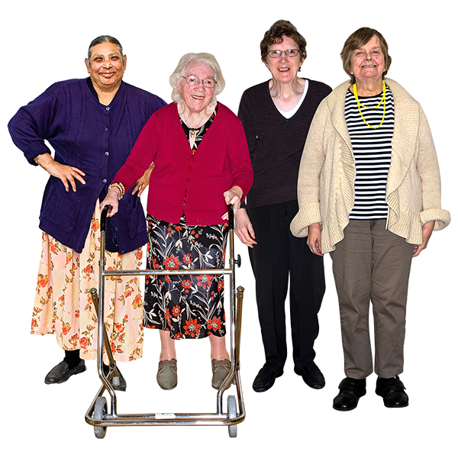
For older people especially, things can get complicated with arranging social care after they leave hospital.
Sometimes someone is ready to leave hospital, but they have to stay in hospital because of a lack of support when they get home.
This is sometimes called a delayed discharge.
This is a problem that has been going on for a while, with lots of the same issues coming up again and again.

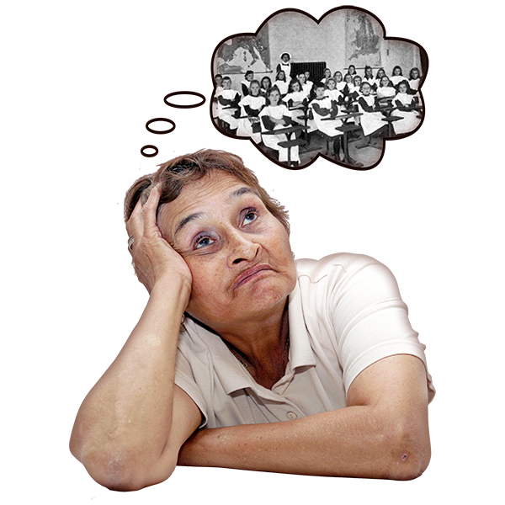
In the UK the first government guidance on this issue was published in 1963. There were delays that go back to the very beginning of the NHS and before.
This is also an international issue. This means it is affecting lots of different health and social care systems around the world.

The research shows that there are lots of problems around health and social care teams working with each other to provide support.

Some of this is because of communication between teams. Other times it’s because the rules and ways of solving problems that these teams follow are different.

There are also risks when sending someone home too early. It can be just as harmful when there isn’t the proper support in place.

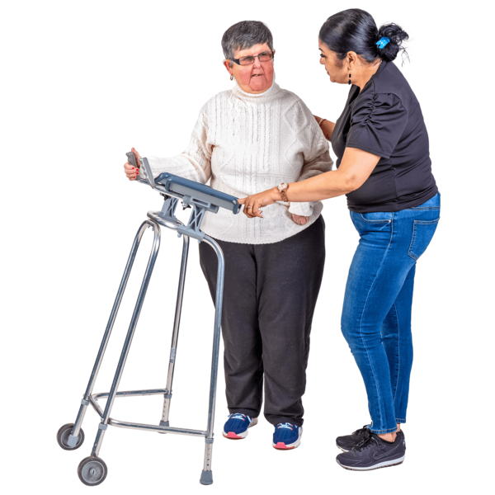
We think that there needs to be big changes in the system. We think more needs to be done to see things through the eyes of the older person in hospital.
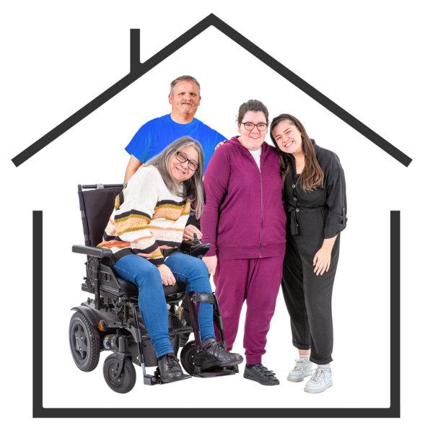
We need to focus on what matters to them and their families the most. We need to understand how frustrating this can be.

Avoiding negative and harmful language
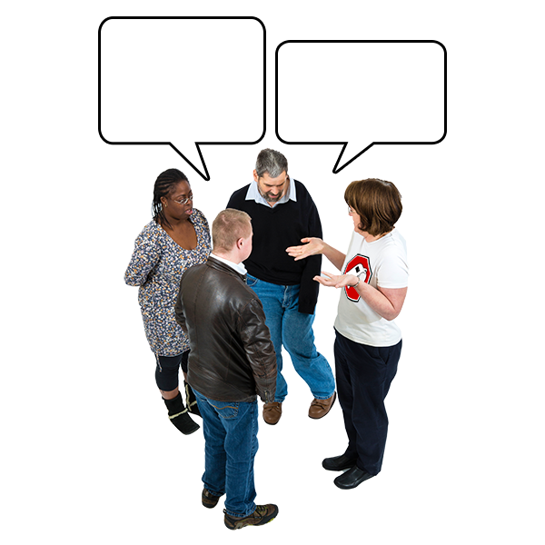
Before exploring these issues further, it is important to talk about the language we use when talking about older people in hospital.

This issue is something that is reported on in news quite a lot. But the language used can often be very harmful.

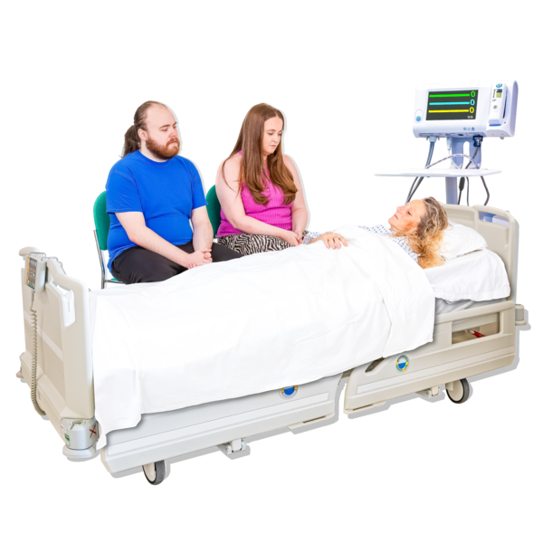
Historically, people have used the term bed blocking. They also described the people stuck in hospital as bed blockers.

This is still the case in the media and sometimes from health professionals.

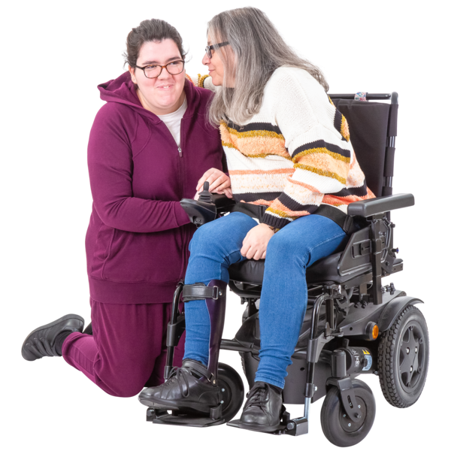
These stories make headlines talking about how this affects hospitals, but not about how it affects people and their families.

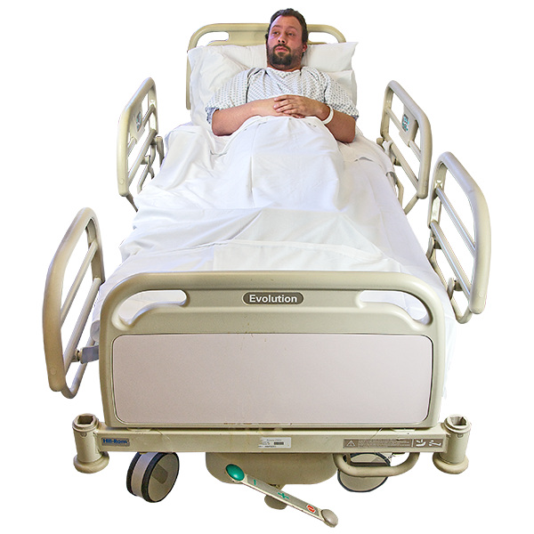
Most people see bed blocking as an offensive and unhelpful term. They feel like it is blaming the victim.

Sometimes the person is treated like it’s their fault they are still in hospital. But that person is likely desperate to get home and is only there because the system can’t organise itself to get them out.

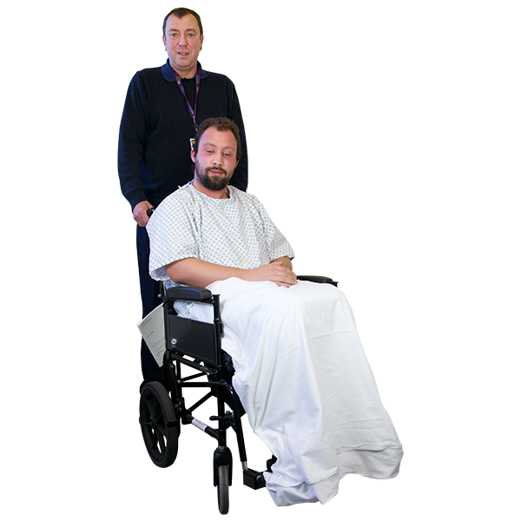
A more neutral term is hospital discharge or delayed discharge.

But, the use of the word discharge has a risk of making hospitals think their role is finished when the person leaves.

It can make hospitals think they don’t have a role in helping people transition out of hospital.
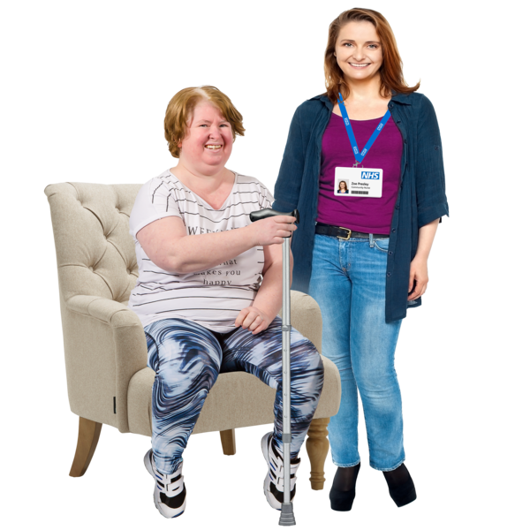
A better way to describe this situation could be delayed transfer of care. This helps explain what is taking a while to set up and keeps all teams involved in the transfer of care.

The problem with this is that longer phrases often get shortened. We don’t think many people wouldn’t understand what DTOCs stands for or how helpful it would be.

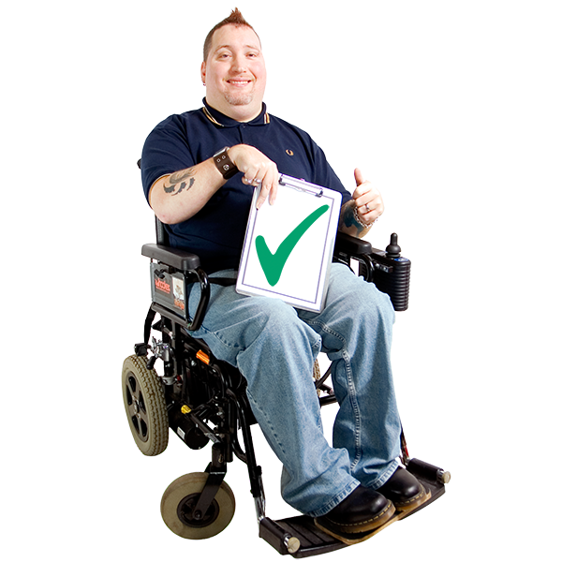
For the rest of this leaflet, we will not use the shortened version but call these situations delayed transfers of care.

What is the impact on health services?

A lot of focus in the NHS currently is around tackling long waiting lists and rebooking cancelled appointments that were caused during COVID.
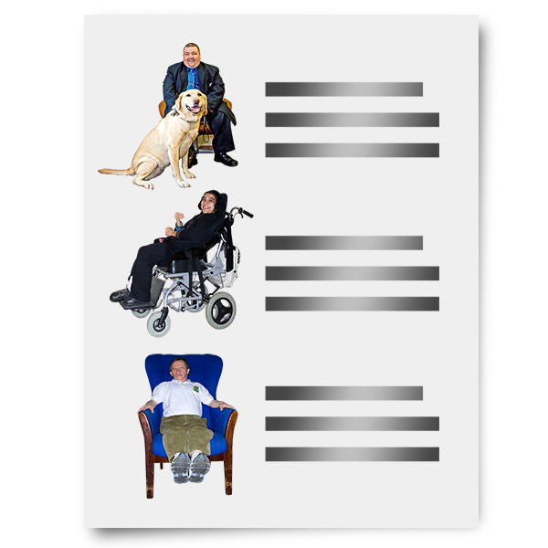
Freeing up beds by solving delayed transfers of care is a big part of getting these waiting lists back under control.
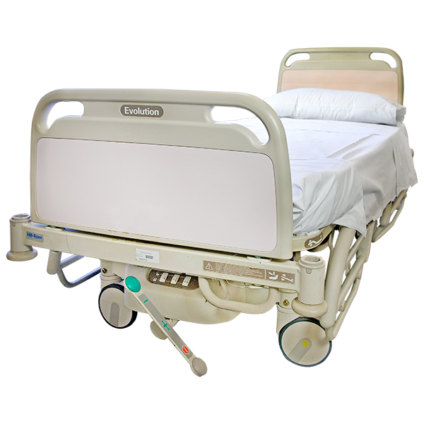
Keeping someone in hospital is expensive. There are also lots of times when people’s need for beds is higher than the beds available.

Because of this, there is a lot of pressure on healthcare staff to not have people in beds that don’t need them.

The delays in people leaving hospital when they are ready to go home is frustrating for a lot of staff.

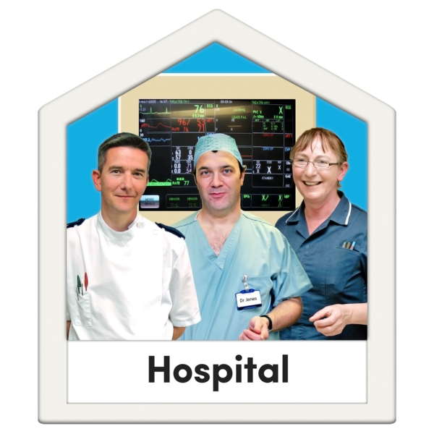
But sometimes those frustrations between health and social care working together can become one-sided towards hospital staff.

This is where the impact on our very strained NHS service is seen as most important, ignoring how important social care can be for older people.

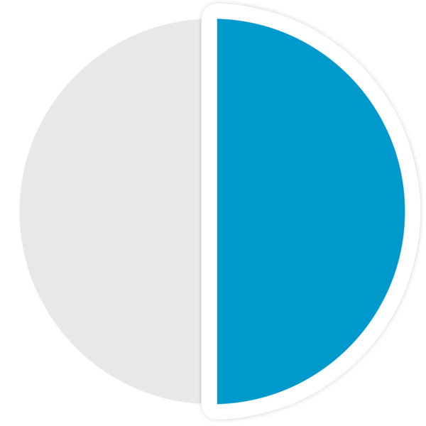
But even though waiting for social care can cause big delays, it actually causes less than half all delays in transfers of care.

Before the COVID 19 pandemic, for example, social care was the reason for about 40% of delays. While this is a lot, the NHS was responsible for the other 60%.

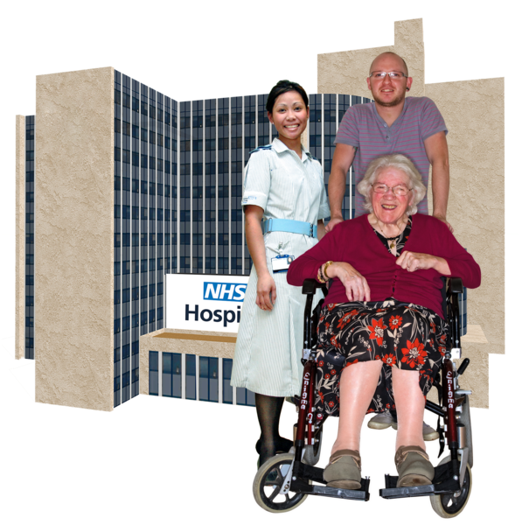
A lot of this is to do with money.
Supporting older people to leave hospital is only a small amount of what adult social care spends its money on.

What is the impact on older people and their families?
While delays leaving hospital have a big impact on the NHS, they have just as big an impact on patients and families.

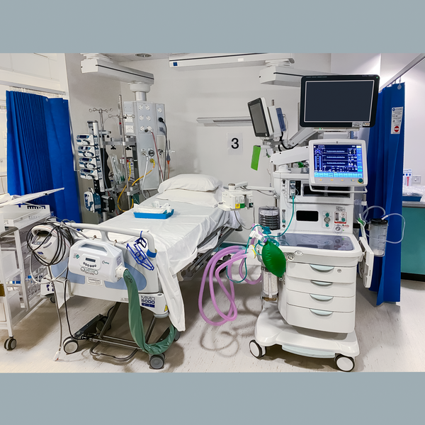
Hospitals are busy and noisy places. Most people want to get home as quickly as they can.

Staying in hospital for longer than you need can also put you at risk of picking up an infection from the hospital, like MRSA.

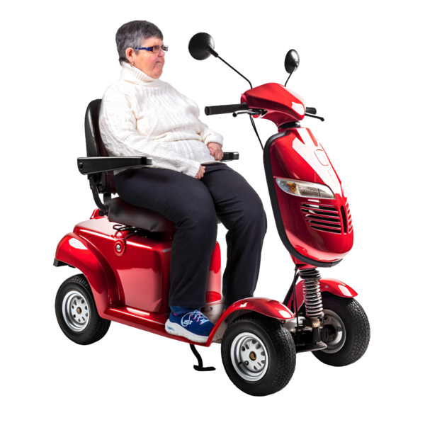
Being in a hospital bed all day can also reduce people’s independence and ability to do different things.

People with learning disabilities or with dementia often find hospital really confusing. This can lead to further issues, which make keeping their independence even harder.

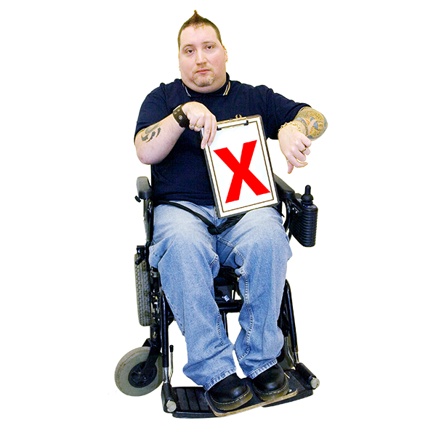
There are lots of other factors that delay transfer of care. Below are some of the issues that have been going on for a long time.

They are:

• bad communication between hospital and community services.

•Bad planning when people need more support after they leave hospital.

• Not telling people or their families when they are being discharged, and this sometimes happens very quickly.

•Relying on unpaid carers when people are discharged, especially when their needs have changed.

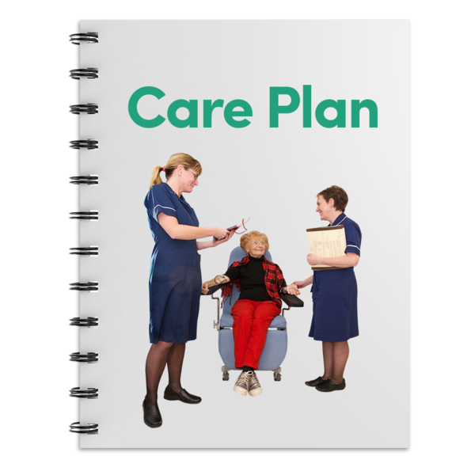
•Not setting up the right support for someone when they leave hospital, or this process being very slow.

•Not thinking about groups of people who might need even more support. This may be people with dementia or homeless people.

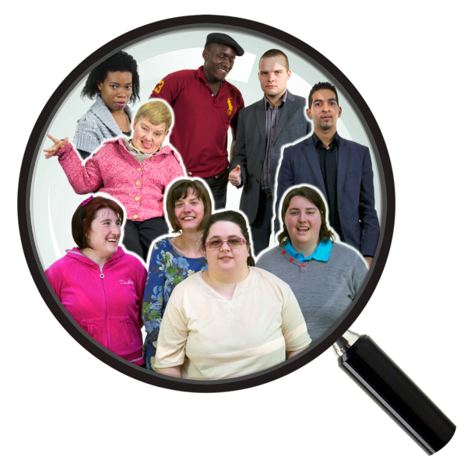
There have been some research studies that talked to older people and to families about how being in a delayed transfer of care feels.

They said it was very upsetting. People describe being at their wit’s end and feeling completely helpless.

They say it feels like they have no say in what happens to them. Their families feel completely taken for granted and left without the right support.

Negative experiences of hospital discharge

This section has some examples from Age UK’s advice line. These are real people’s stories with their names and some details changed to protect their identities.

Mary and Paul’s Story
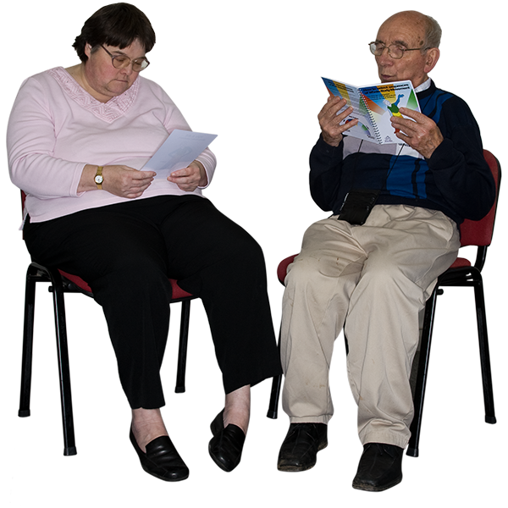
Meet Mary and her Husband Paul. Mary is 85 years old and is currently in hospital.

Paul rang Age UK’s advice line for help with their situation.

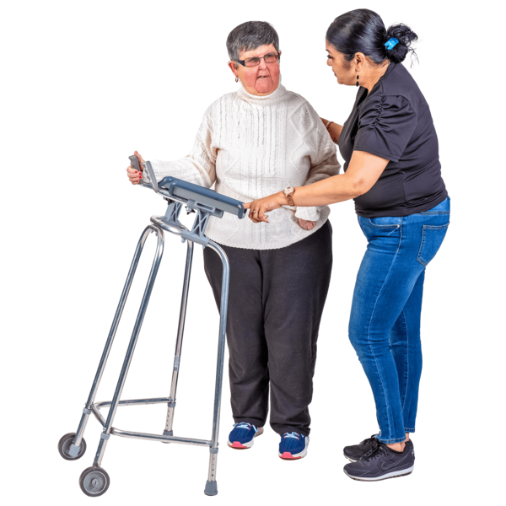
Mary has lost her mobility during her time at the hospital.

Yesterday the hospital told Paul that Mary was ready for discharge today. They told him she can’t stay in the hospital anymore.

Paul is confused because nobody has come to see what she will need to help her recover at home.

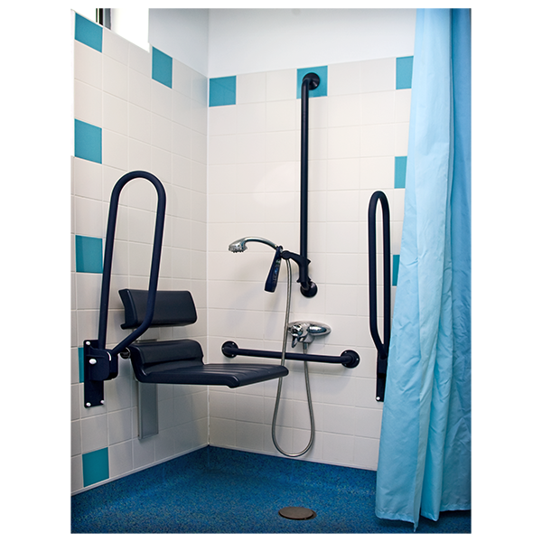
There hasn’t been any talk about if Mary can get her mobility back. No one has talked about what adaptations they need at home.

Paul was able to delay Mary’s discharge for a day by getting the Patient Advice and Liaison Service involved. They are also known as PALS.

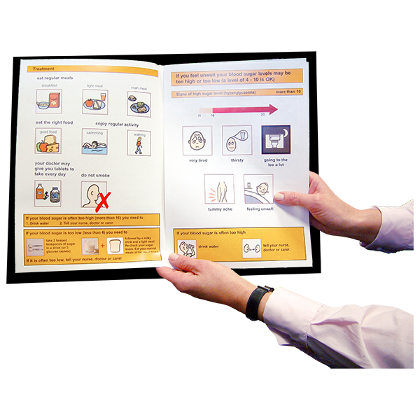
Paul wasn’t given any information about Mary’s rights, or about how they are going to manage at home.

Rachel and Janet’s story
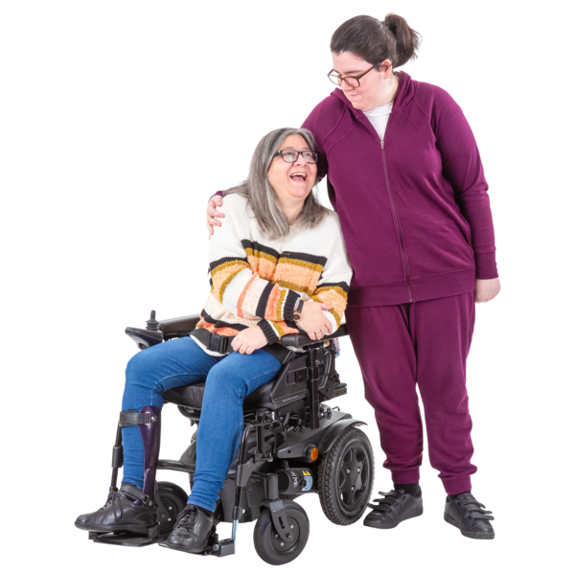
Meet Rachel and Janet. Janet is Rachel’s daughter. She rang the Age Uk advice line. Her mother Rachel is in hospital for the second time in 10 days.

Rachel lives in her own home, but Janet doesn’t feel like she is safe at home currently. Janet feels she shouldn’t have been discharged home before and is going to complain.

Before Rachel went back into the hospital, the Intermediate Care Team agreed that she wasn’t safe at home.

Now that Rachel is back in hospital Janet is worried that the same thing will happen again.

Janet doesn’t know what the responsibilities of the hospital social worker are and who, if anyone, links all the assessments up.

What’s the big picture?
Some of the biggest issues aren’t just about delays in leaving hospital. There are lots of challenges and problems that mean people have bad experiences.

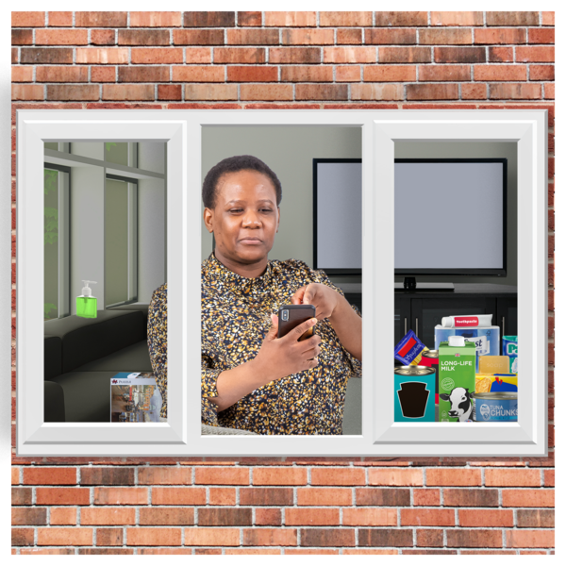
There can be big problems with sending someone home too early from hospital as well.
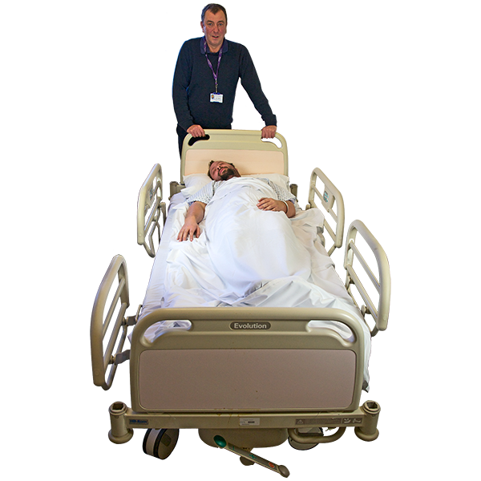

This is called premature discharge which is when someone feels pressured to leave the hospital before they feel ready to go home.

Hospital discharges cause problems when they are badly organised. There should be more focus on working as a whole team to help someone.

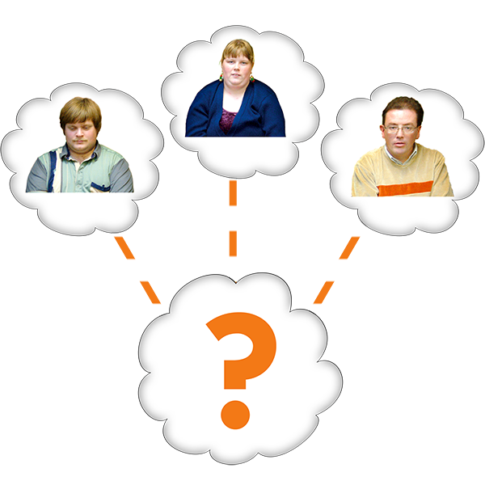
When pressures increase on hospitals, staff feel like they have to send people home at almost any cost.

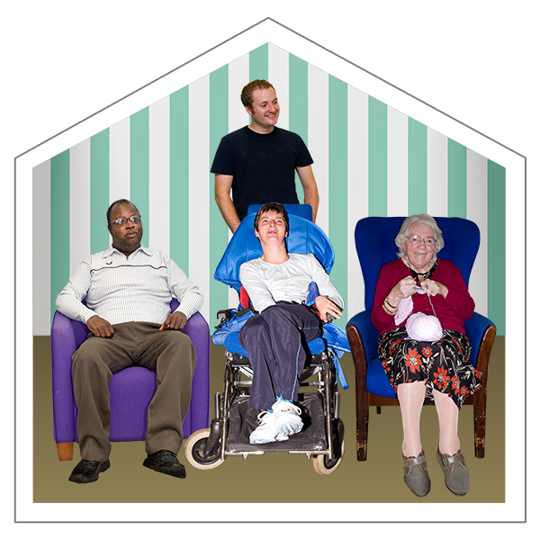
This can lead to people being sent to
care homes, rather than taking the time to help people return to their own homes.

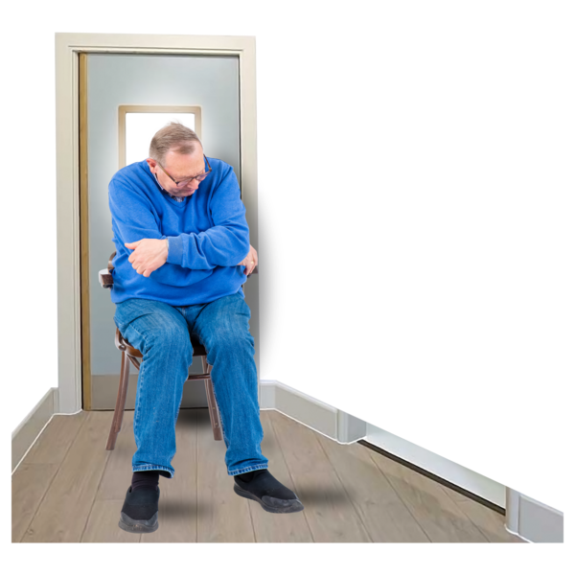
There is a big risk that short-term care home stays will turn into permanent ones. The main reasons for this are understaffing and lack of access to things to help people recover.
This can lead to people being told they are unable to be at home safely far earlier in their lives than what is necessary.

Lots of people would argue that no one should be admitted straight to a care home from hospital unless that is where they were living before.
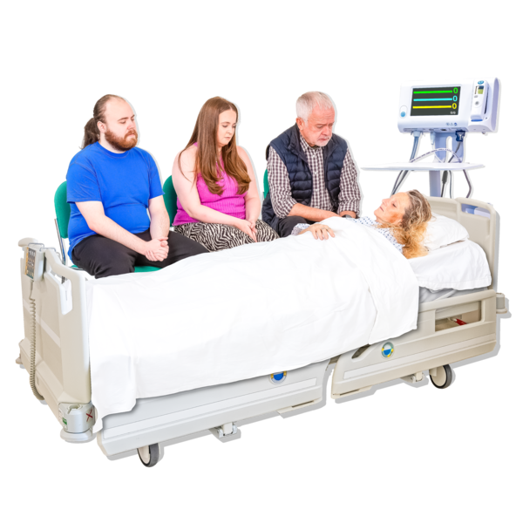
Hospitals are a really bad place to make important and long-term decisions about someone’s future. They might be scared, in pain, disorientated and not themselves.

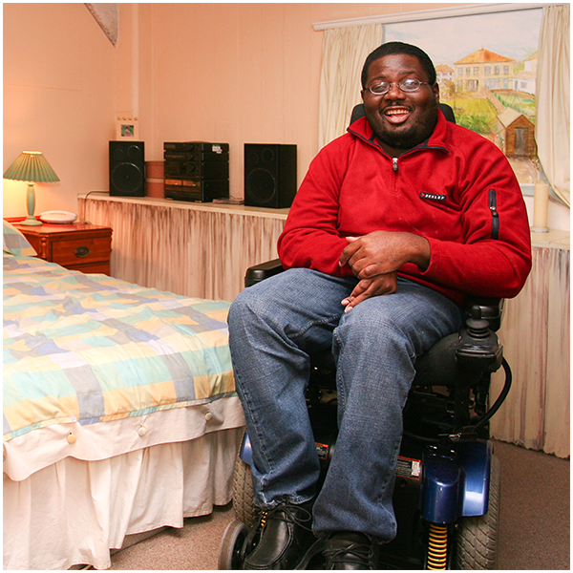
People are usually desperate to get home from hospital. They want to recover with support somewhere they know best before making any big decisions.

There has been efforts in the past to create new services that people can go to for additional support after hospital.

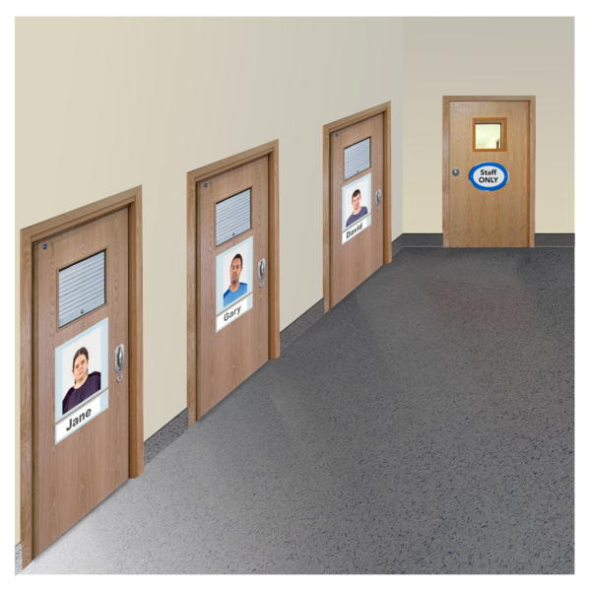
But these services can quickly fill up, becoming just as blocked as the hospital beds they were made to free up.

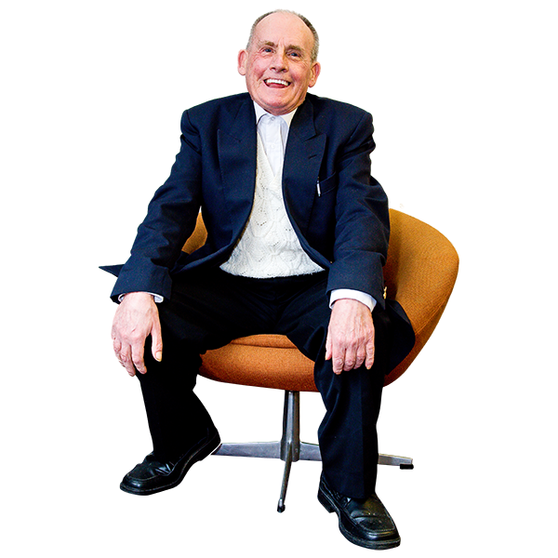
There are some fantastic services that provide personalised care and support. They have been reported to build people’s confidence and help them return home.
But there’s also a danger that even if these services work for some people, it is not solving the problems in hospitals.

We are also not involving older people and families in designing services enough.

While all the policy focus tends to be on discharging people from hospital, it’s just as important to help people stay as healthy and independent as possible.

The Audit Commission pointed out a vicious cycle where there isn’t enough to prevent people getting sick and helping them to recover.

This leads to too many people being admitted to hospitals and discharged to permanent care home places.

Which means there is even less money available to spend on helping people. This then leads to even more hospital admissions and discharges to care homes.

People think there should be more money given to help people stay out of hospitals and support them to recover when they come out.

Gaps in our knowledge
Although this issue has been widely talked about and researched over the years, there are some things we don’t know enough about.

Most research into the amount of delays has been done by medical and clinical researchers.
They review the case notes of patients in hospitals, which have been written by other medical professionals.
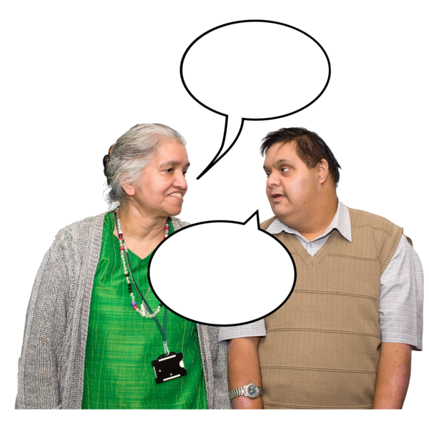
There have been very few attempts to involve older people, families, and front-line social staff in research and conversations.

This means that any solutions put forward won’t include lived experience and staff knowledge. There is a danger to miss things that will solve the problems.

Our group IMPACT argues that people are experts in their own experience. People often know what works for them and they are the only people who go through their journey through services.

Many of the professionals involved in someone’s care often only know them at one moment in time. They don’t see the whole picture.

Some research is so focused on counting how many delays there are, and who they happen to, and miss looking for solutions.

An international review looked at good practice examples, so people can see what solutions already work.

This article is free to read at: https://bmjopen.bmj.com/content/bmjopen/11/2/e044291.full.pdf

What happens next?
While we want this problem to be solved, we know it is very complicated. It is also something that has been a problem for many years all across the world.

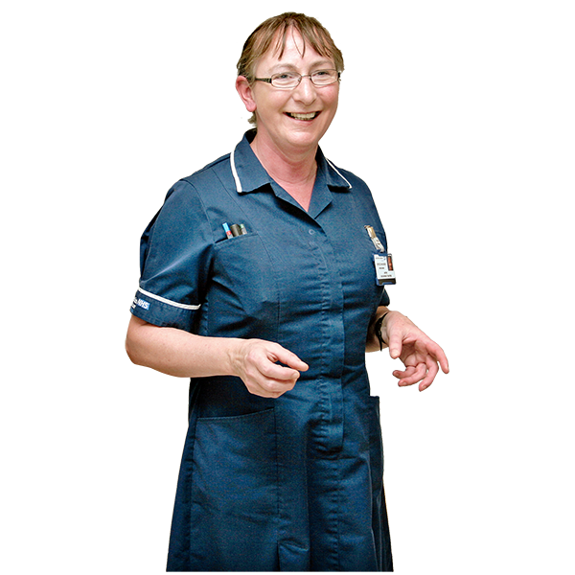
This is difficult because different areas of health care don’t always agree the best way to do things.

Hospitals are focused on and rewarded for being efficient. This means getting someone in, treating them, getting them out again and using the bed for someone else.

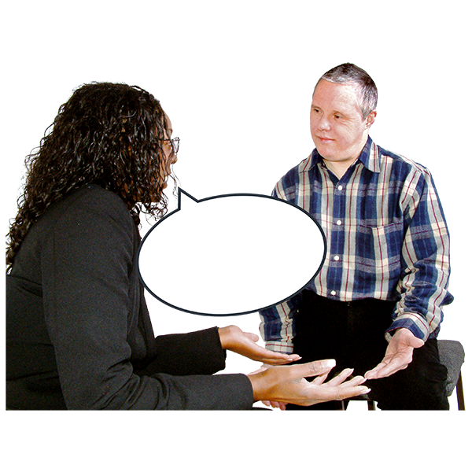
Social care tends to be focused on things that matter to the person. Their work is focused on helping people make big and difficult decisions about their long-term needs.

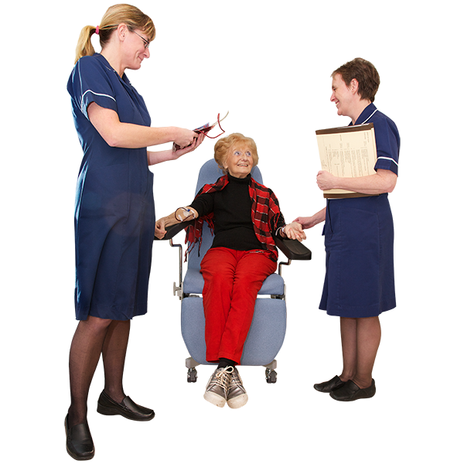
It’s not that one of these ways is right and the other is wrong, they’re just different. But sometimes these two different ways of doing things don’t work well together.
Focusing on what matters to older people
We know there isn’t any magic answers to these issues. But we might still be able to make progress.
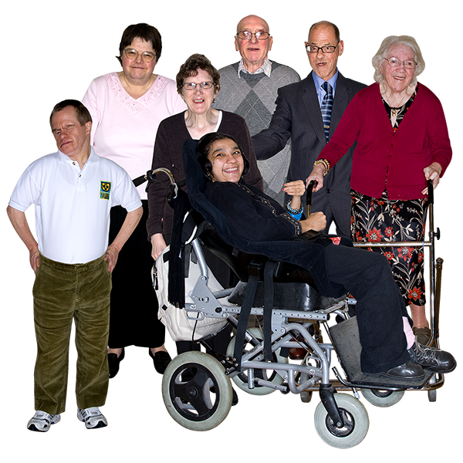
We should focus on the experiences of older people and what matters to them.
Although nearly 30 years old, an interesting example comes from work
by the ‘Fife User Panels’ project.

They talked to lots of different people about how they wanted to be treated when leaving hospital.

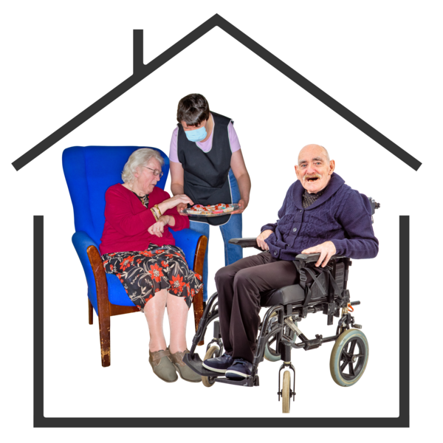
Their guide included things like making sure the person’s home was ready for them, there was support in place, and that they were given plenty of notice.

There is also good practice examples from the Social Care Institute for Excellence. On twitter, there is a hashtag called #SocialCareFuture which has many personal accounts from families.

If you would like more information on either of these studies, please contact our team.

From this research, we think there’s a lot different things health and support staff can do.

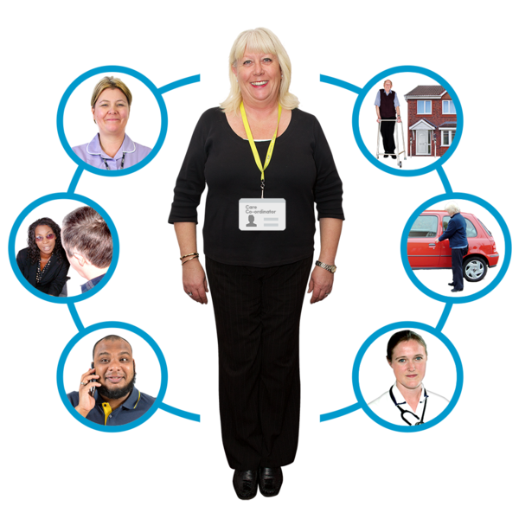
We need to focus on what we can do beyond our own roles and organisations. We need to think about ways we can help make sure support is as joined up as possible.

Rather than passing problems on to others and getting frustrated, we need to know that this is often no one person’s fault.

Local organisations need to have good relationships with each other and find practical ways to solve problems together.
People who write policy should look into what can be changed to make working together easier.
Doing these things would make changes on three different levels: individual, organisational and structural.

Individual means things people do on their own within their job or role. Like making sure not to discharge someone when it would be unsafe.

Organisational means people do things together in their workplace. This could mean that a ward agrees to have things in place to help people go home when they are ready.

Structural is things like policy for the whole country. This could mean that anyone staying in hospital over a certain time has to have a review of their needs.
We think that co-ordinated action is needed at all three levels if we are to make progress.

This document was translated into Easy Read by Sheffield Voices.

