IMPACT Evidence Review
- Choice and Control

Easy read version

What is the issue?

There are lots of discussions in the UK about how people who use social care can have greater choice about the support they get.

Research shows that people live better lives when they have full choice and control in the way they are cared for.

When people are allowed to be creative about the care they receive, people feel more confident, happy, and more included in society.

People think that there are only two ways in which can receive care.
They think that people can either be in control of their lives and manage their own care. This is known as personalised care.

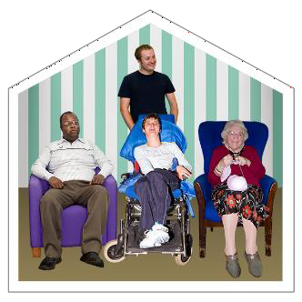
Or they think people can’t be in control of their lives and have as much choice. This is known as commissioned care

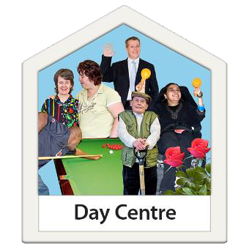
An example of personalised care would be where you have a budget and you choose who looks after you and where you go every day. This could be to places like swimming or dancing.

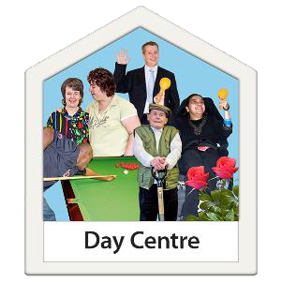
An example of commissioned care would be a day service where lots of people go and the council arrange this and pay for it.

Some people do not know that people can have a mixture of both.

There are lots of examples of how people receive a mixture of both personalised services and commissioned services.

IMPACT wants to find out more about how people can find a ‘middle way’ between personalised services and commissioned services.

We want to know how people with mental health issues, people with a learning disability and people in supported living could have more choice.

People in different parts of the UK use different words to describe the ways that people have choice and control over their support.

Let’s take a look at the different ways people across the UK do things

England
In England they use something called

Individual Service Fund.
This is where someone else can manage a personal budget for you if you are not able to.
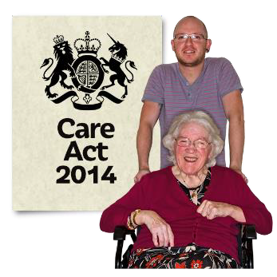
You do have choice and control but someone else just manages your social care budget.
Individual Service Funds have been used to 20 years and are in the Care Act 2014.

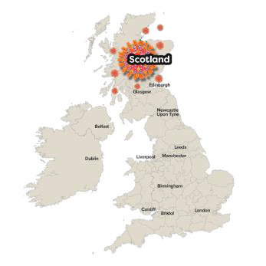
Scotland
Scotland also uses Individual Service Funds and have been using them for 25 years.

Individual Service Funds allows people to put their money together to buy services together. This is called ‘pooling’ money.

When people pool money they can do things together, go on trips, or buy things everyone can use.

Another example would be to pooling money to buy services. This could be in supported living.

Wales
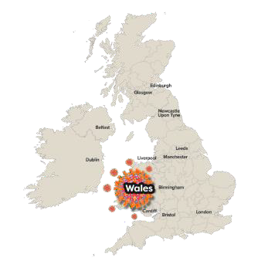
Wales use things like citizens or user led co-operatives.

A co-operative is a type of business where a group of people come together to set one up and they share who runs it and share the money out.

Different types of co-operatives have been created. Some people have created co-operatives which are user- led, meaning the people who use the service also own it.

Some people have created what is called multi stakeholder co-operatives. This means that users, staff and community are own it.

A disabled person could also buy a service from a co-operative which is owned by its employees.

Northern Ireland
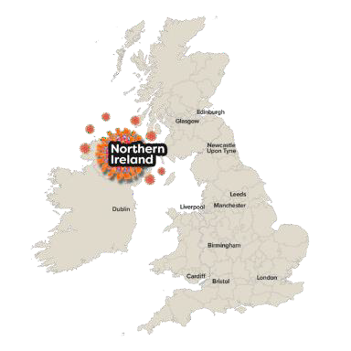
In 2014 the idea of self-directed support
came in.
This is where people are given a budget to choose their own social care. Like the Individual Service Fund, people can choose whether they manage the budget or ask an organisation to manage it for them.

Even though the words are different, each country has things in common. They are working towards all ways that people can have some choice and control over their lives.

The four key things that these different ways of making sure people have choice have in common:

- People are given a social care budget

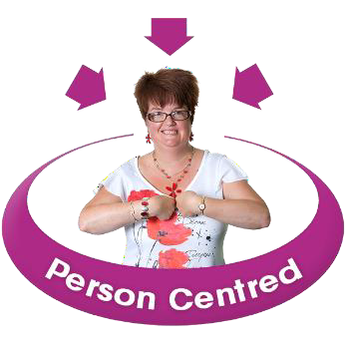
- Support is personalised

- The budget is there to help someone

lead a good life

- The person getting the budget makes all the decisions about how they want their life to look

So what does this mean for me?

“I can use my hours/ budget flexibly and I can choose what I

“I get the support on the days and times that are right for
me.”
am supported with.”

“I am supported where it makes sense for me, at home and out and about.”
“I choose who I want to support me, my support worker knows me, and I know them.”

“I choose how I am supported, and my support workers know this is
important to me.”

What is good about the different ways of giving people choice:

People have more confidence and have better health and wellbeing.

People need less support and have

better relationships.

People are able to self-advocate and
make decisions on their own.

People can be more creative because care is flexible. This works well for people who have changing health needs.

People are more aware of their rights and what everyone’s roles are. They know who is responsible for what.

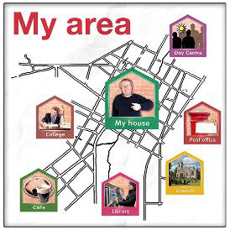
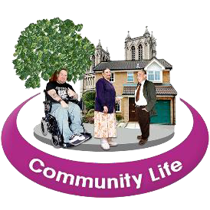
Council’s money is spent locally to help

small enterprises and projects.

We make better use of the community.

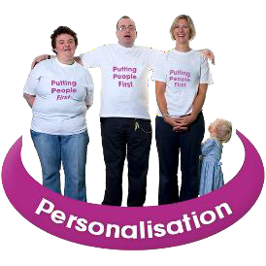
Service providers have more business opportunities. They can offer more personalised services to people.

Service providers have regular money coming in and could become a trusted provider. This is a list that the council has of good providers in the area.

But how does this work?

People must make changes for this to work.

Everyone will need to work alongside
people who need support.

This includes people who provide services, families, community groups and local authorities.

This is an example of Individual Service Funds and how they work
Person meets social worker for an assessment and to decide the budget
Information is given to person about the Individual Service Funds
Person decides if they want to use the Individual Service Funds

Person meets the provider to work out a plan

Everyone agrees to the new plan

Together an agreement is created

Support is put in place
Everyone agrees to meet and review the plan regularly

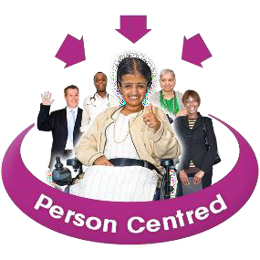
Tips for making this happen

Try out these new ways of doing things to get some experience.

Place the person at the centre of decision making. Keep thinking about what they want to achieve in their lives.

Have good communication. Meet regularly so people can learn and share together.

Create training for both social workers and care providers so staff are always learning how best to support people.

Make accessible information with and for people who use services and their carers.

Make an easy way to look at what is being spent so everyone knows where the money is going.

Make sure to include all costs so that whatever people are working towards works well.

Keep checking that everything is working for the person receiving care and the people supporting them.

Thank you for reading this
If you have any questions, please contact Kate Hamblin k.a.hamblin@sheffield.ac.uk
07960899421

