IMPACT Evidence Review:
coming out of long-stay hospitals
Prepared by Jon Glasby, IMPACT Director, June 2023

What is the issue?

In recent years, there has been growing concern about the number of people with learning disabilities and/or autistic people being admitted to hospital for extended periods of many years with no planned date for them to leave.

Although the UK decided to close asylums for people with learning disabilities from the 1960s onwards, there has been a growth in people admitted to ‘assessment and treatment units’, with widespread recognition that some people stay here for far too long, sometimes with little ‘assessment’ or ‘treatment’ that could not be provided elsewhere. Other people live in secure units, mental health hospitals or in an NHS campus alongside other services. We have called all these ‘long-stay’ settings, as a shorthand.

Despite repeated policies to help people leave hospital and live in the community, progress has been painfully slow.

Just to give one example - around 2,000 people live like this in England at any one time (see https://digital.nhs.uk/data-and-information/data-collections-and-data-sets/data-collections/assuring-transformation). The average length of stay is about 5.5 years, and 350 people have been in hospital for more than ten years.

This is a figure from England, but there are similar issues in all four nations (Hatton, 2016; Macdonald, 2018; Mental Welfare Commission for Scotland, 2016; Mills et al., 2020; Palmer et al., 2014 – see also Box 1/Table 1 for a summary of key statistics from a number of official reviews across the four nations).

No thinks this is acceptable – but solving these issues has been really difficult.

Box 1: Official reviews across the four nations
In 2022, Ince et al reviewed previous research around delays in leaving long-stay hospitals. Five national/official reviews from across the United Kingdom were also included:

England: In addition to the NHS Digital data quoted above, a review of seclusion and restraint in hospitals for people with learning disabilities was carried out by the Care Quality Commission (CQC) - the regulator of health and care services in England. It explored the experiences and effects of long-term hospital stays, segregation and seclusion, discharge and transition planning and barriers to people moving on (CQC, 2020).

Northern Ireland: A review of progress of the resettlement programme for delayed discharges, commissioned by the Northern Ireland Housing Executive who carried out the programme, also exploring reasons for slow progress (Palmer et al., 2014).

Scotland (2 reviews):

- A review of delayed discharges entitled ‘No Through Road’ conducted by the Mental Welfare Commission for Scotland (2016), investigating the extent of and reasons for delayed discharges from learning disability hospital units across Scotland.
- A review of all long stay, ‘out of area’ placements (people placed in services outside their local area), commissioned by the Scottish Government. It reports the extent and length of delays for out of area patients with learning disabilities and complex needs, and purported reasons for delays (MacDonald, 2018).

Wales: National Care Review of the care and treatment of people with learning disabilities and/or autism in all 55 hospital units caring for Welsh citizens (Mills et al., 2020), which examined readiness for transition and the appropriateness of peoples’ settings for their needs.

Table 1: Delays leaving hospital – official reviews (extract from Ince et al., 2022)

Authors, date, country | Population/setting | Length of stay or delay (where included) | Prevalence of delayed discharge
CQC (2020)  England | In depth reviews of 66 people as part of inspection visits to a wide range of mental health and learning disability services | Data not available | Discharge prevented due to lack of community services for 60% of the 66 people they met
MacDonald (2018)  Scotland | All but one Health and Social Care Partnerships in Scotland | More than 22% over 10 years; 9% for 5-10 years. Many people didn’t answer, but 13 people were delayed for 1 year+, and 10 people who were delayed had placements costing over £150,000 p.a. Only 51% had active discharge plans | 67 people
Mental Welfare Commission for Scotland (2016) | All 18 hospital units in Scotland - 104 people’s records (half of those in Scottish services) | 50% over 3 years; just over 20% over 10 years | Nearly one-third of current inpatients (32%) across Scotland were delayed discharges
Mills et al (2019)  Wales | 256 patients with learning disabilities in units managed directly by, or commissioned by, NHS Wales (across 55 units) | Mean (all patients) – 5.2 years current admission; 53% over 2 years; 19% over 10 years. 18% of current costs (5.994 million) could be reinvested in community services if all people who could be transitioned were transitioned | 80 (54%) people could be considered for transition
Palmer et al (2014)  Northern Ireland | All of Northern Ireland’s learning disability hospital inpatient population, mostly at Muckamore Hospital, Belfast | Average length of stay - 6.2 years (includes short stays of days or weeks – so some must be very long) | No prevalence given but reported progress: 31 March 2014, 24 of 30 people from 2011 target list not resettled; March 2015: with new admissions, 49 people were delayed

Why is this a problem?

This is a real problem for at least four main reasons:

- Hospitals, although potentially needed by some people for specific periods of time, are not designed to support people to lead an ordinary a life. Few people (if anyone) would want to live in a hospital if they could genuinely choose.

- People are often ‘out of area’ – a long way away from their family, friends and local communities.

- There has been a series of horrific care scandals in some such settings, with harrowing accounts of abuse, neglect, deaths and widespread deprivation of human rights.

- Hospital services can be very expensive. This can create a ‘vicious cycle’ where funding is sucked into institutional forms of care, leaving less money for community services and leading to even more people being admitted.

Extract from BBC website

What do we know already?

Despite this, there has been surprisingly little research on why people with learning disabilities and/or autistic people are delayed in such settings. In particular, previous research has often failed to talk directly to people with learning disabilities/autistic people, their families and front-line staff about their experiences of living or working in such settings, what they see as the main barriers and what would help more people to leave hospital.

Some of the ‘solutions’ put forwards are also very weak and lacking in detail. For example, an author might say ‘we need more community services’, but there’s usually little discussion of how many community services we actually have, whether ‘more’ is the answer, what kind of services might actually be needed, what this means in terms of staffing and training, whether having ‘more’ would solve anything by itself, and so on.

The previous research and these gaps in our knowledge are summarised in a free review by Ince et al (2022). This argues that we won’t make more progress until we value people’s lived experience and practice knowledge as important sources of expertise that could help us find better ways of doing things.

New research, drawing on lived experience and practice knowledge.

In response, recent research funded by the National Institute for Health and Care Research (NIHR) tried to generate better ways of supporting people to come out of hospital by working in 3 case study sites to understand the lived experience of people in hospital and their families, as well as the practice knowledge of health and social care staff.

This led to a free online guide and training video (as well as more accessible versions for people and families) which set out ‘ten top tips’ for helping people to leave hospital (see below). These have been endorsed by a number of national health and social care organisations, including organisations representing people with learning disabilities and their families, professional bodies and national policy makers.

Some emerging issues from local Network co-ordinators:

As part of an initial briefing, local Network co-ordinators have said that it would be helpful to know about a few key things that they are struggling with – many of which were also key themes in this research. Please read the full report when it comes out later in 2023 – but examples include:

- Lots of people in the study seemed to have had very traumatic experiences, either as children or as adults, or both. One of the ‘top tips’ talks about the importance of trauma-informed practice (as well as access to specialist psychological support for those people who really need it), so that people are helped to come to terms with what has happened to them.

- Lots of families had been seeking help for many years, initially when their family member was a child. They often felt that no one listened until a major crisis occurred, and then the person was admitted to hospital. It seems really important to provide support early on/at the right time, rather than waiting for an emergency.

- One of the ‘top tips’ looks at how hospitals and community services could develop better relationships, so that hospitals are supported to know what’s available in the community and to feel more comfortable about the complexity of risk with which some community services can work. This was particularly difficult for large providers who support people from all over the country – they can’t possibly know what’s available locally without the help of community services from that area.

- Lots of difficult debates took place around the nature of ‘risk’ and who was responsible for managing risk. Some local Networks might want to explore issues of risk aversion v risk enablement/positive risk taking/risk sharing (including the perspective of people and families).

- People felt that they acquired a lot of labels in hospital and during their broader journey through services. Once they had a label it was almost impossible to get rid of it – and some services seemed to respond to what was written in someone’s file, rather than getting to know them as individual people.

Although the ‘ten top tips’ focus on people coming out of hospital, some local Networks might use them to think about how to prevent people going into hospital in the first place and/or how to support people after hospital/prevent readmissions.

Why are we stuck in hospital – ‘ten top tips’

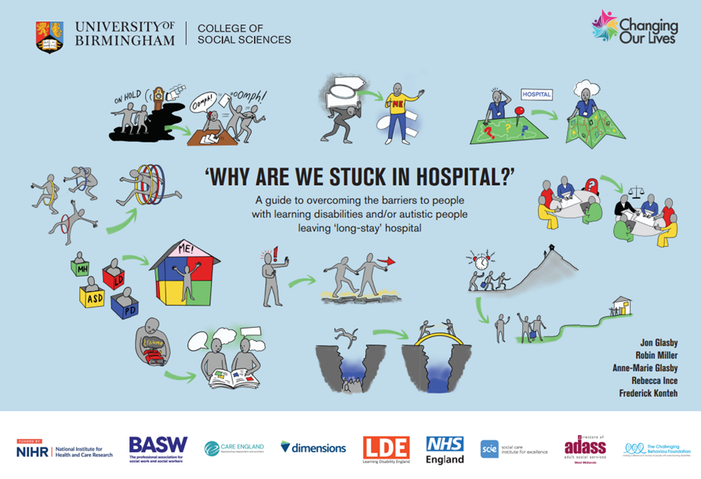

The guide, video and more accessible versions are available free of charge via each of three sites:

- https://www.birmingham.ac.uk/schools/social-policy/departments/social-work-social-care/research/why-are-we-stuck-in-hospital.aspx

- https://changingourlives.org/our-work/research/

- www.scie.org.uk/integrated-care/interventions/transfers-of-care/stuck-in-hospital

The research team also worked with an art gallery to commission a high-profile artist to create an original installation to raise awareness with the general public – including via a billboard campaign (see www.theguardian.com/society/2023/mar/14/thousands-learning-disabilities-trapped-long-stay-hospitals). While many health and social care staff are all too familiar with these issues, members of the public were really shocked, angry and upset that things are like this.

Why are we stuck in hospital – using art to communicate to the general public (Guardian article)

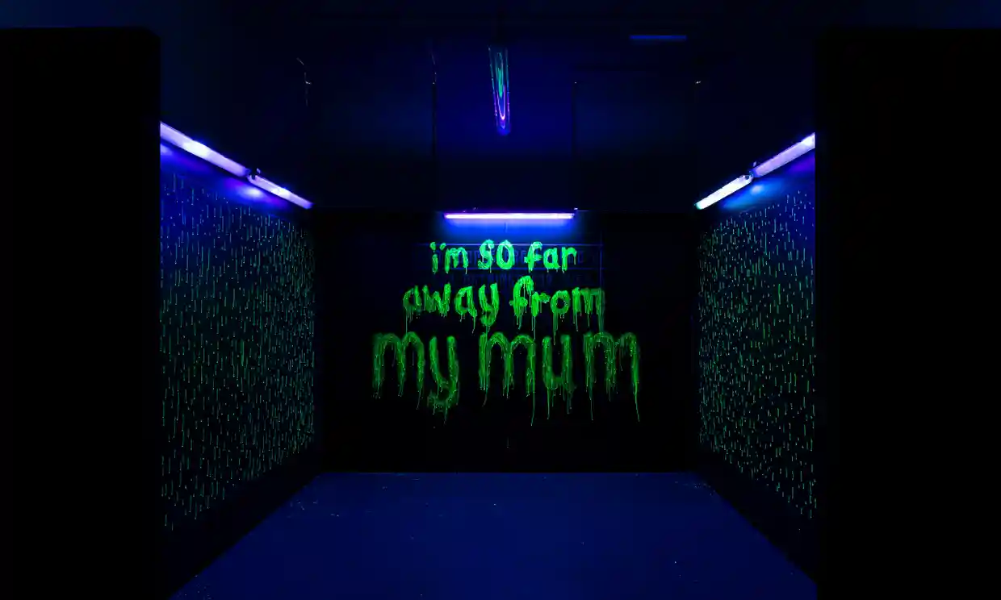

Some other resources

There is also a current NIHR study looking at what helps people to stay living independently in the community after they come out of hospital (https://fundingawards.nihr.ac.uk/award/PB-PG-1217-20032), with emerging findings made available via the ‘Making Positive Moves’ website (https://makingpositivemoves.org/).

The rights-based organisation, Changing Our Lives, has published a series of ‘hospital to home’ books, showing what has worked for people and what’s possible, in spite of all the challenges: https://changingourlives.org/category/stories/hospital-to-home/.

References

Most of this discussion paper is drawn from an initial review and a recent research study which draws on lived experience and practice knowledge:

- Ince, R. et al (2022) ‘Why are we stuck in hospital?’ Understanding delayed hospital discharges for people with learning disabilities and/or autistic people in long-stay hospitals in the UK, Health and Social Care in the Community, https://doi.org/10.1111/hsc.13964

- Glasby, J. et al (2023) ‘Why are we stuck in hospital?’ Barriers to people with learning disabilities/autistic people leaving ‘long-stay’ hospital: a mixed methods study. Birmingham, University of Birmingham/Changing Our Lives (national NIHR report due out in mid-2023) – see https://www.birmingham.ac.uk/schools/social-policy/departments/social-work-social-care/research/why-are-we-stuck-in-hospital.aspx for a summary and all materials

Background references in the text above and on different parts of the UK include:

Care Quality Commission (CQC) (2020) Out of sight: who cares? A review of restraint, seclusion and segregation for autistic people, and people with a learning disability and/or mental health condition. London, CQC

Hatton, C. (2016) Specialist inpatient services for people with learning disabilities across the four countries of the UK, Tizard Learning Disability Review, 21(4), 220-225

MacDonald, A. (2018) Coming home: a report on out-of-area placements and delayed discharge for people with learning disabilities and complex needs. Edinburgh, Scottish Government

Mental Welfare Commission for Scotland (2016) No through road: people with learning disabilities in hospital. Edinburgh, Mental Welfare Commission for Scotland

Mills, S., French, M. and Clarke, A. (2020) Improving care, improving lives: Chief Nursing Officer’s National Care Review of Learning Disabilities Hospital Inpatient Provision Managed or Commissioned by NHS Wales. Cardiff, National Collaborative Commissioning Unit

Palmer, J. et al (2014) The hospital resettlement programme in Northern Ireland after the Bamford Review part 1: statistics, perceptions and the role of the Supporting People programme (a report for the Northern Ireland Housing Executive). Portsmouth, North Harbour Consulting

