IMPACT Evidence Review-

coming out of long-stay hospitals

What is the issue?

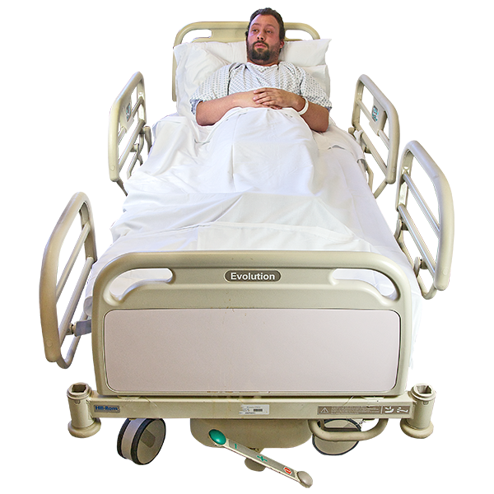
There are a large number of people with learning disabilities and Autistic people being admitted to hospital and staying for a long time.
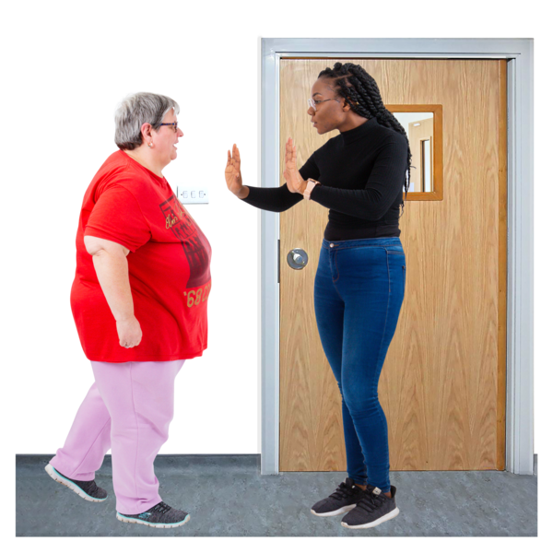
People are very worried that those hospital stays are for many years with no planned time for that person to leave.
In the past, the UK decided to close asylums for people with learning disabilities from the 1960s onwards.

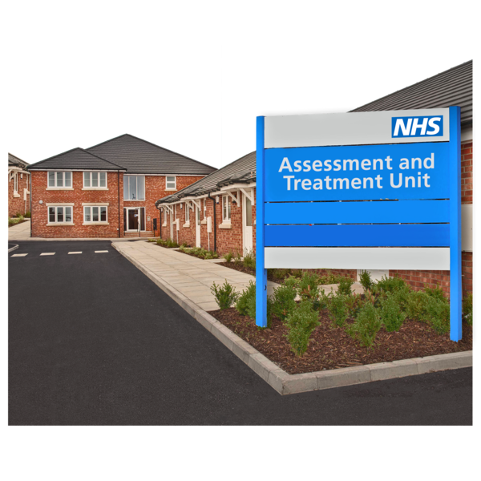
But in recent years, more people are being admitted to places called assessment and treatment units. This is sometimes shortened to ATUs.

Some people stay in these units for far too long. Despite their name, there aren’t enough assessments or treatments provided that couldn’t be done elsewhere.
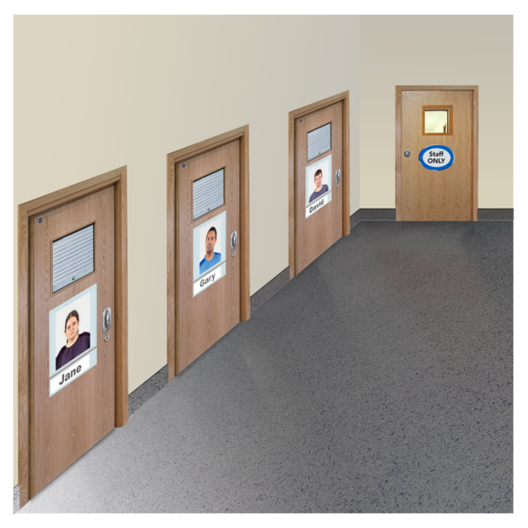
Other people live in secure units, mental health hospitals, or in an NHS site alongside other services.
We call all these types of places, long-stay settings for short.

These long stay settings are meant to have policies to help people leave hospital and live in the community. But progress is very slow.
Around two thousand people are living in long stay settings in England at any time.

The average length of stay for people is about five and a half years. Around three hundred and fifty people have been in hospital for more than ten years.
No one thinks this is acceptable. But solving these issues has been really difficult.

What does this look like across the UK?
In 2022, there was a review of previous research about delays in leaving long-stay hospitals.

Five national and official reviews from across the UK were included.

England

A review of seclusion and restraint in hospitals for people with learning disabilities was carried out by the Care Quality Commission.
Care Quality Commission, which is usually shorted to CQC, are people who look at health and care services in England.

This review looked at people’s experiences of long-term hospital stays. It included things like;
- Segregation and seclusion.
- Discharge and transition planning.
- Barriers to people moving on.

One thing this review found was that discharge was often slowed down due to lack of community services. This happened for 60% of the people they spoke to.

Northern Ireland
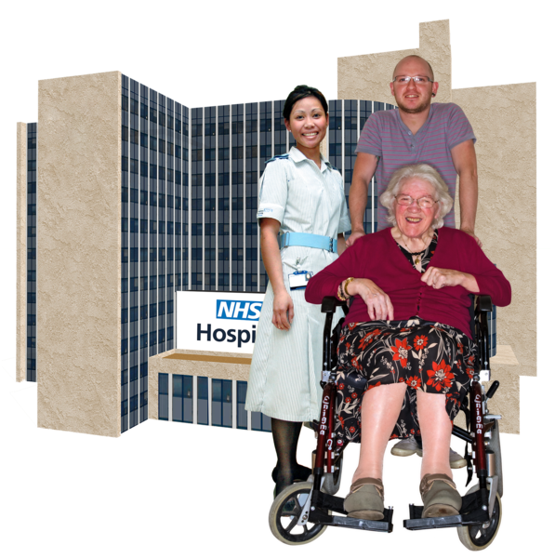
There was a review of progress for a programme that looked at helping people who are delayed in leaving hospital.

While there has been some progress, there is a lot of people still in hospital, with only a few people moved back into the community.
The average stay for people with learning disabilities in their hospital units is just over six years.
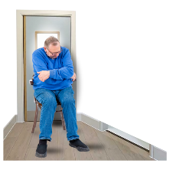
This average time includes short stays of days or weeks, which means some hospital stays must be very long.

Scotland
There was a review of delayed discharges called ‘No Through Road.’

This review looked at the reasons for delayed discharges from learning disability hospital wards.

One thing this review found was that nearly one-third of current inpatients with a learning disability were delayed discharges.
Another review of all long stay and out of area placements was commissioned by the Scottish Government.

Out of area means someone is in hospital somewhere not close to their home or community. Some people are in hospitals a long way from home.

In the report, some of the findings showed that 13 people were delayed in leaving hospital for over a year.

10 people who were delayed had placements costing over £150,000 per year.

Only 51% of people in these units had active discharge plans.

Wales

There was a National Care Review in Wales. This was around the care and treatment of people with learning disabilities and or autism.

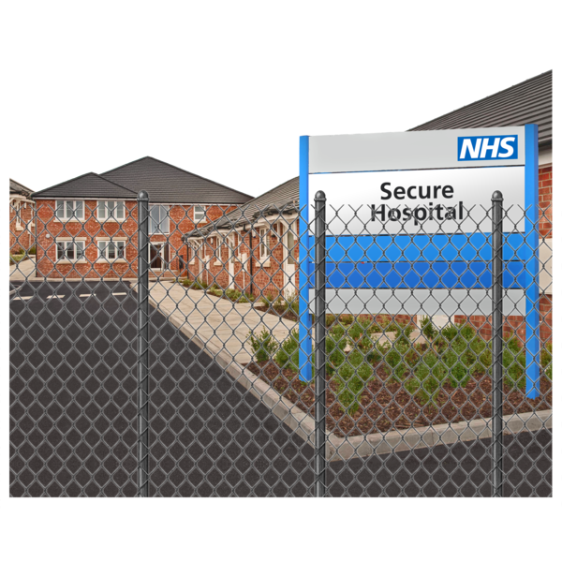
This review looked at how ready people were to move out of hospital. It also looked at whether hospital settings were meeting their needs.

The average time people in Wales were spending in long stay hospitals was just over five years.

This review found that a big chunk of current money being spent on hospital stays could be put into community services right now.
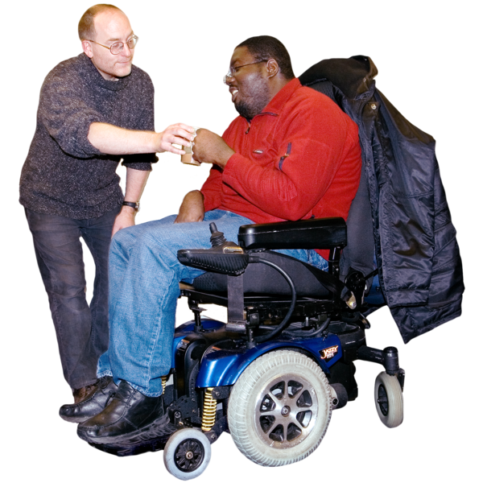
This could happen if all people who are being delayed in hospital were helped back into their community.

Why is this a problem?

Hospitals are not designed to support people to lead an ordinary a life.

Even if hospitals are needed by some people for emergency help, they are not suitable for long stays.

Very few people would want to live in a hospital if they could choose not to.

People are often out of area. Which means they are a long way away from their family, friends, and local communities.

There has been a lot of bad care scandals in some hospital units. These came with stories of abuse, neglect, deaths and people having their rights taken away.

You may have seen stories like this on the news. An example of one of these stories is the scandal around Whorlton hall.

Hospital services can be very expensive. This can create something known as a vicious cycle.

This is when money is used on expensive hospital care, which means less money for community services. Without those services, even more people are being admitted to long stay hospitals.

What do we know already?

There has been surprisingly little research on why people with learning disabilities and autistic people are delayed in long stay settings.

Past researchers hardly ever talked directly to people with learning disabilities and autistic people. They have also not talked their families and front-line staff.

As a community, we have not often been asked what we see as the main barriers. Or what would help more people to leave hospital.

Some of the solutions that are given to help people leave hospital are very weak and don’t have enough detail.

For example, someone might say we need more community services. But there’s not enough discussion of how many community services we already have, and what could be done to make them better.

We think we won’t make more progress until we value people’s lived experience. We need to see people’s experiences as important, which could help us find better ways of doing things.

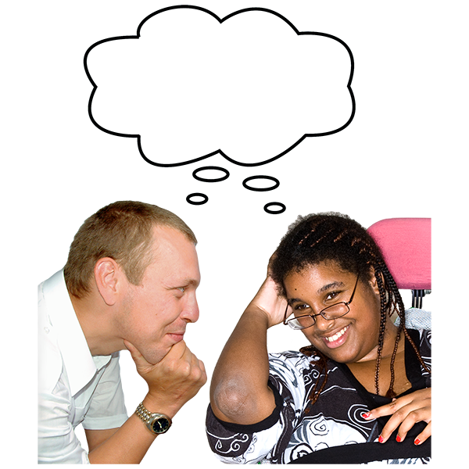
There has been recent research which tried to come up with better ways of supporting people to come out of hospital.

This team worked in three sites to understand the lived experience of people in hospital and their families. They also looked at experiences of health and social care staff.
They made a free online guide and training video. They also made accessible versions for people and their families.

Lots people with learning disabilities and their families have said these videos are good.

Why are we stuck in hospital?

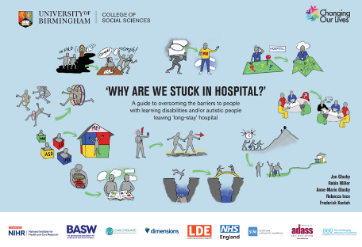
The guide, video and more accessible versions are available free of charge on these three sites:

https://www.birmingham.ac.uk/schools/social-policy/departments/social-work-social-care/research/why-are-we-stuck-in-hospital.aspx
https://changingourlives.org/our-work/research/
www.scie.org.uk/integrated-care/interventions/transfers-of-care/stuck-in-hospital

The research team also worked with an art gallery. They asked an artist to create an original piece of art. This was done to help raise awareness to the public.

It was also covered in newspapers, like this article here:
www.theguardian.com/society/2023/mar/14/thousands-learning-disabilities-trapped-long-stay-hospitals

While many health and social care staff know all about these issues, members of the public were really shocked that things are like this.

Some issues from local Network co-ordinators

Local Network co-ordinators are people that help form the IMPACT Networks. They have said that it would be helpful for us to know about what they are struggling with.

There will be a full report out later this year. Examples include:

Lots of people in the study had very traumatic experiences, either as children or as adults, or both.

People want there to be a focus on something called trauma informed care. This means that people are helped to process with what has happened to them.

Lots of families have been seeking help for many years. They often felt that no one listened until a major crisis occurred, and then the person was admitted to hospital.

People think hospitals and community services need better relationships. This is so they can better support people and show them what’s available in their community.

Lots of difficult debates took place around risk and responsibility. People want to see hospitals do things not in policies when its in someone’s best interest.

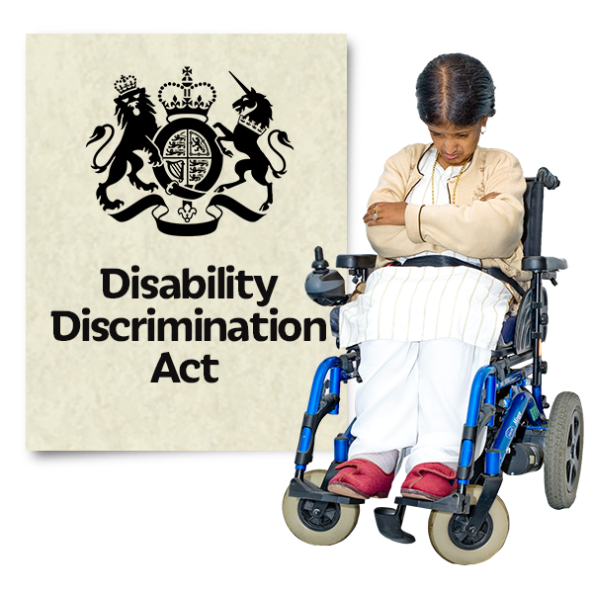
Lots of people are worried about labels. When something is on your record it’s very hard to get rid of.

Other resources

There is also a current study looking at what helps people to stay living independently in the community after they come out of hospital https://fundingawards.nihr.ac.uk/award/PB-PG-1217-20032

The findings of this are published on: https://makingpositivemoves.org/
The rights-based organisation, Changing Our Lives, has published a series of ‘hospital to home’ books.

They are showing what has worked for people coming out of hospital and what’s possible, in spite of any challenges.

There website is : https://changingourlives.org/category/stories/hospital-to-home/.

We can also provide a reference list for our sources, please message or email if you would like this sent to you.

Document translated into Easy Read by Sheffield Voices

