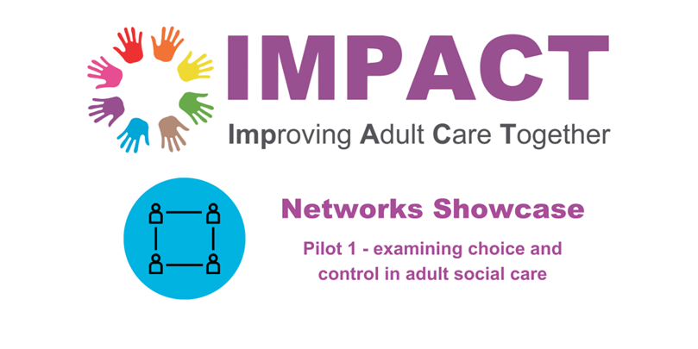

On 24th May 2023, the IMPACT networks team hosted our first showcase event, highlighting the work that the local networks had achieved during their 6-months meeting as a network and where they are now, 6 months on.
This project was our first delivery model pilot on the topic of ‘Choice and Control: Enhancing choice and control for people with mental health conditions and/or learning disabilities; bringing together 8-10 people in each of the four nations to understand the context they operate within, what helps and hinders choice and control, and how they can use evidence from their networks to co-produce a local action plan to create change.
The agenda was as follows; you can click each link for a video snippet of the event:

- What are IMPACT Networks?
- Choice and control in practice in Ireland – Karen McCormick, Georgia, and Lisa
- Independence pays: why choice and control matters to IMPACT and should matter to all of us – Jon Glasby
- IMPACT Networks: reflections of where we are and where we’d like to take choice and control:
- Individual Service Funds in East Ayrshire: Pauline Lunn (InControl Scotland)
- Social Care Cooperatives in Wales: John, Marie, Robert and Clive (Friends United Together), Jenny Phillips (Cwmpas), Rick Wilson and Christian Cowap (Community Lives Consortium) and Lisa Banks (Swansea County Council)
- Individual Service Funds in England: Nuwani De Silva (Independent Lives)

Individual Service Funds in East Ayrshire: Pauline Lunn (InControl Scotland)
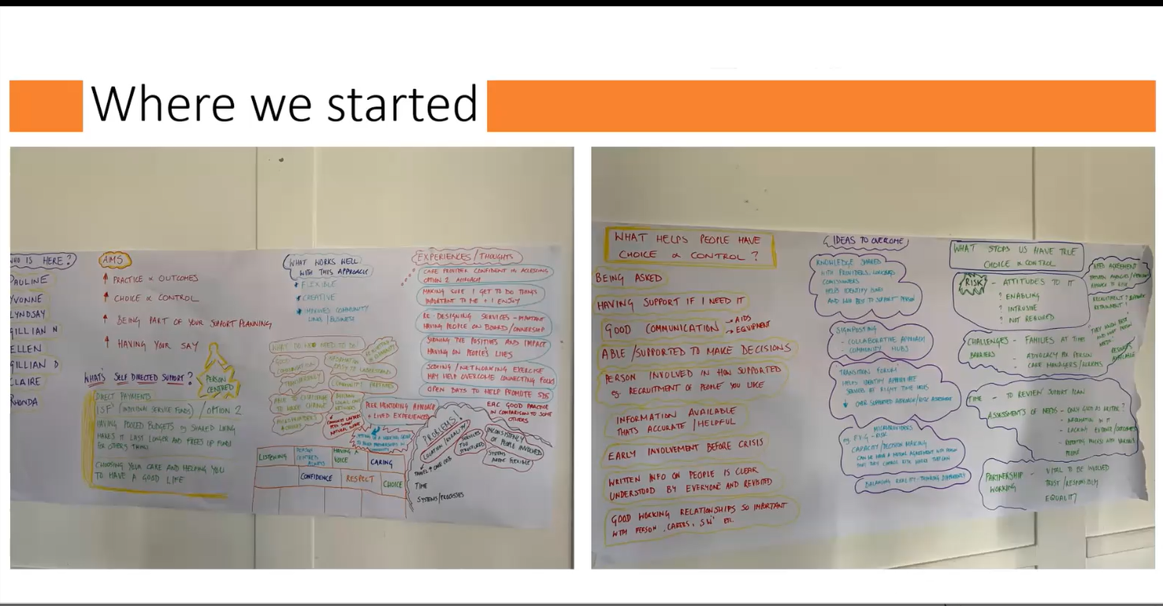

Context: Nationally in Scotland, ISFs are one way of managing an individual budget available under ‘Option 2’ of the Social Care (Self-Directed Support) Act 2013 where funding is allocated to a provider of choice or other third party. Although ISFs were formally introduced in policy in 2013, in practice, they’ve been used in Scotland for 25 years.
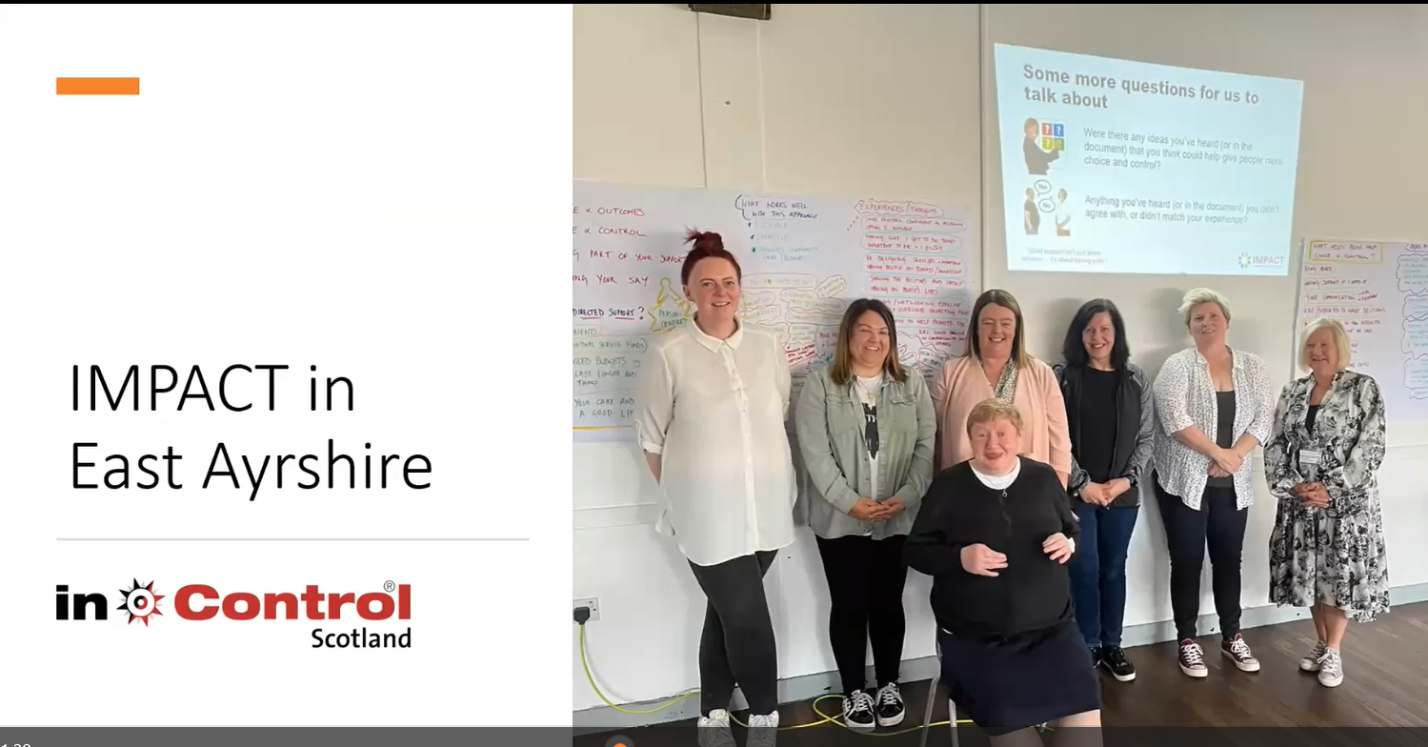
ISFs/ Option 2 are well-established in East Ayrshire- 13% of people receiving support either are receiving an ISF on its own or as part of a bigger support package. However, some groups of people are receiving more ‘traditional’ forms of support in the local authority.

“Creating a team has been empowering, we’re finding it’s really making a difference and people are listening”

See East Ayreshire’s action plan here

After taking part in IMPACT networks and following on from their action plan..
Transformation and Change - supporting people in the community and the workforce
Workforce development: Two Workshops were run to get the views of social workers and social work practitioners, who often don’t get time to reflect and share their views - the main topics that arose were around
- Assessment processes
- Assessment templates
- Liquid logic system - the practise and systems were not joining together
- A need to increase community work - more engagement and increasing capacity
- and various other topics
- Connecting practitioners to directors - started to have conversations, with meetings coming up with the senior management team to improve partnerships.
The resource allocation system was reviewed, workshops were completed which identified information gaps and next steps for improvement
A new partnership was developed with the creator of 24:7 grid system to support areas of work.
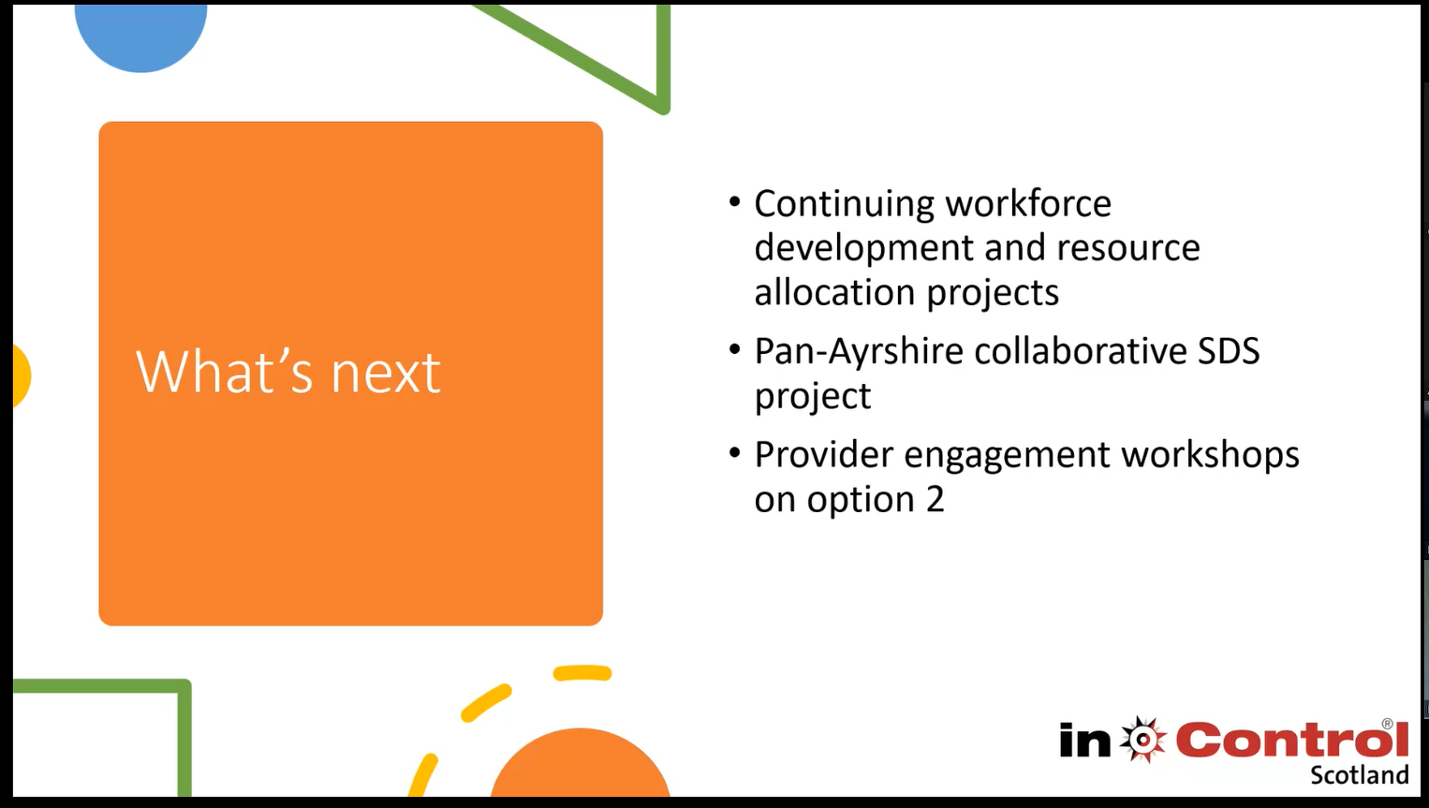

“We are finding a difference, people are listening and it’s becoming more on the agenda.”

Social Care Cooperatives in Wales (Friends United Together, Cwmpas, Swansea Council)

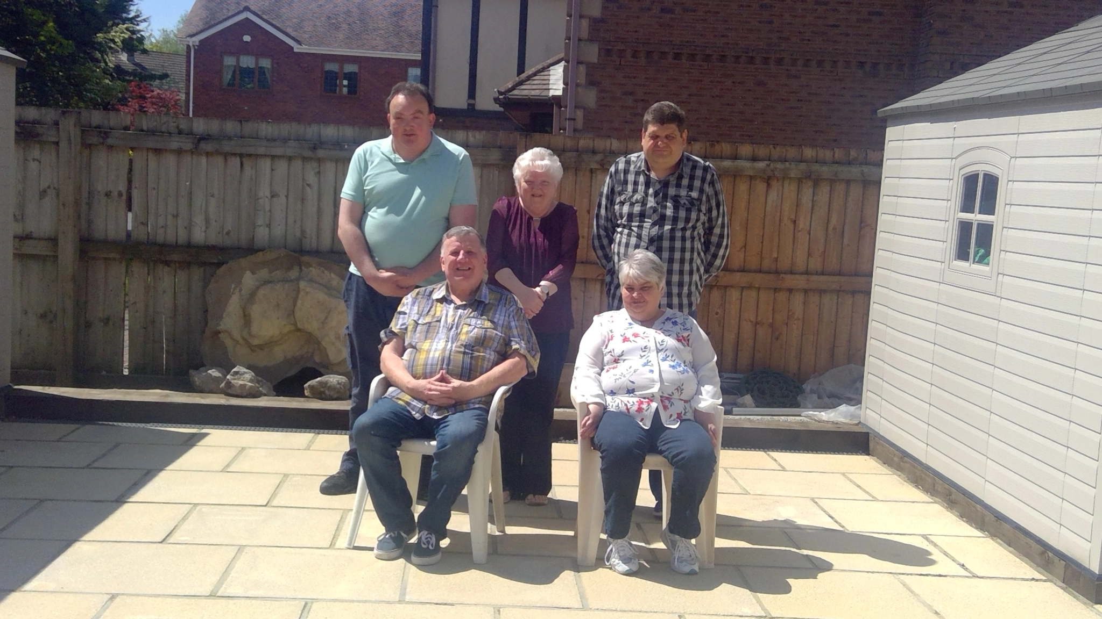

“Hello everyone, my name is Robin Savours and I am one of the founding members of Friends United together. The other founder members are John, Marie, and Clive. We were told several years ago that all services in Swansea were going out for re-tender, and that our current provider may no longer provide a service to us. This also meant that John and Linda would be in a different area to the rest of us. We all wanted to stay together as we had supported each other for many years and become good friends.

This process upset us and Marie was very anxious about this and found it difficult to understand. We also knew that this process would happen every 4 to 5 years and we didn't want to go through the stress and anxiety again..

We made contact with Jo Barlett from CWMPAS with support from Rick. As Jo was independent she was able to help us prepare a letter to Swansea Local Authority outlining our
wishes and what we would like as a group and what we wanted for our future. We met every few weeks with Jo and she helped us develop our skills and supported us to set up our
own co-operative.

“We members meet on a regular basis and we discuss what things we would like to do.
Having Direct payments allows us to manage our time and support hours more effectively. For example, if we don't use our allotted hours we can bank these and use them when it suits us to do what we want.Having flexibility is great for us as we have more control over our lives.

6 months on:

Peoples Voice Media has been commissioned by IMPACT to work with Friends United Together.

Aim: Use Community Reporting techniques to create a video story about Friends United Together Co-op that supports the group to recruit more members and staff, and to spread the word about social care co-ops more widely.

Objectives:
Members of the Co-op develop the following skills:
- Peer-to-peer storytelling
- Video recording
- Video editing
- To create a video rooted in the lived experience of the members that will enable them to share their individual and collective stories with new staff and members.

The learning and awareness from this video will be shared by IMPACT and the Friends United Together teams to support their action plan objectives.

Individual Service Funds in England: Nuwani De Silva (Independent Lives)
Context: In West Sussex, direct payments (DPs) are used to provide people with choice and control. In the early 2000s, there were pilots involving ISF style funding in West Sussex, with the provider acting as a broker, but this was not continued. Around this time, council-managed budgets were introduced; in West Sussex Council responded to a Freedom of Information Act request by Self-Directed Futures to indicate ISFs were not available in 2021.

West Sussex’s main goal: “We wanted at least to see a pilot, and wanted a system that was truly about the person rather than task and time based”.
6 months on…
“We had a bit of luck, everything fell into place at the right time and right place”
- Commissioners are keen to explore ISF’s in more detail
- The work done in the IMPACT Network group gave the impetus for West Sussex to explore further
In December, just as the network finished, research was commissioned into the implementation of ISF with several network members part of that research. A working group (including some of the IMPACT network members) is ongoing, with a pilot project proposed once the working group has concluded and found the best way forward.
Commissioners were happy for Independent Lives to find out about choice and control from their customers in West Sussex to keep the momentum going and learn more about how people feel at the moment
“it’s been a huge journey, and certainly this IMPACT network has helped build momentum and provide connections with other counties and providers with experience of individual service funds with good outcomes. We’re really excited.”

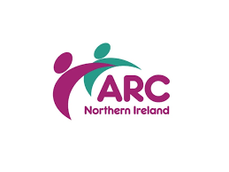
Meanwhile in Northern Ireland…
In Northern Ireland, a Community of Common Interest, coordinated by the Association for Real Change (ARC) Northern IrelandAssociation for Real Change (ARC) Northern Ireland has been meeting to explore choice and control with a specific focus on self-directed support and managed budgets.

By the time that the Showcase took place, the Northern Ireland Community of Common Interest had met twice to discuss how choice and control can be enhanced for people with learning disabilities or mental health conditions.Multiple stakeholders from the Community of Common Interest attended the IMPACT Showcase to see the application of learning across the four nations. The next steps in their community of common interest is to explore the next steps in making managed budgets a reality, raise awareness of self directed support and how to best support people to make their own decisions.

